DOCUMENTATION

ASSIGNMENT 2

QUEUES MANAGEMENT APPLICATION USING THREADS AND SYNCHRONIZATION MECHANISMS

STUDENT NAME: Morandau Felix
GROUP: 30425

CONTENTS

1. Assignment Objective 3
2. Problem Analysis, Modeling, Scenarios, Use Cases 3
3. Design 3
4. Implementation 3
5. Results 3
6. Conclusions 3
7. Bibliography 3

Assignment Objective
Main objective:

Design and implement an application aiming to analyze queuing-based systems by (1) simulating a series of N clients arriving for service, entering Q queues, waiting, being served and finally leaving the queues, and (2) computing the average waiting time, average service time and peak hour.
Sub-objectives:
- Analyze the problem and identify requirements.
- Design the simulation application.
- Implement the simulation application.
- Test the simulation application.

Problem Analysis, Modeling, Scenarios, Use Cases
Functional requirements:
- The simulation application should allow the user to setup the simulation.
- The simulation application should allow the user to start the simulation.
- The simulation application should allow alert the user if the input is invalid.
- The simulation application should display the real-time queues’ evolution.
- The simulation application should display the stats (peak hour, average waiting time, average service time) after the simulation ends.
- The simulation application should save the logs from the simulation in a text file.

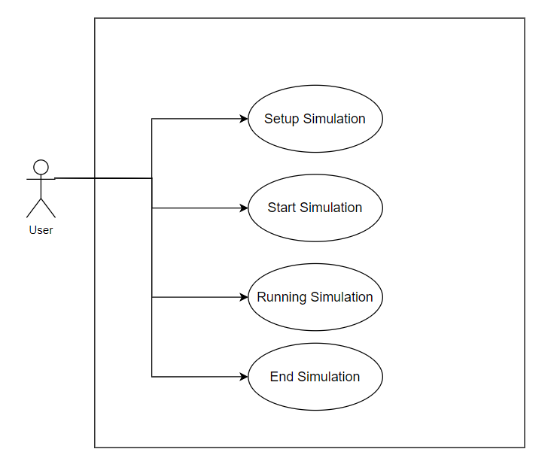
--Use case diagram--
Use Case: setup simulation
Primary Actor: user
Main Success Scenario:
- The user inputs the values for: number of clients, number of queues, maximum simulation time, minimum arrival time, maximum arrival time, minimum service time, maximum service time and chooses the strategy (SHORTEST_QUEUE or SHORTEST TIME) by selecting one of the 2 options.
- The user clicks on start simulation and the inserted values are valid.

Alternative Sequence:
- The user inputs the values for: number of clients, number of queues, maximum simulation time, minimum arrival time, maximum arrival time, minimum service time, maximum service time and chooses the strategy (SHORTEST_QUEUE or SHORTEST TIME) by selecting one of the 2 options.
- The application displays an error message saying that the inserted values are invalid.
- The user has to insert some valid values in order to switch to the success scenario.

Use Case: start the simulation
Primary Actor: user
Success Scenario:
- The user presses the start simulation button and the window changes to the live simulation window.

Use Case: running simulation
Primary Actor: user
Success Scenario:
- The application displays the current time of the simulation, the waiting clients and the queues with the clients. Each client is represented by the following pattern: (client_id, arrival_time, service_time).

Use Case: end of simulation
Primary Actor: user
Main Success Scenario:
- The simulation ends because the maximum simulation time was reached. The final stats are displayed on the screen: peak hour, average waiting time, and average service time.
- The simulation ends because there are no more waiting clients nor clients in queues. The final stats are displayed on the screen: peak hour, average waiting time, and average service time.

Design
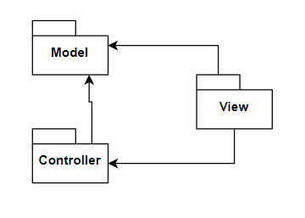
--Package diagram--
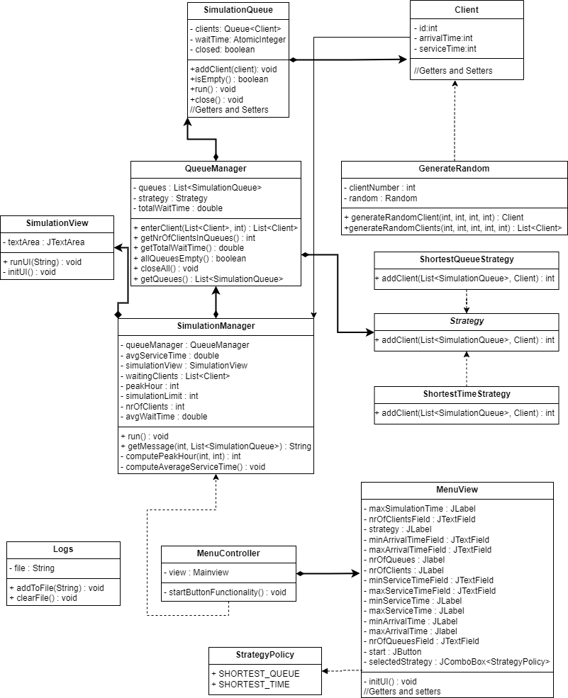
--Class diagram—

Data structures used: BlockingQueue. This was used to ensure a thread safe program.

Implementation
- Package model:
- Client Class
  - Represents the model of a client.
  - It has as fields: client_id (int), arrival_time (int), service_time (int).
  - It implements Comparable<> so that it is easier to sort in a colletion.
- SimuationQueue Class
  - Represents the model of a queue.
  - It is represented by a thread (so that multiple queues can function at the same time just like in real life) by implementing Runnable.
  - It has as fields: clients (BlockingQueue<Client>), waitTime (AtomicInteger), closed (boolean).
  - Important methods:
    - run() -> this function contains the code executed by starting the thread.
    - addClient(Client client) -> this function adds a client to the queue and updates the waitTime which is then returned.
    - close() -> this function stops the execution of the run() function.
- StrategyPolicy Enum
  - Is an enumeration of strategy options (SHORTEST_TIME, SHORTEST_QUEUE).
- Logs Class
  - Is the representation of the file where the logs are saved.
  - Has as fields: file (String) -> the name of the file.
  - Important methods:
    - addToFile(String content) -> adds to the file the contents passed as parameters.
    - clearFile() -> empties the file.
- Package view:
- MenuController Class
  - Implements the logic for the menu window.
  - Has as fields: view (MenuView).
  - It has a method for the button functionality (the start button) which saves the data entered by the user and validates it. After that creates a new SimulationManager with the data given by the user as parameters.
- MenuView Class
  - This represents the window for the main menu.
  - It contains the following text fields:
    - Number of clients.
    - Number of queues.
    - Maximum simulation time.
    - Minimum arrival time.
    - Maximum arrival time.
    - Minimum service time.
    - Maximum service time.
  - It also contains corresponding labels for each text field.
  - The labels are on a panel on the left and the text fields are on the panel on the right. These panels are joined on a content panel.
  - On the bottom of the window there is a button whose functionality was presented in the MenuController class.
- SimulationView Class
  - This represents the window for the simulation.
  - It has a JTextArea on a scroll panel which is refreshed from the SimulationManager every second.

- Package controller:
- GenerateRandom Class
  - This is the class responsible for generating random clients.
  - It has only static methods and fields.
  - It has 2 methods:
    - generateRandomClient(…) -> this method generates a random client with the value of the attributes within the bounds given as parameters.
    - generateRandomClients(…) -> this method generates n random clients by calling the generateRandomClient(…) method.
- QueueManager Class
  - This is the class responsible for managing the queues.
  - It has as fields: queues (List<SimulationQueue>), strategy (Strategy), totalWaitTime (double).
  - In the constructor all the queues are initialized and started.
  - It has some important methods which are of help when handling the queues:
    - enterClient(List<Client>, currentTime) -> this method checks every client for their arrival time and if it’s equal to the current time it is then added to a queue based on the chosen strategy saved in a field. After adding the clients to the correspondic queues this function returns a list of the remaining clients.
    - closeAll() -> method for closing all the queues.
    - getNrOfClientsInQueues() -> method which helps when computing the peak hour.
    - allQueuesEmpty() -> method for checking if all the queues are empty.
- ShortestQueueStrategy Class
  - This is a class implementing the Strategy interface.
  - It overrides the method from strategy (addClient()) in order to choose which queue to receive the client. In this case, the queue with the least amount of clients should get the new client.
- ShortestTimeStrategy Class
  - This is a class implementing the Strategy interface.
  - It overrides the method from strategy (addClient()) in order to choose which queue to receive the client. In this case, the queue with the shortest waiting time should get the new client.
- SimulationManager Class
  - This is the class where the proper simulation happens.
  - It implements Runnable interface.
  - It has as fieds: simulationView (SimulationView), simulationLimit (int), nrOfClients (int), queueManager (QueueManager), waitingClients (List<Clients>), avgServiceTime (double), avgWaitTime (double), peakHour (int).
  - Everything happens in the run() method.
  - While the simulation limit isn’t exceeded and and there are still clients in the simulation the SimulationManager updates the values needed for the final stats (peak hour, avg waiting time, avg service time), updates the queues, updates the logs file and the interface.
  - After the while is completed (the simulation ended), the stats are displayed in the interface and written in the logs file.
  - Peak hour means the timestamp in which the most clients were in running queues.
  - Average waiting time means how many seconds does it take each client until it’s his turn in the queue (reaches the first position).
  - Average service time means how many seconds does each client need to be serviced (doesn’t necessary need to be served, it counts even if he is still in the waiting queue at the end of the simulation).
- Strategy Interface
  - This is an interface having only one abstract method.
  - Method signature: int addClient(List<SimulationQueue> queues, Client client)
  - The returned value of the overridden implementations is always the new waiting time.

Results

Results were obtained by running the three examples given in the assignment. Those are the only results which will be presented here. The full results are in the text files ex1.txt, ex2.txt, ex3.txt from the repository. The following pictures represent the final stats from each example:

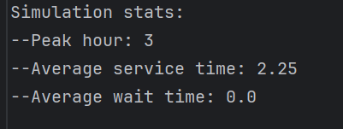
--Ex1—

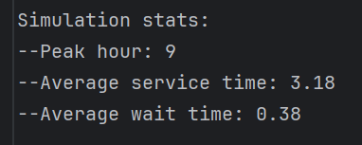
--Ex2—

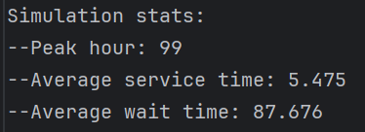
--Ex3—

Conclusions
Learning how to use threads has been a transformative experience in my coding journey. It not only expanded my understanding of programming efficiency but also sharpened my problem-solving abilities by exposing me to race conditions and unpredictable behaviors. These challenges have equipped me with invaluable skills that I am confident will greatly benefit my future projects and work endeavors. Moreover, the insights gained from handling threads have instilled in me a deeper appreciation for the intricacies of concurrent programming, empowering me to develop robust and scalable solutions. As I move forward in my coding journey, I am excited to apply these learnings and continue to grow as a proficient and resourceful developer.

As for future developments, the interface could look a lot better, and a database could be added so every simulation ever made is stored there. We can take it even further by adding a login so that every user has an account which will be stored in the database. Every simulation belonging to a user will also be stored in the database. After all this is implemented, there could be a lot more types of simulations to be created so that the Queue Management Simulation will be just an option. Users will also be able to create their own types if simulations which can be tried by everyone on the app.

In conclusion, this is a scalable application which could evolve in something really used by users wanting to see (visually) how certain things work. I learned a lot from developing this app and if time permits, I will try to take this application to the next level.

Bibliography
- http://tutorials.jenkov.com/java-concurrency/index.html
- https://product.hubspot.com/blog/understanding-thread-dumps
- https://dzone.com/articles/how-to-take-thread-dumps-7-options
- https://www.baeldung.com/java-heap-dump-capture
- https://www.w3schools.com/java/java_threads.asp
- https://www.geeksforgeeks.org/java-threads/
- https://docs.oracle.com/javase/8/docs/api/java/lang/Thread.html
- https://www.javatpoint.com/how-to-create-a-thread-in-java

