Design Research



Date : 18.05.2022

Version : 0.2

Authors : Aleksandar Hadzhiev and Felix Morenc

Version history

|  |  |  |  |
| --- | --- | --- | --- |
| Version | Date | Author(s) | Changes |
| *0.1* | *14.05.2022* | *Aleksandar Hadzhiev* | *Initial Version* |
| *0.2* | *18.05.2022* | *Aleksandar Hadzhiev* | *Added Ideation, Testing and Prototyping phase* |
| *0.3* | *23.05.2022* | *Felix Morenc* | *Further revisions, expanded and revised Empathize, Define, Ideation* |

Table of Contents

I. Empathize 2

II. Define 3

III. Ideation 3

IV. Prototype 5

V. Testing 7

VI. References 7

# Empathize

At the beginning of the project, we were allowed to choose our topic and persona, which we must work on. The decision was to work on the topic of “Education” and the persona is a child in Middle School, outlined in a separate document located in the same repository.

First, we had to understand the topic and what the target group thought about it, so we began the project with reading online documentation, this helped us understand that:

* Children have difficulties concentrating
* Difficulties finding motivation to study
* Time management problems
* Stress
* Distractions
* Etc.

One of those distractions being their smartphone, which is always near them and is keeping them preoccupied.

Second, after deducing what difficulties there were, we moved on to try understanding what could help us solve these key problems. From what we read, we found that a good way to motivate your child to study could be:

* Knowledge before grade, thus challenging them and pushing them to learn more
* Rewarding their labor, be that in the form of physical or psychologically through bonuses
* Freedom in their choices, providing students with a free choice of what they want to learn could motivate them more to put time into their education
* Milestones to keep them motivated, knowing how they're progressing could motivate them more as they can visually see the progress being made

There are additional problems and solutions, which are outside of the scope of our possibilities and are institutional.

# Define

After understanding the topic and the persona better, we started thinking of what the problem is and how we could solve it.

First, we had to define the problem, which in the research we conducted, proved to be multiple that could be tackled. Issues such as:

* Lacking Motivation
* Concentration
* Distractions
* Stress
* Etc.

These are big problems on their own, which makes the task of defining the main problem even difficult, but after much consideration we defined the main problem, which this project will have to solve: *“How can we use distractions, specifically mobile devices, as a tool for motivating students to study?”.*

For this problem we defined a few smaller ones:

* How to motivate students to study?
* How to use the mobile device as a tool to study?
* How to help them keep their concentration?

# Ideation

After defining what this project has as a goal to solve, we started brainstorming ways to do that.

First, we did some foundational research about existing apps/websites in the space and what they do well. One of the most known applications is Duolingo, a language study app with a lot of game like functionalities such as leaderboards, progress, levels and more. There is also the Khan Academy website, which contains a wide range of studying options such as mathematics, this website has badges as rewards, but nothing too gamified as the Duolingo app.

Secondly, there are apps which instead of helping you study have the functionality to help you manage your time, which is also a big problem for students of all ages. Google Calendar is a great way to manage your time and it is not the only one. There are a lot of options a user can use, or it could not be an app but just a day-to-day list of tasks or goals to achieve that day, written on a paper. That is why we did not go down that way.

Thirdly, we thought of a way to combine these two separate concepts (time management and study) and all we could think of was an app, where the user could set his daily schedule. When the time is right to receive a notification and be given different questions to answer with some additional smaller parts to it. The idea itself was overloaded and not something new or to be used for our persona, but the design behind the concept wireframes was rather good and game like.

Finally, after we reached a dead end with the previous idea, we decided to look at something which all kids no matter the age love to do and with the current progress of the technology can do during school time, play games whether they are mobile or desktop. With that in mind we started brainstorming of something which could go in that direction. Games are not something which students will think of when you tell them to study, so we thought instead of “studying” new things, the game should help them exercise what they learnt at school.

The way the MVP of the app will work is as such:

* You open the app and are redirected to the homepage.
* You can choose to fight or to share the app to your friends using the platform you prefer.
* When you start a fight, you will be redirected to the fighting page where you will see the health points of the 2 characters, timer, the characters and 3 different attack options.
* The attack options work as a difficulty system as follow:
* 20 damage – EASY
* 40 damage – MEDIUM
* 60 damage – HARD
* When you choose an option, you will be redirected to the question page, where you will see the health points, timer, the question and the possible answers.
* The app will have a double damage system:
* Answer correctly in less than 5 seconds the damage will be multiplied by 2
* Answer correctly in more than 5 seconds do the 20/40/60 damage attack
* Answer wrong within any time do not do any damage
* After your turn attacking is done, the system will change to defense, where you must answer a question of the same difficulty.
* The defense system works as follow:
* Correct answer no damage to you done
* Wrong answer you receive either 20/40/60 damage
* After the phase is done the app will go back to the battle page where you can choose your new attack, until either you or the enemy is with 0 health points. When either you or the enemy hits the 0 mark the app will display the appropriate message with the options to choose to stop or start a new game.
* The app will also have sound system with the option to play music through the battle or mute it and additional K.O. sound for when the game is over and FIGHT sound for when the battle is started.

The concept has also different functionalities which are not part of the MVP app but are very important to the future of the concept. Functionalities such as:

* Multiplayer 1v1 battles
* Potion system, where the user will have different potions to help him defeat the enemy
* Notification system
* Leveling system
* Different characters, skins for the characters and different battlegrounds
* More stages with different bosses and characters to fight before reaching them
* Additional items to play for (outside of potions), such as armors and tools to increase attack damage or health points – what is important is that to win those items, users will have to participate in various games, which include things though in school to win them
* Fully offline mode

Something very important for this concept is to be kept in the scope of education, because even if the app itself is oriented towards gaming, its main core is helping students with their education and learning process.

# Prototype

During the Ideation phase we did some designing and decided on the style the app should have.

* First View of the App

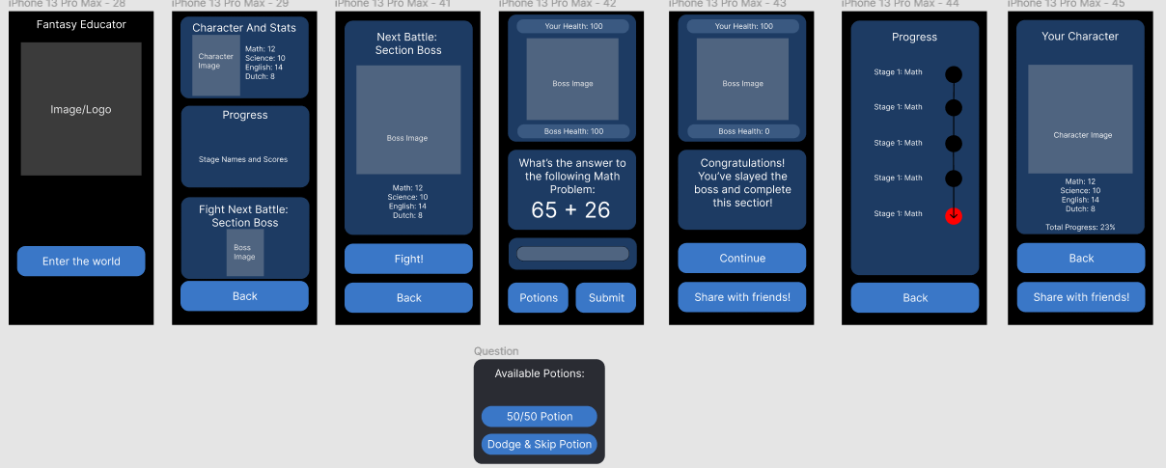

* Second View of The App

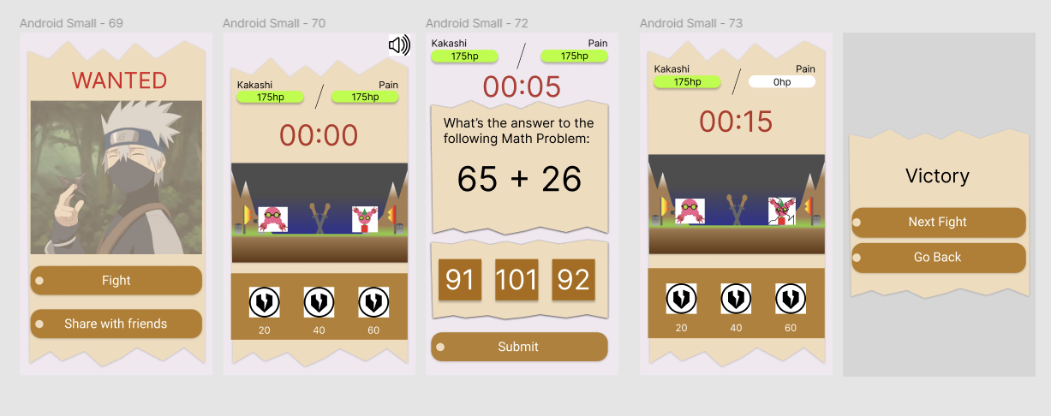

The first view of the app was not good enough because the style was not game like and that is why we decided to change it to more game like environment design using the one we used for our other idea:

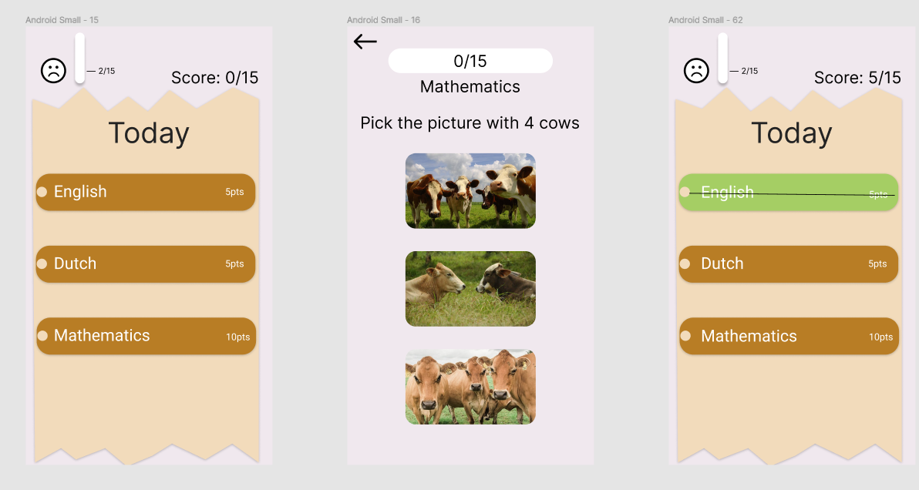

# Testing

We couldn’t really do testing, because we could not get feedback from users from our target group.

# References

Kirstin O´Donovan Certified Life and Productivity Coach, & O´Donovan, K. (2022, March 7). *18 Best Time Management Apps and tools (2022 updated)*. Lifehack. Retrieved May 18, 2022, from <https://www.lifehack.org/articles/technology/top-15-time-management-apps-and-tools.html>

Author: Marija Kojic Marija Kojic is a productivity writer who's always researching about various productivity techniques and time management tips in order to find the best ones to write about. She can often be found testi. (n.d.). *35 best apps for Time Management in 2021*. Clockify Blog. Retrieved May 18, 2022, from <https://clockify.me/blog/apps-tools/best-time-management-apps/>

*The best apps for studying of 2022*. BestApp.com. (2022, May 13). Retrieved May 18, 2022, from <https://www.bestapp.com/best-study-apps/>

Hunt, J. (2022, February 16). *The 8 best study apps to get in 2021*. ThoughtCo. Retrieved May 18, 2022, from <https://www.thoughtco.com/best-study-apps-4164260>

wisdom_fuel. (2021, November 29). *Best study apps - top 12 picks worth downloading*. Wisdom Fuel. Retrieved May 18, 2022, from <https://wisdomfuel.com/best-study-apps/>

Courtney Marraro https://www.universities.com/learn/author/cmarraroprospexdigital-com/. (2021, January 5). *Top problems students face while studying for exams*. Universities.com. Retrieved May 18, 2022, from <https://www.universities.com/learn/articles/3-problems-students-face-while-studying-for-their-final-exams/>

*7 common study problems and how to deal with them*. Oxford Royale Academy. (2022, April 12). Retrieved May 18, 2022, from <https://www.oxford-royale.com/articles/common-study-problems/>

*How to motivate your child to study*. Oxford Learning. (2019, September 25). Retrieved May 18, 2022, from <https://www.oxfordlearning.com/how-to-stay-motivated-to-study/>

*How to motivate a child to study*. Allison Academy. (2021, October 15). Retrieved May 18, 2022, from <https://www.allisonacademy.com/parents/parenting/how-to-motivate-a-child-to-study/>

*20 tips to help you motivate your child to study*. Being The Parent. (2021, September 24). Retrieved May 18, 2022, from <https://www.beingtheparent.com/20-tips-to-help-you-motivate-your-child-to-study/>

Patkar, M., & Mihir Patkar (1305 Articles Published) . (2014, February 24). *5 browser-based fighting games that are actually good*. MUO. Retrieved May 18, 2022, from <https://www.makeuseof.com/tag/5-browser-based-fighting-games-that-are-actually-good/>