MARKETING & FINANCIAL
ANALYSIS REPORT
Superstore Business Intelligence | 2014 – 2017

Prepared by: FELIX ADEDOKUN
Date: 12th April 2026
Classification: Public — No Restrictions

KEY PERFORMANCE INDICATORS AT A GLANCE
$2.29M  Total Sales | $286K  Total Profit | 9,999  Total Orders

Section 1 — Executive Summary

This report presents a comprehensive analysis of a Superstore's marketing performance and financial outcomes for the period of 2014 to 2017. It is intended for senior leadership, department heads, and key stakeholders to support strategic decision-making.

The analysis encompasses an executive overview, regional performance, product performance, customer segment analysis, discount impact analysis, and forward-looking recommendations aligned with the organisation's growth objectives.

Section 2 — Project Objectives

The company faces challenges in understanding why certain product categories generate high sales but low profitability. Management requires data-driven insights into regional performance, product performance, customer segments, and discount strategies to improve overall profitability.

The primary analytical objectives guiding this report are:

Executive Dashboard
- Key Performance Indicators (KPIs)
- Sales Trend with Profit Analysis
Regional Performance
- Which region generates the most sales?
- Which region produces the most profit?
- Which states are operating at a loss?
Product Performance
- Which category generates the highest sales?
- Which products generate losses?
- Which products should be promoted?
Customer Segment Analysis
- Which customer segment generates the highest revenue?
- Which segment is the most profitable?
Discount Impact Analysis
- How does discount strategy affect profit?
- Do higher discounts reduce profitability?
- Which category has the highest discount rate?

Section 3 — Scope of Analysis

Scope Area | Description
Time Period | 2014 – 2017
Markets / Regions | United States
Products | Office Supplies, Furniture, Technology
Customer Segments | Consumer, Corporate, Home Office
Data Sources | Kaggle

Section 4 — Tools & Technologies Used

Tool / Technology | Purpose
Microsoft Excel | Data Cleaning, Pivot Analysis, Dashboard Development, Data Visualisation, and KPI Reporting

Section 5 — Data Collection & Cleaning

Data Collection
The data used for this analysis was sourced from Kaggle. Data collection was carried out over a period of 24 hours, ensuring that all relevant variables aligned with the objectives of the study were captured. The dataset included key fields such as: Ship Mode, Ship Date, Customer Name/ID, Segment, Country, City, State, Product, Category, Sales, Quantity, Discount, and Profit.

Data Cleaning
Prior to analysis, the dataset underwent a comprehensive cleaning process to ensure accuracy and consistency:
- Missing values were identified and addressed using appropriate techniques, including removal or imputation.
- Duplicate records were detected and eliminated to prevent analytical bias.
- Data types were standardised, and inconsistencies in formatting — such as date formats and categorical labels — were corrected.
- The cleaned dataset was validated to confirm its suitability for analysis.

Section 6 — Analysis Framework & Key Insights
The analysis is structured around five core pillars, each addressing a distinct dimension of business performance.

6.1 Executive Overview
The analysis reveals that Technology is the leading revenue and profit driver, while Furniture underperforms across key metrics. Sales trends indicate strong seasonality, with peak performance toward year-end. Additionally, the current discount strategy may be compressing profit margins — presenting an opportunity for optimisation.

The business demonstrates strong overall performance, with substantial sales volume and consistent profitability across nearly 10,000 orders:

- Technology is the primary revenue driver, contributing the highest share of both sales and profit, indicating strong market demand.
- Office Supplies demonstrates a strong profit growth trajectory, suggesting higher margins or more efficient cost management.
- Furniture is the weakest-performing category, indicating potential issues with demand, pricing strategy, or cost structure.
- Monthly sales are volatile, with peaks in September and November, and a notable dip in October — suggesting influence from seasonal or promotional factors.

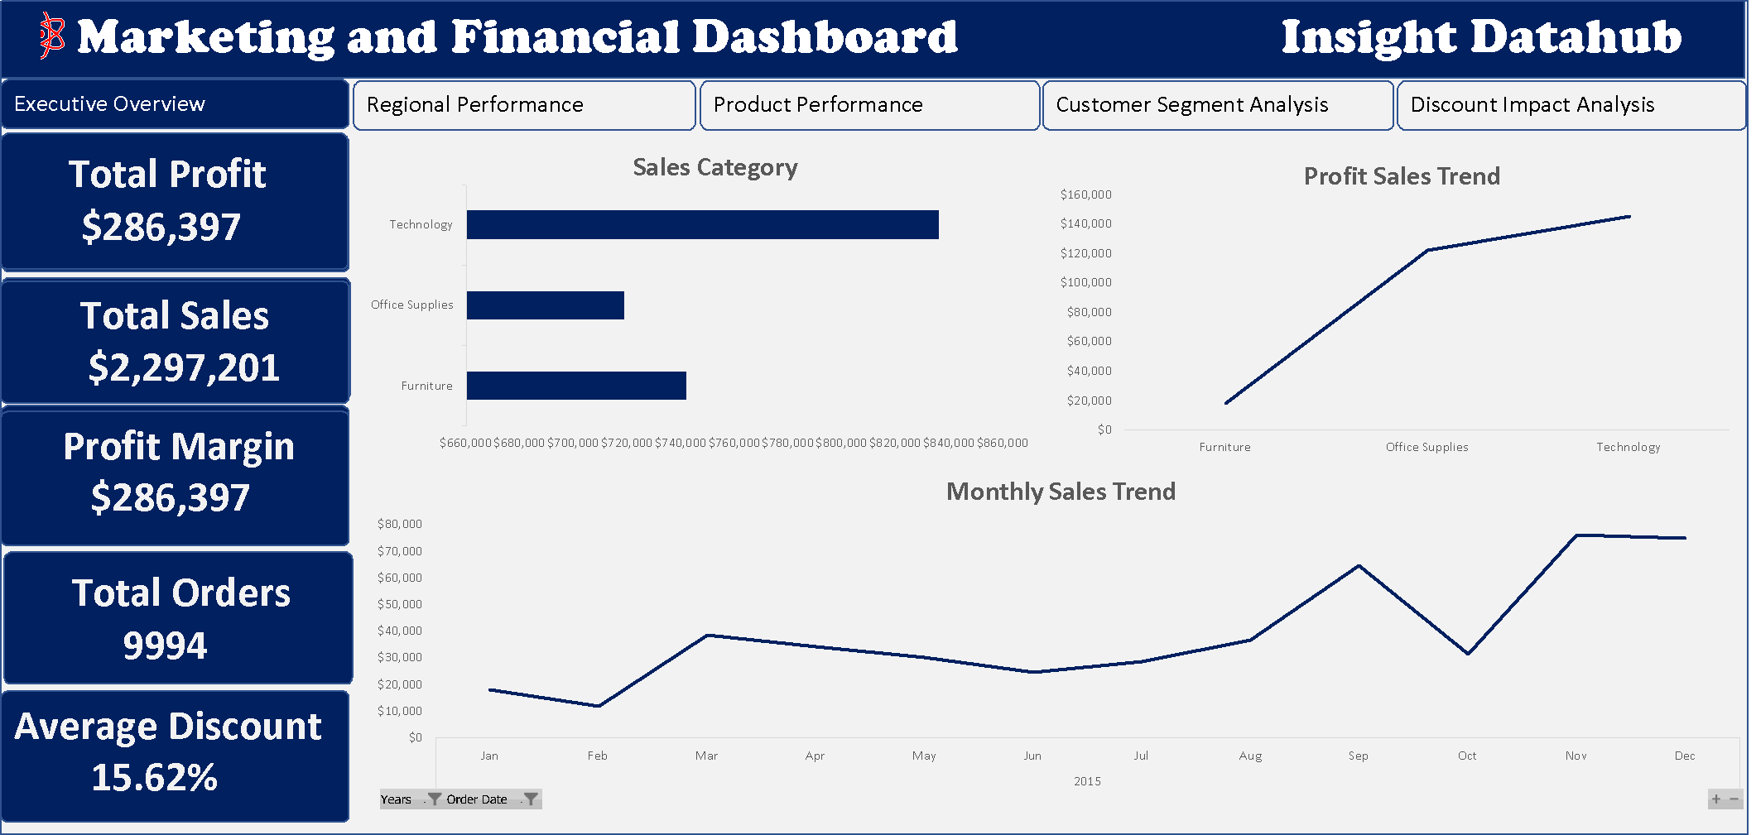
Figure 1: Executive Dashboard — KPI Overview & Sales Trend with Profit (2014–2017)

6.2 Regional Performance
A. Which region generates the most sales?
The West region is the top contributor to overall sales, highlighting a large and active customer base with strong revenue generation capacity.

B. Which region produces the most profit?
The West region also generates the highest profit among all regions, indicating effective pricing strategies and strong market performance — despite significant competition.

C. Which states are operating at a loss?
- Texas — Profit: -$25,729.36 (most significant loss state)

Summary: While the East region drives the highest sales, the West region leads in profitability, reflecting stronger margin performance. The South region underperforms and presents a growth opportunity. At the state level, revenue is highly concentrated, with California as the dominant contributor. Inconsistencies between sales and profit across regions highlight opportunities for pricing and cost strategy optimisation.

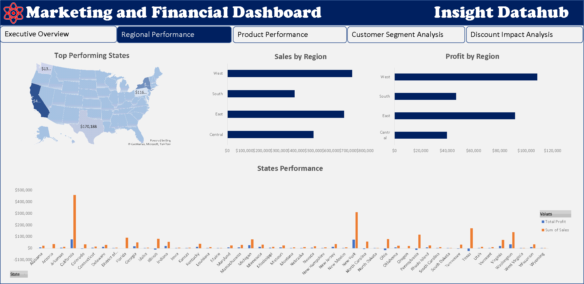
Figure 2: Regional Performance — Sales & Profit by Region and State

6.3 Product Performance
1. Which category generates the highest sales?
Technology generates the highest sales — clearly evidenced by its dominant position in the sales category chart.

2. Which products generate losses?
- Tables (largest loss contributor)
- Bookcases
- Supplies (slight loss)

3. Which products should be promoted?
Products with strong positive profit margins and high promotion potential include:
- Copiers — Highest profit contributor
- Phones
- Accessories
- Chairs
- Storage

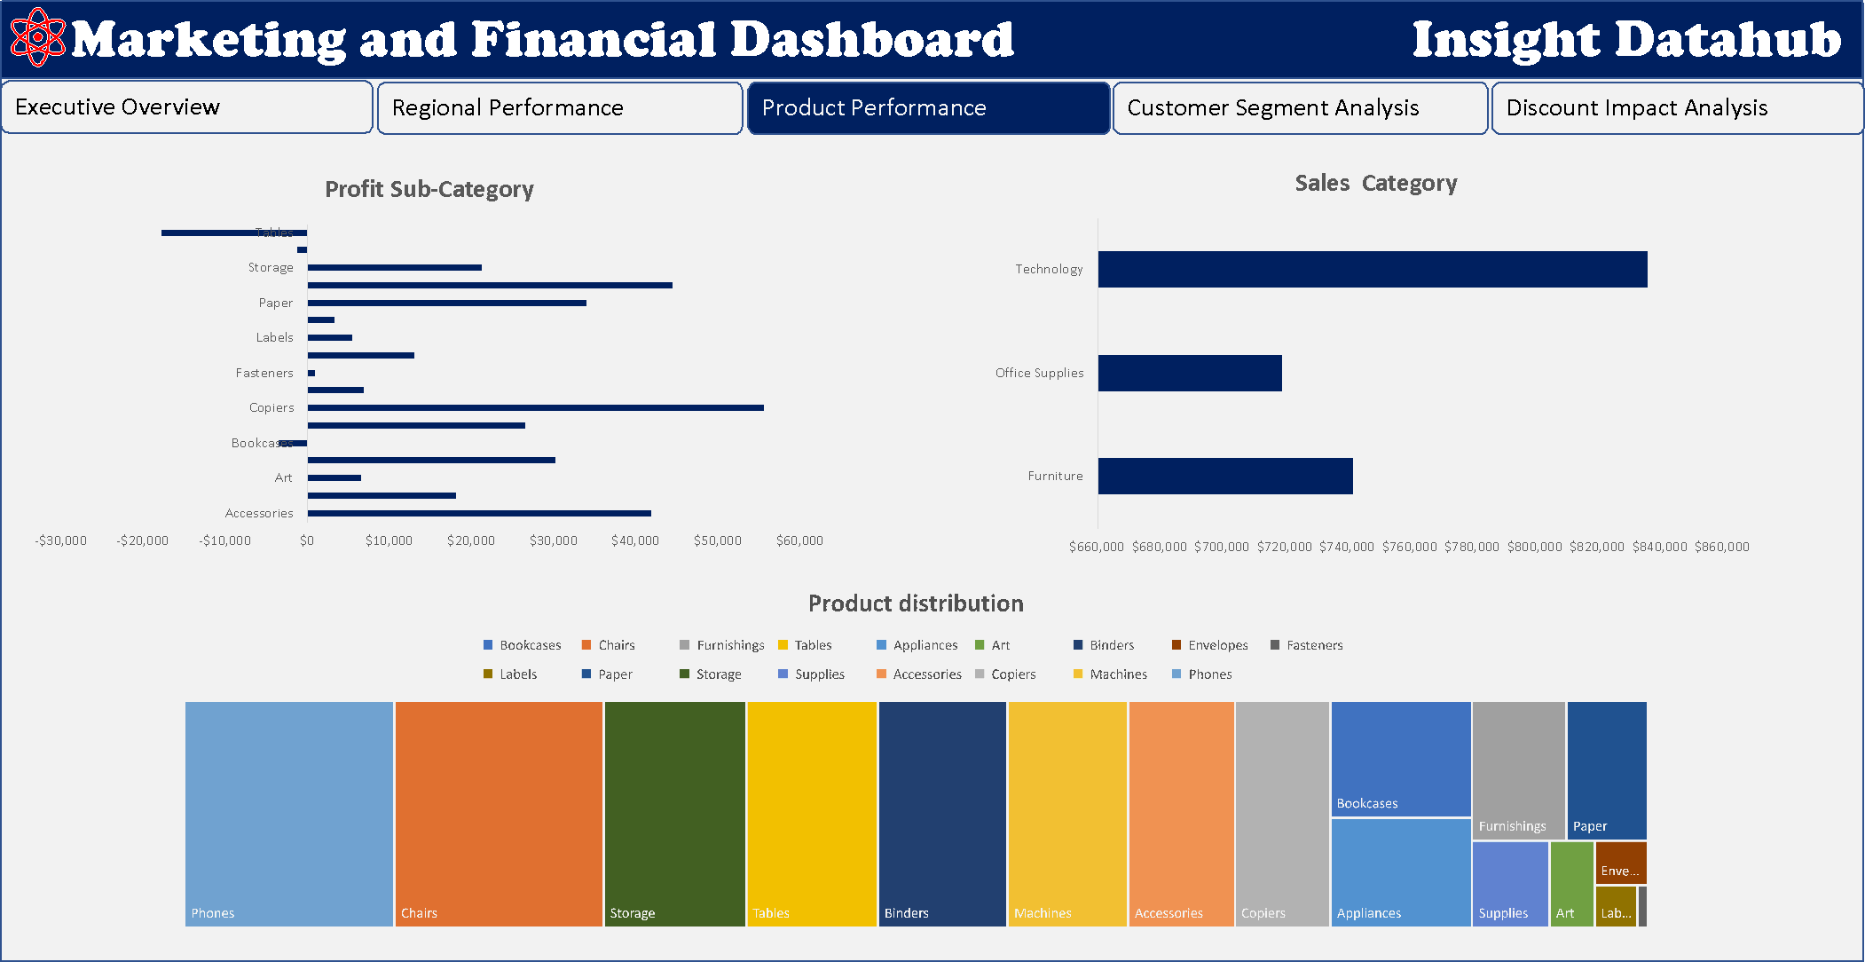
Figure 3: Product Performance — Sales & Profit by Category and Sub-Category

6.4 Customer Segment Analysis
Which customer segment generates the highest revenue?
The Consumer segment generates the highest revenue, holding the largest sales share across both bar charts and pie chart representations.

Which segment is the most profitable?
The Consumer segment is also the most profitable, recording the highest profit in the Profit by Segment analysis.

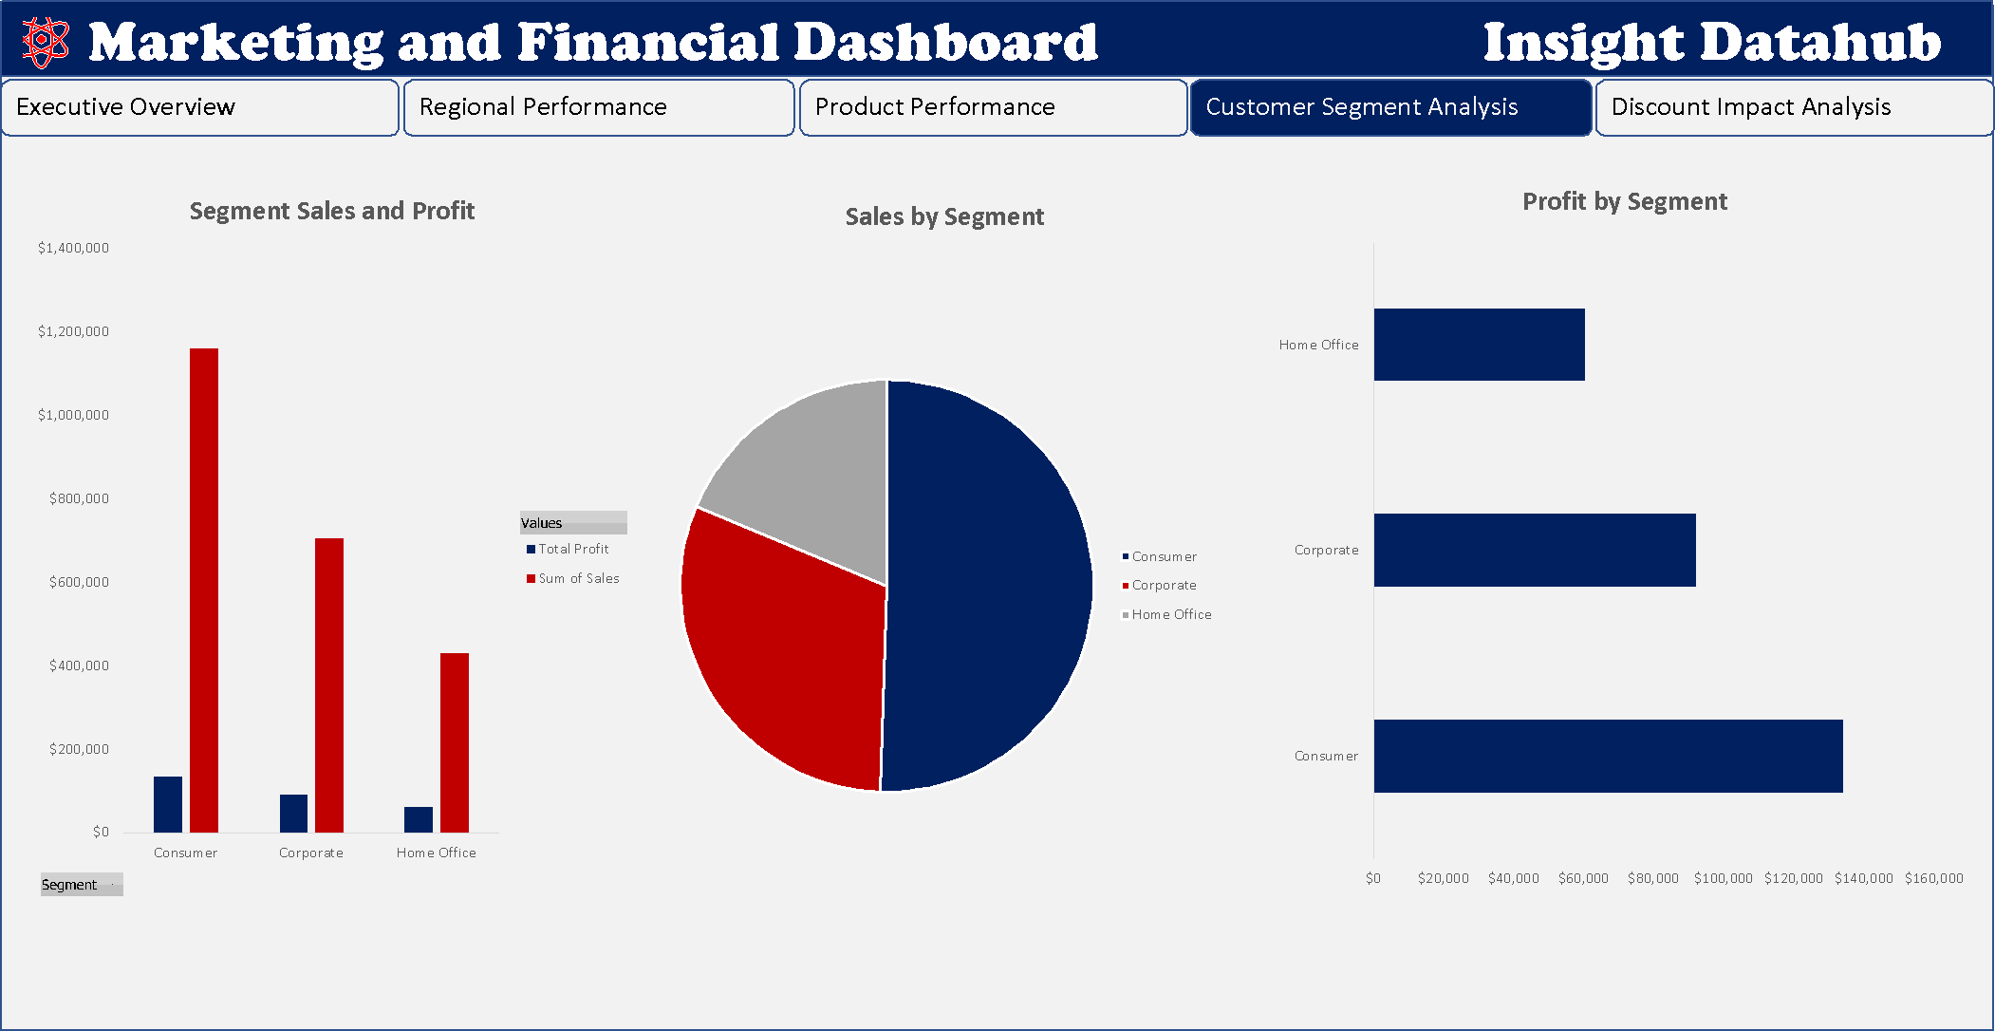
Figure 4: Customer Segment Analysis — Revenue & Profit by Segment

6.5 Discount Impact Analysis
Are we giving too much discount without generating sufficient profit?
- Furniture — Highest average discount (~18–20%)
- Office Supplies — Average discount ~15%
- Technology — Lowest average discount (~12–13%)

Which products drive profit despite discounts — and which are hurting profitability?
From the Profit Margin by Discount analysis, notable findings include:
- Canon imageCLASS 2200 Advanced Copier — Generates very high profit despite discounts, representing a model product for the discount-profit balance.

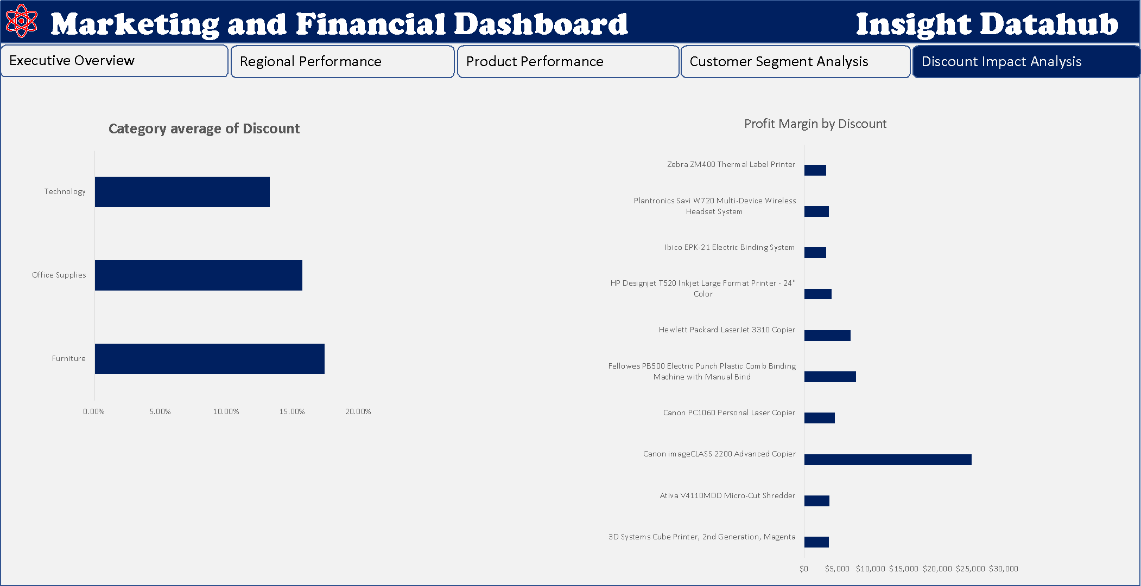
Figure 5: Discount Impact Analysis — Profit Margin by Discount Rate and Category

Section 7 — Recommendations

Based on the insights derived from this analysis, the following strategic recommendations are proposed to improve profitability and operational efficiency:

Discount Strategy Optimisation
- Review and reduce high discount rates on Furniture, which yields the highest discounts but the lowest profitability.
- Implement discount caps by category to prevent margin erosion, particularly for Tables and Bookcases.
- Adopt a data-driven discount framework that ties promotional rates to profit margin thresholds.

Product Portfolio Management
- Prioritise promotion and inventory investment in high-margin products: Copiers, Phones, Accessories, Chairs, and Storage.
- Conduct a profitability review of Tables and Bookcases to determine whether repositioning, repricing, or discontinuation is warranted.
- Leverage Technology's strong performance by expanding the product line or increasing marketing investment in this category.

Regional Strategy
- Replicate the pricing and operational strategies of the West region in the South and Central regions to improve their profitability.
- Conduct a root-cause analysis for loss-making states, especially Texas, to address pricing misalignment or cost inefficiencies.
- Target California and other high-performing states for upselling and cross-selling campaigns.

Seasonal Planning
- Anticipate demand spikes in September and November by aligning inventory, staffing, and marketing efforts accordingly.
- Investigate the October sales dip and develop targeted promotional campaigns to smooth seasonal volatility.

Customer Segment Focus
- Invest in loyalty and retention programmes for the Consumer segment, which drives the highest revenue and profit.
- Develop targeted growth strategies for the Corporate and Home Office segments to diversify revenue sources.

End of Report
Prepared by Felix Adedokun | April 2026 | Classification: Public

