IBM Data Science Capstone Final Project: Battle of the Neighborhoods

Business Decision:

Where to Locate a Professional Services Business -- San Francisco in the SoMa District (South of Market Street), or Seattle in the Pioneer Square district?

Introduction / Project Description:

This data science project proposes a decision structure to address the decision: where should I locate a professional services business, selecting between two neighborhoods that each have a concentration of high-tech startup companies? Example possibilities for the professional services business are:

* Providing data science and data research services to tech companies (such as motivated by this IBM Data Science Professional Certification program)
* Facilities planning and facilities location research services
* Professional human resources contract services
* Professional legal services; on-site health care and monitoring services
* Security services such as IT software hosting and security, or personnel for on-site security monitoring

This project focuses on two neighborhoods noted for their burgeoning growth of technology startups:

* San Francisco, CA: South of Market Street region (SoMa)
* Seattle, WA: Pioneer Square region

Target Audience:

The target audience for this study is CEOs and entrepreneurs and venture capital companies looking to evaluate where to establish a new professional services business. They would care about this data analysis because the study will provide data sources and data science evaluation for several factors important for locating the business, with the thesis that professional services businesses generate greater success when they are located near their client field.

Data Requirements:   
APIs and Datasets Utilized in this Analysis

* Foursquare Venues Database API
* Three Commercial Real Estate Databases: CityFeet.com, 42Floors.com, Loopnet.com
* State and City Corporate Income Tax References for California/San Francisco and Washington/Seattle

Decision Methodology:

For the decision of where to locate a professional services business servicing a high-tech startup hub, I focus on the Financial Impact to the Company. Below I construct a location decision framework with the following methodology:

Assess Financial Impact to the Company, focusing on these factors:

* Commercial Real Estate Prices for office real estate in each region, to rent/lease a facility for company operations
* Corporate Tax Rates for each state and city

Financial Impact to the Company

Financial impact of locating the business in each area, focusing on:

(i) Commercial Office Real Estate: property characteristics, locations, and rental/lease costs, based on current commercial office properties available at the time of this study. I constructed two commercial real estate listings datasets, one for each city and locale, structured with these fields for comparisons:

* Property Address
* Neighborhood or Zip Code for the Specific Neighborhood
* Rental Price per Month
* Property Area in Square Feet
* Rental Price per Square Foot

\* Sources for Commercial Real Estate properties and availability in San Francisco and Seattle: https://www.cityfeet.com, https://42floors.com, https://www.loopnet.com

(ii) Corporate Tax Rates by State and City

To document the financial impact of business taxes, I calculate two tax planning scenarios for each neighborhood, for C corporation business taxes based on a percent of either gross receipts (gross sales), or net income before taxes, as appropriate for the state and city. Corporate tax rates are referenced here:

* State of California and San Francisco city business taxes: https://www.ftb.ca.gov/businesses/index.shtml, https://sftreasurer.org/business
* State of Washington and Seattle city business taxes: https://dor.wa.gov/find-taxes-rates/business-occupation-tax, <https://www.seattle.gov/business-licenses-and-taxes>

Results:  
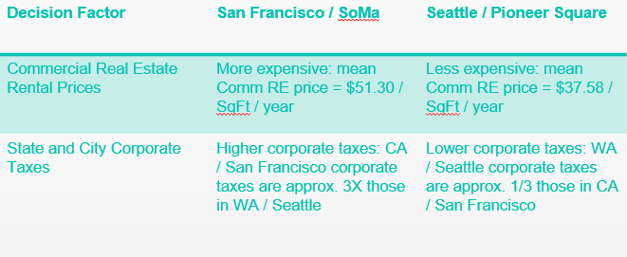

Discussion of Result

Based on the analysis above, Seattle / Pioneer Square contributes a significantly lower corporate financial cost and shows to be a more attractive technology startup business location.

However, there are clearly additional factors to consider for the location of a technology-based professional services company startup, especially:

* Access to skilled technology personnel to staff the specific business
* If the firm is venture capital funded, then the VCs' preferences for location are clearly important

Conclusion:  
Based on the analysis in this data science study on where to locate a professional services company, I would prioritize locating the professional services business in Seattle / Pioneer Square, a location with a significantly lower corporate costs than in San Francisco.