1

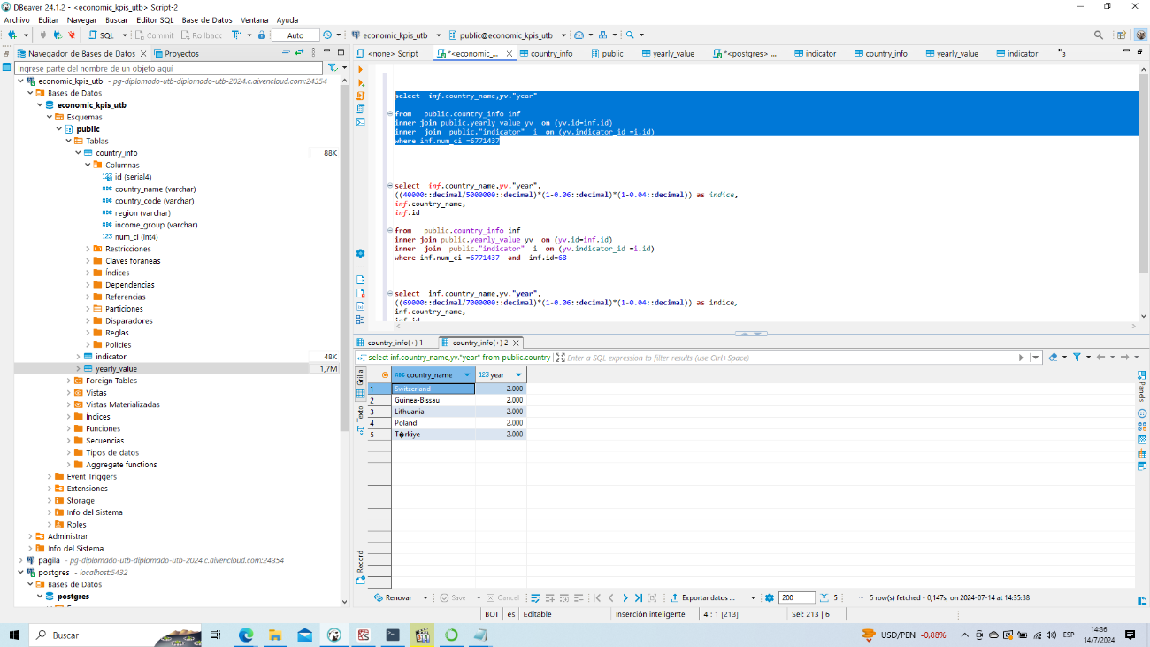

**select** ***inf***.country_name,***yv***."year"

**from** public.country_info inf

**inner** **join** public.yearly_value yv **on** (yv.id=inf.id)

**inner** **join** public."indicator" i **on** (yv.indicator_id =i.id)

**where** inf.num_ci =6771437

2

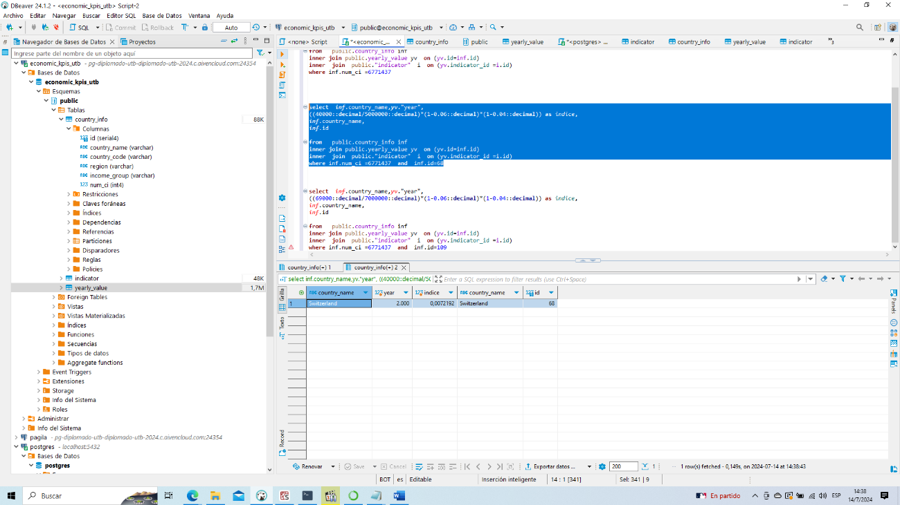

**select** ***inf***.country_name,***yv***."year",

((40000::**decimal**/5000000::**decimal**)*(1-0.06::**decimal**)*(1-0.04::**decimal**)) **as** *indice*,

***inf***.country_name,

***inf***.id

**from** public.country_info inf

**inner** **join** public.yearly_value yv **on** (yv.id=inf.id)

**inner** **join** public."indicator" i **on** (yv.indicator_id =i.id)

**where** inf.num_ci =6771437 **and** inf.id=68

2.------------------------------------

**select** ***inf***.country_name,***yv***."year",

((69000::**decimal**/7000000::**decimal**)*(1-0.06::**decimal**)*(1-0.04::**decimal**)) **as** *indice*,

***inf***.country_name,

***inf***.id

**from** public.country_info inf

**inner** **join** public.yearly_value yv **on** (yv.id=inf.id)

**inner** **join** public."indicator" i **on** (yv.indicator_id =i.id)

**where** inf.num_ci =6771437 **and** inf.id=109

3

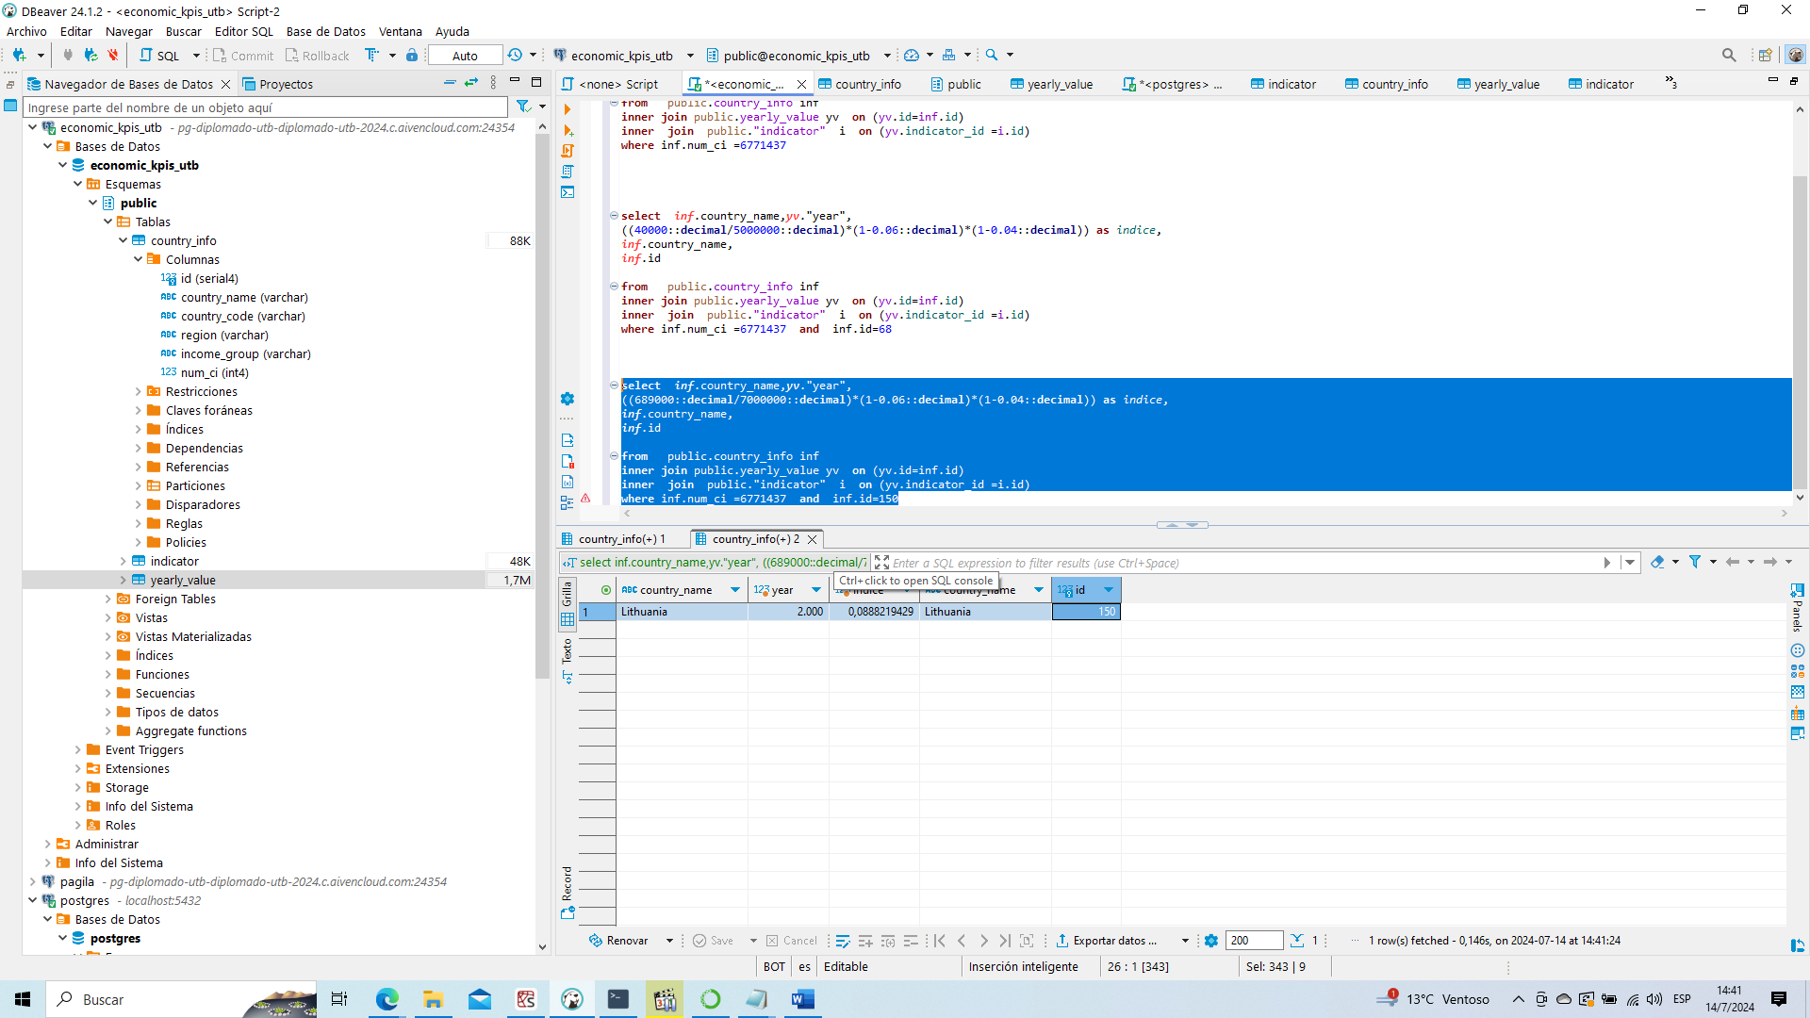

**select** ***inf***.country_name,***yv***."year",

((689000::**decimal**/7000000::**decimal**)*(1-0.06::**decimal**)*(1-0.04::**decimal**)) **as** *indice*,

***inf***.country_name,

***inf***.id

**from** public.country_info inf

**inner** **join** public.yearly_value yv **on** (yv.id=inf.id)

**inner** **join** public."indicator" i **on** (yv.indicator_id =i.id)

**where** inf.num_ci =6771437 **and** inf.id=150

4

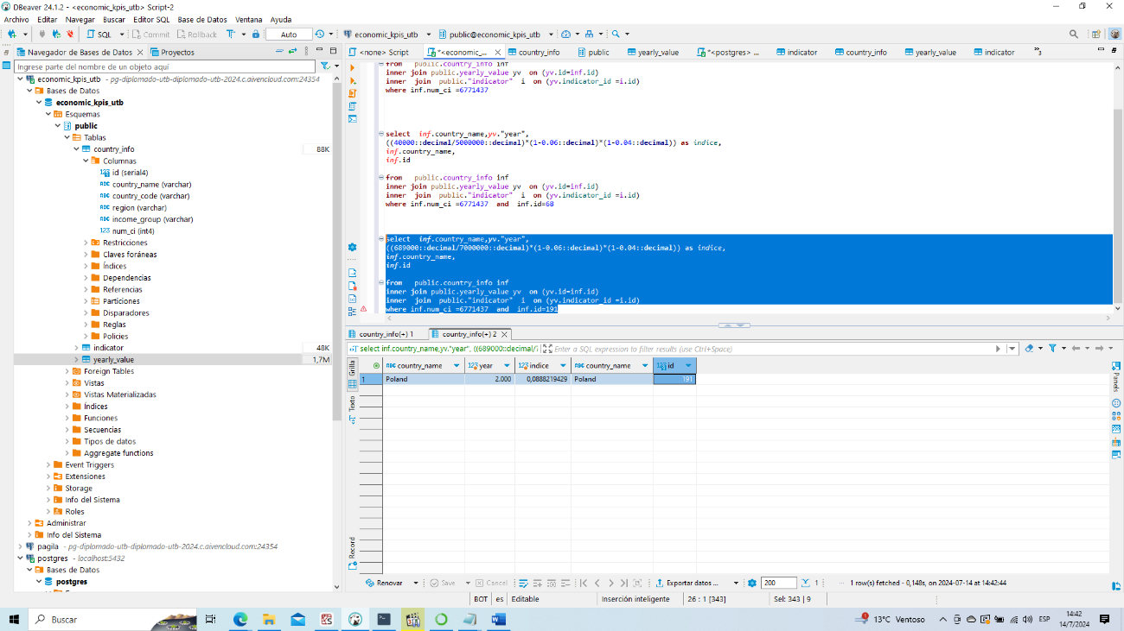

**select** ***inf***.country_name,***yv***."year",

((689000::**decimal**/7000000::**decimal**)*(1-0.06::**decimal**)*(1-0.04::**decimal**)) **as** *indice*,

***inf***.country_name,

***inf***.id

**from** public.country_info inf

**inner** **join** public.yearly_value yv **on** (yv.id=inf.id)

**inner** **join** public."indicator" i **on** (yv.indicator_id =i.id)

**where** inf.num_ci =6771437 **and** inf.id=191

5

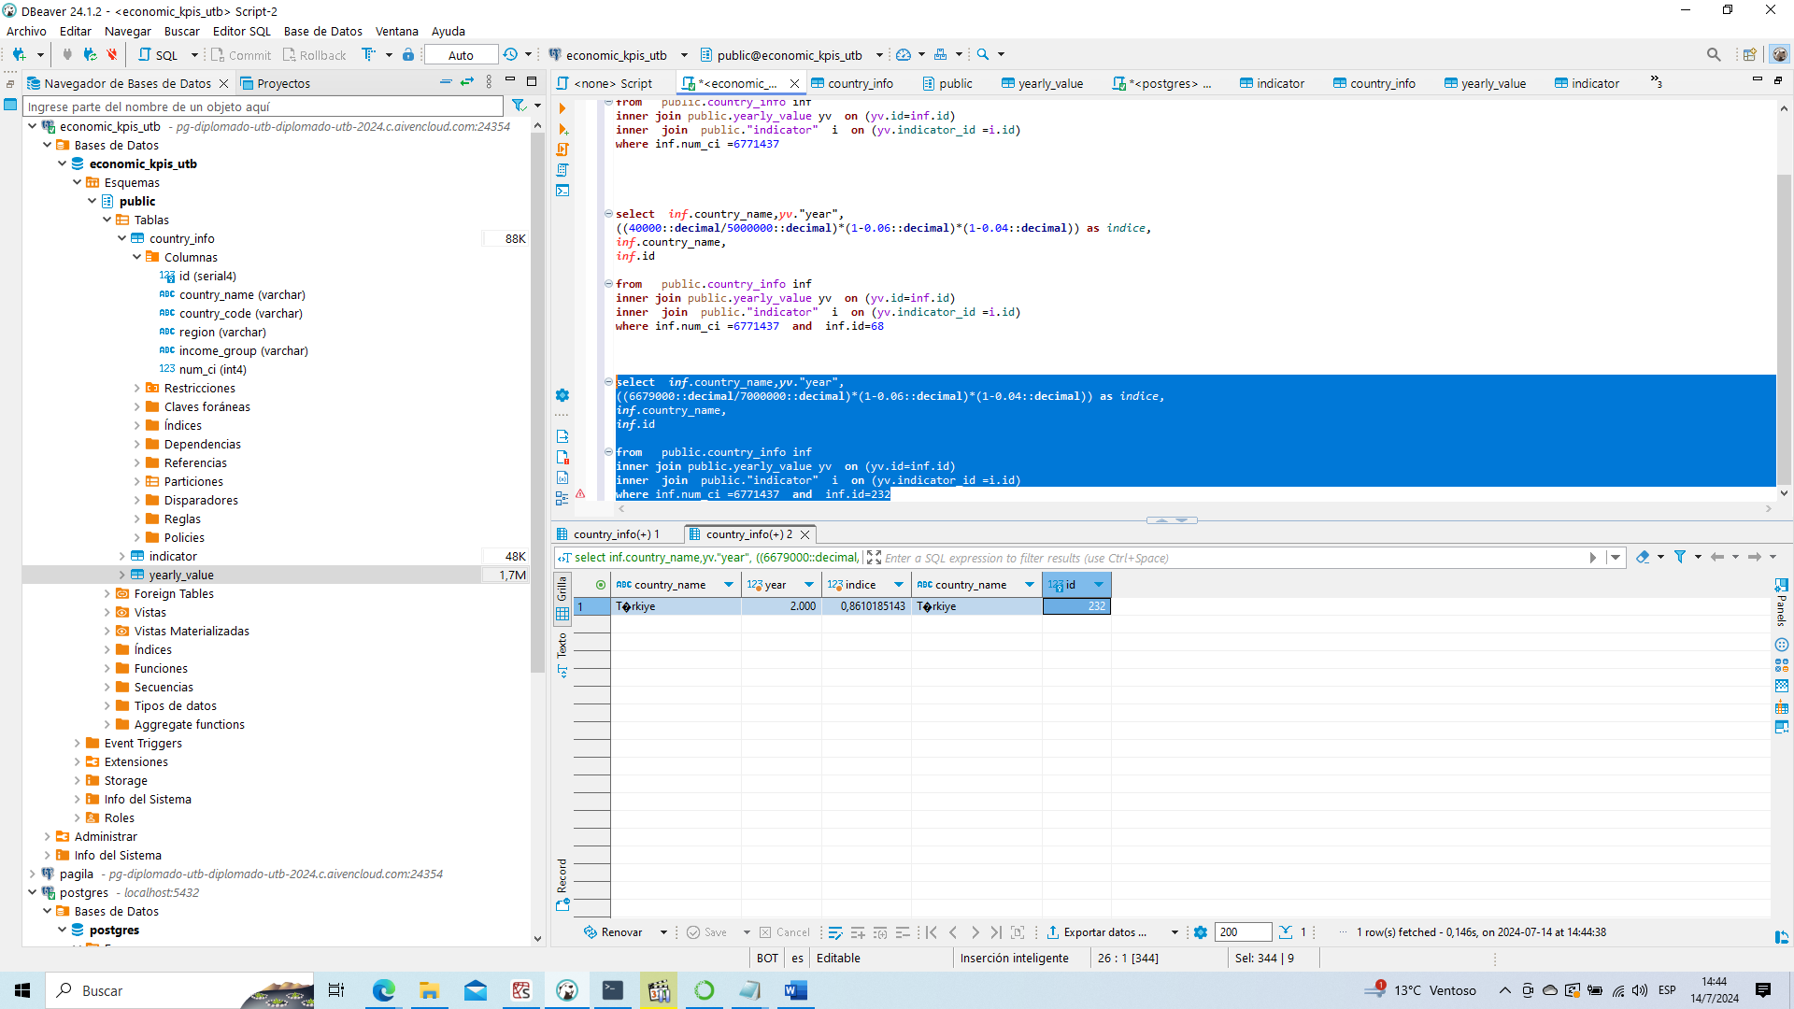

**select** ***inf***.country_name,***yv***."year",

((6679000::**decimal**/7000000::**decimal**)*(1-0.06::**decimal**)*(1-0.04::**decimal**)) **as** *indice*,

***inf***.country_name,

***inf***.id

**from** public.country_info inf

**inner** **join** public.yearly_value yv **on** (yv.id=inf.id)

**inner** **join** public."indicator" i **on** (yv.indicator_id =i.id)

**where** inf.num_ci =6771437 **and** inf.id=232

tgihub

[felix8384/T-ecnicas-y-Herramientas-para-el-An-alisis-de-Datos (github.com)](https://github.com/felix8384/T-ecnicas-y-Herramientas-para-el-An-alisis-de-Datos)