|  |
| --- |
| **Replace me with your project title[1]**  Felix Agbavor1, 2, Matthew Falcione1, Victor Flamini1  1 School of Biomedical Engineering, Drexel University, USA  Course : BMES 550  Instructor: Ahmet Sacan  Date : 2020-11-08 |

[2]*abstract

A one-paragraph summary of the project. Introduce the problem and identify the need for your application. Describe your model and implementation (mention the programming/modeling environment you used). Summarize the key features of your application. Summarize benchmarking, accuracy/performance experiments or tests, if applicable.

# introduction

Problem description, Motivation. Why are we studying this problem? What is the biomedical need? Public health stats, if available.

Biology/Physiology:

* Describe the underlying biology/physiology/physics/computerScience for the problem you are studying.

* Find figures illustrating the system (remember to cite the sources).

Goals:

* What are you trying to achieve with the application you are developing?

* Who are the target end users and use cases?

* If successful, how will your application and findings/result influence our understanding or medical practice; or the current research methodology?

Related Work:

* Provide a short survey of related work. Put this study in the context of others. Find out what else is being done in this area. Use a citation manager (e.g., Endnote) to automate creation of references, e.g., [1].

# Dataset

* If you are using a dataset, describe the experiment(s) that produced the datasets you are analyzing in your project. What are the experimental groups? How was the data collected?

# methods and IMplementation

* Describe the methods and software you used. Cite any third party software or library you utilized.

* Describe your analysis workflow. e.g, normalization, types of statistical tests, thresholds, etc.

* Give implementation details (programming language, operating system, etc.)

* Provide a high-level description of your implementation. A flowchart is recommended to summarize the workflow and implementation.

* If you create and utilize a database, describe the database schema (table names and what information is kept).

* If you used code developed by others, provide reference. Describe how you modified/improved/adapted their code.

# Experiments and REsults

* Describe one or more sample use cases.

* Include snapshots of your application and the results it produces.

* Describe main options and parameters for your application.

* If applicable, compare your results to those from related work.

* Prefer figures (e.g., bar charts) over tables to present your results.

* If you use tables to report your results, use References->Insert Caption->Table,OnlyLabel&Number to insert cross-reference to tables. E.g., See Table 1).

* Have something intelligible to say about each figure/table you include.

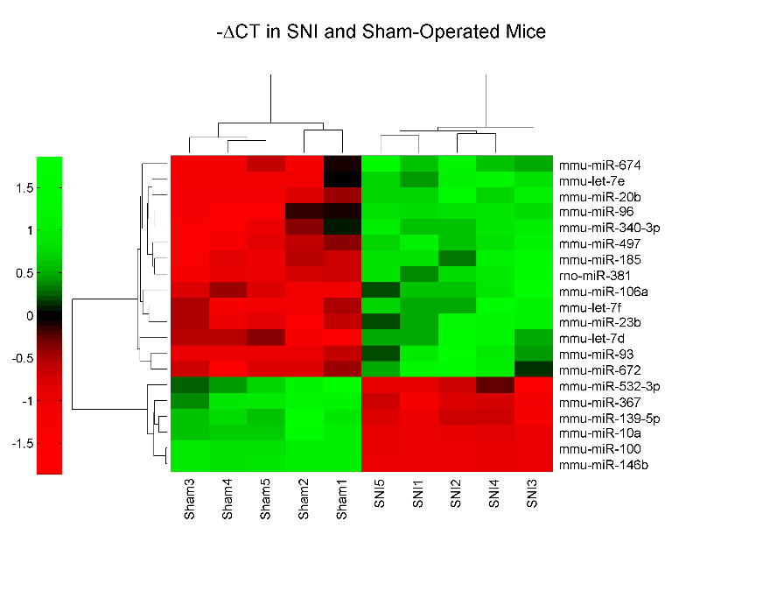

**Figure 1. This is an example figure.** Each figure must have a title (Use References -> Insert Caption in MS Word) and additional text describing what the figure shows. When referring to a figure in the text, always use References->Cross-reference. Do not manually write the figure number.

|  |  |  |
| --- | --- | --- |
| Name | Fold Change | p-value |
| hsa-miR-25# | -3.9 | 1.1E-06 |
| hsa-let-7c | -2.5 | 2.1E-05 |
| hsa-miR-939 | -4.6 | 5.6E-06 |
| hsa-let-7a | -2.5 | 0.002 |
| hsa-let-7b | -2.4 | 5.5E-05 |

**Table 1. Top-5 most significantly differentially expressed miRNAs.** Each table must have a title. Use References -> Insert Caption in MS Word to insert the caption. Provide additional text describing what the table shows. Make the table appear close to its cross-reference, but move it around to avoid spanning multiple pages.

# DISCUSSION

* Summarize/discuss your results, without repeating verbatim what you already have in the Abstract or Results.

* Do your results make sense biologically? Find studies that support your findings. (E.g., you found 10 genes in your Alzheimer's dataset analysis, check literature to see if these genes are known for their involvement in Alzheimer's).

* What are the limitations of your study?

* What follow up studies can be performed to improve upon your findings?

* Describe future work. How can your application be extended/improved?

# References

1. Sacan, A., I.H. Toroslu, and H. Ferhatosmanoglu, *Integrated search and alignment of protein structures.* Bioinformatics, 2008. **24**(24): p. 2872-9.

1. Avoid using identical title to any other publication. Scholarly articles are supposed to be unique identifiers and you do not want your report to appear as a version of the original appear on search engines. If your project is based on a paper, use a title that reflects what you did.
2.