**Revised Manuscript**

**Hill-Robertson Interference Reduces Genetic Diversity on a Young Plant Y-chromosome**

Josh Hough, Wei Wang, Spencer C. H. Barrett, and Stephen I. Wright

Department of Ecology and Evolutionary Biology, University of Toronto

Associate Editor: Bret Payseur

Article Type: Genetics of Sex

TOC Subsection Heading: Population and Evolutionary Genetics

Corresponding Author: Josh Hough

Keywords: Deleterious mutations; Interference selection; Nucleotide diversity; Suppressed recombination

Running title: sex chromosome evolution

**Abstract**

X and Y chromosomes differ in effective population size (*Ne*), rates of recombination, and exposure to natural selection, all of which can affect patterns of genetic diversity. On Y chromosomes with suppressed recombination, natural selection is expected to eliminate linked neutral variation and lower the *Ne* of Y compared to X chromosomes or autosomes. However, female-biased sex ratios and high variance in male reproductive success can also reduce Y-linked *Ne*, making it difficult to infer the causes of low Y-diversity. Here, we investigate the factors affecting levels of polymorphism during sex chromosome evolution in the dioecious plant *Rumex hastatulus* (Polygonaceae). Strikingly, we find that neutral diversity for genes on the Y chromosome is on average 2.1% of the value for their X-linked homologues, corresponding to a chromosome-wide reduction of 93% compared to the standard neutral expectation. We demonstrate that the magnitude of this diversity loss is inconsistent with reduced male *Ne* caused by neutral processes. Instead, using forward simulations, transcriptome and cytological estimates of the number of constrained sites, and estimates of the distribution of deleterious fitness effects, we show that Y chromosome diversity loss can be explained by purifying selection acting in aggregate over a large number of genetically linked sites. Simulations also suggest that observed Y-diversity levels are consistent with the joint action of purifying and positive selection, but only for models in which there were fewer constrained sites than we empirically estimated. Given the relatively recent origin of *R. hastatulus* sex chromosomes, our results imply that Y-chromosome degeneration in the early stages may be largely driven by selective interference rather than by neutral genetic drift of silenced Y-linked genes.

**Introduction**

Morphologically distinct sex chromosomes have evolved multiple times independently in plants and animals [(Westergaard 1958; Ohno 1969; Bull and Others 1983; Charlesworth 1991, 2015)](https://paperpile.com/c/N4uYXf/46xQc+LnTpI+vRr5K+ikuVx+qy7Xo). Despite clear biological differences between these kingdoms, X and Y chromosomes in both lineages have undergone similar genetic changes. In each kingdom, the loss of recombination between X and Y chromosomes is associated with an accumulation of deleterious mutations and a gradual loss of functional genes from the Y chromosome [(Bachtrog 2013; Hough et al. 2014; Bergero et al. 2015)](https://paperpile.com/c/N4uYXf/WQfC+AqGhr+U4pni), and in some species, such genetic degeneration has also led to the evolution of dosage compensation on the X chromosome [(Charlesworth 1996; Mank 2009; Muyle et al. 2012; Papadopulos et al. 2015)](https://paperpile.com/c/N4uYXf/6ybp0+HF2Vv+ZDq84+2hH4h). The independent evolution of these phenomena in such taxonomically distant groups as mammals and flowering plants suggests that general evolutionary mechanisms are involved, but inferring the causes of molecular evolution and patterns of polymorphism in genomic regions that lack recombination is a longstanding challenge for both theoretical and experimental biologists [(Eshel and Feldman 1970; Charlesworth 1978; Feldman et al. 1980; Barton 1995; Nordborg et al. 1996; Otto and Feldman 1997)](https://paperpile.com/c/N4uYXf/YKwsW+E19tK+izxx6+NT0JO+N7so8+YRGwo).

One fundamental difference between X and Y chromosomes is that there are 1/3 as many Y-linked gene copies as X-linked ones in a diploid population. Therefore, genes on the Y chromosome are expected to experience an effective population size (*Ne*) that is 1/4 that of autosomal genes, and 1/3 that of X-linked genes (assuming an equal number of reproducing females and males). The lowered *Ne* of the Y chromosome implies that the level of neutral polymorphism maintained at equilibrium, proportional to the product of *Ne* and the neutral mutation rate, *μ*, should be lower for Y-linked genes than for their X-linked counterparts. In the absence of recombination, genes on the Y chromosome are also expected to be in strong linkage disequilibrium, making them vulnerable to diversity loss due to selection against strongly deleterious mutations (background selection; [Charlesworth et al. 1993)](https://paperpile.com/c/N4uYXf/fY5eF) and selective sweeps of strongly beneficial mutations (genetic hitchhiking; Maynard [Smith and Haigh 1974)](https://paperpile.com/c/N4uYXf/LTeCt). Furthermore, the build-up of genetic associations among selected mutations (fitness covariance) on the Y means that selection will act non-independently across the chromosome, such that selection at a focal site may "interfere" with selection at linked sites [(Hill and Robertson 1966)](https://paperpile.com/c/N4uYXf/Od5Oy). A large body of work has now shown that such selective interference effects are expected to reduce both the efficacy of selection and the equilibrium level of neutral variability [(Fisher 1930; Muller 1964; Hill and Robertson 1966; McVean and Charlesworth 2000; Kaiser and Charlesworth 2009; Good et al. 2014)](https://paperpile.com/c/N4uYXf/CniCq+wTEiI+Od5Oy+vfe1D+hVh3p+NMuOb), with the magnitude of the effect depending on the number and density of sites experiencing selection. These arguments all suggest that large non-recombining Y chromosomes with many linked selected sites should harbor a lower amount of neutral variability than predicted based on the number of Y chromosomes in a population (1/4 that of autosomes). However, the relative importance of neutral and selective factors in reducing chromosome-wide levels of diversity is not well understood.

In addition to reduced diversity arising from selection, in species with female-biased sex ratios or extensive male-male competition, high variance in male reproductive success is also expected to reduce the *Ne* experienced by genes on the Y chromosome [(Caballero 1995; Charlesworth 2002; Laporte and Charlesworth 2002; Ellegren 2009)](https://paperpile.com/c/N4uYXf/acMVj+Mm8WH+i4BuT+ovPpp), suggesting that inferences about the effects of linked selection need to be distinguished from these processes. Because variance in male reproductive success differentially affects the *Ne* of X, Y, and autosomal chromosomes [(Kimura and Crow 1964; Nomura 2002)](https://paperpile.com/c/N4uYXf/9BUEj+6kIfM), evidence for this can be obtained by comparing levels of silent site variability on X and Y chromosomes relative to that on autosomes. For example, variance in male reproductive success reduces male *Ne*, which reduces the Y/A diversity ratio relative to the neutral expectation (1/4), but also causes an increase in the X/A ratio. Based on such comparisons, studies in humans, for example, have suggested that the observation of an inflated X/A ratio can be explained by an historical excess of breeding females compared to males [(Bustamante and Ramachandran 2009; Hammer et al. 2010; Cotter et al. 2016)](https://paperpile.com/c/N4uYXf/ALLE7+sXvh3+FkvgU).

Despite widespread interest in determining the evolutionary factors that affect neutral diversity on sex chromosomes [(Ellegren 2009; Bachtrog 2013)](https://paperpile.com/c/N4uYXf/ovPpp+U4pni), we still know very little about how sex- ratio variation or selective processes have affected levels of diversity on more recently evolved sex chromosomes. The time scales over which these processes are likely to be important are therefore not well understood. In humans, estimates of silent site diversity on the Y are considerably lower than predicted under neutral evolutionary models, and simulations suggest that observed levels of diversity are consistent with the action of extensive purifying selection [(Wilson Sayres et al. 2014)](https://paperpile.com/c/N4uYXf/S6uio). However, given that human sex chromosomes originated ~200 million years ago [(Lahn and Page 1999; Ross et al. 2005)](https://paperpile.com/c/N4uYXf/H1RvL+RLSj1), it is not clear whether purifying selection might have had a similarly strong effect on Y chromosomes that arose much more recently - e.g., within the last ~20 MYA in the case of dioecious plants [(Charlesworth 2015)](https://paperpile.com/c/N4uYXf/qy7Xo).

Simulations of strong selection models (background selection and genetic hitchhiking) suggest that these processes may have the greatest effects during the earliest stages of sex chromosome evolution, before the Y has lost many of its genes [(Bachtrog 2008)](https://paperpile.com/c/N4uYXf/rJdBv). Moreover, theory suggests that even weak purifying selection, when aggregated over a large number of genetically-linked sites, can generate strong deviations from neutrality, whereas classic background selection theory breaks down in such cases [(McVean and Charlesworth 2000; Comeron and Kreitman 2002; Comeron and Guthrie 2005; Kaiser and Charlesworth 2009; Good et al. 2014)](https://paperpile.com/c/N4uYXf/vfe1D+Mi2iu+PsxZa+hVh3p+NMuOb). Given that a large number of selected sites are likely to be in linkage disequilibrium on a recently evolved Y chromosome, such interference selection is *a priori* likely to be a strong force affecting the evolution of young plant sex chromosomes. However, if there has been widespread gene silencing during the early stages of Y-chromosome evolution, as in *Drosophila albomicans* [(Zhou and Bachtrog 2012)](https://paperpile.com/c/N4uYXf/w05fm), then diversity loss might be expected to be less severe on younger Y chromosomes. That is, if Y-linked gene silencing occurs early during sex chromosome evolution due to a combination of dosage compensation, heterochromatin formation, and/or loss of regulatory elements, then few sites may be under selection, and Y chromosome degeneration may be driven primarily by genetic drift rather than selective interference. Understanding the relative importance of inefficient selection and neutral genetic drift during Y chromosome evolution is therefore a major open issue.

To investigate the factors affecting nucleotide diversity in the early stages of sex chromosome evolution, we analyzed neutral polymorphism levels on X, Y, and autosomal chromosomes in the plant *Rumex hastatulus* (Polygonaceae). This species is a dioecious annual with heteromorphic X and Y chromosomes that originated ~15 MYA [(Navajas-Perez 2005; del Bosque et al. 2011; Grabowska-Joachimiak et al. 2015)](https://paperpile.com/c/N4uYXf/DG65w+9NZlM+JQPHK), making Y chromosomes in this species over 100 million years younger than the highly degenerated Y chromosomes in mammals [(Lahn and Page 1999; Ross et al. 2005)](https://paperpile.com/c/N4uYXf/H1RvL+RLSj1). *Rumex hastatulus* has also received particular attention because of the occurrence of an interesting polymorphism in sex chromosome system, in which both XY and XY1Y2 male genotypes occur in geographically distinct populations [(Smith 1955, 1963, 1964, 1969)](https://paperpile.com/c/N4uYXf/oJJlx+slbYQ+RAnI8+FWTbg). The derived XY1Y2 sex chromosome system in this species is thought to have originated through an X-autosome fusion, with the current XY system maintaining the ancestral chromosome complement [(Smith 1964)](https://paperpile.com/c/N4uYXf/oJJlx). Interestingly, despite the relatively recent origin of sex chromosome polymorphism in *R. hastatulus*, there is evidence that both the ancestral and neo-Y-chromosomes have undergone gene loss and functional deterioration [(Hough et al. 2014; Crowson et al. 2017)](https://paperpile.com/c/N4uYXf/WQfC+cx0C). Here, to ensure that our estimates of polymorphism levels on X, Y, and autosomes are not biased by non-equilibrium conditions arising from the X-autosome fusion, we focus only on the XY system with the ancestral chromosome complement.

Of particular relevance to our study, *R. hastatulus* populations exhibit female-biased reproductive sex ratios, with a mean sex ratio of ~0.6 [(Pickup and Barrett 2013)](https://paperpile.com/c/N4uYXf/6Ic3G). Indeed, the occurrence of female-biased sex ratios in dioecious flowering plants has been found to be more common in species with heteromorphic X and Y chromosomes than in those with monomorphic sex chromosomes [(Field et al. 2013; Hough et al. 2013)](https://paperpile.com/c/N4uYXf/acehU+qfGqx). In *R. hastatulus*, the availability of field measurements of sex-ratio variation thus provides an opportunity to test both neutral and selective models of Y-chromosome diversity loss during sex chromosome evolution.

**Materials and Methods**

*Population samples and sex-Linked genes*

We analyzed sex-linked and autosomal genes identified from Illumina RNA sequence data from 12 population samples (1 male and 1 female from each of 6 populations). Samples were collected in 2010 from throughout the native range of the XY sex chromosome system in *R. hastatulus* (locations in Table S1), and plants were grown in the glasshouse at the University of Toronto from seeds collected from open-pollinated females. We extracted RNA from leaf tissue using Spectrum Plant Total RNA kits (Sigma-Aldrich). Isolation of mRNA and cDNA synthesis used standard Illumina RNAseq procedures, and sequencing was conducted on two Illumina HiSeq lanes with 150-bp paired-end reads at the Genome Quebec Innovation Centre. Reads from these samples were mapped to a *R. hastatulus* female reference transcriptome [(Hough et al. 2014)](https://paperpile.com/c/N4uYXf/WQfC) using the Burrows–Wheeler Aligner [(Li and Durbin 2010)](https://paperpile.com/c/N4uYXf/Suq9a), followed by Stampy [(Lunter and Goodson 2011)](https://paperpile.com/c/N4uYXf/VNdQA). We used Picard tools (http://picard.sourceforge.net) to process mapping alignments and called SNPs using the Unified Genotyper from the Genome Analysis Toolkit variant calling software [(McKenna et al. 2010)](https://paperpile.com/c/N4uYXf/e8VYG).We filtered SNPs with quality scores less than 60, and required each sample to have coverage greater than 10x, and individual genotype quality scores (GQ) at SNP sites greater than 30. These filters were imposed to decrease errors associated with heterozygous SNP calling and phasing for the sex-linked genes. The RNAseq data from these population samples were previously reported [(Hough et al. 2014)](https://paperpile.com/c/N4uYXf/WQfC), where they were used to validate the ascertainment of sex-linked genes identified through segregation analysis; raw sequences are available from the GenBank Short Read Archive under accession no. SRP041588. Here, to focus on sex-linked genes likely to be relatively older and closer to equilibrium, we focused on the previously described set of 460 X/Y genes for which a Y homolog was found in both sex chromosome systems (i.e., X/Y genes where the Y copy was inferred to be on the Y1 chromosome).

*Autosomal genes and X-linked genes in females*

In evaluating evidence for nucleotide diversity differences between X and Y chromosomes, it is important to distinguish between reduced Y-linked diversity, and the possibility that X-linked diversity is elevated above the level predicted from a neutral model. To do this, we normalized our sex-linked diversity estimates by autosomal diversity, and compared empirical X/A and Y/A nucleotide diversity ratios to those predicted from neutral models and from simulations (described below). Because the criteria for ascertaining autosomal loci in [Hough et al. (2014)](https://paperpile.com/c/N4uYXf/WQfC) were based on identifying four segregating SNPs per locus, and since this set of genes is likely to be higher in diversity than the average autosomal gene, here we instead used the larger set of all non-sex linked (putatively autosomal) genes as our autosomal reference. We filtered genes in this set to remove any genes that may have been sex-linked but were not identified as such by Hough et al.'s (2014) conservative ascertainment criteria. In particular, we removed: (i) any genes in which there was evidence for at least one SNP with a sex-linked segregation pattern, (ii) any genes where SNPs showed fixed heterozygosity in males and fixed homozygosity in females, (iii) genes with less than 10X coverage or greater than 100X coverage from independently obtained genomic coverage data (Beaudry et al., in prep), to filter out duplicates or genes with highly repetitive sequences, and (iv) any genes containing SNPs with large (>0.4) allele frequency differences between males and females. Finally, we removed genes with fewer than 50 filtered synonymous sites to avoid biasing our results toward genes that may have been particularly short due to assembly problems, or particularly low quality following our filtering. This filtering resulted in a final set of 12,356 autosomal genes. We took a similar approach to estimating polymorphism levels for X-linked loci in females for the final filtered set of 172 sex linked genes (see below).

*Phasing X and Y alleles*

To estimate polymorphism for X and Y sequences separately in males, it is necessary to infer the phase of SNPs in sex-linked transcripts. In previous work, phasing alleles on *R. hastatulus* sex chromosomes was achieved using segregation analysis from a genetic cross. Here, to phase SNPs from population samples where such segregation data was unavailable, we used HAPCUT [(Bansal and Bafna 2008)](https://paperpile.com/c/N4uYXf/buDh4), a maximum-cut based algorithm that reconstructs haplotypes using sequenced fragments (Illumina read data) from the two homologous chromosomes to output a list of phased haplotype blocks containing the polymorphic variants on each chromosome. Because the resulting haplotype blocks produced by HAPCUT contained SNPs that were phased relative to each other, but not designated to either the X or Y chromosome, we assigned individual variants to X or Y by independently identifying fixed X-Y differences within each haplotype block (i.e., sites where all females were homozygous, and all males were heterozygous). Identifying such fixed differences within phased haplotype blocks enabled us to then infer the correct phase (X or Y) of the polymorphisms from HAPCUT’s output. In particular, this was done by matching the phase of fixed X-Y differences with neighboring polymorphic sites: when a fixed X-Y difference occurred in the same phased haplotype block as a polymorphic site, then the variants in that block were assigned to either X or Y based on the known phase of the fixed difference with which they were matched. SNPs that were identified outside of phased blocks, in blocks where there was evidence of phasing error due to Y-specific SNPs in both haplotypes, or in blocks without fixed X-Y differences, were recorded as missing data. Note that our coverage criteria and requiring the presence of fixed X-Y differences also helps minimize the possibility of poor mapping of Y reads due to X-Y divergence and low Y-specific expression. Finally, we filtered out SNPs with quality scores < 60, individual genotype quality scores <30, and those within a distance of 10bp or less from indels. As with the autosomal genes, we also removed genes with less than 50 synonymous sites.

We further validated the results of HAPCUT’s allele phasing by comparing the accuracy of this method with the phasing-by-segregation method that was conducted in [(Hough et al. 2014)](https://paperpile.com/c/N4uYXf/WQfC). To do this, we first phased the sequence data from parents and their progeny using HAPCUT’s algorithm (using the same parameters as for the population data), and then identified cases where SNPs were inferred on the Y chromosome by HAPCUT, but where the true level of polymorphism due to family structure (father and sons) was zero. We identified 7% of sex-linked genes that either had phasing errors or genotyping errors. Based on this family-level test for false SNPs, this corresponds to a SNP error rate estimate of 1.7 x 10-4. Note that this rate is very low relative to population-based estimates of polymorphism on the X and autosomes (Table 1), and therefore should have minimal effects on our estimation of the X/A ratio. Furthermore, we can avoid phasing errors on the X by using diversity estimated from females rather than phased males. In fact our synonymous diversity estimate on the X from phased males (0.00472) is very close to that estimated from females (0.00453, Table 1), with the difference between them nearly equal to the estimated SNP error rate on the Y from the family data. However, because this error rate is high relative to the expected level of polymorphism on the Y chromosome, and we do not have an equivalent unphased comparison for the Y, we conducted a further filtering step for phased Y-linked SNPs and identified false positive SNP calls arising from: (i) phasing errors caused by gene duplicates (more than two haplotypes), (ii) polymorphisms around indels, and (iii) genotyping errors caused by low Y-expression. This final filtering was conducted by manually checking each individual putative polymorphism on the Y chromosome using IGV [(Robinson et al. 2011)](https://paperpile.com/c/N4uYXf/Ku8ej). Genes with identified SNP calling errors on the Y were removed, and following all filtering procedures we were left with a set of 173 sex-linked genes for further analysis.

*Estimating nucleotide diversity on sex chromosomes and autosomes*

For each locus in our analysis, we calculated Watterson’s (1975) estimator of the population parameter , where *Ne* is the diploid effective population size, and *μ* is the per-base mutation rate per-generation, using a modified version of the Perl program Polymorphurama [(Bachtrog and Andolfatto 2006)](https://paperpile.com/c/N4uYXf/3SMV3). We also used Polymorphurama to calculate the average pairwise differences *πsyn*and Tajima’s D at synonymous sites (Tajima, 1989). To compare sex-linked and autosomal loci, we calculated the average value of for each chromosome type, weighted by the number of synonymous sites in each gene (Figure 2). We obtained 95 % confidence intervals for X/A and Y/A ratios by bootstrapping per gene using the BCa method [(Efron and Tibshirani 1994)](https://paperpile.com/c/N4uYXf/Tqe9h) implemented in the Boot package in R [(Canty and Ripley 2012)](https://paperpile.com/c/N4uYXf/Nq7ux), and calculating X/A and Y/A on each iteration for 20000 replicates each. Bootstrapping was conducted on the final filtered set of 173 sex-linked and 12355 autosomal genes.

Note that the lack of recombination on the Y chromosome implies that statistical assumptions about independence across loci are violated, suggesting that the true uncertainty in the Y/A estimate may be wider than implied by bootstrapping. To address this, we also used a maximum likelihood approach [(Wright and Charlesworth 2004)](https://paperpile.com/c/N4uYXf/m7Vbn) to independently estimate a credibility interval for the Y/A ratio (Figure S1). Because of the thousands of genes involved, a likelihood method incorporating divergence to control for heterogeneity in mutation rate was not feasible, as this would require maximizing the likelihood estimate of the mutation rate for each locus independently. However, previous analysis of divergence data does not suggest important chromosomal differences in synonymous divergence contributing to diversity heterogeneity (see Results). Therefore, we assumed no heterogeneity in mutation rate, no recombination between Y-linked genes, and free recombination between autosomal loci. Our model thus had two parameters: , our estimate of Watterson's theta for autosomal genes, and *f*, the ratio of effective population size of the Y chromosome to autosomes. We varied both parameters and evaluated the likelihood for *f* from 0.001 to 1, and per base pair from 0.001 to 0.01. In particular, we evaluated the likelihood of and *f*, given (i) the observed number of synonymous segregating sites for each *i* of *n* autosomal loci *Si*  (ii) the number of segregating sites on the Y chromosome *SY* , and (3) the total number of sites per locus (*LI* and *LY*). The likelihood of (, *f* ) is given by:

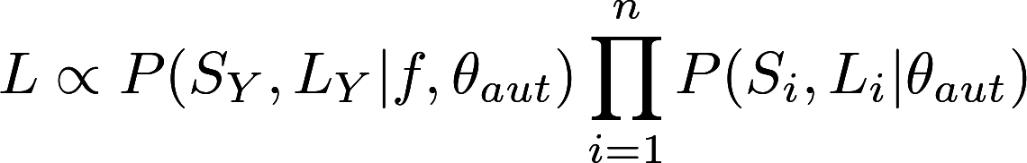

*Neutral predictions and the effect of sex ratio bias on diversity*

To test whether our estimated levels of diversity on X, Y and autosomal chromosomes could be explained by neutral processes, including female-biased population sex ratios or high variance in male reproductive success, we compared our normalized X/A and Y/A diversity estimates to the corresponding neutral predictions for a given effective population size "sex ratio", *r* = *Nef* / (*Nef + Nem*). Because we were primarily interested in determining the parameter space within which a reduced male *Ne* could result in Y/A and X/A diversity ratios consistent with our data, we tested the fit of our estimates to predictions across the full range of *r* (0.1 to 0.9; we excluded all-female or all-male cases). For autosomal and sex-linked effective population sizes given by:

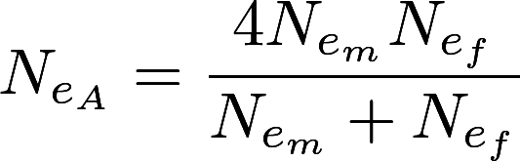

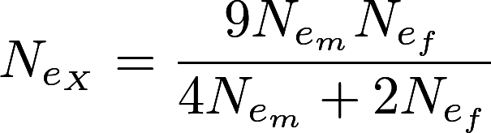

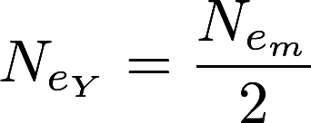

[(Wright 1931)](https://paperpile.com/c/N4uYXf/cmLjf), and the corresponding expected X/A and Y/A ratios can be expressed as:

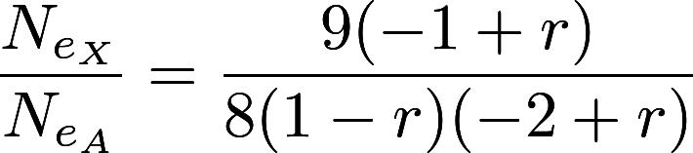

and

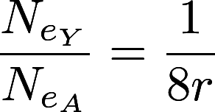

respectively. Note that when *r* = 0.5, *NeX* / *NeA* = 0.75, and *NeY* / *NeA* = 0.25, as in the standard neutral model [(Wright 1931)](https://paperpile.com/c/N4uYXf/cmLjf). With a female-biased ratio, however, the expected X/A ratio can become greater than 1, approaching 1.125 in the limit as *r*→1 [(Caballero 1995)](https://paperpile.com/c/N4uYXf/acMVj).

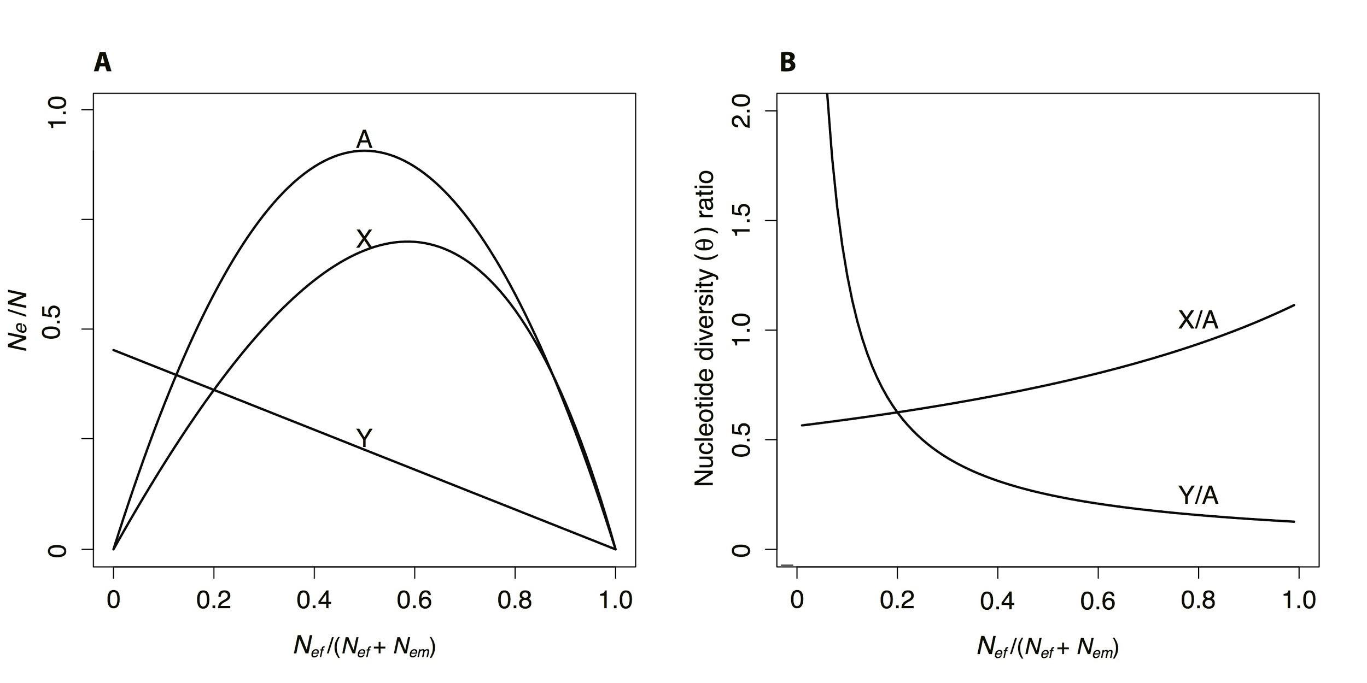

**Figure 1.** (A) Normalized effective population sizes at equilibrium for genes on autosomes, X chromosomes, and Y chromosomes as a function of the sex ratio. (B) The corresponding X/A and Y/A ratios of nucleotide diversity predicted at equilibrium, assuming equal neutral mutation rates for sex-linked and autosomal genes.

*Simulations of purifying selection*

To study the effects of purifying selection on expected levels of Y-chromosome diversity, we conducted forward-time simulations of haploid Y chromosomes using the software SFS_CODE [(Hernandez 2008)](https://paperpile.com/c/N4uYXf/3J60J). We first estimated the distribution of fitness effects of deleterious amino acid mutations from our polymorphism data for X-linked genes using the method of [(Keightley and Eyre-Walker 2007)](https://paperpile.com/c/N4uYXf/oTiEN), which fits a gamma distribution of negative selection coefficients to the observed frequency distribution of nonsynonymous and synonymous polymorphisms. This analysis estimated a mean strength of selection (*Ns*) of 493, and a shape parameter of 0.258 for the X chromosome. Rescaling the effective population size for the Y chromosome assuming a sex ratio of 0.6 gives a mean *Ns* for the Y of 493 x 0.259=128. We then used this estimated gamma distribution to parameterize the simulations, initializing them with our estimated θaut (Table 1), adjusted to reflect the neutrally expected *NeY* for a sex ratio of *r* = 0.6, 0.0055 x 0.21=0.0011. To match our sample size and the number of synonymous sites sampled from our data (see Supporting Information), the simulations sampled 6 haploid chromosomes, and the genome sequence contained 45,331 bp of linked neutral sequence from which we calculated silent site diversity, *πs*. To increase computational speed, we simulated a population of 500 haploid chromosomes. For each parameter set, we conducted replicate simulations (see below) and calculated *πs* for each replicate simulation.

To examine the expected reduction in diversity, we needed an independent estimate of *L*, the number of sites under selection on the Y chromosome. Our previous estimates based on cytological measurements suggested that there may be roughly 5,600 genes on the X [(Hough et al. 2014)](https://paperpile.com/c/N4uYXf/WQfC). We also previously estimated that approximately 28 percent of genes had degenerated, leaving us with an estimated 1568 genes remaining on the Y chromosome. Using the average number of codons in genes of *Arabidopsis thaliana* (426) [(Haas et al. 2003)](https://paperpile.com/c/N4uYXf/5iLwN), and assuming 2/3 of each codon are under selection, this would imply 1.3 MB of selected sites, which we used to run our simulations. For this parameter set, we ran 50,000 simulated datasets to quantify the expected diversity loss under this model. In addition, we ran simulations over a range of values of *L*, up to a maximum of 5x106 (Figure 3), again with 50,000 replicate simulations per parameter set. To obtain an estimate of *L*, we calculated the approximate likelihood of our observed data based on the proportion of simulations in which *πs* was less than 0.00011 and greater than 0.00009, based on our empirical estimate (Table 1). In addition, to assess the fit to a summary of the observed frequency spectrum, we also calculated the combined likelihood of the observed number of silent sites and number of singletons.

*Simulations including positive selection*

We also considered the possibility of positive selection playing a role in the loss of diversity on the Y chromosome. To do this, we modified the above simulations to include a proportion of functional sites subject to positive selection, with the remaining proportion subject to the purifying selection parameters described above. To explore the likelihood of our observed diversity reduction, we varied the proportion of sites under positive selection (from 0 to 0.005), as well as the total number of functional sites, *L* (over a grid of values ranging from 50000 bp to 1300000 bp), and ran 20,000 replicate simulations per parameter set. We assumed a gamma distribution of selection coefficients with the same strength and shape as our distribution of deleterious fitness effects given above.

**Results and Discussion**

Extensive *loss of Y-chromosome diversity*

Our analysis of polymorphism levels across the genome of the dioecious plant *R. hastatulus* revealed a widespread loss of neutral diversity from the Y chromosome (Table 1, Figure 2). In particular, neutral diversity for Y-linked genes was on average ~ 2.2% of the value for their homologues on the X chromosome. Taking 1/4 of the mean autosomal diversity as the equilibrium expectation for θ*Y* under neutrality, this corresponds to a chromosome-wide reduction of 93% relative to the standard neutral model [(Wright 1931)](https://paperpile.com/c/N4uYXf/cmLjf). Note that by normalizing X and Y diversity estimates by autosomal diversity levels, our results indicate that the difference between X and Y homologues is not due to an elevation of diversity on the X chromosome, but a Y-specific reduction. Interestingly, our results also suggest an elevation of X-linked diversity (X/A=0.85) compared to the neutral prediction (X/A=0.75), though the confidence intervals on this estimate are wide, ranging from 0.74 to 0.95 (Figure 2). Given the empirically-estimated sex ratio of *r* = 0.6 in *R. hastatulus* [(Pickup and Barrett 2013)](https://paperpile.com/c/N4uYXf/6Ic3G), however, the X/A elevation we observed is not unexpected; the neutrally-predicted X/A ratio for a sex ratio of 0.6 is ~ 0.8 (Figure 2; Equation 4). The frequency spectra of variant sites of X, Y and autosomal loci, as quantified by mean Tajima’s D at synonymous sites are similar (X, -0.43; Y, -0.34; Autosomal, -0.27). Although our estimates of diversity have not been normalized by divergence, previous work has shown that the average synonymous substitution rate, between *R. hastatulus* and the non-dioecious outgroup *Rumex bucephalophorus* is comparable for sex-linked (0.2016) and autosomal genes (0.219), and we found no evidence for significant differences in substitution rate between Y and X chromosomes [(Hough et al. 2014)](https://paperpile.com/c/N4uYXf/WQfC). It is therefore unlikely that our results are caused by mutation rate differences between sex-linked and autosomal genes.

**Table 1**. Observed and expected neutral polymorphism at silent sites (θsyn) on sex chromosomes and autosomes in *Rumex hastatulus*. Values in parentheses indicate the observed and expected diversity values on sex chromosomes relative to autosomes (Figure 1).

|  |  |  |
| --- | --- | --- |
| **Chromosome** | **Observed θsyn** | **Expected θsyn** |
| Autosome | 0.0055 | 0.0055 |
| X | 0.0045  (X/A = 0.82) | 0.0041  (X/A = 0.75) |
| Y | 0.0001  (Y/A = 0.018) | 0.0014  (Y/A = 0.25) |

*Female biased sex ratios and variance in male reproductive success*

The occurrence of female-biased sex ratios in *R. hastatulus* is expected to lower Y diversity through a reduction in male *Ne* and thus a reduction in the *Ne* of the Y chromosome. Male *Ne* could be further reduced by high variance in male reproductive success, which is expected in annual wind-pollinated plants such as *R. hastatulus* that commonly exhibit extensive phenotypic plasticity in plant size and flower production. Given that male plants in this species produce large amounts of pollen, and female flowers are uniovulate, there may indeed be strong competition among males to fertilize ovules. Such competition should cause a proportional increase in X-linked diversity to a level that is close to (or even higher than) levels of autosomal diversity [(Caballero 1995)](https://paperpile.com/c/N4uYXf/acMVj), while simultaneously reducing Y-linked diversity. In common with most flowering plants, we do not have marker-based estimates of variance in male reproductive success in *R. hastatulus*. We therefore tested whether an overall reduction in male *Ne*, arising either from high variance in male reproductive offspring number and/or a female biased population sex ratio, could explain our observed Y/A and X/A ratios, by comparing our data to neutral predictions across the full range of values for the *Ne* sex ratio, *r*.

As shown in Figure 2, the expected reduction in Y/A as a function of *r* is substantially higher than our observed Y/A diversity ratio. Indeed, the lower limit for the Y/A ratio in a neutral model is 1/8, such that even in the extreme case where *r* = 0.9, the expectation for Y/A is ~0.14, which is substantially higher than our observed estimate Y/A= 0.018 (Table 1; Figure 2). Moreover, such large reductions in *Nem* would also predict levels of X/A diversity that are significantly larger than we observed (Figure 2). Our results therefore indicate that, although reduced male *Ne* arising from sex-biased demography is expected to contribute to reduced Y chromosome polymorphism, it is insufficient to explain the Y/A reduction we observed.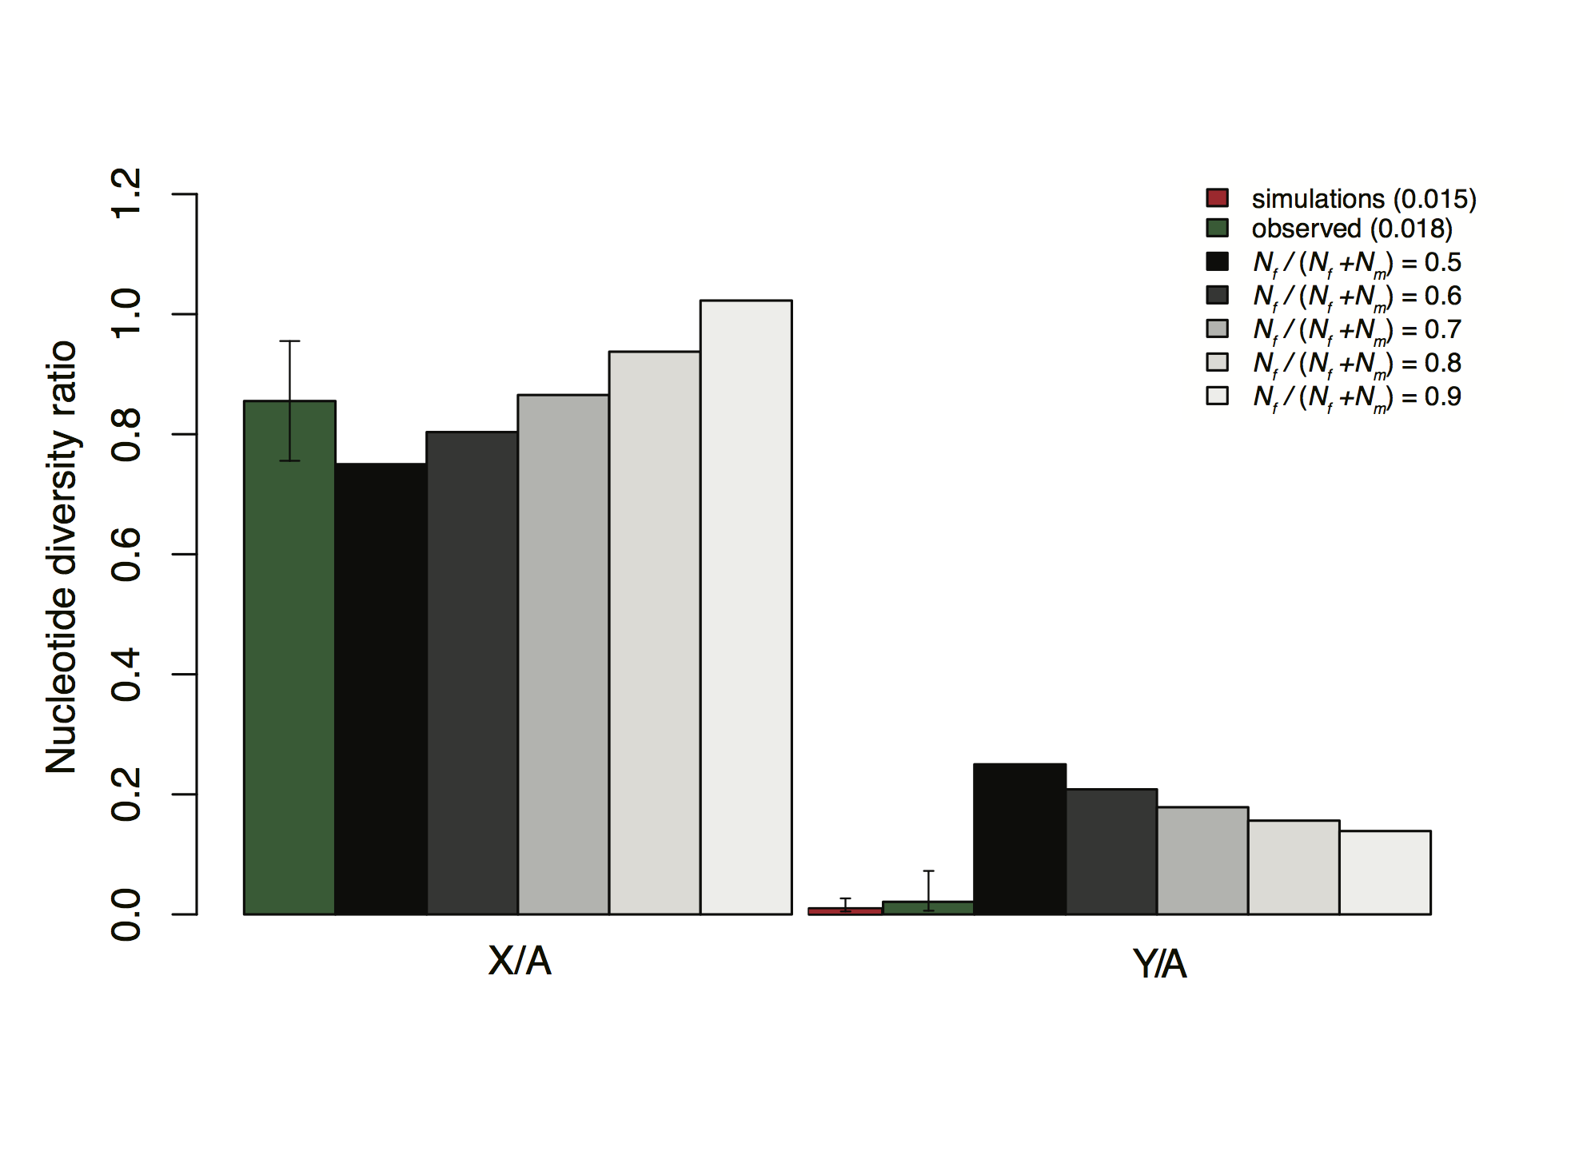**Figure 2.** Observed and predicted X/A and Y/A ratios of neutral diversity. Predictions are shown for increasing values of the effective population size sex ratio, Nef / (Nef + Nem). We calculated observed estimates of X/A and Y/A as the average θ across genes, weighted by the number of synonymous sites per gene. We modeled purifying selection using forward simulations implemented in SFS_CODE, and the simulated Y/A diversity ratio shown was obtained from

from a model with 1.3 million selected sites (see methods). Simulations were initialized using the estimated distribution of fitness effects of deleterious amino acid mutations from our polymorphism data for X-linked genes using the method of (Keightley and Eyre-Walker 2007), which estimated a mean strength of selection (Ns) of 493, and a shape parameter of 0.258 for the X chromosome. Rescaling the effective population size for the Y chromosome assuming a sex ratio of 0.6 gives a mean Ns for the Y of 493 x 0.259=128. We used this estimated distribution to parameterize the simulations, initializing them with our estimated θaut (Table 1), adjusted to reflect the neutrally expected NeY for a sex ratio of r = 0.6. To match our sample size and the number of synonymous sites sampled from our data (see Supporting Information), our simulations sampled 6 haploid chromosomes, and the genome sequence contained 45,331 bp of linked neutral sequence from which we calculated silent site diversity. Confidence intervals were calculated by bootstrapping (20000 replicates) using the BCa method [(Efron 1987)](https://paperpile.com/c/N4uYXf/zopq6) implemented in the Boot package in R [(Canty and Ripley 2012)](https://paperpile.com/c/N4uYXf/Nq7ux). Simulations commands are given in the SI text.

*Purifying Selection*

Selection against strongly deleterious mutations is expected to be an important factor reducing genetic variability in regions with low recombination [(Charlesworth et al. 1993; Nordborg et al. 1996)](https://paperpile.com/c/N4uYXf/fY5eF+YRGwo). The effects of such “background selection” (BGS) have been well studied theoretically [(Nordborg et al. 1996; Charlesworth et al. 1997; Kim and Stephan 2000)](https://paperpile.com/c/N4uYXf/3sHtw+YRGwo+TVrTD) and the theory has been used to explain patterns of genetic diversity across genomes [(Comeron 2014)](https://paperpile.com/c/N4uYXf/VEEpP) and plays a central role in explanations for diversity loss on Y chromosomes in mammals [(Wilson Sayres et al. 2014)](https://paperpile.com/c/N4uYXf/S6uio) and *Drosophila* [(Charlesworth 1996; McAllister and Charlesworth 1999)](https://paperpile.com/c/N4uYXf/SXfYG+6ybp0). Under background selection theory for a Y chromosome, the predicted loss of diversity is modeled as a reduction in the equilibrium *Ne* such that *π*≅(Y/A)*4*Nef*0 *μ* , where *f*0=*e****-U/sh***, *U* is the mutation rate to strongly deleterious variants on the Y, and *s* and *h* are selection and dominance coefficients [(Hudson and Kaplan 1995)](https://paperpile.com/c/N4uYXf/OKQCt). This yields the expected value of *π* under the model: E[*π*] = *π*0*e****-U/sh***, where *π*0 is the expected diversity in the absence of BGS, *π*0 = (Y/A)*4*Ne μ*, and Y/A is the expected ratio of the effective population size of the Y relative to autosomes. Here, assuming that the proportion of males is 0.4, and therefore that Y/A is 0.21 of the total *Ne*  estimated from autosomes as a result of the female biased sex ratio in *R. hastatulus* [*(*Pickup and Barrett 2013*)*](https://paperpile.com/c/N4uYXf/6Ic3G)*,* and using *s* = 0.003 as estimated from the distribution of fitness effects of deleterious mutations, the corresponding expected diversity on the Y chromosome under BGS is E[*π*] = 2.5x10-6 for a haploid Y chromosome mutation rate of 7x10-9 per nucleotide per generation [(Ossowski et al. 2010)](https://paperpile.com/c/N4uYXf/a8XH9) and 1.3 MB of selected sites estimated from transcriptome and cytological data (see Methods). Although there is considerable uncertainty in these parameters, the calculation yields an expected value of diversity that is 70% lower than we observed (Table 1; Figure 2).

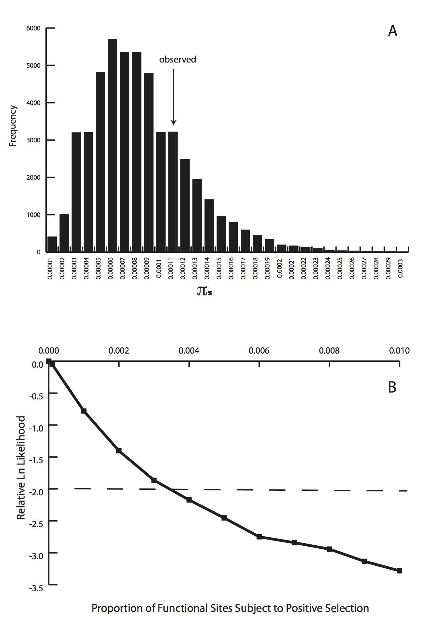

**Figure 3-** Results of forward computer simulations, assuming the independently estimated 1.3 MB of functional sites. **A:** distribution of diversity levels from simulations with purifying selection alone. **B:** likelihood of the observed *π*s from forward simulations of a nonrecombining Y chromosome with both purifying and positive selection, varying the proportion of functional sites under positive selection.

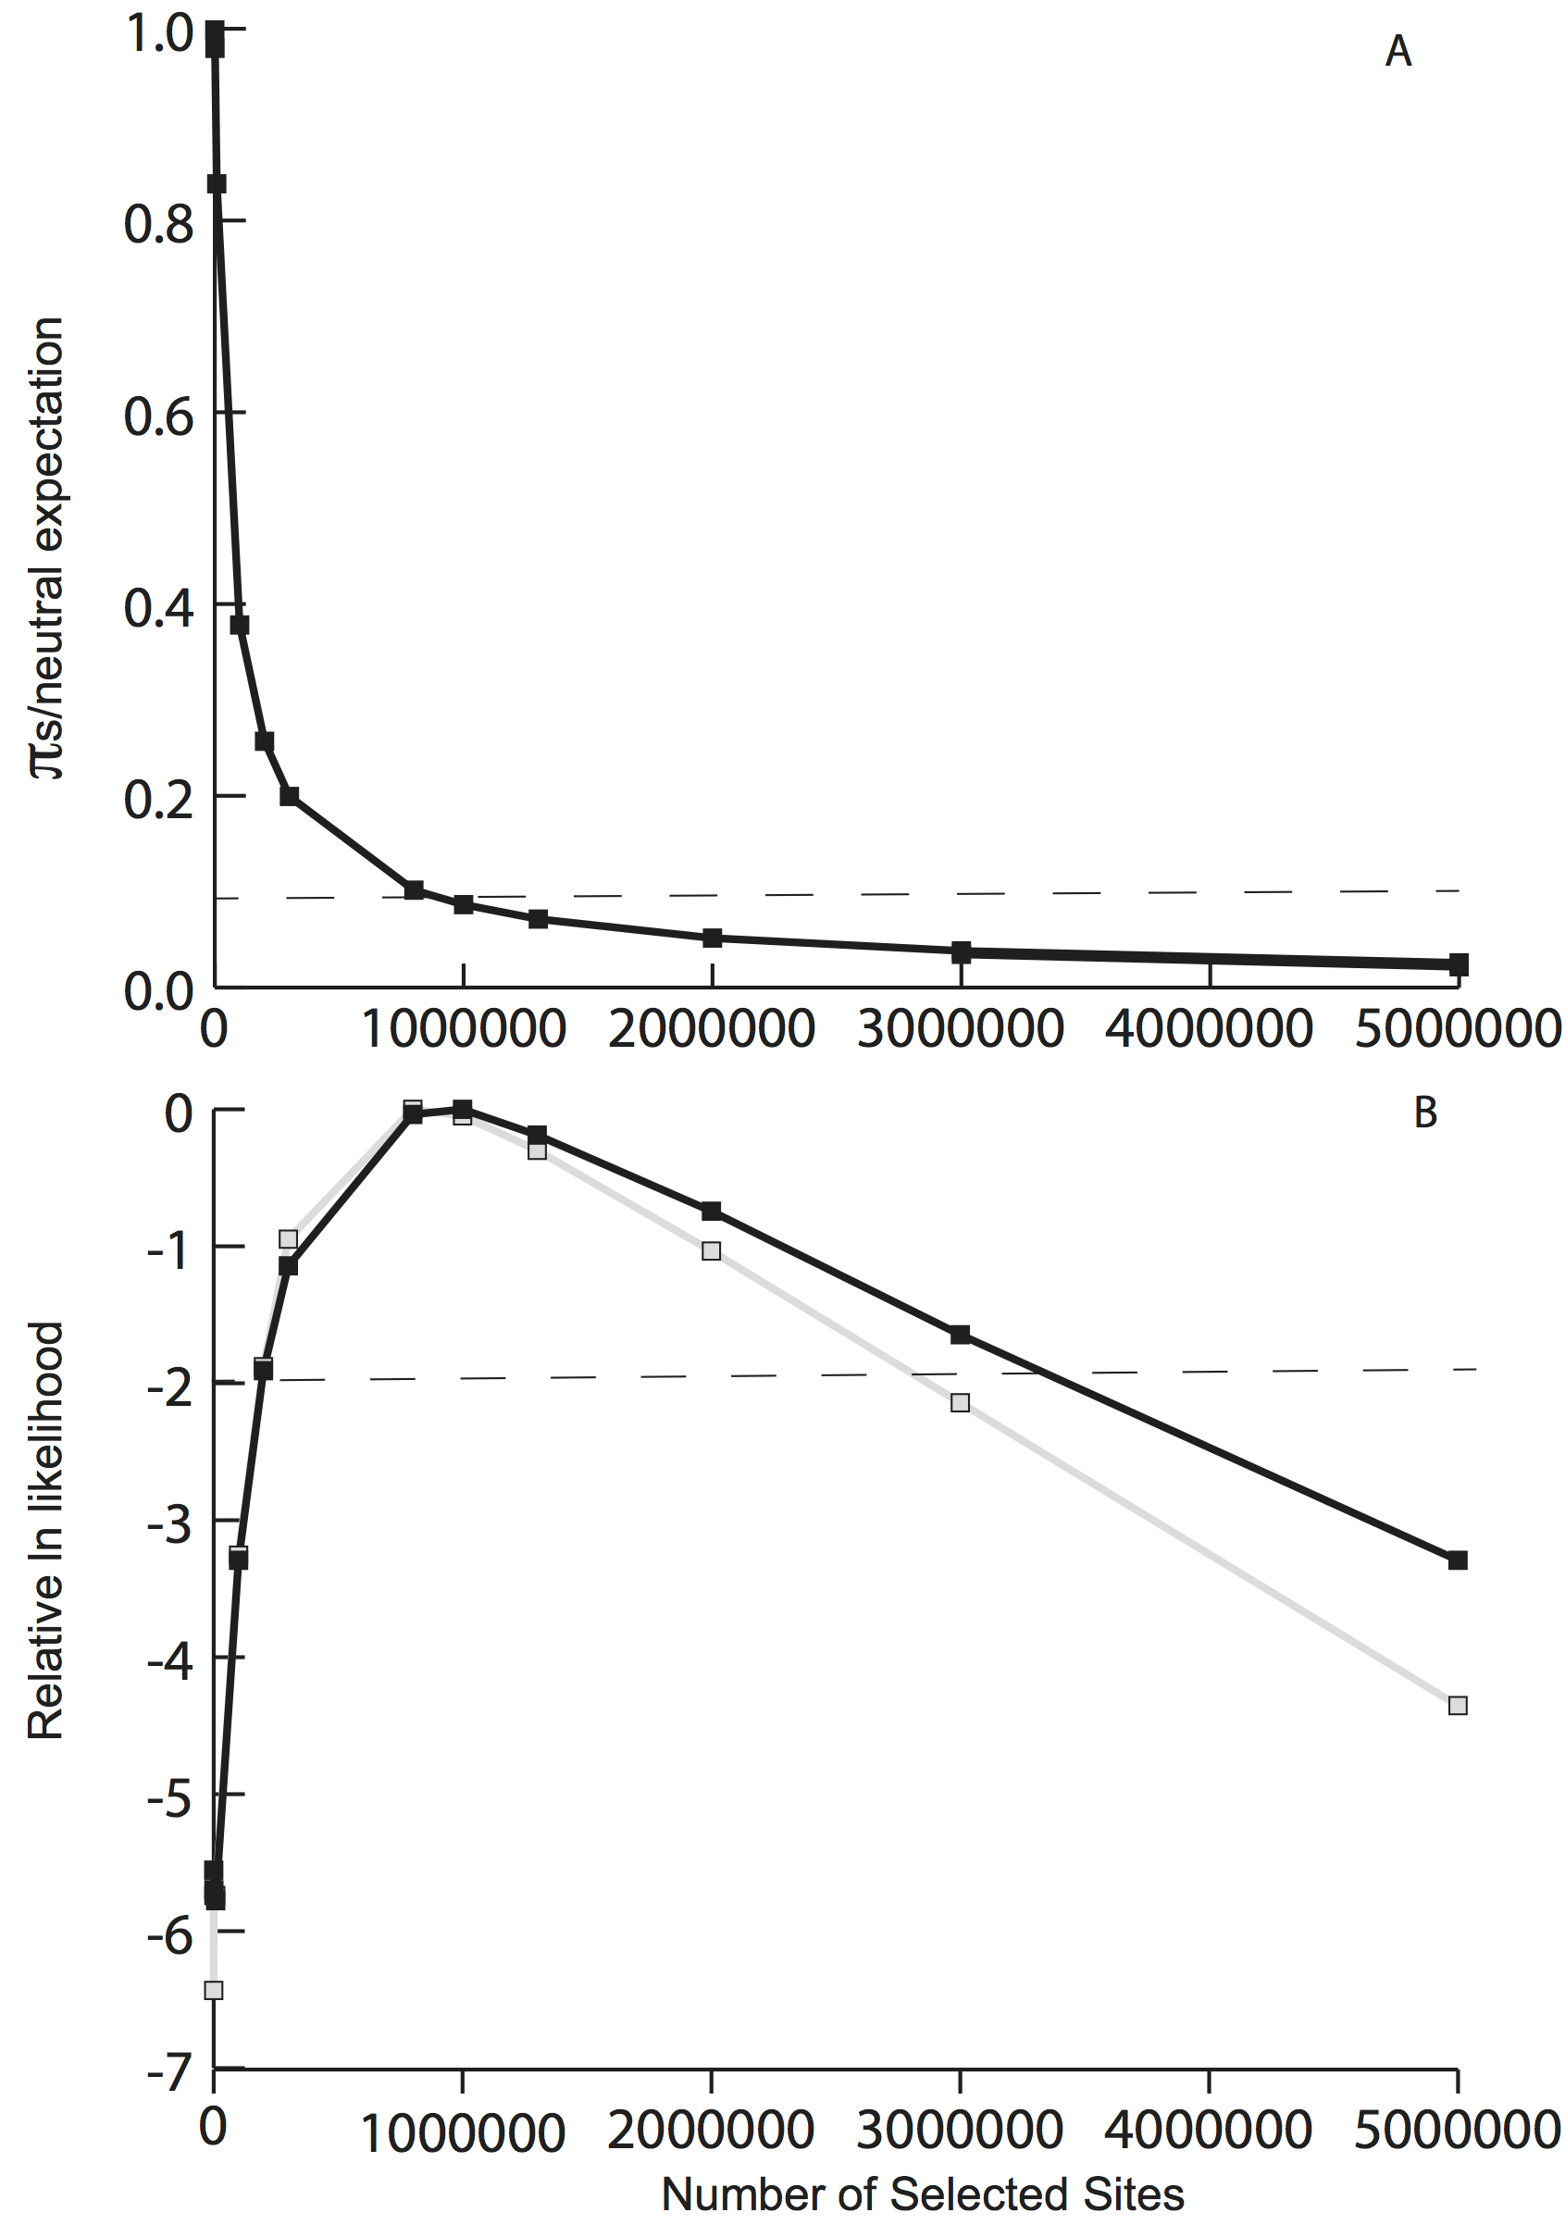

**Figure 4.** Results from forward simulations of purifying selection, varying the number of sites under selection, L. **A:** estimated silent site diversity *πs* relative to the neutral prediction *π*0 as a function of the number of selected sites. The dashed line corresponds to our estimate of diversity loss on the Y chromosome (*πY* ). B: the relative likelihood curve for the number of selected sites, with the dashed line reflecting the approximate 95% credibility interval. Black line: likelihood surface for the observed *πs*; gray line, likelihood surface for the observed number of segregating sites and number of singletons.

Importantly, BGS assumes independence among sites, and the theory breaks down when many linked sites are subject to selection at the same time. This is because high linkage disequilibrium causes the behavior of selected alleles to interfere with the action of selection at linked sites [(McVean and Charlesworth 2000; Comeron and Kreitman 2002; Kaiser and Charlesworth 2009; Good et al. 2014)](https://paperpile.com/c/N4uYXf/NMuOb+hVh3p+vfe1D+Mi2iu). As there are no analytical formulae for predicting the outcome of selection on many linked alleles experiencing selection and drift, however, simulations are fundamental to understanding such selective interference in realistic situations [(McVean and Charlesworth 2000; Comeron and Kreitman 2002;](https://paperpile.com/c/N4uYXf/NMuOb+hVh3p+vfe1D+Mi2iu) [Comeron et al. 2007](https://paperpile.com/c/N4uYXf/IZAOx); [Kaiser and Charlesworth 2009; Good et al. 2014](https://paperpile.com/c/N4uYXf/NMuOb+hVh3p+vfe1D+Mi2iu)). We therefore conducted forward simulations of purifying selection using our estimated parameters for the distribution of fitness effects of deleterious mutations, and tested whether interference selection could result in a level of Y-diversity at neutral sites similar to the level we observed. Using simulations with the estimate of the distribution of deleterious fitness effects and the independently estimated number of sites under selection from cytological and transcriptome data (L=1.3 MB), we find that our observed loss of diversity fits very well with this model of linked purifying selection (Figure 2, Figure 3A). This suggests that purifying selection on our estimated number of constrained sites can explain the observed reduction in neutral diversity on the Y chromosome.

While these simulations suggest a strong fit between the observed and expected loss of diversity under this model of purifying selection alone, we can also explore more broadly the range of possible values of L that are consistent with our data, by varying this parameter in simulated datasets. Under a model of purifying selection, our maximum likelihood estimate of the number of selected sites, *L* is large (~ 1 MB), close to our independent estimate (1.3 MB), and may be as large as approximately 3 MB (Figure 4). We obtain similar conclusions when we fit the data to a summary of the site frequency spectrum (Figure 4B, gray line). Thus, these results are consistent with the hypothesis that the early stages of Y degeneration are characterized by the persistence of a large number of sites subject to purifying selection.

Although our analyses of purifying selection models are consistent with our observed reduction in Y-linked diversity, it is also possible that beneficial mutations have contributed to diversity loss. Adding a fraction of positively selected sites to the model with the independently estimated number of constrained sites (1.3MB) reduces the likelihood (FIgure 3B), suggesting that if our estimation of the number of constrained sites is accurate, a model with purifying selection alone is most consistent with the observed data. On the other hand, if there are in fact fewer constrained sites than estimated, models incorporating a non-trivial fraction of positively selection sites become more plausible (Figure 5). However, the most likely parameter space includes models with no beneficial mutations, and so there is not strong statistical support for a role for beneficial mutations. Overall, our observed loss of diversity is consistent with an important role for linked selection, with either the effects of purifying selection alone and/or the combined effects with positive selection driving the loss of diversity on the Y chromosome.

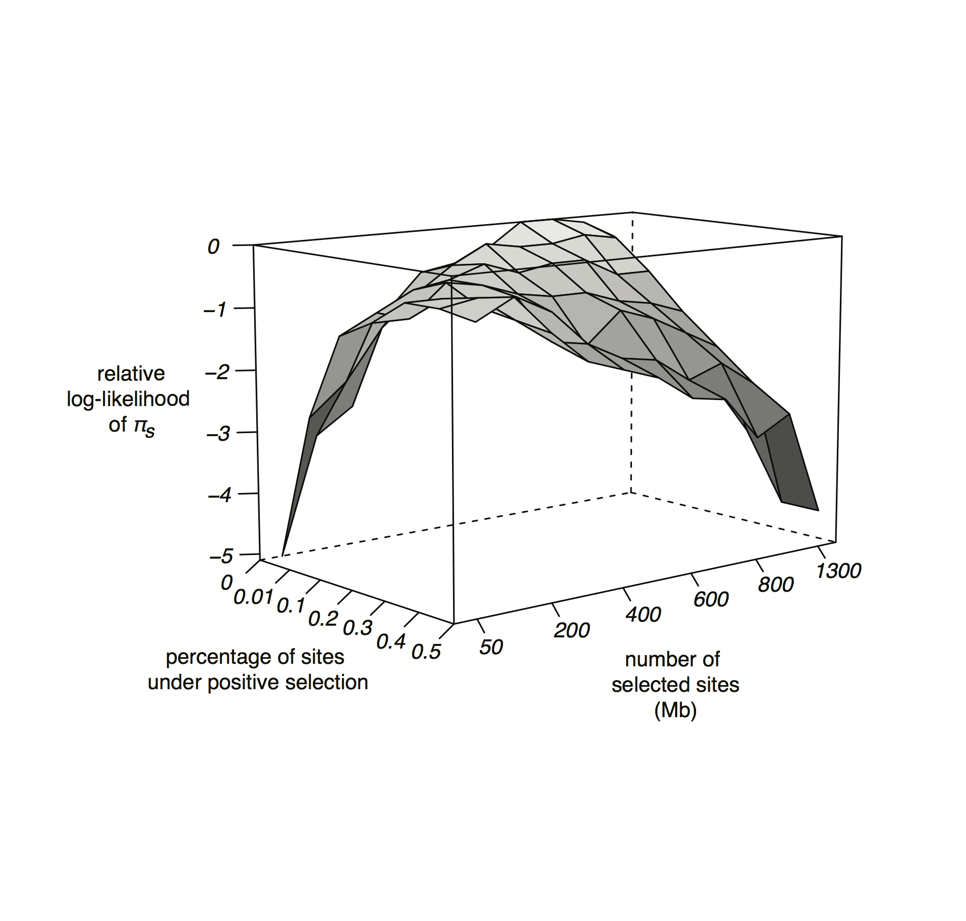

**Figure 5.** Relative ln-likelihood of *πs* as a function of the number of selected sites and the proportion of sites subject to positive selection from forward simulations. Simulations shown using mean strength of both positive and negative selection to be Ns=128.

One important caveat to our conclusions is that we have not considered the possible effects of background selection and selective sweeps in the recombining regions of the X chromosome and autosomes. Studies in a number of taxa, particularly in humans and maize [(Hammer et al. 2010; Beissinger et al. 2016)](https://paperpile.com/c/N4uYXf/ALLE7+oCTOM), have shown that diversity on recombining chromosomes increases as a function of distance from genes, likely due to the increasing effects of linked selection near regions with a high density of functional sites. Since the non-recombining Y chromosome will not experience this escape from hitchhiking away from genes, our conclusion about diversity loss on the Y may be conservative, and the true loss of diversity may be more extreme in unconstrained regions. In particular, if genome structure and selection parameters in *Rumex* are comparable to humans, we would predict the most gene-rich regions of recombining chromosomes to experience an approximately 60% reduction in diversity [(McVicker et al. 2009)](https://paperpile.com/c/N4uYXf/09yq9), implying that our ratio of Y-linked to autosomal diversity in unconstrained regions may be as low as 0.011, in comparison to the ratio of 0.018 estimated here. While this may imply even stronger effects of background selection and selective sweeps than inferred here, we note that correcting for this may provide an even better fit to the purifying selection model with our independently estimated number of selected sites (Figure 3). Future work integrating whole genome polymorphism analyses and estimates of the number of selected sites will enable examination of this possibility, to test whether the ratio of both Y/A and X/A diversity changes as a function of distance from genes [(Hammer et al. 2010)](https://paperpile.com/c/N4uYXf/ALLE7).

Using our observed loss of diversity on the Y chromosome, we can ask whether the inferred reduction in the effective population size explains our signal of reduced selection efficacy we observed on the Y compared with the X in Hough *et al*. (2014). In particular, our previous work revealed a 2.57-fold increase in the rate of nonsynonymous relative to synonymous divergence. To address the rate of increased divergence expected on the Y, we can use our estimated DFE of deleterious mutations from the X chromosome data. In particular, the inferred DFE on the X implies that 15.7 % of nonsynonymous sites have a strength of selection (Ns) <1, and are in the nearly neutral zone. If we use the estimated shape of the gamma distribution from the X, and take the observed reduction in diversity on the Y relative to the X of 0.021 to readjust the expected mean *Ns* for this chromosome, we predict that the Y chromosome should have 42.4% of mutations as effectively neutral. Thus, we expect a 2.7-fold increase in the fraction of effectively neutral deleterious mutations, which is very close to our observed increase of 2.57 in *dN/dS*. This provides further evidence to suggest that selective interference, rather than relaxed selection *per se*, is the primary factor driving Y chromosome degeneration in *Rumex*.

**Conclusions**

The non-recombining region of a Y chromosome produces evolutionary dynamics that are similar to a haploid asexual population, with the lack of recombination resulting in a build up of genetic associations among selected sites, a loss in the efficiency of selection, and an increase in the variance of population fitness [(Fisher 1930; Muller 1964; Hill and Robertson 1966; McVean and Charlesworth 2000; Comeron and Kreitman 2002; Kaiser and Charlesworth 2009; Good et al. 2014)](https://paperpile.com/c/N4uYXf/CniCq+wTEiI+Od5Oy+vfe1D+hVh3p+NMuOb+Mi2iu). Our study of neutral diversity levels on the relatively young *R. hastatulus* sex chromosomes provides clear evidence for an extensive loss of neutral diversity on the Y chromosome. Whereas neutral models of sex-biased demography were unable to explain the magnitude of diversity loss, forward population genetic simulations suggest that the extensive loss of diversity is most likely due to purifying selection, with a possible role for positive selection. While standard background selection theory over-predicted the loss of diversity on the Y chromosome, simulations of purifying selection acting over a large number of linked selected sites resulted in a level of Y-diversity that was similar to what we observed. Our results are therefore consistent with theory on interference selection, and suggest that the effects of interference is likely an important force in the evolution of young Y chromosomes. Moreover, our results imply that when a large number of linked sites are subject to purifying selection, early stages of Y-chromosome degeneration may largely be driven by the effects of interference rather than by widespread silencing of Y-linked genes and their subsequent degeneration through neutral drift.

**Acknowledgments**

We thank Felix Beaudry for providing genomic coverage data for quality filtering. This research was funded by Discovery grants to SCHB and SIW from the Natural Sciences and Engineering Research Council of Canada, and by an OGS scholarship to JH.

**References**

[Bachtrog, D. 2008. The temporal dynamics of processes underlying Y chromosome degeneration. Genetics 179:1513–1525.](http://paperpile.com/b/N4uYXf/rJdBv)

[Bachtrog, D. 2013. Y-chromosome evolution: emerging insights into processes of Y-chromosome degeneration. Nat. Rev. Genet. 14:113–124.](http://paperpile.com/b/N4uYXf/U4pni)

[Bachtrog, D., and P. Andolfatto. 2006. Selection, recombination and demographic history in *Drosophila miranda*. Genetics 174:2045–2059.](http://paperpile.com/b/N4uYXf/3SMV3)

[Bansal, V., and V. Bafna. 2008. HapCUT: an efficient and accurate algorithm for the haplotype assembly problem. Bioinformatics 24:i153–9.](http://paperpile.com/b/N4uYXf/buDh4)

[Barton, N. H. 1995. A general model for the evolution of recombination. Genet. Res. 65:123–145.](http://paperpile.com/b/N4uYXf/N7so8)

[Beissinger, T. M., L. Wang, K. Crosby, A. Durvasula, M. B. Hufford, and J. Ross-Ibarra. 2016. Recent demography drives changes in linked selection across the maize genome. Nat Plants 2:16084.](http://paperpile.com/b/N4uYXf/oCTOM)

[Bergero, R., S. Qiu, and D. Charlesworth. 2015. Gene loss from a plant sex chromosome system. Curr. Biol. 25:1234–1240.](http://paperpile.com/b/N4uYXf/AqGhr)

[Bull, J. J.. 1983. Evolution of sex determining mechanisms. The Benjamin/Cummings Publishing Company, Inc.](http://paperpile.com/b/N4uYXf/vRr5K)

[Bustamante, C. D., and S. Ramachandran. 2009. Evaluating signatures of sex-specific processes in the human genome. Nat. Genet. 41:8–10.](http://paperpile.com/b/N4uYXf/sXvh3)

[Caballero, A. 1995. On the effective size of populations with separate sexes, with particular reference to sex-linked genes. Genetics 139:1007–1011.](http://paperpile.com/b/N4uYXf/acMVj)

[Canty, A., and B. Ripley. 2012. boot: Bootstrap R (S-Plus) functions. R package version 1.](http://paperpile.com/b/N4uYXf/Nq7ux)

[Charlesworth, B. 2002. Effective population size. Curr. Biol. 12:R716–7.](http://paperpile.com/b/N4uYXf/Mm8WH)

[Charlesworth, B. 1978. Model for evolution of Y chromosomes and dosage compensation. Proc. Natl. Acad. Sci. U. S. A. 75:5618–5622.](http://paperpile.com/b/N4uYXf/YKwsW)

[Charlesworth, B. 1996. The evolution of chromosomal sex determination and dosage compensation. Curr. Biol. 6:149–162.](http://paperpile.com/b/N4uYXf/6ybp0)

[Charlesworth, B. 1991. The evolution of sex chromosomes. Science 251:1030–1033.](http://paperpile.com/b/N4uYXf/ikuVx)

[Charlesworth, B., M. T. Morgan, and D. Charlesworth. 1993. The effect of deleterious mutations on neutral molecular variation. Genetics 134:1289–1303.](http://paperpile.com/b/N4uYXf/fY5eF)

[Charlesworth, B., M. Nordborg, and D. Charlesworth. 1997. The effects of local selection, balanced polymorphism and background selection on equilibrium patterns of genetic diversity in subdivided populations. Genet. Res. 70:155–174.](http://paperpile.com/b/N4uYXf/3sHtw)

[Charlesworth, D. 2015. Plant contributions to our understanding of sex chromosome evolution. New Phytol. 208:52–65.](http://paperpile.com/b/N4uYXf/qy7Xo)

[Comeron, J. M. 2014. Background selection as baseline for nucleotide variation across the *Drosophila* genome. PLoS Genet. 10:e1004434.](http://paperpile.com/b/N4uYXf/VEEpP)

[Comeron, J. M., and T. B. Guthrie. 2005. Intragenic Hill-Robertson interference influences selection intensity on synonymous mutations in *Drosophila*. Mol. Biol. Evol. 22:2519–2530.](http://paperpile.com/b/N4uYXf/PsxZa)

[Comeron, J. M., and M. Kreitman. 2002. Population, evolutionary and genomic consequences of interference selection. Genetics 161:389–410.](http://paperpile.com/b/N4uYXf/Mi2iu)

[Comeron, J. M., A. Williford, and R. M. Kliman. 2007. The Hill–Robertson effect: evolutionary consequences of weak selection and linkage in finite populations. Heredity 100:19–31.](http://paperpile.com/b/N4uYXf/IZAOx)

[Cotter, D. J., S. M. Brotman, and M. A. Wilson Sayres. 2016. Genetic diversity on the human x chromosome does not support a strict pseudoautosomal boundary. Genetics 203:485–492.](http://paperpile.com/b/N4uYXf/FkvgU)

[Crowson, D., S. C. H. Barrett, and S. I. Wright. 2017. Purifying and positive selection influence patterns of gene loss and gene expression in the evolution of a plant sex chromosome system. Mol. Biol. Evol. 34:1140–1154.](http://paperpile.com/b/N4uYXf/cx0C)

[del Bosque, M. E. Q., R. Navajas-Pérez, J. L. Panero, A. Fernández-González, and M. A. Garrido-Ramos. 2011. A satellite DNA evolutionary analysis in the North American endemic dioecious plant *Rumex hastatulus* (Polygonaceae). Genome 54:253–260.](http://paperpile.com/b/N4uYXf/DG65w)

[Efron, B. 1987. Better Bootstrap Confidence Intervals. J. Am. Stat. Assoc. 82:171–185.](http://paperpile.com/b/N4uYXf/zopq6)

[Efron, B., and R. J. Tibshirani. 1994. An Introduction to the Bootstrap. CRC Press.](http://paperpile.com/b/N4uYXf/Tqe9h)

[Ellegren, H. 2009. The different levels of genetic diversity in sex chromosomes and autosomes. Trends Genet. 25:278–284.](http://paperpile.com/b/N4uYXf/ovPpp)

[Eshel, I., and M. W. Feldman. 1970. On the evolutionary effect of recombination. Theor. Popul. Biol. 1:88–100.](http://paperpile.com/b/N4uYXf/NT0JO)

[Feldman, M. W., F. B. Christiansen, and L. D. Brooks. 1980. Evolution of recombination in a constant environment. Proc. Natl. Acad. Sci. U. S. A. 77:4838–4841.](http://paperpile.com/b/N4uYXf/E19tK)

[Field, D. L., M. Pickup, and S. C. H. Barrett. 2013. Comparative analyses of sex-ratio variation in dioecious flowering plants. Evolution 67:661–672. Wiley Online Library.](http://paperpile.com/b/N4uYXf/acehU)

[Fisher, R. A. 1930. The genetical theory of natural selection. OUP Oxford.](http://paperpile.com/b/N4uYXf/CniCq)

[Good, B. H., A. M. Walczak, R. A. Neher, and M. M. Desai. 2014. Genetic diversity in the interference selection limit. PLoS Genet. 10:e1004222.](http://paperpile.com/b/N4uYXf/NMuOb)

[Grabowska-Joachimiak, A., A. Kula, T. Książczyk, J. Chojnicka, E. Sliwinska, and A. J. Joachimiak. 2015. Chromosome landmarks and autosome-sex chromosome translocations in *Rumex hastatulus,* a plant with XX/XY1Y2 sex chromosome system. Chromosome Res. 23:187–197.](http://paperpile.com/b/N4uYXf/9NZlM)

[Haas, B. J., A. L. Delcher, S. M. Mount, J. R. Wortman, R. K. Smith Jr, L. I. Hannick, R. Maiti, C. M. Ronning, D. B. Rusch, C. D. Town, *et al.* 2003. Improving the *Arabidopsis* genome annotation using maximal transcript alignment assemblies. Nucleic Acids Res. 31:5654–5666.](http://paperpile.com/b/N4uYXf/5iLwN)

[Hammer, M. F., A. E. Woerner, F. L. Mendez, J. C. Watkins, M. P. Cox, and J. D. Wall. 2010. The ratio of human X chromosome to autosome diversity is positively correlated with genetic distance from genes. Nat. Genet. 42:830–831.](http://paperpile.com/b/N4uYXf/ALLE7)

[Hernandez, R. D. 2008. A flexible forward simulator for populations subject to selection and demography. Bioinformatics 24:2786–2787.](http://paperpile.com/b/N4uYXf/3J60J)

[Hill, W. G., and A. Robertson. 1966. The effect of linkage on limits to artificial selection. Genet. Res. 8:269–294.](http://paperpile.com/b/N4uYXf/Od5Oy)

[Hough, J., J. D. Hollister, W. Wang, S. C. H. Barrett, and S. I. Wright. 2014. Genetic degeneration of old and young Y chromosomes in the flowering plant *Rumex hastatulus*. Proc. Natl. Acad. Sci. U. S. A. 111:7713–7718.](http://paperpile.com/b/N4uYXf/WQfC)

[Hough, J., S. Immler, S. C. H. Barrett, and S. P. Otto. 2013. Evolutionarily stable sex ratios and mutation load. Evolution 67:1915–1925.](http://paperpile.com/b/N4uYXf/qfGqx)

[Hudson, R. R., and N. L. Kaplan. 1995. Deleterious background selection with recombination. Genetics 141:1605–1617.](http://paperpile.com/b/N4uYXf/OKQCt)

[Kaiser, V. B., and B. Charlesworth. 2009. The effects of deleterious mutations on evolution in non-recombining genomes. Trends Genet. 25:9–12.](http://paperpile.com/b/N4uYXf/hVh3p)

[Keightley, P. D., J. L. Campos, T. R. Booker, and B. Charlesworth. 2016. Inferring the frequency spectrum of derived variants to quantify adaptive molecular evolution in protein-coding genes of *Drosophila melanogaster*. Genetics 116.188102.](http://paperpile.com/b/N4uYXf/lWaCw)

[Keightley, P. D., and A. Eyre-Walker. 2007. Joint inference of the distribution of fitness effects of deleterious mutations and population demography based on nucleotide polymorphism frequencies. Genetics 177:2251–2261.](http://paperpile.com/b/N4uYXf/oTiEN)

[Kimura, M., and J. F. Crow. 1964. The number of alleles that can be maintained in a finite population. Genetics 49:725–738.](http://paperpile.com/b/N4uYXf/9BUEj)

[Kim, Y., and W. Stephan. 2000. Joint effects of genetic hitchhiking and background selection on neutral variation. Genetics 155:1415–1427.](http://paperpile.com/b/N4uYXf/TVrTD)

[Lahn, B. T., and D. C. Page. 1999. Four evolutionary strata on the human X chromosome. Science 286:964–967.](http://paperpile.com/b/N4uYXf/H1RvL)

[Laporte, V., and B. Charlesworth. 2002. Effective population size and population subdivision in demographically structured populations. Genetics 162:501–519.](http://paperpile.com/b/N4uYXf/i4BuT)

[Li, H., and R. Durbin. 2010. Fast and accurate long-read alignment with Burrows--Wheeler transform. Bioinformatics 26:589–595.](http://paperpile.com/b/N4uYXf/Suq9a)

[Lunter, G., and M. Goodson. 2011. Stampy: a statistical algorithm for sensitive and fast mapping of Illumina sequence reads. Genome Res. 21:936–939.](http://paperpile.com/b/N4uYXf/VNdQA)

[Mank, J. E. 2009. The W, X, Y and Z of sex-chromosome dosage compensation. Trends Genet. 25:226–233.](http://paperpile.com/b/N4uYXf/ZDq84)

[McAllister, B. F., and B. Charlesworth. 1999. Reduced sequence variability on the Neo-Y chromosome of *Drosophila americana americana*. Genetics 153:221–233.](http://paperpile.com/b/N4uYXf/SXfYG)

[McKenna, A., M. Hanna, E. Banks, A. Sivachenko, K. Cibulskis, A. Kernytsky, K. Garimella, D. Altshuler, S. Gabriel, M. Daly, and M. A. DePristo. 2010. The Genome Analysis Toolkit: a MapReduce framework for analyzing next-generation DNA sequencing data. Genome Res. 20:1297–1303.](http://paperpile.com/b/N4uYXf/e8VYG)

[McVean, G. A., and B. Charlesworth. 2000. The effects of Hill-Robertson interference between weakly selected mutations on patterns of molecular evolution and variation. Genetics 155:929–944.](http://paperpile.com/b/N4uYXf/vfe1D)

[McVicker, G., D. Gordon, C. Davis, and P. Green. 2009. Widespread genomic signatures of natural selection in hominid evolution. PLoS Genet. 5:e1000471.](http://paperpile.com/b/N4uYXf/09yq9)

[Muller, H. J. 1964. The relation of recombination to mutational advance. Mutat. Res. 106:2–9.](http://paperpile.com/b/N4uYXf/wTEiI)

[Muyle, A., N. Zemp, C. Deschamps, S. Mousset, A. Widmer, and G. A. B. Marais. 2012. Rapid *de novo* evolution of X chromosome dosage compensation in *Silene latifolia*, a plant with young sex chromosomes. PLoS Biol. 10:e1001308.](http://paperpile.com/b/N4uYXf/HF2Vv)

[Navajas-Perez, R. 2005. The evolution of reproductive systems and sex-determining mechanisms within *Rumex* (Polygonaceae) inferred from nuclear and chloroplastidial sequence data. Mol. Biol. Evol. 22:1929–1939.](http://paperpile.com/b/N4uYXf/JQPHK)

[Nomura, T. 2002. Effective size of populations with unequal sex ratio and variation in mating success. J. Anim. Breed. Genet. 119:297–310..](http://paperpile.com/b/N4uYXf/6kIfM)

[Nordborg, M., B. Charlesworth, and D. Charlesworth. 1996. The effect of recombination on background selection. Genet. Res. 67:159–174.](http://paperpile.com/b/N4uYXf/YRGwo)

[Ohno, S. 1969. Evolution of Sex Chromosomes in Mammals. Annu. Rev. Genet. 3:495–524.](http://paperpile.com/b/N4uYXf/LnTpI)

[Ossowski, S., K. Schneeberger, J. I. Lucas-Lledó, N. Warthmann, R. M. Clark, R. G. Shaw, D. Weigel, and M. Lynch. 2010. The rate and molecular spectrum of spontaneous mutations in A*rabidopsis thaliana*. Science 327:92–94.](http://paperpile.com/b/N4uYXf/a8XH9)

[Otto, S. P., and M. W. Feldman. 1997. Deleterious mutations, variable epistatic interactions, and the evolution of recombination. Theor. Popul. Biol. 51:134–147.](http://paperpile.com/b/N4uYXf/izxx6)

[Papadopulos, A. S. T., M. Chester, K. Ridout, and D. A. Filatov. 2015. Rapid Y degeneration and dosage compensation in plant sex chromosomes. Proc. Natl. Acad. Sci. U. S. A. 112:13021–13026.](http://paperpile.com/b/N4uYXf/2hH4h)

[Pickup, M., and S. C. H. Barrett. 2013. The influence of demography and local mating environment on sex ratios in a wind-pollinated dioecious plant. Ecol. Evol. 3:629–639.](http://paperpile.com/b/N4uYXf/6Ic3G)

[Robinson, J. T., H. Thorvaldsdóttir, W. Winckler, M. Guttman, E. S. Lander, G. Getz, and J. P. Mesirov. 2011. Integrative genomics viewer. Nat. Biotechnol. 29:24–26.](http://paperpile.com/b/N4uYXf/Ku8ej)

[Ross, M. T., D. V. Grafham, A. J. Coffey, S. Scherer, K. McLay, D. Muzny, M. Platzer, G. R. Howell, and C. et al Burrows. 2005. The DNA sequence of the human X chromosome. Nature 434:325–337.](http://paperpile.com/b/N4uYXf/RLSj1)

[Smith, B. W. 1969. Evolution of sex-determining mechanisms in *Rumex*. Chromosomes Today 2:172–182.](http://paperpile.com/b/N4uYXf/slbYQ)

[Smith, B. W. 1955. Sex chromosomes and natural polyploidy in dioecious *Rumex*. J. Hered. 46:226–232. Am Genetic Assoc.](http://paperpile.com/b/N4uYXf/RAnI8)

[Smith, B. W. 1964. The evolving karyotype of *Rumex hastatulus*. Evolution 18:93–104.](http://paperpile.com/b/N4uYXf/oJJlx)

[Smith, B. W. 1963. The Mechanism of Sex Determination in *Rumex hastatulus.* Genetics 48:1265–1288.](http://paperpile.com/b/N4uYXf/FWTbg)

[Smith, J. M., and J. Haigh. 1974. The hitch-hiking effect of a favourable gene. Genet. Res. 23:23–35.](http://paperpile.com/b/N4uYXf/LTeCt)

[Westergaard, M. 1958. The mechanism of sex determination in dioecious flowering plants. Adv. Genet. 9:217–281.](http://paperpile.com/b/N4uYXf/46xQc)

[Wilson Sayres, M. A., K. E. Lohmueller, and R. Nielsen. 2014. Natural selection reduced diversity on human Y chromosomes. PLoS Genet. 10:e1004064.](http://paperpile.com/b/N4uYXf/S6uio)

[Wright, S. 1931. Evolution in Mendelian Populations. Genetics 16:97–159.](http://paperpile.com/b/N4uYXf/cmLjf)

[Wright, S. I., and B. Charlesworth. 2004. The HKA Test Revisited. Genetics 168:1071–1076. Genetics.](http://paperpile.com/b/N4uYXf/m7Vbn)

[Zhou, Q., and D. Bachtrog. 2012. Chromosome-wide gene silencing initiates Y degeneration in *Drosophila*. Curr. Biol. 22:522–525.](http://paperpile.com/b/N4uYXf/w05fm)