**Supporting Information**

**Hill-Robertson Interference Reduced Genetic Diversity on a Young Plant Y-chromosome**

Josh Hough, Wei Wang, Spencer C. H. Barrett, and Stephen I. Wright

Editor: Bret Payseur

Article Type: Genetics of Sex

TOC Subsection Heading: Population and Evolutionary Genetics

Corresponding Author: Josh Hough

Keywords: Deleterious mutations; Interference Selection; Nucleotide diversity; Suppressed recombination

**SI Tables**

**Table S1**. Population identities (ID) and location information for *R. hastatulus* samples

|  |  |  |  |  |
| --- | --- | --- | --- | --- |
| Population ID | Location | Altitude | Latitude | Longitude |
| TX-MTP | Mount Pleasant, Texas | 130 | 33.17453 | 94.98799 |
| OK-RAT | Rattan, Oklahoma | 138 | 34.15755 | 95.41325 |
| TX-LIV | Livingston, Texas | 83 | 30.69947 | 94.79981 |
| LA-DER | De Ridder, Lousiana | 67 | 30.8941 | 93.3143 |
| TX-ATH | Athens, Texas | 145 | 32.18471 | 95.8032 |
| OK-WIL | Willis, Oklahoma | 211 | 33.89663 | 96.83533 |

**SI Figures**

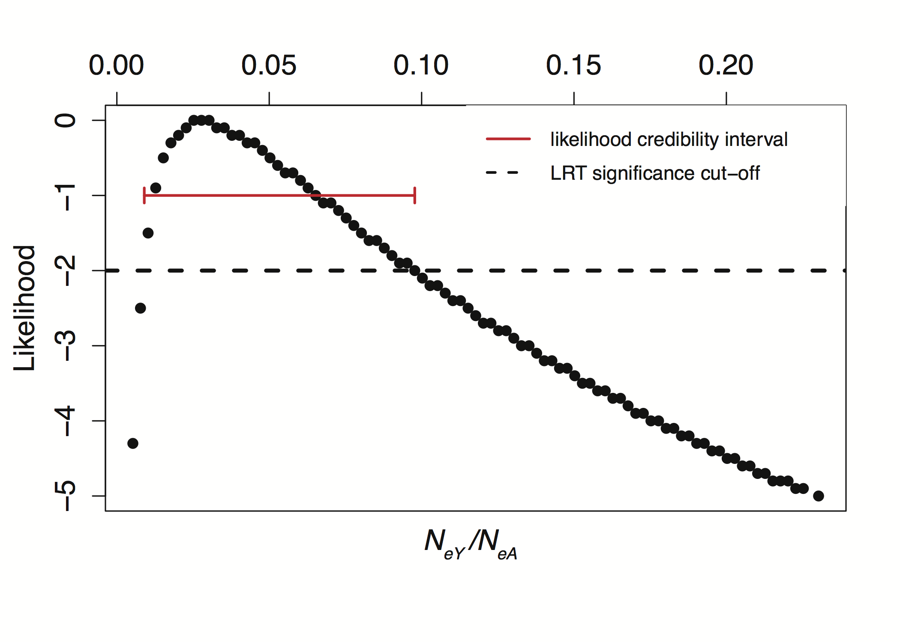

**Figure S1**. Likelihood estimation of the Y/A ratio

**Simulation code**

To study the effects of purifying selection on expected levels of Y-chromosome diversity, we conducted forward-time simulations of haploid Y chromosomes using the software SFS_CODE [(Hernandez 2008)](https://paperpile.com/c/N4uYXf/3J60J). The SFS_CODE source code was obtained from: <http://sfscode.sourceforge.net/SFS_CODE/index/index.html>. Simulation commands for purifying selection and purifying + positive selection are given below.

purifying selection alone

./sfs_code 1 50000 -r 0 -t 0.0011 -P 1 -TE 1 -L 2 45331 $L -a N -W L 1 2 0 1 1 0.258 0.002 -n 6 -N 500 -A

Where we varied $L, the number of sites under selection, over a grid of values from 50000 to 5000000. We ran 50,000 replicate simulations per parameter set.

purifying and positive selection

./sfs_code 1 20000 -r 0 -t 0.0011 -P 1 -TE 1 -L 2 45331 $L -a N -W L 1 2 $p 0.258 0.002 0.258 0.002 -n 6 -N 500 -A

Where we varied $L, the number of sites under selection, over a grid of values from 50000 to 1300000, and $p, the proportion of sites subject to positive selection, from 0 to 0.005 (see Figure 5) and we ran 20,000 replicate simulations per parameter set.