平面分割结果

``原始点数：640x480（307200）
### After filtByVoxelGrid, cloud size: 66280x1.
x_grid_size = 0.005, y_grid_size = 0.005, z_grid_size = 0.005;

### 拟合平面
After filtByStatisticalOutlierRemoval, cloud size: 54808x1.
参数：mean_k = 50, std_dev = 1.0;

经测试，k=5,剩余点数=54808x1。毫无变化。

### 拟合平面结果
Fitting plane ax+by+cz+d=0.
The 4 parames are: 0.00542204, -0.820956, -0.570966, 0.465334

Detected plane: Cloud size: 46680x1
The rest part: Cloud size: 8128x1

### 原图
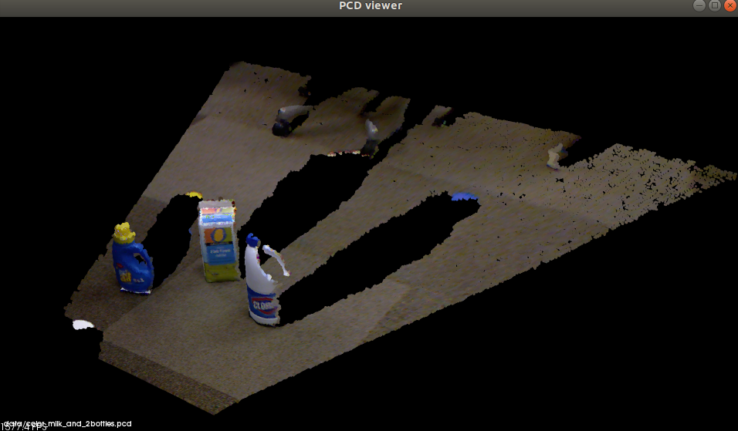
### 平面：
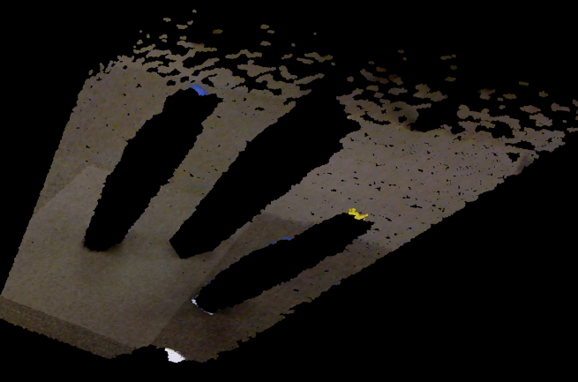
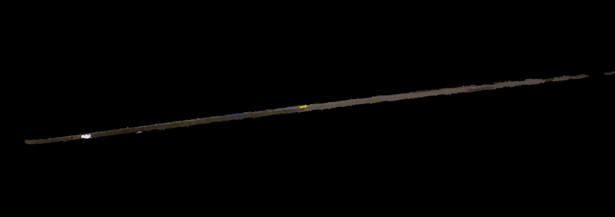
### 剩余部分
