What WSDL is for?
- When you create a service, you typically do it because you want other people to use it.

- In order for them to do that, they need to know what information to send to the service, what information the service is going to send back, and where to find the service in the first place.

- It is much more helpful to have a standard, preferably human- and machine-readable, format for this information.

What is WSDL?

- It is an XML document.

- It used to describe Web services .It specifies:
- The location of the service.
- The operations (or methods) the service exposes.

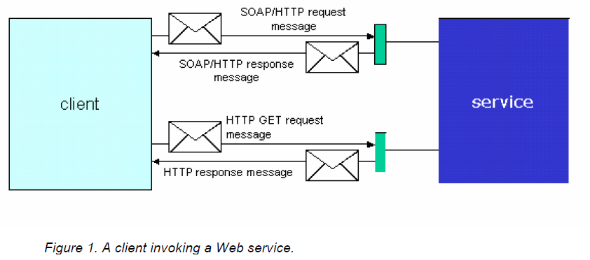

- Web service and a client invoking it in two different ways: Using
- SOAP.
- HTTP GET.

- Each invocation consists of a request and a response message.

The WSDL Document Structure

- Abstract part: describes

- The messages it sends and receives
- The operation associates a message exchange pattern with one or more messages

- Concrete part: specifies

- Transport and wire format details for one or more interfaces.
- A port (an endpoint) associates a network address with a binding.
- A service which groups together endpoints that implement a common interface.

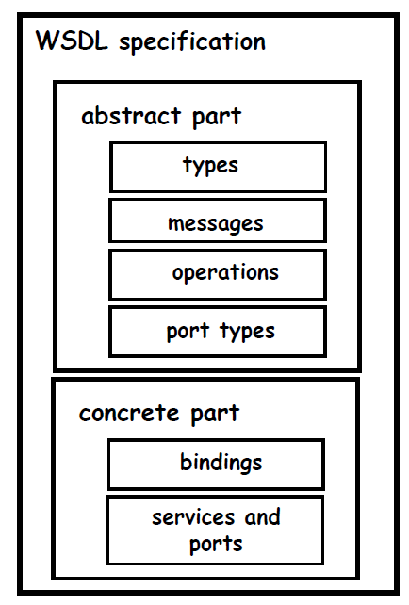

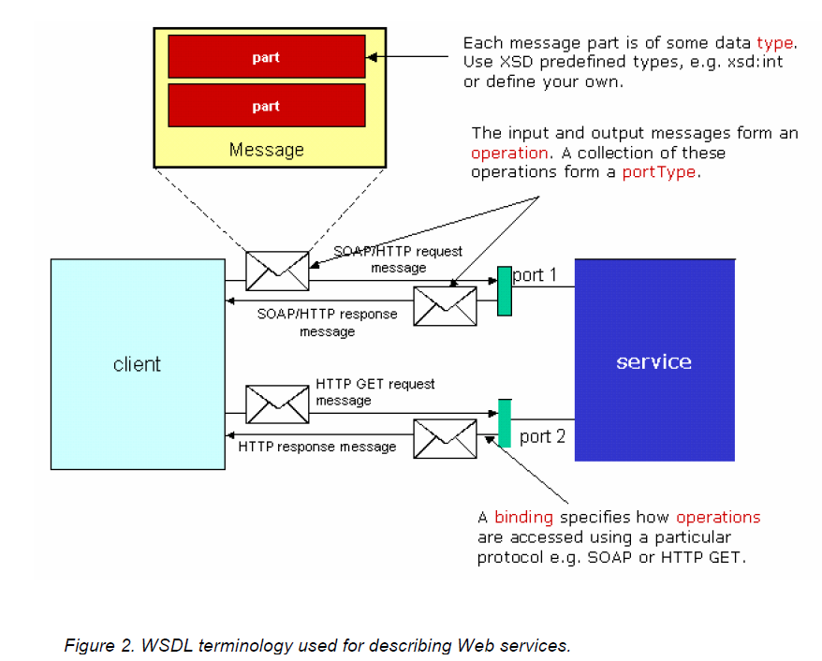

- Types
- Types– containers for data type definitions using some type system (such as XSD).

- The types element encloses data type definitions that are relevant for the exchanged messages.

The class is called Weather and has one method (for now) called GetTemperature:

Public Function GetTemperature(ByVal zipcode As String, _
ByVal celsius As Boolean) As Single
'just sends a harcoded value for now
If celsius Then
GetTemperature = 21.7
Else
GetTemperature = 71.06
End If
End Function

You can think of the class as the Web service and the GetTemperature method as an operation on that service.

To describe this service, you use the WSDL <service> element. All WSDL elements belong to the WSDL namespace, which is defined as:http://schemas.xmlsoap.org/wsdl/

As an example, consider a service that you call weatherservice, the service would be defined using WSDL like this:

<definitions name ='weatherservice'
xmlns='http://schemas.xmlsoap.org/wsdl/'>
<service name='WeatherService' >
……
</service>
</definitions>

- Definition

- The <definitions> element is the root element of the WSDL document.

- Here, we declare the WSDL namespace as the default namespace for the document so all elements belong to this namespace unless they have another namespace prefix.

- Service

- Each service is defined using a service element.

- Inside the service element, you specify the different ports on which this service is accessible.

- Port

- A port specifies the service address, for example, http://localhost/demos/wsdl/devxpert/weatherservice.asp

- The port definition would be like this:

<port name='WeatherSoapPort' binding='wsdlns:WeatherSoapBinding' >
<soap:address location='http://localhost/demos/wsdl/devxpert/weatherservice.asp' />
</port>

- Each port has a unique name and a binding attribute.

- When using SOAP, the port element contains a <soap:address/> element with the actual service address.

- A Web service may be accessible on many ports.

- For this Web service, you would have different ports each one with a different name.

- A Web service does not have to be exposed using SOAP.
For example, if your Web service is exposed via HTTP GET, the port element would contain an <http:address/> element similar to this:

<http:address location="http://localhost/demos/wsdl/devxpert/weatherGET.asp"/>

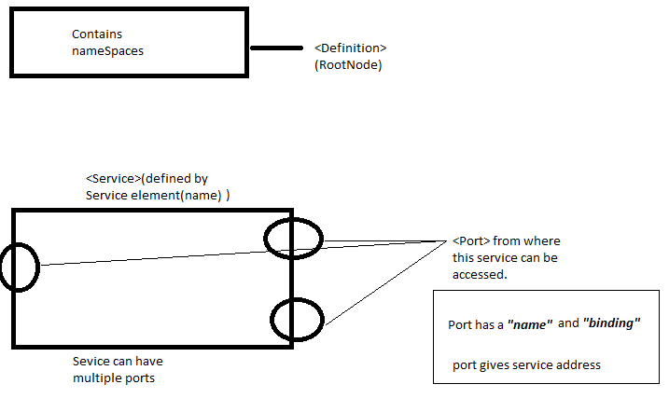

- Message

- A message is protocol independent, that is, a message may be used with SOAP, HTTP GET, or any other protocol.

- There’s the input or request message, which is sent from the client to the service and there’s the output or response message, which is sent back the opposite way.

- When you’re using SOAP, keep in mind that the word message here refers to the payload of the SOAP request or response. That is, the message does not include the SOAP envelope, headers, or fault.

- To describe the message structures, you use the WSDL <message> element.

- Each <message> contains zero or more <part> elements. A <part> corresponds to a parameter or a return value in the RPC call.

- Each <part> must have the same name and data type as the parameter it represents

- A request message sent from client to service and a response message sent back to the client:

<message name='Weather.GetTemperature'>
<part name='zipcode' type='xsd:string'/>
<part name='celsius' type='xsd:boolean'/>
</message>
<message name='Weather.GetTemperatureResponse'>
<part name='Result' type='xsd:float'/>
</message>

- Port Types and Operations

- To define our message as a request and response pair we use <operation> element.
- An operation specifies which message is the input and which message is the output like this:
<operation name='GetTemperature' parameterOrder='zipcode celsius'>
<input message='wsdlns:Weather.GetTemperature' />
<output message='wsdlns:Weather.GetTemperatureResponse' />
</operation>

- The parameterOrder attribute is optional and may be used to specify a space-delimited list of part names to indicate the order of parameters when making the RPC call.

- Inside the <operation> you specify <input> and <output> elements. Each refers to the corresponding message by its fully qualified name, e.g. wsdlns:Weather.GetTemperature.

- The collection of all operations (i.e. methods) exposed by your service is called a portType and is defined using the WSDL <portType> element like this:

<portType name='WeatherSoapPort'>
<operation name='GetTemperature' parameterOrder='zipcode celsius'>
<input message='wsdlns:Weather.GetTemperature' />
<output message='wsdlns:Weather.GetTemperatureResponse' />
</operation>
<!-- other operations would go here -->
</portType>

- So the <operation> element is a child of <portType>. You can call the portType whatever you want.

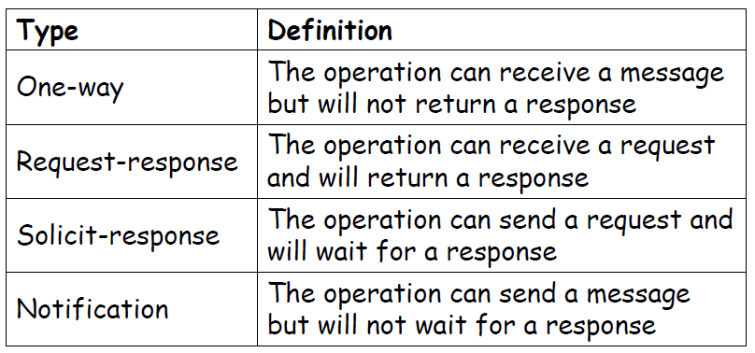

- Binding

- To define the concrete aspects of operations, you use the WSDL <binding> element:

<binding name='WeatherSoapBinding' type='wsdlns:WeatherSoapPort' >
….
</binding>

- The name of the binding can be whatever you want. However, you must use this same name for the binding attribute on the <port> element.

- Inside the <binding> element you have a WSDL SOAP extension element called <soap:binding> which is used to specify the transport protocol you’re using (SOAP can be used over HTTP,SMTP, or possibly any other transport) and the style of request (rpc and document are the two styles). For example:

<soap:binding style='rpc'
transport='http://schemas.xmlsoap.org/soap/http' />

- Then for each operation that this service exposes, you specify the value of the SOAPAction(it is like a function that web service can perform.) HTTP header.

- SOAPAction is an HTTP header that the client sends when it invokes the service.
Transport tells us about the protocol.
- The SOAP server may use this header to determine the service or use it in any other way it needs to. You specify the SOAPAction like this:

<binding name='WeatherSoapBinding' type='wsdlns:WeatherSoapPort' >
<soap:binding style='rpc' transport='http://schemas.xmlsoap.org/soap/http' />
SoapAction tells us about the endpoint to hit
<operation name='GetTemperature' >
<soap:operation
soapAction='http://tempuri.org/action/Weather.GetTemperature' />
....
</operation>
</binding>

- Basically, you add an <operation> element with the same name as the operation you defined earlier.

- Within this <operation> you add a <soap:operation> with the soapAction attribute.

- Finally, as I mentioned earlier, you must specify how the input and output messages of this operation are encoded, the complete binding looks like this:

<binding name='WeatherSoapBinding' type='wsdlns:WeatherSoapPort' >
<soap:binding style='rpc' transport='http://schemas.xmlsoap.org/soap/http' />
<operation name='GetTemperature' >
<soap:operation
soapAction='http://tempuri.org/action/Weather.GetTemperature' />
<input>
<soap:body use='encoded' namespace='http://tempuri.org/message/'
encodingStyle='http://schemas.xmlsoap.org/soap/encoding/' />
</input>
<output>
<soap:body use='encoded' namespace='http://tempuri.org/message/'
encodingStyle='http://schemas.xmlsoap.org/soap/encoding/' />
</output>
</operation>
</binding>

- Within the <operation> you add an <input> and an <output> element and use a <soap:body> element within each to specify how the data is encoded.

- The URI http://schemas.xmlsoap.org/soap/encoding/ indicates the SOAP encoding style as described in the SOAP 1.1 specification. Now the WSDL file is complete and you can start using it from SOAP clients.

