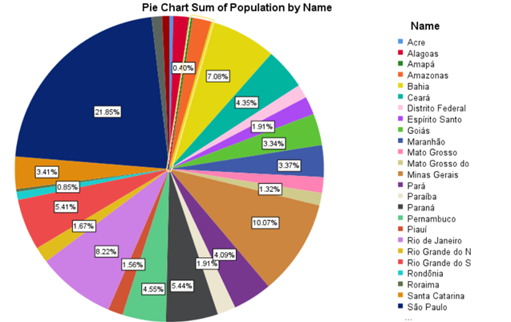

From chart 2 and 3, excluding major states like Rio de Janeiro and Sao Paolo, we can see that the mean

of the sales in Rio Grande Do Sul and Parana have higher sales even though they are less populated than other major states like Bahia.