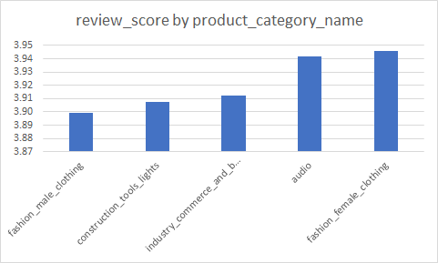

From chart 02 and 03 we observe that we know that Acre and Amapa have similar population distributions but Amapa has almost double the sales. This could be due to the fact that Olist services 21% more of their product categories Amapa.

