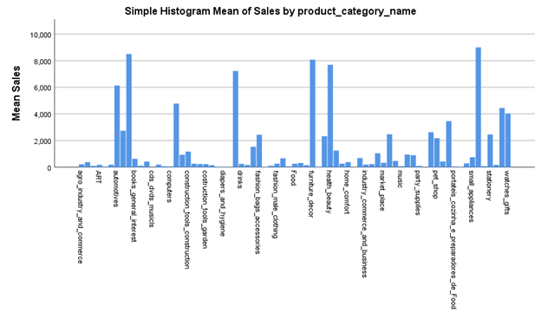

This dataset was found on kaggle titled “Brazilian E-Commerce Public Dataset by Olist”This particular dataset took some degrees of pre-processing. Gathering the data required from 9 sub data files and collect them, arrange them as well as translate them from Portuguese. Also, data about the population distribution in Brazil was collected open source site. MS Excel was mainly used to compile the data as per requirements. The order id uniquely identifying every case.

