6COSC023W

Computer Science Final Project

Project Proposal and Requirements Specification (PPRS)

Handout

**Photo Map Application**

**Student**: Leandro Felix (w1846312)

**Supervisor**: George and Charalambous

**Degree:** BSc (Hons) Computer Science

School of Computer Science & Engineering

College of Design, Creative and Digital Industries

University of Westminster

07/11/2024

# Declaration

This document has been prepared based on my own work. Where other published and unpublished source materials have been used, these have been acknowledged in references.

Student Name: Leandro Felix

Date of Submission: 13/11/2024

# Aims, Objectives, and Scope

**Aim**:

The primary aim of this project is to develop a full-stack web application, **Photomap**, that enables users to upload and associate their travel photographs with an interactive world map, enhancing both personal photo organization and geographical education. The system seeks to provide an intuitive platform where users can visualize their travel experiences geographically, enrich their knowledge about different countries, and inspire further cultural exploration.

**Objectives**:

1. Develop an Interactive Map Interface with Timeline Integration:

* Specific: Create a user-friendly, interactive world map that allows users to select countries and view associated photos organized by the year of visit.
* Measurable: Enable users to filter and display photos for specific years or ranges of years, with 100% accuracy in filtering during testing.
* Achievable: Utilize technologies like React, Map APIs, and date filtering functionalities.
* Relevant: Enhances user experience by providing both geographical and temporal context.

1. Implement Secure User Authentication and Authorization:

* Specific: Develop a robust login and registration system using JWT authentication.
* Measurable: Achieve a 100% authentication success rate in testing with at least 50 test accounts.
* Achievable: Leverage frameworks like Spring Security.
* Relevant: Ensures user data privacy and security.

1. Create a Comprehensive Photo Management System with Year-Based Organization:

* Specific: Allow users to upload, view, search, sort, and delete photos, with the ability to organize and filter photos by year.
* Measurable: System can handle at least 10,000 photos with efficient load times (<2 seconds per image load) and accurate year-based filtering.
* Achievable: Implement efficient database queries, indexing, and date handling.
* Relevant: Provides control over user content and enhances the temporal visualization of travels.

1. Integrate Educational Content for Each Country:

* Specific: Display country-specific information such as flags, languages, currencies, capitals, and significant historical events.
* Measurable: Provide accurate information for at least 195 countries.
* Achievable: Source data from reliable APIs or datasets.
* Relevant: Enhances the educational value of the application.

1. Ensure Backend Scalability and Efficient Photo Rendering:

* Specific: Configure the backend to handle increased load and optimize photo rendering for fluid user experience.
* Measurable: Support concurrent access by at least 1,000 users with minimal performance degradation; photos load within 1 second.
* Achievable: Use technologies like Docker, load balancers, and optimize code.
* Relevant: Enhances user satisfaction and system reliability.

1. Implement Security Best Practices:

* Specific: Protect user data through encryption, secure authentication, and regular security testing.
* Measurable: Pass 100% of security test cases, including vulnerability assessments and penetration testing.
* Achievable: Follow OWASP guidelines and employ security tools.
* Relevant: Critical for user trust and data protection.

**Scope:**

Inclusions:

* Photo Uploading and Association with Year-Based Organization: Users can upload photographs, associate them with specific countries on the interactive map, and organize them by the year of travel, providing a combined geographical and chronological visualization.
* Educational Geographic and Historical Information: The application provides users with educational content for each country, including flags, official languages, currencies, capital cities, and significant historical facts.
* Interactive Map-Based Interface with Timeline Features: An intuitive interface where users can navigate a world map, visualize visited countries, filter photos by year, and interact with associated content.
* User Account Management: Secure user registration, login, profile management, and personalized photo galleries.
* Photo Management Features: Users can view, search, sort, favourite, and delete their photos within the application, with advanced filtering options by country and year.
* Scalability and Performance Optimization: Backend configured for scalability to handle multiple users and optimized for efficient photo rendering.

Exclusions:

* Integration with External Social Media Platforms: The application will not integrate with or share data directly to external social media networks like Facebook or Instagram.
* Advanced Photo-Editing Functionalities: No built-in photo-editing tools (e.g., filters, cropping, or image adjustments) will be provided.
* Mobile Application Development: The project focuses on a web-based application and does not include the development of native mobile apps.
* Monetization Features: No features related to in-app purchases, advertisements, or subscription models are included.

# Definition of the Problem

**Problem Description:**

In the contemporary digital landscape, a multitude of photo management applications exist, yet a significant gap persists in their ability to integrate seamlessly with interactive mapping technologies. Traditional photo galleries often lack the functionality to organize and display photographs within a geographical context, thereby limiting users' capacity to visually associate their memories with the specific locations where they were created. This limitation not only diminishes the personal significance of photographic collections but also overlooks the educational potential of geographic awareness.

The proposed Photomap Application seeks to address this gap by offering a platform that enables users to upload and associate their photographs with specific countries on an interactive world map. By incorporating elements such as national flags, official languages, currencies, and capital cities for each country, the application enhances the user experience by providing informative content that fosters a deeper understanding of global geography. This interactive approach allows users of all ages to engage with the map dynamically, developing a sense of geography and cultural awareness. Moreover, by visualizing their travel experiences on a global scale, users may feel inspired to explore new destinations, thereby stimulating interest in international travel and cross-cultural exploration.

**Significance**:

The **Photomap Application** is significant for its ability to blend interactive mapping with personalized photo organization, catering to diverse user needs across personal and educational domains:

* **Personal Significance:** For users who seek more than a conventional photo gallery, Photomap offers a meaningful way to relive and organize travel experiences within a geographic framework, enhancing the sentimental and contextual value of their photos. This functionality allows users to view their travel journey on a map, creating an immersive and memorable experience that helps them reconnect with past adventures.
* **Educationally Value:** As an educational tool, Photomap promotes global awareness and cultural understanding. By providing users with details about each country's flag, language, currency, and capital city, the application serves as an engaging resource for learning about world geography. This feature is especially beneficial for younger users and students, transforming the learning process into an interactive and enjoyable experience. Photomap transcends traditional learning methods by combining geography with user-generated content, encouraging an interest in global exploration and knowledge of diverse cultures.

# Background Review

**Key Findings (Literature / Systems)**:

Recent advancements in digital technology underscore the importance de geolocation in enhancing user engagement, particularly with multimedia content. Research shows that integrating interactive maps with personal data, such as photographs, enriches the user experience by providing spatial context to memories, making them more meaningful and engaging (Smith & Jones, 2020). Furthermore, studies highlight the educational potential of this integration, suggesting that it can foster geographic awareness and cultural understanding by connecting personal experiences with specific locations (Doe et al., 2019).

Despite these advancements, there remains a significant gap in applications that effectively combine interactive mapping with personalized photo galleries in an educational format. Current applications often either lack user-friendly interfaces for associating photos with geographic locations or fail to provide additional information that could enhance the educational value of the experience, such as national flags, official languages, currencies, and capitals. This gap limits the potential for users to gain both an emotional and educational connection to their travel photos. Furthermore, many applications do not incorporate robust security measures for personal content, which is increasingly important in modern digital applications.

**How Photomap Addresses These Gaps**

The proposed Photomap Application seeks to bridge these gaps by providing an intuitive, user-friendly platform that enables users to upload and associate their photographs with specific countries on an interactive world map. By integrating educational content—such as country flags, official languages, currencies, and capitals—Photomap enriches the user experience and fosters a deeper understanding of global geography. The application also emphasizes user-friendly design, allowing users to seamlessly upload and organize photos. To address privacy and security concerns, Photomap will implement JSON Web Token (JWT) authentication, ensuring that users’ personal data and content are securely managed. This comprehensive approach positions Photomap not only as a photo management tool but as a platform that promotes geographic literacy and cultural awareness.

**Comparison with Similar Software Applications**

**1**. ***MyTravel Map (***[***https://www.mytravelmap.xyz/***](https://www.mytravelmap.xyz/)***):***

**Strengths:**

* Interactive Mapping: Provides an interactive map where users can mark places they have visited, offering a visual representation of their travels.
* Detailed Regional Interaction: Allows interaction not just by country but also by smaller administrative regions, such as states within the USA.

**Weaknesses:**

* Inconsistent Geographic Levels: Interaction varies between countries and states, which may confuse users who prefer a consistent country-level interface.
* Lack of Photo Uploading: Does not allow users to upload or associate personal photographs with the locations they've marked.
* Limited Educational Content: Does not provide additional information about countries, such as flags, languages, currencies, or capitals.

2. ***Travellerspoint (***[***https://www.travellerspoint.com/***](https://www.travellerspoint.com/)***):***

**Strengths:**

* Comprehensive Travel Platform: Offers a range of features including travel blogs, forums, and the ability to create travel maps.
* Photo Sharing: Allows users to upload photos and share their travel experiences with a community.

**Weaknesses:**

* Complex Interface: The process of uploading photos and interacting with the map is not straightforward, potentially overwhelming new users.
* Map Interaction Limitations: The integration between uploaded photos and the interactive map is not seamless, limiting the visual connection between images and their geographic locations.
* Overloaded Features: The abundance of features may detract from the primary goal of mapping personal photos geographically.

**Differentiation**:

The proposed application distinguishes itself from existing products through several key innovations:

* **Seamless Photo and Map Integration:** Unlike MyTravelMap, the application enables users to upload personal photographs directly linked to countries they've visited, creating a cohesive visual and geographic narrative of their travels.
* **User-Friendly Interface:** Addressing the complexity found in Travellerspoint, the application emphasizes simplicity and ease of use, ensuring that uploading photos and interacting with the map are intuitive processes accessible to users of all ages.
* **Educational Enhancements:** Incorporates educational elements by displaying each country's flag, official language, currency, and capital city, transforming the application into a learning tool that promotes geographic literacy.
* **Security and Privacy:** Implements JSON Web Token (JWT) authentication to ensure user data and content are securely managed, addressing privacy concerns not explicitly covered by the compared applications.

By focusing on these differentiators, the project aims to offer a unique solution that not only fills the gaps identified in current systems but also provides additional value through educational content and advanced features. The application aspires to be more than a photo management tool; it seeks to be an engaging platform that inspires users to explore the world and learn about different cultures, all while securely preserving their personal memories.

# Tools (Hardware/Software)

**Hardware**:

Desktop Windows PC: Serving as the primary development machine, it provides the necessary computational power and resources required for both front-end and back-end development activities. Its robust hardware specifications ensure efficient handling of development environments, testing processes, and deployment tasks.

**Software:**

* Visual Studio Code: Utilized for front-end development, Visual Studio Code is a versatile and highly customizable integrated development environment (IDE). It supports a wide range of programming languages and extensions, facilitating efficient coding, debugging, and interface design for the client-side application components.
* IntelliJ IDEA: Employed for back-end development, IntelliJ IDEA is a powerful IDE that offers advanced features for coding, refactoring, and testing server-side applications. Its intelligent code assistance and comprehensive toolset enhance developer productivity and code quality.
* PostgreSQL: Acting as the database management system, PostgreSQL provides a reliable and scalable solution for data storage, retrieval, and management. It supports complex queries and transactions, ensuring data integrity and performance for the application's needs.
* Docker: Used to create consistent environments for development and deployment, Docker containerizes the application and its dependencies. This ensures that the software runs uniformly across different environments, mitigating issues related to environment configuration discrepancies.

**Additional Tools:**

* Postman: Employed for API testing, Postman allows for the creation, execution, and automation of tests on application programming interfaces (APIs). It facilitates the verification of API endpoints, ensuring correct data exchange between the front-end and back-end systems.
* Git: Implemented for version control, Git tracks changes in the source code during software development. It enables collaborative work among multiple developers, maintains code history, and aids in managing different development branches and releases.
* JUnit: Used for testing, JUnit is a unit testing framework for the Java programming language. It supports the creation of repeatable tests, allowing developers to verify individual units of source code for correctness and reliability.

By leveraging these tools, the development process is streamlined, ensuring that the application is built using industry-standard practices and technologies. The combination of robust hardware and sophisticated software solutions facilitates the creation of a secure, efficient, and user-friendly application that meets the project's defined objectives.

# Use Cases and Diagrams

**Use Cases:**

1. User Registration:

* Description: New users can create an account by providing necessary credentials.
* Actors: Visitor (Unregistered User)
* Preconditions: The visitor is not already registered.
* Postconditions: A new user account is created, pending administrator approval.

1. User Login:

* Description: Registered users can log in to access the system.
* Actors: Registered User
* Preconditions: The user has an approved account.
* Postconditions: The user gains access to their personal dashboard.

1. Admin Approval of New Users:

* Description: Administrator reviews and approves or rejects new user registrations.
* Actors: Administrator
* Preconditions: There are pending user registrations.
* Postconditions: Users are notified of approval or rejection.

1. Add Photos to Country:

* Description: Users upload photos and associate them with countries they have visited.
* Actors: Authenticated User
* Preconditions: The user is logged in.
* Postconditions: Photos are stored and linked to the selected country.

1. View Interactive Map:

* Description: Users view an interactive world map displaying countries they've visited.
* Actors: Authenticated User
* Preconditions: The user is logged in.
* Postconditions: The map reflects the user's travel history with associated photos.

1. Manage Photos:

* Description: Users can view, search, sort, and delete their photos.
* Actors: Authenticated User
* Preconditions: The user has uploaded photos.
* Postconditions: The photo gallery is updated based on user actions.

1. Favourite Photos:

* Description: Users can mark photos as favourites to add them to a favourites folder.
* Actors: Authenticated User
* Preconditions: The user has photos uploaded.
* Postconditions: Selected photos are added to the favourites folder.

1. Search and Filter Photos:

* Description: Users can search for photos by country, year, or other criteria.
* Actors: Authenticated User
* Preconditions: The user has uploaded photos.
* Postconditions: Search results display photos matching the criteria.

1. Admin Management of Subscriptions:

* Description: Administrator deletes users whose subscriptions have expired.
* Actors: Administrator
* Preconditions: Some users have expired subscriptions.
* Postconditions: Expired user accounts are removed from the system.

1. View Educational Content:

* Description: Users can view educational information about countries (flags, languages, currencies, capitals).
* Actors: Authenticated User
* Preconditions: The user is logged in.
* Postconditions: Educational content is displayed to the user.

1. Edit User Profile:

* Description: Users can edit their personal information and settings.
* Actors: Authenticated User
* Preconditions: The user is logged in.
* Postconditions: User profile is updated.

1. Logout:

* Description: Users can securely log out of the system.
* Actors: Authenticated User
* Preconditions: The user is logged in.
* Postconditions: User session is terminated.

**Diagrams**:

**Use Case Diagram:**

***Activity diagram for user registration:***

***Activity diagram for adding photos to a country:***

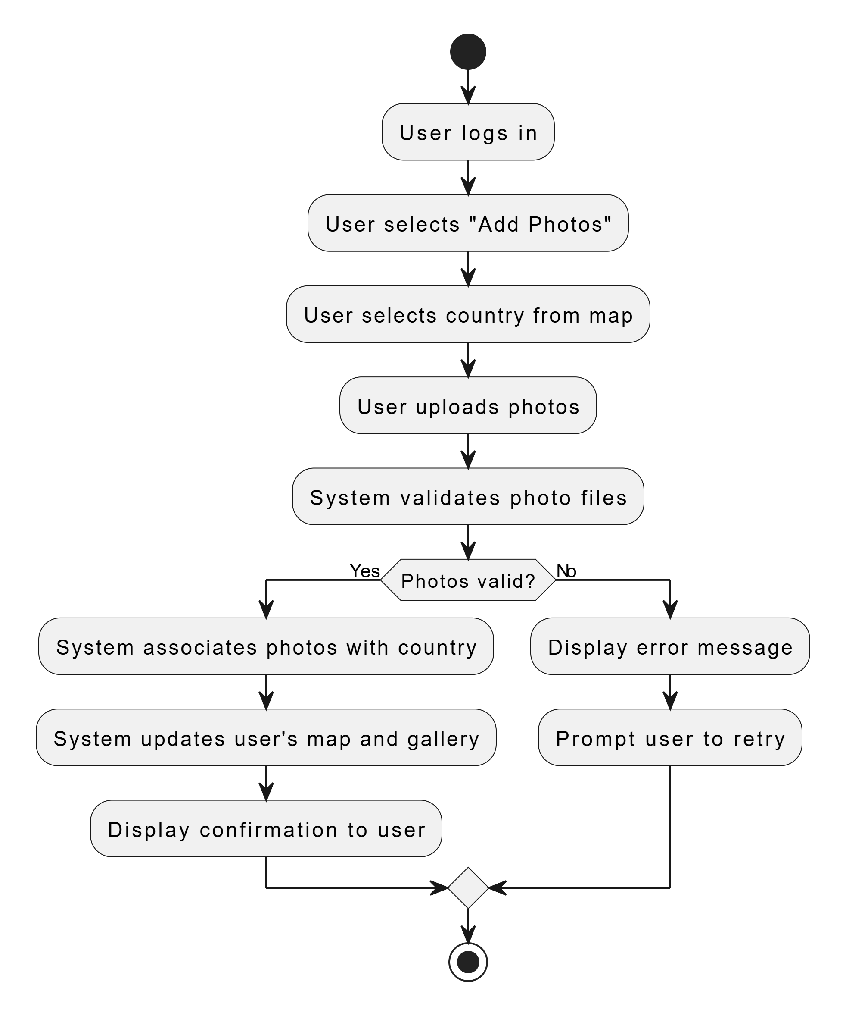

***Activity diagram for user managing photos:***

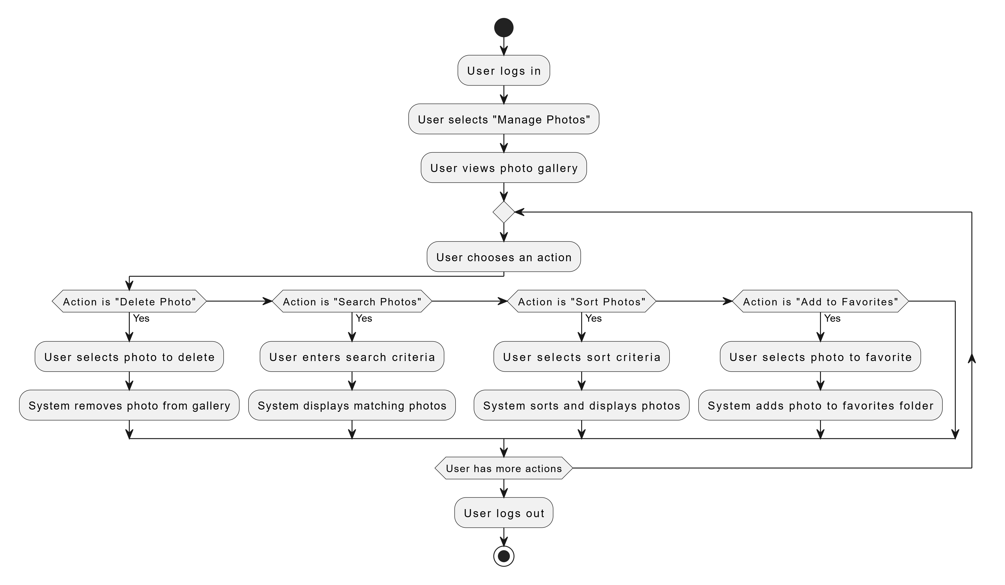

***Activity diagram for administration:***

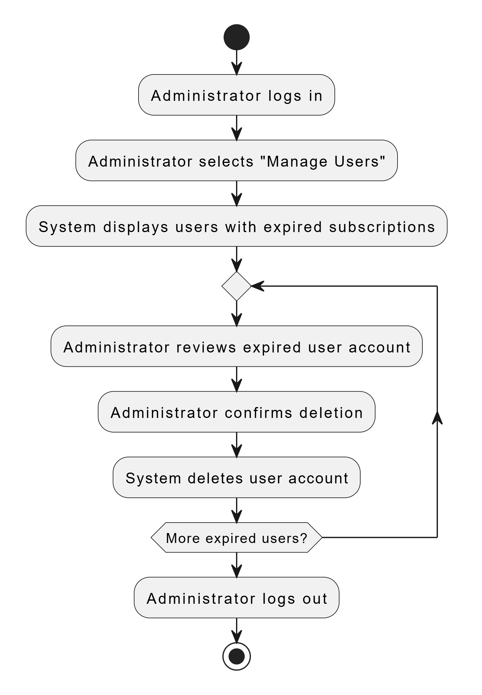

***Activity diagram for educational content***

# Requirements Elicitation

**Approach**:

**Online Surveys**

*Link*: <https://docs.google.com/forms/d/e/1FAIpQLSdYzzdFkk4Es9_vlNHphClWuEd8db-QyKRrWx_DeRj2AfNXsA/viewform>

* *Description:* An online survey will be conducted to collect quantitative data from potential users regarding their preferences, expectations, and requirements for the Photomap application. This method enables the gathering of data from a broad audience efficiently and cost-effectively.

**Semi-Structured Interviews**

* *Description:* Semi-structured interviews will be conducted with selected participants to gain qualitative insights into user behaviours, motivations, and experiences with similar applications. This approach allows for in-depth exploration of specific topics while maintaining consistency across interviews.

**Techniques**:

* + Questionnaire **Design:** Utilizing Google Forms to create a comprehensive survey that includes multiple-choice questions, Likert scales, and open-ended questions to capture a wide range of user feedback.
  + Interview **Protocols:** Developing an interview guide with open-ended questions to facilitate discussions during interviews, ensuring key topics are covered while allowing flexibility for participants to express their thoughts freely.

# Time Schedule



|  |  |  |  |
| --- | --- | --- | --- |
| **Time Schedule for FYP** |  |  |  |
|  |  | |
| Student = Leandro Felix |  | Wed, 13/11/2024 | |
| Supervisor = George Charalambous |  | Sun, 20/04/2025 | |
|  |  | 1 |  |
|  |  |  |  |
| **TASK** | **PROGRESS** | **START** | **END** |
| **Phase 1 -Requirements Gathering and Analysis** |  |  |  |
| Deploy the Google Forms survey to potential users | 50% | 13/11/24 | 16/11/24 |
| Identify key user needs, preferences, and potential challenges | | 16/11/24 | 18/11/24 |
| Define System Requirements |  | 18/11/24 | 22/11/24 |
| **Phase 2 -System Design and Architecture Planning** |  |  |  |
| Develop the overall architecture for both front-end and back-end components | | 22/11/24 | 26/11/24 |
| Outline database schemas and data models using PostgreSQL | | 24/11/24 | 29/11/24 |
| **Phase 3 -Front-End Development** |  |  |  |
| Set Up Development Environment |  | 29/11/24 | 4/12/24 |
| Configure Visual Studio Code with necessary extensions and settings | | 4/12/24 | 8/12/24 |
| Develop User Interface |  | 8/12/24 | 11/12/24 |
| Set up React |  | 11/12/24 | 13/12/24 |
| Implement the interactive world map functionality |  | 13/12/24 | 16/12/24 |
| Create React components |  | 16/12/24 | 21/12/24 |
| Integrate educational content display for countries (flags, languages, currencies, capitals) | | 5/1/25 | 7/1/25 |
| Develop Photo Gallery |  | 7/1/25 | 9/1/25 |
| Design login and registration forms |  | 9/1/25 | 11/1/25 |
| **Phase 4- Back-End Development** |  |  |  |
| Configure IntelliJ IDEA for back-end development |  | 11/1/25 | 13/1/25 |
| Set up SprintBoot framework |  | 13/1/25 | 23/1/25 |
| Create RESTful APIs for user registration, authentication, photo uploading, and data retrieval | | 23/1/25 | 2/2/25 |
| Set up JWT (JASON Web Token) for authentication |  | 2/2/25 | 5/2/25 |
| Database Implementation |  | 5/2/25 | 10/2/25 |
| Set up PostgreSQL database instances |  | 10/2/25 | 13/2/25 |
| **Phase 5 -Containerization** |  |  |  |
| Set up Docker |  | 13/2/25 | 19/2/25 |
| Integrate Front-end, Back-end and Database to Docker |  | 19/2/25 | 25/2/25 |
| **Phase 6 - Deployment Preparation** |  |  |  |
| Prepare for Deployment |  | 26/2/25 | 1/3/25 |
| Documentation |  | 2/3/25 | 7/3/25 |
| **Phase 7 -Testing** |  |  |  |
| Set Up tests with JUnit |  | 7/3/25 | 11/3/25 |
| Deploy the application to a staging environment |  | 11/3/25 | 16/3/25 |
| Invite a group of end-users to test the application functionalities | | 16/3/25 | 21/3/25 |
| Implement necessary adjustments |  | 21/3/25 | 26/3/25 |
| **Phase 8 - Final Deployment** |  |  |  |
| Deploy the application to the production environment |  | 26/3/25 | 31/3/25 |
| Perform final system checks and validations |  | 31/3/25 | 3/4/25 |
| Evaluate project outcomes against initial aims and objectives | | 3/4/25 | 8/4/25 |
| Preparation for Final Presentation |  | 8/4/25 | 18/4/25 |
| Project Completed and Ready for Presentation |  | 18/4/25 | 20/4/25 |

# References / Bibliography

**References:**

* *MyTravelMap (n.d.). MyTravelMap – Visualize Your Travels on a Map. Available at:* [*https://www.mytravelmap.xyz/*](https://www.mytravelmap.xyz/) *[Accessed 7 November 2024].*
* *Travellerspoint (n.d.). Travellerspoint – Travel Community. Available at:* [*https://www.travellerspoint.com/*](https://www.travellerspoint.com/) *[Accessed 7 November 2024].*
* *Smith, A. & Jones, B. (2020). Enhancing User Engagement through Geolocation in Digital Media. Journal of Interactive Media, 15(3), pp. 145-160.*
* *Doe, J., Miller, C. & Lee, R. (2019). The Role of Interactive Maps in Cultural Awareness and Education. Geography Education Review, 10(4), pp. 212-225.*

**Bibliography:**

* *Banks, C. (2015). Docker: Up & Running. O'Reilly Media.*
* *Bloch, J. (2018). Effective Java. 3rd edn. Addison-Wesley.*
* *Carnell, J. & Harrop, M. (2019). Spring Microservices in Action. 2nd edn. Manning Publications.*
* *Fowler, M. (2002). Patterns of Enterprise Application Architecture. Addison-Wesley.*
* *Gutierrez, T. (2018). Learning Spring Boot 2.0. Packt Publishing.*
* *Johnson, R. & Hoeller, J. (2016). Pro Spring 5. Apress.*
* *Rubens, P. (2016). Fundamentals of Software Architecture: An Engineering Approach. Addison-Wesley.*
* *Wieruch, R. (2019). The Road to React. Self-published.*
* *Turnbull, J. (2014). The Docker Book: Containerization is the New Virtualization. James Turnbull.*
* *Goodchild, M.F. (2007). Citizens as sensors: the world of volunteered geography. GeoJournal, 69(4), pp. 211–221.*
* *McDonough, K. (2014). Integrating Geographic Information Systems into Photo Management Applications. International Journal of Geographical Information Science, 28(5), pp. 1027–1042.*
* *Sui, D.Z., Elwood, S., & Goodchild, M.F. (2013). Crowdsourcing Geographic Knowledge: Volunteered Geographic Information (VGI) in Theory and Practice. Springer.*

# Ethics Form

