**A Low Cost Culture Tube Spectrophotometer**

BIOE521 - 12/3/2015 - Felix Ekness, Brian Landry

**Abstract**

A ubiquitous synthetic biology protocol is to grow liquid cultures of cells in 14mL culture tubes within a large orbital shaker incubator to a desired optical density (OD) for various experimental reasons. The challenging and at times frustrating aspect of this protocol is quantifying when the cells have reached their desired density. Traditionally, researchers either pipette samples into cuvettes and read these on a expensive spectrophotometer or hold each culture tube up to a light source and estimate OD based on experience. The first approach is expensive and does not scale well with increasing culture tubes while the latter approach is susceptible to large errors especially at low ODs (<0.1 OD 600nm). We have solved this problem with the development of a compact and cheap spectrophotometer named the Rapid Optical Density Detector (RODD) that can measure OD through the culture tubes. RODD uses the Beer-Lambert law, an Arduino Uno, a single light-to-frequency converter, and a 600nm LED, a four segment LED display, a push button, and a 3D printed enclosure to cheaply and rapidly measure the OD of liquid cultures within 14mL culture tubes with a resolution of +/- 0.01 OD.

**Background and Significance**

In synthetic biology laboratories, measuring and tracking the density of cells within liquid cultures is paramount to nearly all *in vivo* experiments. As bacteria grow in liquid media, they consume nutrients and increase in density. During growth, the available nutrients decrease, resulting in phenotypic changes that affect experimental outputs. Thus it is crucial for experiments to end at the same cell density to avoid phenotypic changes, such as variations in DNA replication speed. To measure cell density within standard 14mL liquid culture tubes, two techniques are used: measuring the absorbance of the culture using a spectrophotometer or measuring absorbance through eyeballing.

Spectrophotometers measure the absorbance of a 600nm laser through a 1cm path of the liquid culture. This measurement is known as the optical density (OD) at 600nm (OD600) and is a standard proxy for microbial cell density. Spectrophotometers have been around for decades and although they are ubiquitous in laboratories, they are costly to purchase ($500-2000 used on Ebay and >$5000 new from VWR [1,2]), bulky, and require samples be placed into expensive ($1/per), non reusable cuvettes. Their high cost limits labs to usually one spectrophotometer and the requirement of pipetting samples into cuvettes becomes financially and time costly for >10 samples as well as perturbs the growth of the liquid cultures being measured. While there have been attempts to make cheap spectrophotometers, they have been impractical for laboratory environments or use the same time intensive and costly cuvettes [3,4].

The other technique of measuring liquid culture OD is through eyeballing the liquid culture within its culture tube against a light source. This technique requires experience but is cheap, quick, and does not perturb the growth environment of the cultures. Measuring OD with this method is prefered for >10 samples but is known to be highly inaccurate even for the most experienced researcher. **Thus a cheap, quick to use, and accurate spectrophotometer is needed to enable synthetic biologists to rapidly and precisely measure OD of large quantities of experimental liquid culture tubes without perturbing the growth environment of the cells.**

**Design and Development**

Below are the specifications for our spectrophotometer named Rapid Optical Density Detector (RODD):

|  |  |  |
| --- | --- | --- |
| **Property** | **Specification** | **Achieved Value** |
| Measurement Range | 0.05-0.5 OD600 | 0.05-1.0 OD600 |
| Precision | <0.02 OD600 | +/- 0.01 OD600 |
| Portability | Can be located next to an incubator but can still use a wall outlet for power | Achieved specification |
| Measurement rate | > 10 Samples/minute | 30 samples/minute |
| Visual Readout | Contains at least 2 significant figures | Contains 3 significant figures and a sign |
| Durability | Capable of being roughly handled and occasionally dropped | Survived testing and simulated dropping |
| Ease of use | Requires minimal interaction and promotes quick use | A single button press activates the machine which then has continual readout to the user |
| Cost | <$50 | Button = $0.5  Arduino Uno = $24.95  600nm LED = $0.35  Light-to-frequency-converter = $3.56  LED Display = $16.95  3D printed Housing = negligible  **Total = $46.31** |

**User interface design**

We approached our user interface with the goal of it being simple and quick to use. This meant limiting user interaction and achieving quick feedback to the user of the predicted OD600 of the culture. We first specified the four usage modes of the device:

1. Turned on
2. Measuring the blank
3. Measuring a sample
4. Turned off

Our first design decision was to condense the user input required to transition from the 4th state to the 1st and then 2nd states to a single button press, which both turns on the device, activating the numeric display, as well as initiates the blanking procedure. To further simplify usage we then automated transition from measuring the blank to measuring a sample to occur after one second of measuring the blank. While the device is measuring the sample it displays a one second running average of the OD600 reading. This real time display speeds up feedback to the user of the measured OD600 of the culture, decreasing the time required to quantify the density of the culture. It additionally removes the need for the user to signal the RODD each time a new sample is being measured, instead the user simply inserts the new sample and waits for the reading to stabilize after one second. Lastly, we created an automated turn off of the RODD after 10 minutes, both negating the need for the user to turn it off as well as removing the possibility of it accidentally being left on for long periods of time. A summary of the designed workflow is depicted in the flowchart below.

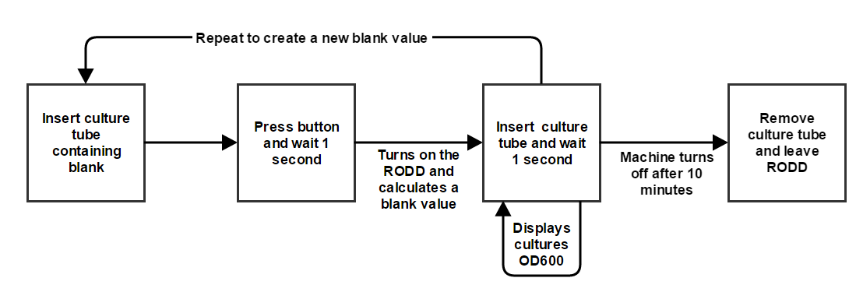

Figure 1: RODD user workflow flowchart

**Spectrophotometer part selection**

Part selection for RODD focused on attaining a high signal to noise ratio with relatively cheap parts. This lead to initially choosing a light-to-frequency-converter (LTFC) (part TSL237) that linearly converts input light intensity to an output square wave frequency over 5 logs of light intensity and an economical red laser (VLM-635/650-03 Series) with a wavelength of 635-650nm and beam diameter of 6+/-1 mm. After wiring these to an Arduino Uno and placing them within our custom 3D printed housing (see Figure 2A), it was observed that slight tilting of the culture tube dramatically changed the output of the LTFC. This was due to the laser’s focused beam and how the beam traveled through the culture tube. A slight change in the angle of entry into the culture tube resulted in a refraction large enough to shift the focus of the beam away from the center of the LTFC. This resulted in large OD600 variability from tube to tube which caused the noise of the system to surpass the signal. To fix this issue, the laser was swapped out for a less powerful but wider beam diameter LED. Since the LED’s beam diameter entering the culture tube is much larger than the laser’s, the effect of the refraction was predicted to be much less since the main focus of the LED beam should still hit the LTFC after refraction (see Figure 2B). Upon testing this hypothesis, the signal to noise ration was greatly increased with the LED OD600 light source configuration and thus RODD uses an LED instead of laser OD600 light source.

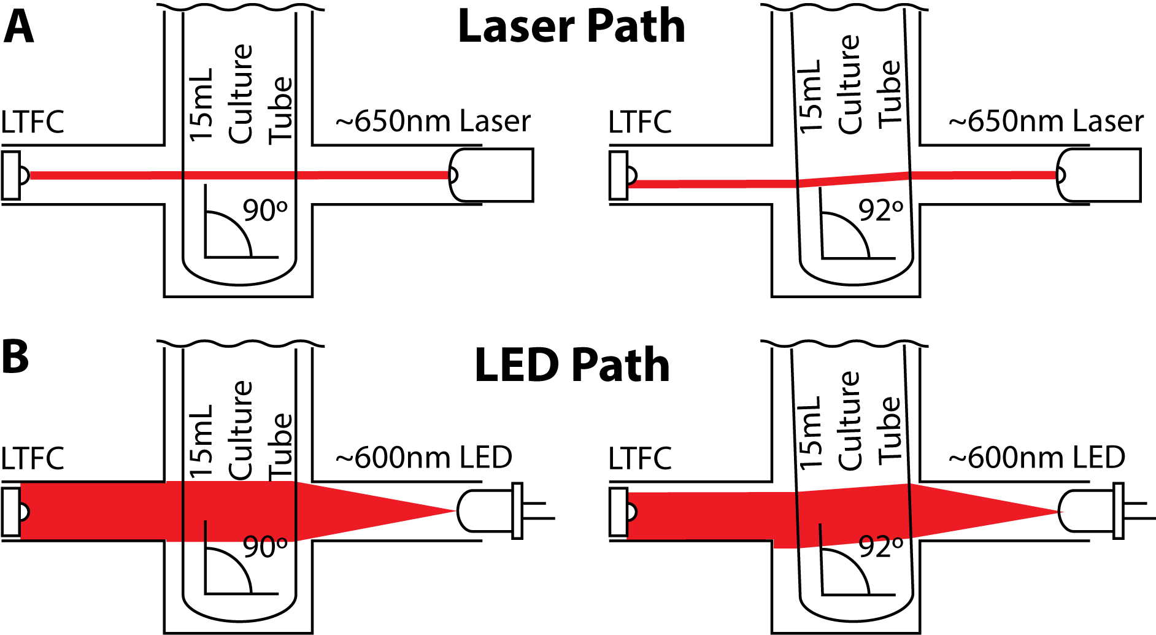

Figure 2: Beam path deviation of OD light source due to refraction when culture tube is tilted by 2º

**Design of casing**

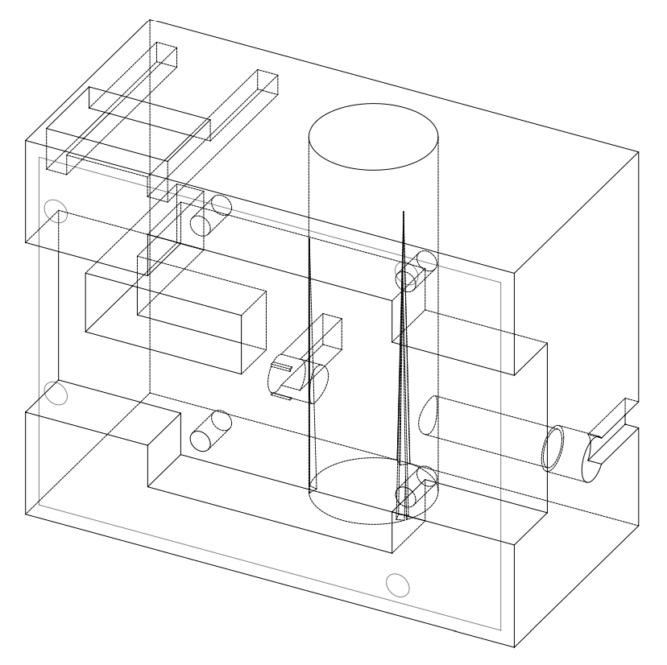

Figure 3: Diagram of the custom 3D printed housing that RODD uses.

When considering the selection of materials and organization of the physical parts of the RODD we took into expected levels of handling, our prior knowledge as well as the various fabrication technologies we had access to. We choose to 3D print over technologies such as laser cutting to create the casing for the RODD because it enabled the creation of various enclosed wiring paths. This resulted in compartmentalized wiring hidden from the user which we hope will make the connections more durable. We also had previous experience creating and printing models and had access to a 3D printer in our lab. The final model which was printed is shown below.

During testing of prototypes of our device we found that the angle of the culture tube greatly influenced measured absorbance, particularly when used with a laser (see Figure 2). Although the light source was changed to an LED to fix this issue, we also redesigned the culture tube holder to have a tighter fit. We used three triangular protrusions placed on the sides of the tube holder which decreased the relative diameter of the holder from the entry to the bottom of the holder (Figure 3). These protrusions in addition to the use of an LED light source eliminated previously identified noise generated from the vertical angle of the culture tube within its holder.

**Coding**

The RODD was programmed in the Arduino Programming Language using the standard arduino sketch format. The core of the program is contained in a loop which updates the state of the device at a set interval. The loop checks for changes in the state of the button, and then begins countdowns to both end the blanking of the device (measures light intensity through a culture with no cells which is a proxy for input light source) after one second and operation of the device after 10 minutes. It then records experimental measurements from the LTFC, computes the OD600 through the Beer-Lambert law, and displays the computed output on a four segment LED screen.

An important feature of this design was to create a responsive system while also supporting continuous integration from the synchronous photodetector. The original design queried the photodetector for a measurement over a one second time period. However, this locked the system for the entire second, making both the button and LED unresponsive during this period. To accommodate this while still calculating a one second average from the photodetector we created a continuously updated buffer which stored the last ten measurements from the photodetector. The LTFC was then queried ten times a second for a 100 millisecond period and these values were stored in the buffer. This permitted updates of the LED and button state every 100ms creating a much more responsive system. Additionally, it enabled the display of a continuously updating one second running average OD600 value to the user.

**Quantification and Qualification**

**Calibration Technique**

RODD was calibrated to display OD600 using 10 serially diluted titanium dioxide colloid solutions (suspended in water). These solutions were first read on our lab’s commercial spectrophotometer within 1mL cuvettes (Table 2, column 1). Then these solutions were measured within 14mL culture tubes at a volume of 4mL within RODD (Table 2, column 2). With both of these measurements, a first order polynomial was fitted to the spectrophotometer and RODD readings to create a mapping between spectrophotometer OD600 and RODD absorbance. This mapping was then hard coded into the core code that calculates RODD OD. The standard titanium dioxide solutions were then remeasured with the now calibrated RODD, yielding OD600 values +/-0.01 away from the spectrophotometer OD600 measurements of the same standard solutions (Table 2, column 3).

|  |  |  |
| --- | --- | --- |
| **Spectrophotometer OD600** | **Raw RODD OD** | **Calibrated RODD OD600** |
| 0.0325 | 0.01 | 0.04 |
| 0.08145 | 0.05 | 0.09 |
| 0.13062 | 0.09 | 0.13 |
| 0.16941 | 0.12 | 0.16 |
| 0.18323 | 0.14 | 0.18 |
| 0.21266 | 0.16 | 0.21 |
| 0.23708 | 0.18 | 0.25 |
| 0.41538 | 0.34 | 0.41 |
| 0.92972 | 0.76 | 0.94 |

Table 2: Spectrophotometer and RODD OD readings of 10 serially diluted titanium dioxide colloid solutions.

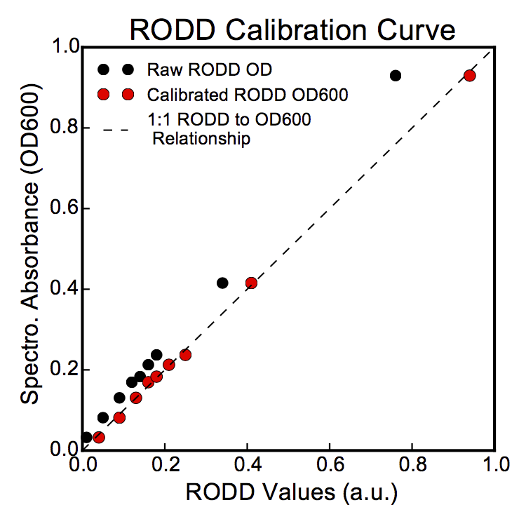

Figure 4: Plot of the values located in Table 2. The 1:1 RODD to OD600 relationship is the ideal relationship between the OD600 values RODD reads and what the spectrophotometer outputs

**Deployment**

The extensive prototyping accomplished in this project has led to a device that is ready for preliminary deployment in our lab environment. We have begun to use the RODD to measure the OD600 of cultures in our incubator in the Tabor Lab (see image below). However there are several additional improvements which we are interested in examining. Primarily we would like to extend our 3D enclosure to cover the Arduino in addition to our electrical components. We expect this will increase the hardiness of the RODD and lead to a better user experiences. We are also interested in adding a web based storage system for the OD600 measurements from the device. We envision a system where the user presses the button after inserting each culture, which records the current reading to a spreadsheet that can subsequently be access via the internet. We look forward to adding these improvements to the RODD and demonstrating its long term performance in the Tabor Lab.

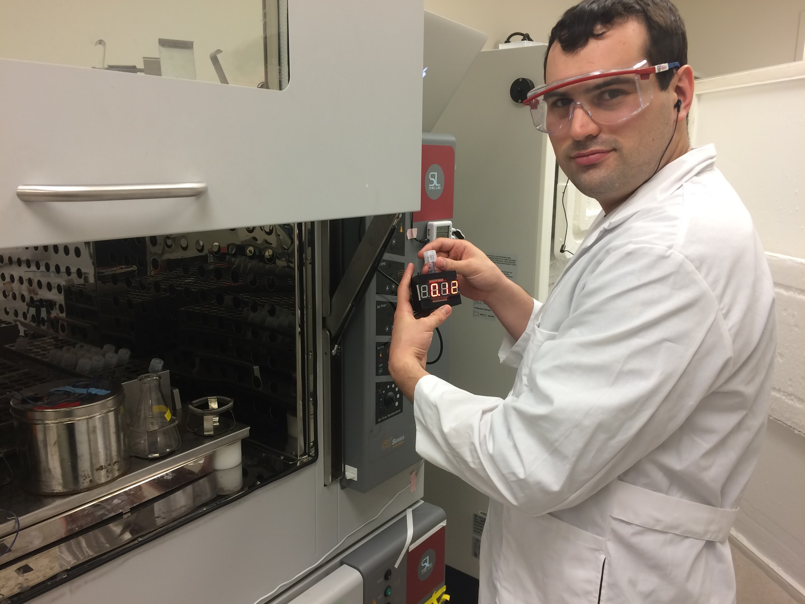

Figure 5: RODD in action

.

**Citations**

[1] Ebay. Search Term: “Spectrophotometer.” http://www.ebay.com/bhp/spectrophotometer

[2] VWR. Product Category: “Spectrometers.”

https://us.vwr.com/store/search?label=&vpc=&pimId=597202

[3] D. R. Albert, M. A. Todt, H. F. Davis. “A Low-Cost Quantitative Absorption

Spectrophotometer.” *J. Chem. Educ*. 2012, 89, 1432-1435.

[4] Dusjagr. “Optical Density Sensor aka Kafi-Schnapps Detektor.” *Makerbot Thingiverse*. Apr

15, 2013. http://www.thingiverse.com/thing:74415