|  |  |
| --- | --- |
| **Soal Praktikum**  *Practicum Case* |  |
| COMP6360  Algorithm and Programming |
| **Teknik Informatika**  *Computer Science* | CS-COMP6360-Var02 |
| **Periode Berlaku Mulai** Semester Ganjil 2018/2019  ***Valid on*** *Odd Semester Year* 2018/2019 | **Revisi 00**  *Revision 00* |

## Learning Outcomes

* Write a program in C language in problem solving

## Topic

* Session 02 – Arithmatic Operation

## Sub Topics

* Creating a program using arithmatic operation

## Soal

*Case*

Create a simple program that can calculate unsorted math equation. Here are the descriptions of the program:

* At the beginning of the program, program will show this formula:
  + x = (sqrt(a) + b^3 – c*b) / a
* Ask user to input **a**, **b**, and **c**.
* Show the result of x.
* Show the second formula:
  + y = (d*b + x/c – a)^2
* Ask user to input **y**.
* Show the result of y.

**Please run the EXE file to see the sample program.**

**Print Screen of first unsorted math equation**

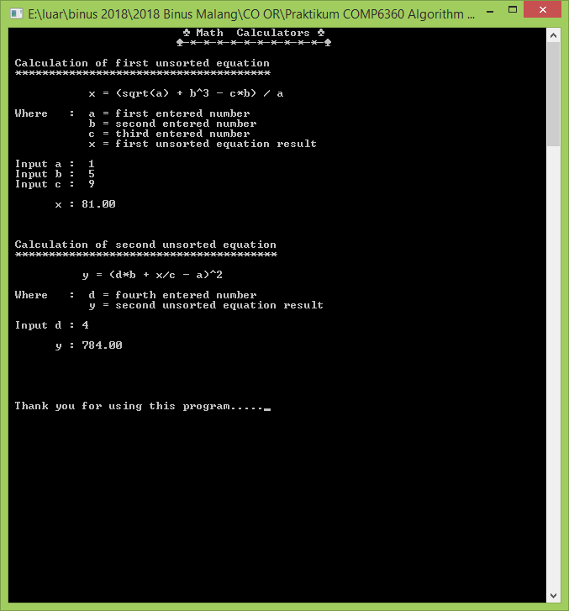

**Print Screen of second unsorted math equation**

