|  |  |
| --- | --- |
| **Soal Praktikum**  *Practicum Case* |  |
| COMP6360  Algorithm and Programming |
| **Teknik Informatika**  *Computer Science* | CS-COMP6360-Var01 |
| **Periode Berlaku Mulai** Semester Ganjil 2018/2019  ***Valid on*** *Odd Semester Year* 2018/2019 | **Revisi 00**  *Revision 00* |

## Learning Outcomes

* Write a program in C language in problem solving

## Topic

* Session 06 – Function

## Sub Topics

* Function
* Passing Parameter by Value

## Soal

*Case*

Program Gambar Segiempat is a program that can display Rectangle to the screen using the input from user. User will be asked to choose between 2 menu :

1. Segiempat dengan Simbol :
   1. This menu will display rectangle with the symbol from user.
   2. User will be asked to key in the number of rectangle, and also the symbol that will be used to create the rectangle
2. Segiempat dengan Angka
   1. This menu will display rectangle with the number from user
   2. User will be asked to key in the number of rectangle.

The program should consist of 1 main modul and 2 sub moduls

At the end of the program, user will be asked whether they want to repeat the process or not. If they choose Y or y, the program will be repeated.

**Please run the EXE file to see the sample program.**

**Print Screen of First Screen**

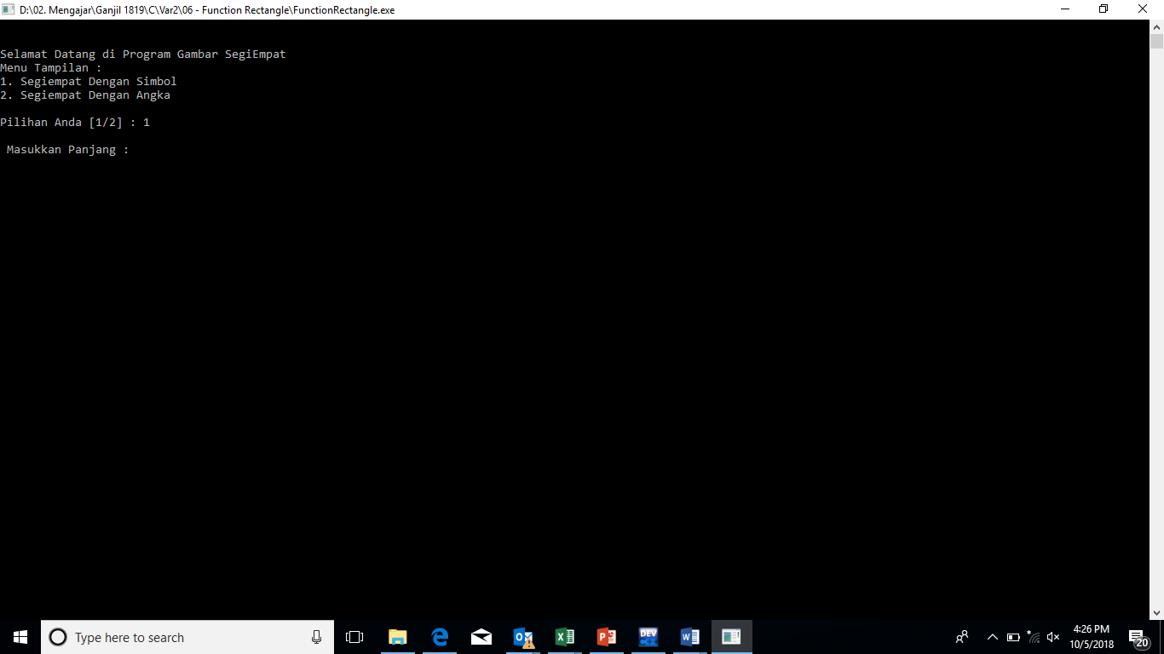

**Print Screen of Second Screen**

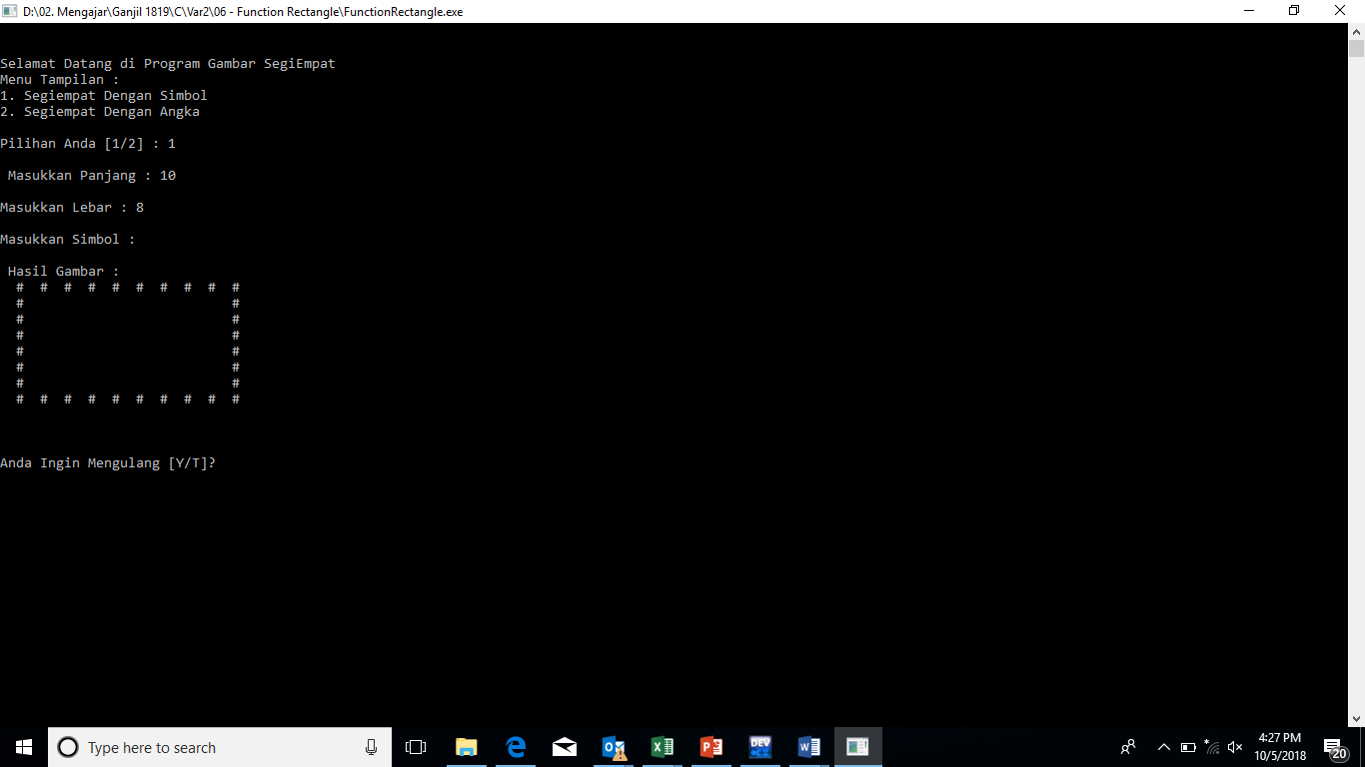

**Print Screen of Third Screen**

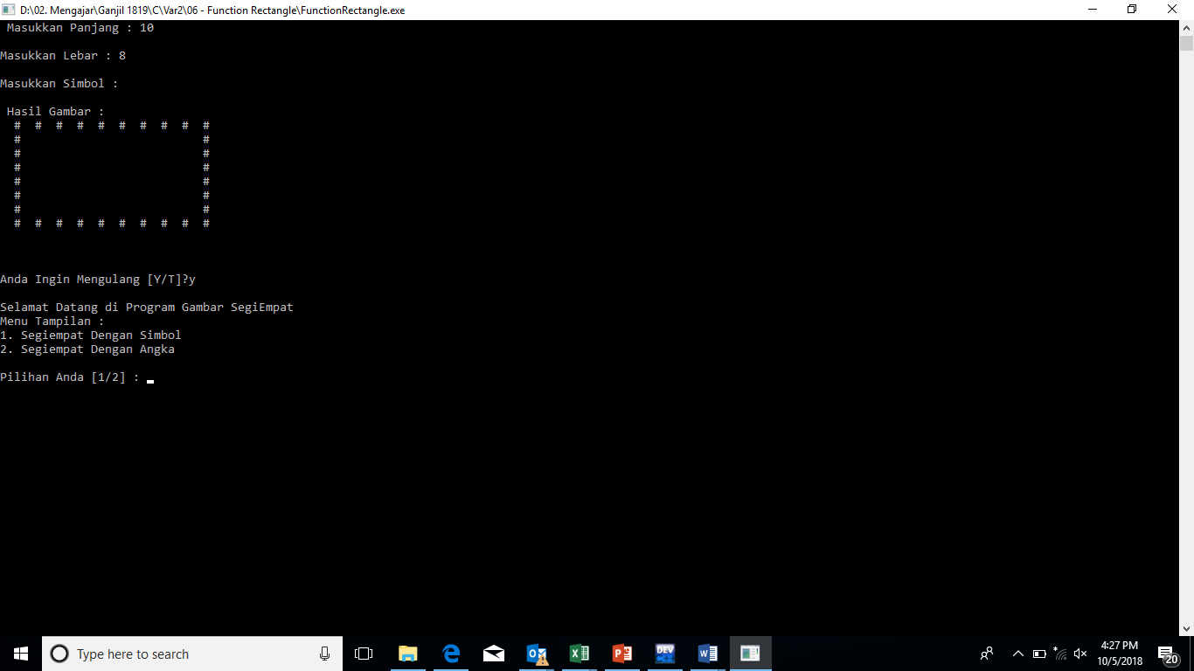

**Print Screen of Fourth Screen**

