|  |  |
| --- | --- |
| **Soal Praktikum**  *Practicum Case* |  |
| COMP6360  Algorithm and Programming |
| **Teknik Informatika**  *Computer Science* | CS-COMP6360-Var02 |
| **Periode Berlaku Mulai** Semester Ganjil 2018/2019  ***Valid on*** *Odd Semester Year* 2018/2019 | **Revisi 00**  *Revision 00* |

## Learning Outcomes

* Write a program in C language in problem solving

## Topic

* Session 07 – Recursive

## Sub Topics

* Recursive
* Iteration

## Soal

*Case*

Program My Factorial is a program that can produce the result of factorial based on input from user. Details of the program as follow :

* The program can show the calculation from first number to the last number of the user input.
* Program will be repeated when user press ‘Y’ or ‘y’
* Use function toupper()

The program should consist of 1 main modul and 1 sub modul

**Please run the EXE file to see the sample program.**

**Print Screen of First Screen**

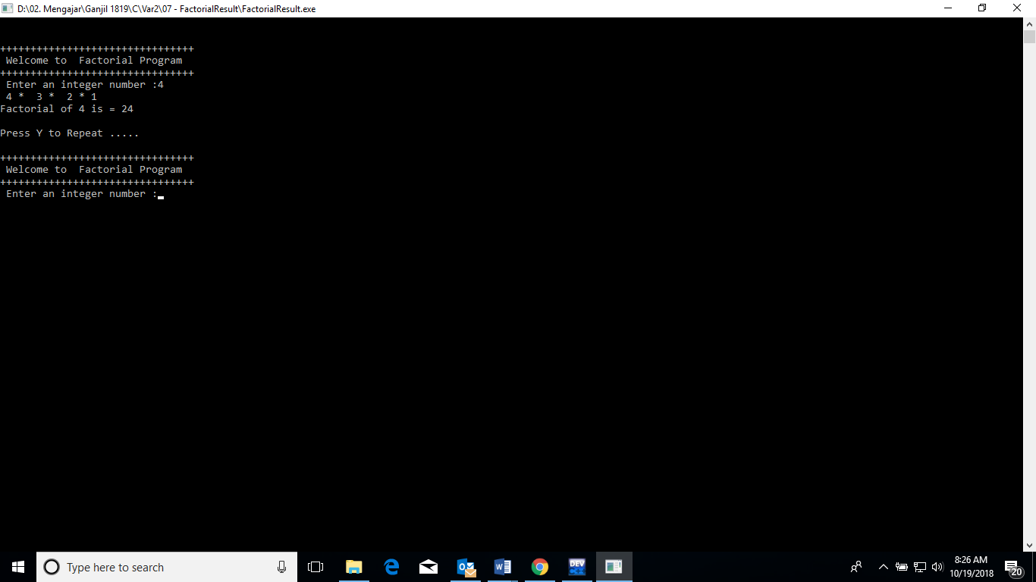

**Print Screen of Second Screen**



**Print Screen of Third Screen**

