Felix Filipi

2301877590

1. select max(price) as "Maximum Price", min(price) as "Minimum Price", cast(round(avg(price),0)as decimal(18,2)) as "Average Price"from MsTreatment;

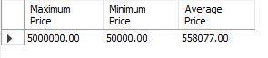

1. select StaffPosition, left(StaffGender,1) as Gender, concat('Rp. ',cast(avg(StaffSalary) as decimal(10,2))) as "Average Salary" from MsStaff group by StaffPosition,StaffGender;

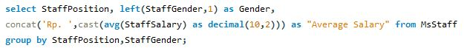

Hasil:

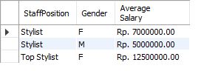

1. select date_format(TransactionDate, '%b %d. %Y') as TransactionDay,Count(TransactionDate) as "Total Transaction per Day" from HeaderSalonServices group by TransactionDay;

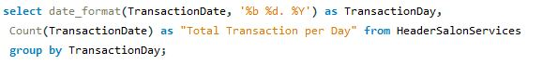

Hasil:

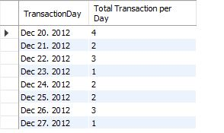

1. select upper(CustomerGender), Count(TransactionDate) as "Total Transaction" from HeaderSalonServices,mscustomer where MsCustomer.CustomerId = HeaderSalonServices.CustomerId group by CustomerGender;

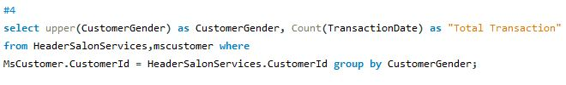

Hasil:

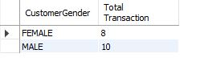

1. select MsTreatmentType.TreatmentTypeName, Count(HeaderSalonServices.TransactionId) as "Total Transaction" from MsTreatmentType, HeaderSalonServices, MsTreatment, DetailSalonServices where MsTreatmentType.TreatmentTypeId = MsTreatment.TreatmentTypeId and MsTreatment.TreatmentId = DetailSalonServices.TreatmentId and DetailSalonServices.TransactionId = HeaderSalonServices.TransactionId group by TreatmentTypeName order by "Total Transaction" desc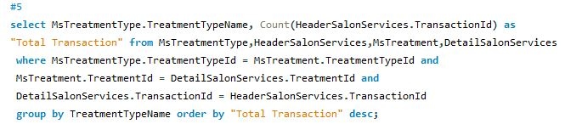

Hasil:

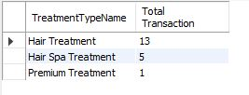

1. select date_format(TransactionDate, '%d %b %Y') as "Date", concat('Rp. ',cast(sum(Price) as decimal(10,2))) as "Revenue per Day" from MsTreatment, DetailSalonServices,HeaderSalonServices where MsTreatment.TreatmentId= DetailSalonServices.TreatmentId and DetailSalonServices.TransactionId=HeaderSalonServices.TransactionId group by TransactionDate HAVING SUM(Price) BETWEEN 1000000 AND 5000000;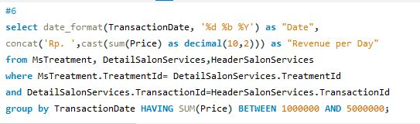

Hasil:

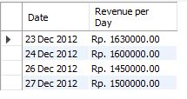

1. select replace(MsTreatment.TreatmentTypeId,"TT0","Treatment Type") AS 'ID', TreatmentTypeName, concat(cast(count(MsTreatment.TreatmentTypeId) as signed),' Treatment') AS "Total Treatment per Type" from MsTreatmentType, MsTreatment where MsTreatmentType.TreatmentTypeId = MsTreatment.TreatmentTypeId group by TreatmentTypeName having COUNT(MsTreatment.TreatmentTypeId) > 5 order by COUNT(MsTreatment.TreatmentTypeId) DESC;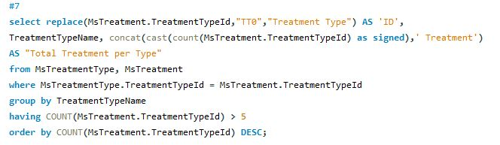

Hasil:

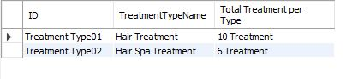

1. select LEFT(StaffName,instr(StaffName,' ')) as StaffName, DetailSalonServices.TransactionId, Count(DetailSalonServices.TreatmentId) as "Total Treatment per Transaction" from HeaderSalonServices,MsStaff,DetailSalonServices where MsStaff.StaffId = HeaderSalonServices.StaffId and HeaderSalonServices.TransactionId = DetailSalonServices.TransactionId GROUP BY HeaderSalonServices.TransactionId;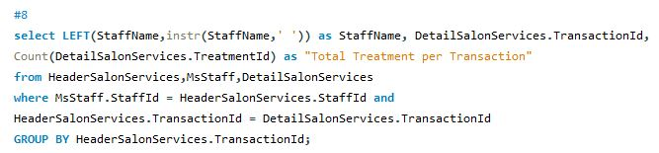

Hasil:

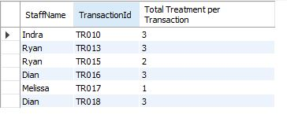

1. select TransactionDate, CustomerName, TreatmentName, Price from MsCustomer,HeaderSalonServices,MsStaff,DetailSalonServices,MsTreatment where MsCustomer.CustomerId = HeaderSalonServices.CustomerId and HeaderSalonServices.StaffId = MsStaff.StaffId and HeaderSalonServices.TransactionId = DetailSalonServices.TransactionId and DetailSalonServices.TreatmentId = MsTreatment.TreatmentId and dayname(transactiondate)= 'Tuesday' and StaffName like '%Ryan%' order by TransactionDate asc;

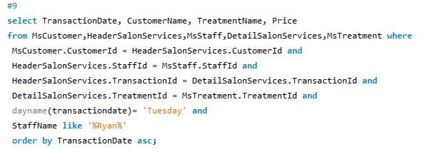

Hasil:

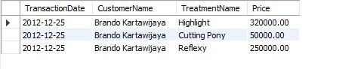

1. SELECT TransactionDate, CustomerName, SUM(Price) AS TotalPrice FROM HeaderSalonServices, MsCustomer, DetailSalonServices, MsTreatment WHERE HeaderSalonServices.CustomerId = MsCustomer.CustomerId and

HeaderSalonServices.TransactionId = DetailSalonServices.TransactionId and DetailSalonServices.TreatmentId = MsTreatment.TreatmentId and day(TransactionDate) > 20 GROUP BY TransactionDate ASC;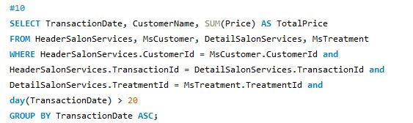

Code Select nomor 10:

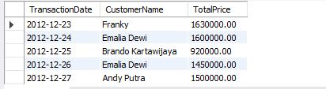

Beberapa hasil tidak sesuai dengan contoh karena perbedaan insert yang digunakan (Soal tidak jelas).