Felix Filipi

2301877590

1. select TreatmentId, TreatmentName from MsTreatment where TreatmentId in ('TM001','TM002');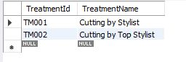
2. select TreatmentName, Price from MsTreatment where MsTreatment.TreatmentTypeId in (select MsTreatmentType.TreatmentTypeId from MsTreatmentType where TreatmentTypeName not in ('Hair Treatment','Hair Spa Treatment'));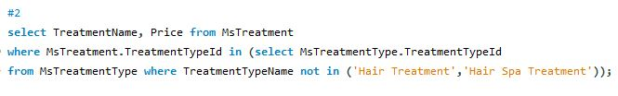

Hasil:

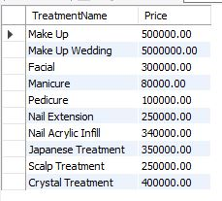

1. select CustomerName, CustomerPhone, CustomerAddress from mscustomer,HeaderSalonServices where MsCustomer.CustomerId = HeaderSalonServices.CustomerId and length(CustomerName)>8 and dayname(TransactionDate)in ('Friday');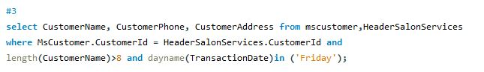

Hasil:



1. insert into DetailSalonServices values ('TR009','TM005');

select TreatmentTypeName, TreatmentName,Price from MsCustomer,MsTreatment,MsTreatmentType,DetailSalonServices,HeaderSalonServices where MsTreatment.TreatmentTypeId = MsTreatmentType.TreatmentTypeId and MsTreatment.TreatmentId = DetailSalonServices.TreatmentId and DetailSalonServices.TransactionId = HeaderSalonServices.TransactionId and HeaderSalonServices.CustomerId = MsCustomer.CustomerId and MsCustomer.CustomerName in (select CustomerName from MsCustomer where CustomerName like '%Putra%') and day(TransactionDate)=25;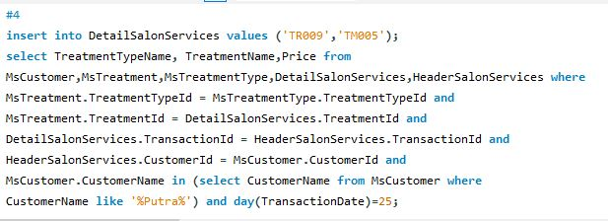

Hasil:



1. select StaffName, CustomerName, date_format(TransactionDate, "%b %d, %Y") as TransactionDate,TreatmentId from MsStaff,MsCustomer, HeaderSalonServices, DetailSalonServices where exists(select MsTreatment.TreatmentId from MsTreatment where DetailSalonServices.TreatmentId = MsTreatment.TreatmentId and MsStaff.StaffId = HeaderSalonServices.StaffId and MsCustomer.CustomerId = HeaderSalonServices.CustomerId and HeaderSalonServices.TransactionId = DetailSalonServices.TransactionId and convert(right(MsTreatment.TreatmentId,1),unsigned)%2=0);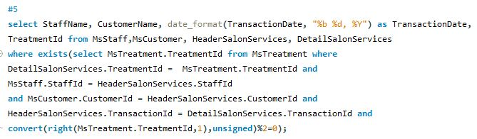

Hasil:

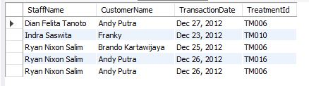

1. select CustomerName,CustomerPhone,CustomerAddress from MsCustomer where exists(select StaffName from MsStaff,HeaderSalonServices where MsCustomer.CustomerId=HeaderSalonServices.CustomerId and HeaderSalonServices.StaffId = MsStaff.StaffId and length(StaffName)%2=1);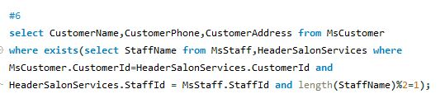

Hasil:

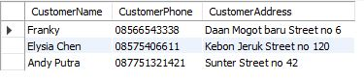

1. select right(StaffId,3) as ID, substring(substring(StaffName, instr(StaffName, ' '),

length(StaffName)),1,instr(substring(StaffName,instr(StaffName,' ')+1,length(StaffName)),' ')) as Name from MsStaff where length(StaffName) - length(replace(StaffName,' ','')) = 2 and exists (select CustomerGender from MsCustomer, HeaderSalonServices where MsCustomer.CustomerId = HeaderSalonServices.CustomerId and CustomerGender not like "Male"); 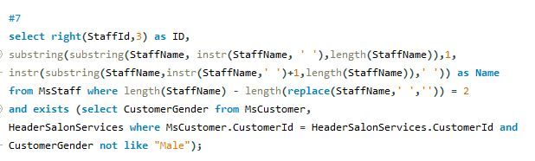

Hasil:

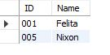

1. select TreatmentTypeName, TreatmentName,Price from(select avg(price) as average from MsTreatment) as avrg, MsTreatmentType, MsTreatment where MsTreatment.TreatmentTypeId = MsTreatmentType.TreatmentTypeId and price>average;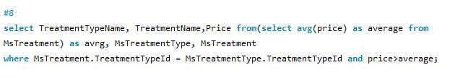

Hasil:

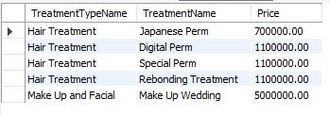

1. select StaffName, StaffPosition, StaffSalary from(select max(StaffSalary) as maximum, min(StaffSalary) as minimum from MsStaff) as Staff ,MsStaff where StaffSalary = maximum or StaffSalary = minimum;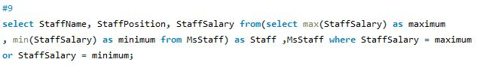

Hasil:

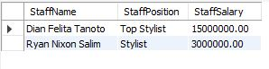

1. select CustomerName, CustomerPhone, CustomerAddress, count(MsTreatment.TreatmentId) as 'Count Treatment' from(select max(Semua) as maximum from(select count(MsTreatment.TreatmentId) as semua from MsCustomer,HeaderSalonServices, DetailSalonServices, MsTreatment where MsCustomer.CustomerId = HeaderSalonServices.CustomerId and HeaderSalonServices.TransactionId = DetailSalonServices.TransactionId and DetailSalonServices.TreatmentId = MsTreatment.TreatmentId group by MsCustomer.CustomerName, MsCustomer.CustomerPhone, MsCustomer.CustomerAddress) as semua)as maximum, MsCustomer,MsTreatment,DetailSalonServices,HeaderSalonServices where MsCustomer.CustomerId = HeaderSalonServices.CustomerId and HeaderSalonServices.TransactionId = DetailSalonServices.TransactionId and DetailSalonServices.TreatmentId = MsTreatment.TreatmentId group by MsCustomer.CustomerName, MsCustomer.CustomerPhone, MsCustomer.CustomerAddress,maximum having count(DetailSalonServices.TreatmentId) = maximum;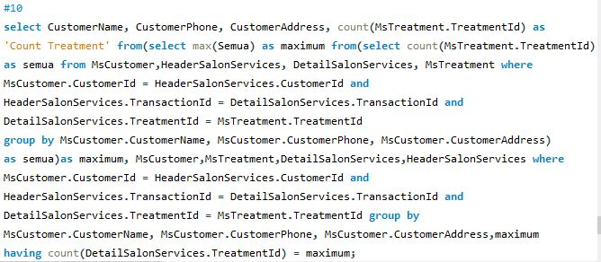

hasil:

