2.2 Programming Techniques

Naming Variables

How does the computer remember where it stored your test score? There is a real problem – the computer could be dealing with millions of variables at a time and needs to list where they are.

The solution – **give variables names**.

To make coding easier, use the variable conventions (rules) below:

* Describe what the variable holds
* Begin with a lower case letter of the alphabet
* Uses camelCase
* Consist of a single word, or multiple words with no spaces (e.g. studentAge)

1.1

Describe a suitable variable that will hold a student’s name, according to the rules above.

1.2

Describe a suitable variable that will hold a student’s address according to the rules above.

1.3

Describe a suitable variable that will hold a person’s score from a game according to the rules above.

1.4

Describe a suitable variable that will hold a players score in a game according to the rules above.

1.5

Describe a suitable variable that will hold a person’s date of birth according to the rules above.

1.3-

Names of variables are called labels. Write down labels to represent all of the values that you would need for a school register system that would store student details in your school.

Task 2-Assignment

1. In a new file write the code below to set up points and score.

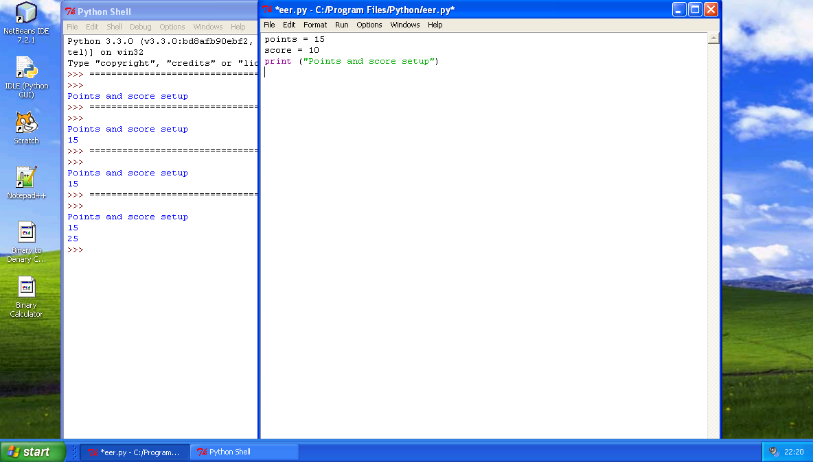

1. To see how points and score show values, we will complete the following table.
   1. Predict what will happen when you add the code to the code above
   2. Trying the code yourself in Python

|  |  |  |
| --- | --- | --- |
| **Code to write at the end of current program** | **a) Predicted output** | **b) Actual output**  **When added to twovar()** |
| No extra code | Points and score setup | Points and score setup |
| print (points) | 15 | 15 |
| result = points + score | No output | No output |
| result = points + score  print (result) |  |  |
| result = points - score |  |  |
| print (points + score) |  |  |
| points = score |  |  |
| points = score  print (points) |  |  |

1. Try this code in Python

x=7

y=x+1

z=x+y

print (z)

What is Y?

What is Z?

Complete the following program so that the variables print out “The cat sat on the mat”

Word1=‘the’

Word2=‘cat’

Word3=‘sat’ and so on…..

name=‘Bob’

print(‘Hello’, name)

What will happen in this program…

name=‘Bob’

name=‘Liz’

print(‘Hello’, name)

word = "hello"+"You"

print (word)

print (word[5])

print (word[3:])

print (word[:3])

print (len(word))

What is happening here? Explain Below

* Create a program which has 3 variables (a, b and c)
* A=12
* B=6
* C should = A+B
* Write a program which will print C