# 2.2 Programming Techniques

# Lists and Arrays

## Task 1-First Array

Using the Excel worksheet, you must choose an appropriate variable name for the following football teams. Using the table below, put the following football teams into the excel table.

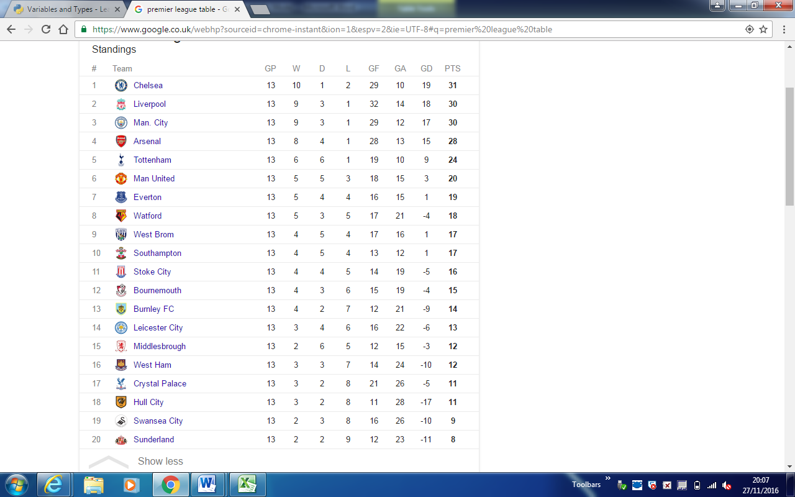

Did you know?

Remember a list is a structure that will contain many items of data which can be different. The data is indexed so that a particular item of data can be easily found

An array is a structure that contains many items of data which is the same type. The data is indexed so that a particular item of data can be easily found

## Task 2- Second Array

* Using the same table make sure you create another array in Excel which includes the points each of the 20 teams have. Remember in your new array the point score must have the same index value as your previous table. For example, Chelsea will be in index position 0, therefore their point score of 31 must also be in index position 0. Remember to choose a suitable variable name!
* Create another table on the same Excel sheet; you must now create an array for the team position in the premier league. Remember that if Chelsea is index position 0 for their point score and team name then it should also be in position 0 for its place in the premier league.

## Task 3-Python Programming

* Now that you have created arrays in Excel, you should be able to use this data and create a program in python which outputs a team’s name, point score and position in the premier league for each of the teams you have included in your array.
* Make sure you include print screens of the code you have produced, provide this as evidence in Word, make sure you label your code to show how each line works. This important because remember you have a written exam that will ask you to understand the theory behind why and how a program works.

Green Task-

For those who feel more confident with using one dimensional arrays. You should look at using two dimensional arrays instead of having two separate one dimensional arrays!