Software Engineering Lab Report
Student Name: Poorvi Rangaswamy
SRN: PES1UG24AM193
Lab Title: Lab 2: Agile Backlog Creation & Sprint Simulation in Jira
Project Topic: Faculty Research Grant & Publication Tracker

Mock Sprint Simulation 1
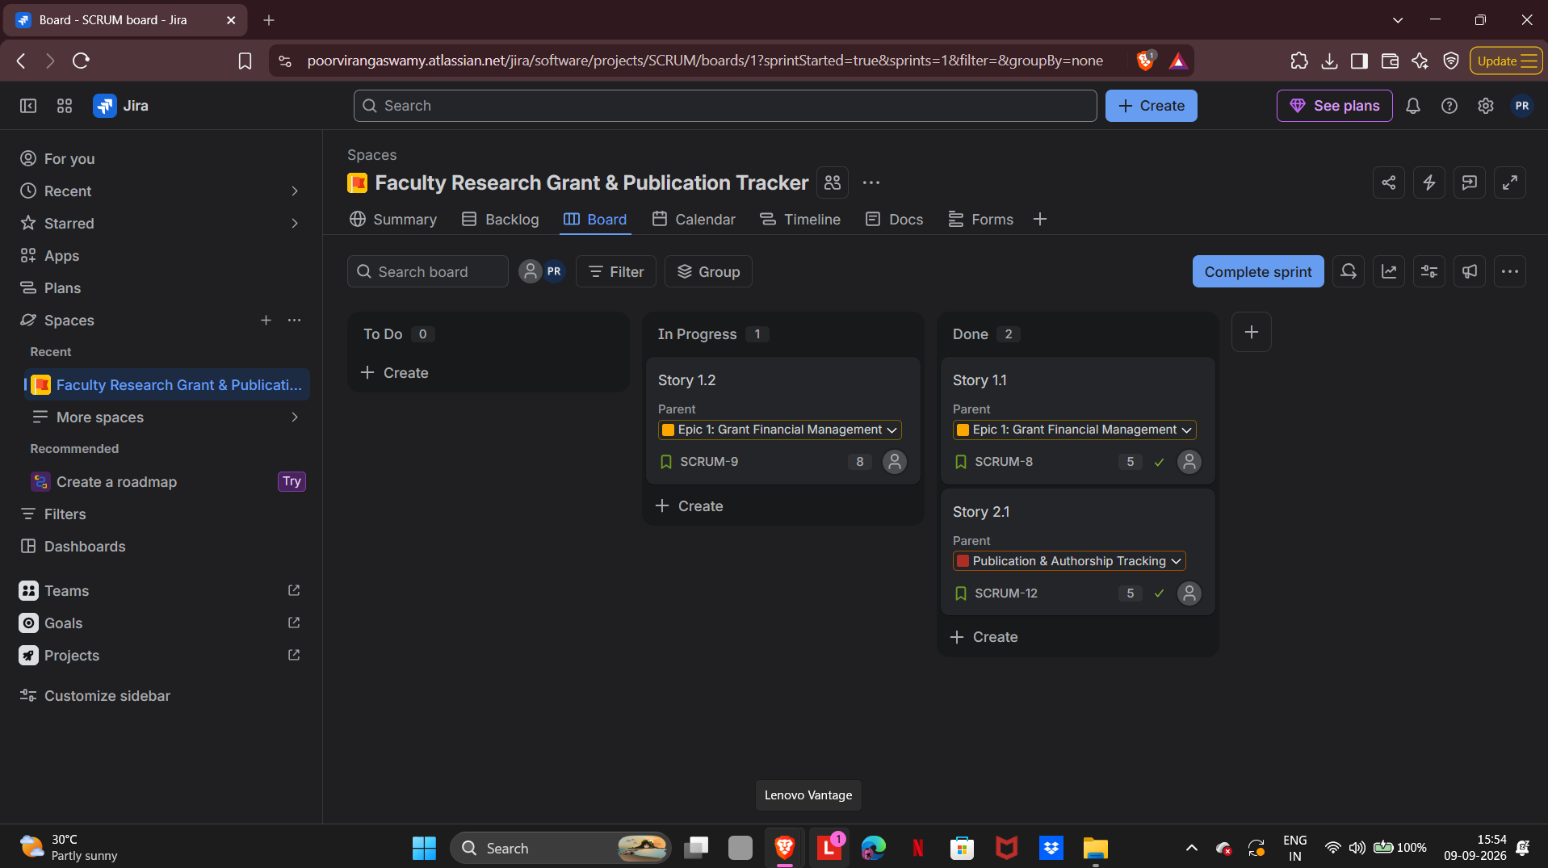

Burndown Chart 1
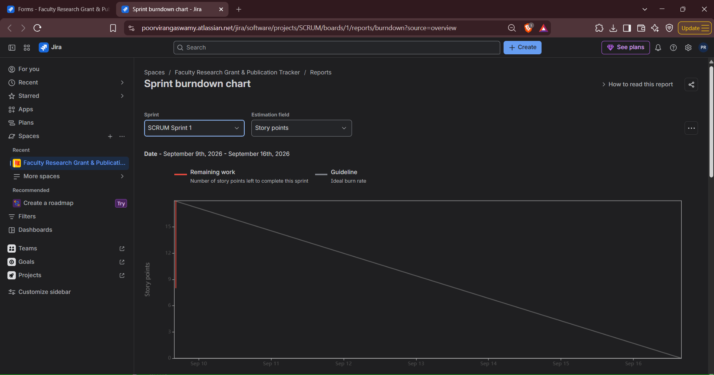

Mock Sprint Simulation 2
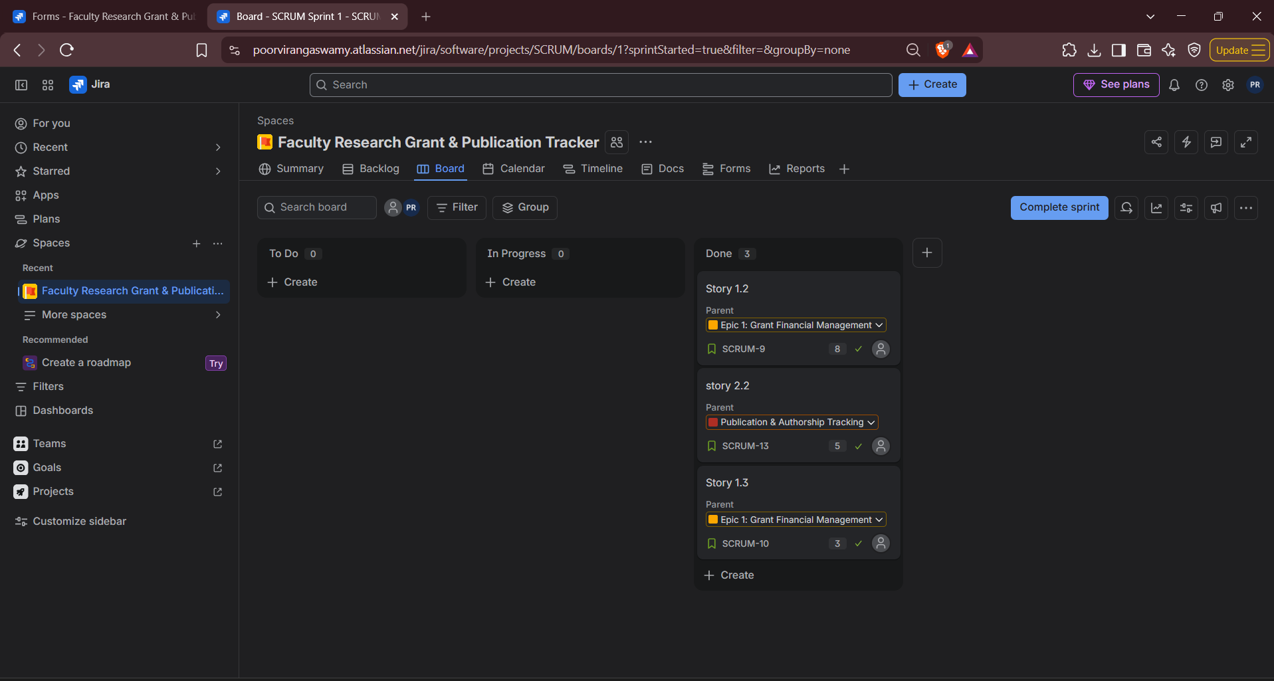

Burndown Chart 2

