Der **Microsoft Testmanager 2013** kann dazu verwendet werden um Testpläne zu organisieren, Test Cases zu erstellen und zu verwalten und um manuelle Tests auszuführen.

**Lab Management** ist ein Tool von Microsoft für Software-Tester, mit welchem virtuelle Umgebungen verwaltet werden. Es können Lab-Umgebungen für ein Teamprojekt auf Team Foundation Server erstellt und verwaltet werden. Eine virtuelle Umgebung ist eine Sammlung von virtuellen Maschinen. Jede dieser virtuellen Maschinen stellt eine Rolle dar (z.B. Webserver, Datenbankserver, Desktopclient,…), die für die Anwendung, die wir entwickeln, testen bzw. ausführen möchten, erforderlich ist. Labmanagement kann dazu verwendet werden um alle virtuellen Maschinen in einer virtuellen Umgebung für die Ausführung und den Test einer Anwendung zu starten. 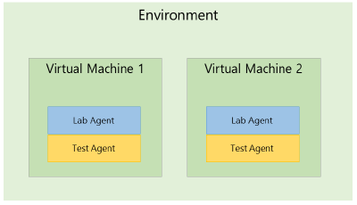

Es gibt zwei Typen von Lab-Umgebungen: die Standardumgebung und die SCVMM-Umgebung. Eine Standardumgebung kann physische und virtuelle Computer mit einer beliebigen Virtualisierungsplattform enthalten. Eine SCVMM-Umgebung kann ausschließlich virtuelle Computer enthalten, die von SCVMM auf der Hyper-V-Virtualisierungsplattform verwaltet werden. Weitere Informationen zu Lab-Umgebungen finden Sie unter Verwenden einer Lab-Umgebung für den Anwendungslebenszyklus.

Allgemeiner Ablauf (Standard-Lab-Umgebung):

* Testmanager starten, Verbindung mit Team-Projekt auf TFS und Testplan herstellen
* Lab-Center öffnen
* Test-Controller installieren, konfigurieren und mit Team-Projekt-Sammlung verknüpfen

**Notwendige Schritte**

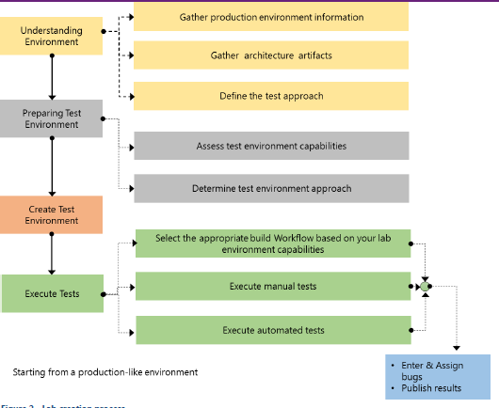

Gather production environment information

Obtaining information about the target production environment from your IT department is very important if you want to create a test production-like environment. SCVMM allows you to move physical computers to virtual machines if you want to avoid rebuilding the operating system and reinstalling applications. Depending on the following criteria, you can determine the P2V (online or offline) or V2V conversion.

* Physical server topology
* Operating system version and service pack
* Server type (physical, virtual)
* Server role
* Lab Management capacity planning

Define the Test Approach

After you determine the production environment information and the application architecture, you must define your test approach. First, determine how many servers you will require in your test environment to meet your test mission. Base this number on how many test cases you have to run. Next, based on the testing techniques that you will use in the execution test step, you can determine the test type and the test components that you will need in your environment.

* Obtain the following information from your test team.
* Determine the test mission
* Assess possible testing techniques
* Define the test metrics
* Define the test plan from the requirements
* Determine the test type (manual or automated)
* Determine if you need to test in parallel
* Identify the test area and environment
* Identity the test case flow details

Preparing the Test Environment

Creating Standard Environments using existing test rigs

If your project has existing test rigs then these can easily be integrated into Lab Manager and used for testing. This is done by adding the existing servers into Standard Environments. Lab Manager will then install the Test Agent on all the servers and allow all Lab Management features to be used on these rigs.

To create a standard environment, follow the steps in Creating a Standard Environment on MSDN.

Assess test environment capabilities

The test lab environment is dependent on the application types and your choice of consolidating the server and client test environments. There is no recommendation for the golden templates that are used to run the test lab environment. However, you should consider the following criteria:

* The test environment should resemble the production environment as closely as possible.
  + When you work with a Web Application or Client Server test lab environment, the environment should be split into a server VM and a client VM. In other words, you should define and implement a server and a separate client golden template, which are hosted as separate virtual environments.
  + When working with server or client environments that will be supported and maintained on different platforms or operating systems, each environment should be defined and implemented in a separate golden template. For example, when you are developing and testing a solution that has to run on Windows XP, Windows 7, and Windows Server 2008 R2, you would define and implement three different templates, which are hosted as separate virtual environments.

Determine the test environment approach

Before you create an environment, you need to create some basic assets in SCVMM. These assets will serve as the starting point for creating environments. In particular, you have to create either virtual machines or virtual machine templates. In SCVMM, you can create new virtual machines from any of the following production sources:

* Existing virtual production hard disks (VHDs)
* Existing production virtual machines
  + Hyper-V virtual machines
  + Virtual Server virtual machines
  + VMware virtual machines
* Existing physical computers

Your choice of virtual machine sources will depend largely on your needs and existing infrastructure.

* **Existing Hyper-V or Virtual Server Virtual Machine** 
  + Used when you want to create a clone of a virtual machine for testing, UAT, or Stage/Preproduction Environment.
* **VMware to Virtual Machines Conversion** 
  + See this conversion approach and considerations in V2V: Converting Virtual Machines in VMM9.
* **Physical to Virtual Machines Conversion** 
  + See this conversion approach and considerations in P2V: Converting Physical Computers to Virtual Machines in VMM

Creating the Test Environment

There are two ways to create an environment:

* New virtual environment
* Composed virtual environment

To create a new virtual environment (or also referred to as SCVMM environment), follow the steps in Creating an SCVMM Environment Using Stored Virtual Machines and Templates11 on MSDN.

http://msdn.microsoft.com/en-us/library/ee518915.aspx