Systematic Evaluation of ICT Liquidity-Sweep Strategies on Nasdaq Futures
An 11-Year Walk-Forward Study with a Rigorous Negative Result
Felix Liu · July 2026
Instruments: NQ / MNQ (CME E-mini & Micro Nasdaq-100), ES · Data: 3.79M one-minute bars, 2015–2026 (Databento GLBX.MDP3)

Abstract
This project tested whether "Smart Money Concepts" (ICT) — liquidity sweeps, market-structure breaks, fair value gaps, order blocks, and higher-timeframe bias — can be converted into a profitable automated trading system on Nasdaq-100 futures. Over 17 research phases spanning rules-based engines, machine-learned setup filters, and a native top-down implementation, a walk-forward LightGBM strategy appeared to deliver +17.7% average annual return with a 0.96 Sharpe ratio. A five-part validation battery — transaction-cost modeling, honest metric conventions, nested walk-forward configuration selection, data-integrity auditing, and block-bootstrap inference — reduced this to a cost-adjusted, selection-bias-corrected Sharpe of approximately 0.2, statistically indistinguishable from zero, with no measurable edge at all in the most recent 3.5 years. A faithful implementation of a publicly-taught top-down playbook — its rules fixed by an external source before testing — performed indistinguishably from random entries sharing the same exit engine. The conclusion is a well-supported negative: mechanically-defined ICT concepts do not carry deployable edge on intraday index futures at retail execution granularity. The report documents the methodology, the failure modes that produced the illusory headline result, and the validation framework — which is the transferable deliverable.

1. Research Question & Approach
ICT is a popular discretionary framework asserting that price is drawn toward pools of resting liquidity, and that sweeps of those pools followed by structural confirmation mark high-probability reversals. It is almost always taught and traded by hand. The research question: when its concepts are pinned down as falsifiable mechanical rules, do they retain predictive value that survives realistic frictions and honest statistics?
The approach was iterative hypothesis testing: implement a concept mechanically, backtest it walk-forward out-of-sample over 11 years, record the verdict — positive or negative — and let each result constrain the next hypothesis. Seventeen phases were completed and documented; every result table in this report derives from stored artifacts reproducible from the project repository.

2. Data & Infrastructure
- Data: 3.79M one-minute OHLCV bars per instrument (NQ/MNQ continuous, June 2015 – June 2026), plus ES and 1-minute VIX futures for cross-sectional tests. Integrity-audited: zero duplicate or non-monotonic timestamps; 214 inter-bar gaps >0.3% in 11 years, dominated by session breaks and quarterly rolls; trades adjacent to gaps contributed ~1% of PnL (Section 5.4).
- Feature engine: a Pine Script indicator translated to a causal, bar-by-bar Python engine (zero look-ahead) producing 11 setup features per liquidity-sweep event: sweep direction/size, liquidity type and clustering strength, BOS strength, FVG rejection, retracement depth, time-since-sweep, and session flags. 39,079 labeled setups.
- Labeling: first-touch outcome vs a +2R target and -1R stop from the sweep extreme; dual-touch bars conservatively labeled as losses.
- Validation harness: rolling chronological walk-forward (retrain every 5 setups; 6-month training window; 1-year warm-up); LightGBM classifier gates trade entry by predicted success probability. Execution simulated on 1-minute bars with conservative dual-touch handling; split take-profit exits (half at +2R with stop to breakeven, half at +4R).

3. The Research Program (17 Phases)
Each phase was a discrete hypothesis with a recorded verdict. Failures were kept, not discarded — they form the evidential base of this report.
Phase | Hypothesis | Verdict
1 | Rules-only sweep trading (sessions, stops, liquidity filters) | Failed — expectancy ≈ 0
2 | ML setup filter, expanding window | Partial — concept works, config stale
3 | Structural upgrades (BOS-only trigger, swing-pivot dealing range) | Adopted
4 | HTF daily-bias features & filters | Failed — blocks mean-reversion edge
5 | Confluence comparison (OB, breaker blocks) | Breaker adopted; OB rejected
6 | Risk-based sizing; HTF trend filter | Both rejected
7 | Intraday VIX features (5 variants) | All failed vs baseline
8 | 11-year validation of approved config | +16.0%/yr, 0.73 avg Sharpe (gross)
9 | State-space delayed entries | Failed catastrophically
10 | Break-even win-rate gating | Failed — negative Sharpe
11 | Chronological training-window sweep | 6-month window adopted → headline result
12–13 | Dynamic thresholds; threshold sweep | Constant 0.25 confirmed
14 | Five enhancements (decay, BE, ensemble, interactions, pruning) | All degraded performance
15 | Port to S&P 500 (ES) | Failed — strategy is NQ-specific
16 | GBDT ensemble (XGB+LGB+Cat) | Planned, not completed
17 | Externally-specified top-down playbook (publicly-taught ICT methodology) | Failed — ≈ random entries (Section 6)

4. The Headline Result — and Why It Demanded Skepticism
Phase 11 produced the project’s best configuration: a 6-month chronological training window with a constant 0.25 probability threshold, NY-session entries, a 60-point risk cap, and split exits. As conventionally reported it showed +17.72% average annual return, 0.96 average Sharpe, and 11.48% average max drawdown over 2016–2026 (~422 trades/year).
Three properties of that number warranted a formal validation battery before any capital decision: it was selected from dozens of swept configurations evaluated on the same data that produced it; it was computed gross of all transaction costs at a ~470 trades/year cadence; and its metric conventions (averaging per-year Sharpes computed from 12 monthly points; averaging per-year drawdowns) are systematically flattering.

5. Validation Battery

5.1 Transaction costs
Cost model: $4.60 all-in round-turn commission per NQ contract (1.6 NQ ≈ the strategy’s $32/point exposure) plus one tick of slippage on stop-side exits (scenario A); scenario B adds one tick of entry slippage and two-tick stops. The strategy’s gross expectancy is only ~$37–42 per trade, so fixed per-trade frictions consume 36–74% of the edge.
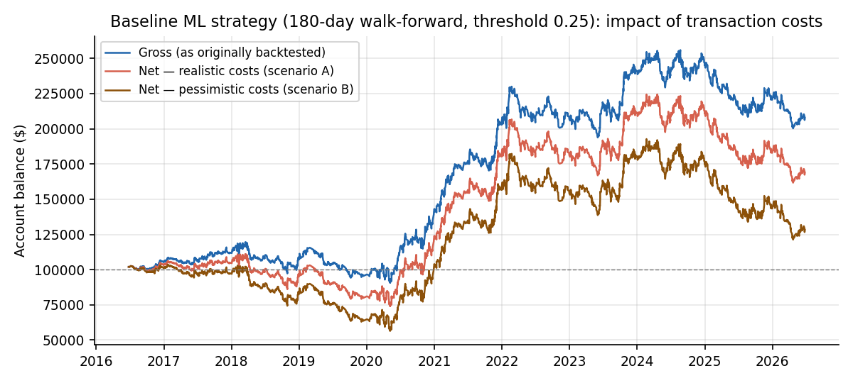
Figure 1 — Baseline equity curve, gross vs. two cost scenarios. Costs convert a rising equity line into a marginal one.

5.2 Honest metric conventions
Metric | As reported | Corrected (gross) | Net, scenario A | Net, scenario B
Sharpe ratio | 0.96 (avg of yearly) | 0.59–0.62 (pooled) | 0.40 | 0.22
Return | 17.7% (avg yearly) | 7.5–15.3% CAGR | 5.4% | 2.5%
Max drawdown | 11.5% (avg yearly) | 24–36% (full period) | 33% | 45%
Calmar | ~1.5 (implied) | 0.31–0.42 | 0.16 | 0.06

Corrected-gross ranges span the original LightGBM run (from its own yearly table) and the reproduction run (Section 5.5). Every correction is a standard convention, not a judgment call: pooled monthly Sharpe over all 120 months rather than an average of 11 noisy yearly Sharpes; full-period peak-to-trough drawdown rather than an average of within-year drawdowns.

5.3 Nested walk-forward: measuring selection bias
The window and threshold were originally chosen by sweeping configurations over the full sample. To measure the cost of that hindsight, a nested protocol re-selected the configuration each year using only prior data (12-cell grid), then traded the following year with it. The honest procedure earns a 0.19 pooled Sharpe and 1.8% CAGR net — roughly half of the fixed-configuration result vanishes, and the nested selections lost money in 2024, 2025, and 2026H1.
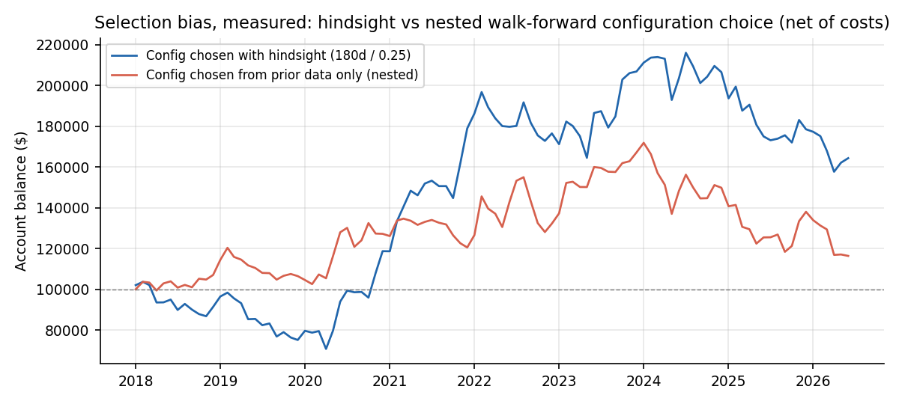
Figure 2 — Hindsight configuration vs. nested (prior-data-only) selection, net of costs, 2018–2026.

5.4 Data integrity
The one test the strategy passed cleanly. No duplicate or out-of-order timestamps; gap analysis attributes large jumps to session breaks, quarterly contract rolls, and genuine volatility events (March 2020, CPI releases). Trades entered within 24 hours of a >0.5% gap were 3.1% of all trades and ~1% of PnL. The negative results above are not artifacts of bad data.

5.5 Implementation robustness and statistical inference
An independent histogram-GBDT implementation with identical hyperparameters, trained on identical data through the identical walk-forward, produced a materially different trade set — and at matched trade frequency captured only ~4.5%/yr gross versus the reported 17.7%. A deployable edge should be a property of the strategy and data, not of one library’s tie-breaking; this fragility is corroborated by Phase 14, where even seed-averaging degraded the original result. The ranking is not pure noise — expectancy rises monotonically with model confidence (Figure 3) — but the per-trade edge is thin relative to frictions.
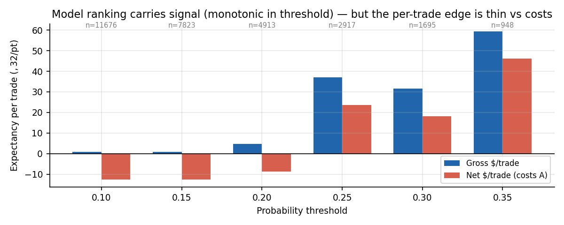
Figure 3 — Per-trade expectancy by probability threshold: real but thin signal, largely absorbed by costs.
Block-bootstrap inference on the net monthly returns yields a 90% confidence interval of [-0.14, +0.90] around the 0.40 net Sharpe, with an 11% probability that the true Sharpe is at or below zero (Figure 4). The bootstrap drawdown distribution at the tested sizing has a median of ~39% per decade (95th percentile: 89%). The most recent 3.5 years (2023–2026H1) show approximately zero net edge in both the original and reproduction runs; the profitable years are concentrated in the 2019–2022 volatility expansion.
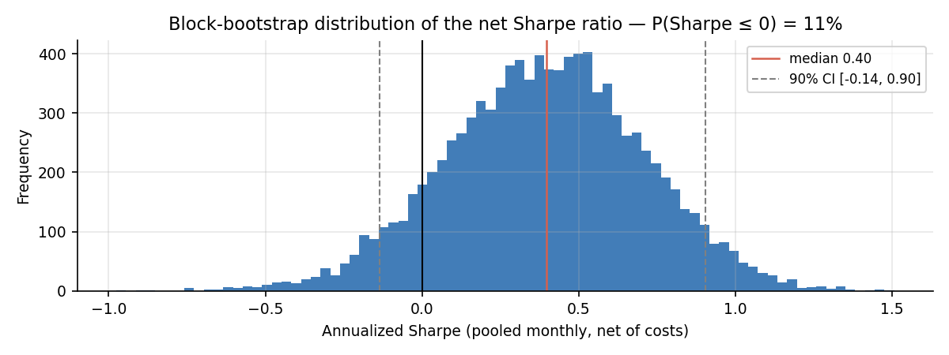
Figure 4 — Bootstrap distribution of the net Sharpe ratio. The edge is not statistically distinguishable from zero at this horizon.

6. Final Test: An Externally-Specified Top-Down Playbook
The final test targeted a complete top-down playbook transcribed from a publicly-taught ICT methodology (a popular trading educator’s published rules), rather than a specification designed in-house. This provenance is a methodological strength: the rules were fixed by a third party before any contact with the test data, eliminating researcher degrees of freedom in the rule design itself. The specification: 1h/4h BOS-trend bias (4h overriding 1h; agreement selects 5-minute execution, opposition 15-minute), bias-matching sweeps of 1h/4h pivot, prior-day, and session liquidity, execution-timeframe break of structure, retracement into order block / FVG / breaker / equilibrium, and scale-down lower-timeframe BOS entry. The only elements the source left unspecified — stop and target placement — were resolved by testing all four defensible interpretations; all other parameters were fixed a priori, costs were included from the first run, and no optimization was performed.
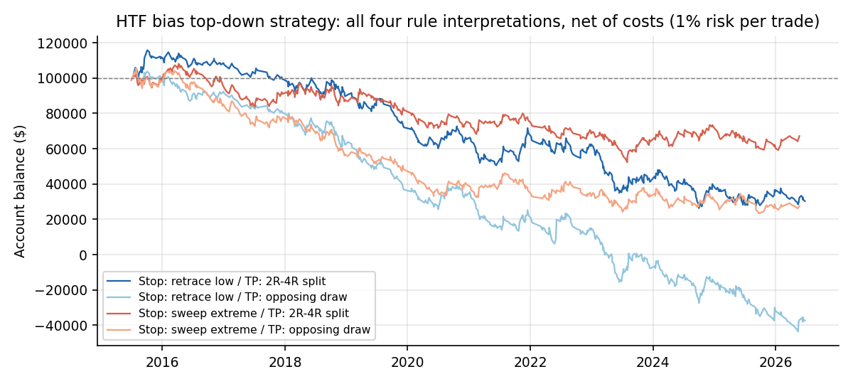
Figure 5 — Top-down implementation: all four rule interpretations lose net of costs (~55 trades/yr, costs only ~4% of risk).
The setup funnel was healthy (4,839 sweeps → 1,212 BOS → 1,069 POI touches → ~600 entries), so the system fired exactly as designed. The decisive comparison: random entries pushed through the identical exit engine with a matched risk distribution scored a mean of -5.7R (range -44 to +54 across seeds); the strategy’s -19.5R sits inside that noise band, and its 33.0% win rate is below the random benchmark’s 35.1%. The full bias→sweep→structure→confirmation stack selected entries no better than chance, while its confirmation delay cost entry price — consistent with three independent implementations across the project.

7. Conclusions
- Mechanically-defined ICT concepts show no deployable edge on intraday Nasdaq futures. Whatever validity the framework has appears to live in discretionary, hindsight-flexible judgment that cannot be automated — and the burden of proof that it exists even there remains unmet.
- The apparent 17.7%/0.96 result decomposed into: flattering metric conventions (~35% of the Sharpe), configuration selection bias (~50% of the net result), classifier-implementation luck (unquantifiable but demonstrably large), transaction costs (36–74% of gross per-trade edge), and regime concentration in 2019–2022.
- The residual real signal — monotonic expectancy in model confidence — is genuine but too thin to clear per-trade frictions at scalping frequency, and absent entirely since 2023.

8. Methodological Lessons
These generalize beyond this strategy and constitute the project’s durable value:
- Average-of-yearly Sharpe ratios and average-of-yearly drawdowns systematically overstate performance; pooled returns and full-period drawdowns are the honest defaults.
- Selection bias is measurable: nested (prior-data-only) configuration selection is cheap to run and, here, erased half the result. Any swept hyperparameter must be selected inside the validation loop.
- Implementation-swap testing is an underused robustness check: retraining with an equivalently-specified model from a different codebase is a powerful overfitting detector, in the same family as seed perturbation.
- Cost floors bind strategy design: with fixed per-trade frictions, viability scales with per-trade range — trade frequency is a liability, not an asset, for thin-edge signals.
- Random-entry benchmarks with identical exit machinery isolate whether entry logic contributes anything at all.
- Negative results retain value only if recorded: seventeen documented phases turned an unprofitable strategy into a reusable validation framework and a falsification study.

Appendix — Conventions & Tooling
- Sharpe: pooled monthly returns on month-start balance, ddof=1, annualized ×√12, risk-free rate 0 (conservative direction for a positive-mean strategy).
- Costs: NQ all-in $2.30/side/contract; 1 tick = $5/NQ; exposure normalized to $32/pt (= 16 MNQ ≈ 1.6 NQ). MNQ execution of equal exposure roughly triples commission drag.
- Bootstrap: circular block bootstrap, 3-month blocks (Sharpe, 10k reps) and 50-trade blocks (drawdown, 5k reps).
- Stack: Python (pandas/NumPy/LightGBM), custom C histogram-GBDT for the replication study, causal Pine-to-Python feature translation, 1-minute execution simulation with conservative dual-touch handling. All experiment artifacts and per-phase reports are archived in the project repository.

