System design document for Coffee Break

Version: 0.1

Date: torsdag den 11 maj 2017

Author: Felix

This version overrides all previous versions.

# 1 Introduction

General info. What is this? What does it describe?

## 1.1 Definitions, acronyms and abbreviation

Todo-list – A list of different tasks that the user wishes to get done.

Task – The simple item that the user can add to his/her Todo-list

List task – A more complex version of a task, which creates the Task with the specified name and also contains a list of different tasks that the user can use to specify a list of tasks in a single place. This way, the user receives another option when they wish to organize/structure their Todo-list.

Time Category – The category which tasks can be sorted into which involve a certain timeframe

Label Category – Custom categories that the user can create through either adding custom labels/tags onto their task during creation, or through setting up static categories which are always visible.

Test-driven development – Abbreviated as TDD. Before any new code is written for the application, a test for the specified component will be make using the different specifications for the component as guidelines. This will lessen the number of bugs in the end product. The procedure can be read in depth at <https://blog.jetbrains.com/idea/2016/12/live-webinar-the-three-laws-of-tdd/> .

MVC – “Model, View, Controller”, a design model used in the most applications/programs today. The Model is the database which handles all of the logic and calculations. The View is the what is actually shown to the user, and the Controller handles the interaction between the user and the Model.

Object Oriented implementation – A certain form of programming paradigm, where the coding is divided into different objects and classes. This is to break up the different tasks into smaller, more manageable parts and then tackling the problem by creating one “puzzle piece” at a time.

# 2 System architecture

The most overall, top level, description of the system. Which (how many) machines are involved? What software on each (which versions). Which responsibility for each software? Dependency analysis. If more machines: How do they communicate? Describe the high level overall flow of some use case. How to start/stop system.

An ​UML deployment diagram​, possibly drawings and other explanations. Possibly UML sequence diagrams​ for flow.​

(Persistence and Access control further down)

Any general principles in application? Flow, creations, ...

# 3. Subsystem decomposition

For each identified software above (that we have implemented), describe it ...

## 3.1 “...First software to describe” ...

Recap: What is this doing (more detailed)

Divide it into top level subsystems. An ​UML package diagram for the top level. Describe responsibilities for each package (subsystem). Describe interface. Describe the flow of some use case inside this software. Try to identify abstraction layers. Dependency analysis Concurrency issues.

If a standalone application

* Here you describe how MVC is implemented
* Here you describe your design model (which should be in one package and build on the domain model)
* A class diagram for the design model.



Figure 1 MVP Design Pattern

### MVC, MVP and MVVM

The system of this application has been implemented using the standard MVC architectural design principle. In an Android application, all MVC-based architectural flows will look similar to this independently of the specific implementation you choose.

For the Android API, there are three fitting MVC patterns: MVC, MVP and MVVM. These three implementations all share the same principle of separating the calculations and data into the Model and displaying the data independently inside the View. What distinguishes them from each other is the way that the Model and View communicate: through a Controller, Presenter or a Viewmodel.

This application is based on the MVP-pattern, where the Presenter acts as the brains of the operation. Instead of having a Controller which consists of all the implementation logic that the View needs to display the data of the Model, the Presenter only handles the communicative logic between the Model and the Views. More precisely, the Presenter keeps track of the user interaction in the View and modifies the Model accordingly, but the View itself handles the logic for what it should display. With that said, the necessary Data that will be displayed for the User is fetched from Model by the Presenter and handed to its associated Activity in the View. The Activity then inflates the necessary XML-Layout to show on the screen.

An Activity sort of acts as a small Controller for each specific View, and the Presenter is the communicator between the Activity and the Model, only telling information that is necessary to be shared between the two. This way, the View never communicates directly with the Model, due to all the representational logic being implemented in the Activity. When the User interacts with the View, the Activity will notify the Presenter, which then tells the Model to make the necessary calculations. Conversely, the results are then sent back to the Activity via the Presenter, which then updates the View.

#### Pros and Cons of MVP

For smaller applications such as this one, going with MVC instead of MVP and MVVM may be beneficial. More specifically, applications with few Activities and XML-Layouts that can be coupled together and don’t have many hierarchies won’t necessarily need to have a delegating Controller to handle the work between the rest. The Activities and Fragments themselves may be enough for handling the communicational logic and don’t get too bloated in the process. The benefits will be less code to implement, and therefore less time needed for the same result.

The backside of the use of MVC instead of the other patterns is that the Controller and the View become very tightly coupled. In return, this makes the Controller hard to test using *TDD* due to the dependencies of the View, but also quite hard to *Maintain* as the Controller will easily get code added in the future, making it bloated and brittle. Using MVC also has a *Modularity* and *Flexibility* -issue. Due to the Controller being so tightly coupled with the View, it may even be an extension of the View itself. If the View will need to be changed in the future, then the Controller also will have to change.

Therefore, we chose to go with MVP. Even though implementing the application in this fashion means more code, MVP handles these issues in a better manner. Having the Views consist of both the XML-layouts and their respective Activities/Fragments, and letting the Controller for each View be the Presenter in the form of an external class allows for better *Modularity*, *Flexibility* and *Reusability* of code. In return, this gives a more *Maintainable* end product.

### Diagrams

* Dependencies (​STAN​ or similar) - UML sequence diagrams for flow.

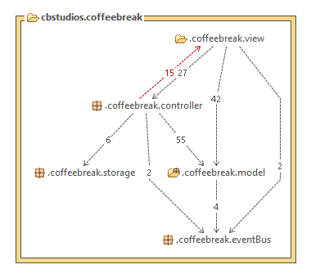The STAN diagram above shows the dependencies between the four different main packages: Model, View, Controller and Storage/Util, plus the used Android Event Bus library.

Figure 2 STAN Diagram of the MVP structure

So far, there aren’t any circular dependencies, except for those between the Controllers and Views. However, this circular dependency is necessary due to the Presenter in the Controller package acts as the mediator between the View and Model. Therefore, it gets called by the Activity in the View when the User interacts with the application. The dependency in the reverse direction is due to the Presenter returning information from the Model when the View is to be updated in a major way. This is one of the trade-offs for choosing to go with MVP, because the “Controller” of MVC is split into two, the mediating Presenter and the structuring Activity. (See MVC, MVP and MVVM for more information.)

The direct dependencies between the Model and the View packages is due to the Adapter class and its inherent ViewHolder class, which represent each existing task in the categorized list and updating their respective Task directly when its state is changed.

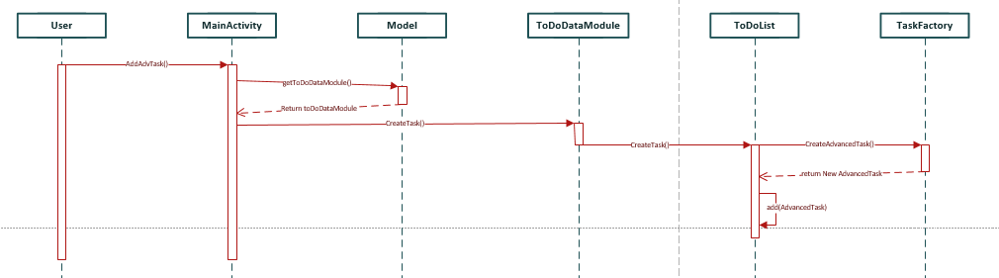

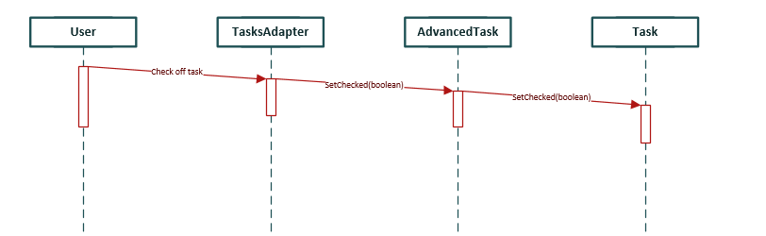

### Quality

All tests are found in *Application/CoffeeBreak/app/src/test/java/cbstudios/coffeebreak/*. The name of each test is a description of what the test tests.

Some of the tests are tests for use-cases. These tests test the functionality of the software on a higher level compared to the other tests. The name of such a test is marked with ”UC”.

#### List of tests

* CategoryListTest
* ModelTest
* MultipleDayTimeCategoryTest
* SaveAndLoadTest
* SingleDayTimeCategoryTest
* TaskEqualsAndHashcodeTest
* TaskFactoryTest
* TaskSorterTest
* ToDoDataModuleTest
* UCCreateAndCheckTaskTest
* Quality tool reports, like ​PMD​ (known issues listed here)

NOTE: Each Java, XML, etc. file should have a header comment: Author, responsibility, used by.., uses ...

## 3.2 “...next software to describe” ...

As above….

# 4. Persistent data management

How does the application store data (handle resources, icons, images, audio, …). When? How? URLs, pathe’s, … data formats… naming..

# 5. Access control and security

Different roles using the application (admin, user, …)? How is this handled?

# 6. References

The three laws of Test Driven Development - <https://blog.jetbrains.com/idea/2016/12/live-webinar-the-three-laws-of-tdd/>