This plugin only operates on the Smart Client and visualizes data from the head detection and skeleton channels.

Install: Create a folder in C:\Program Files\Milestone\MIPPlugins and put the compiled files there. Restart the Smart Client.

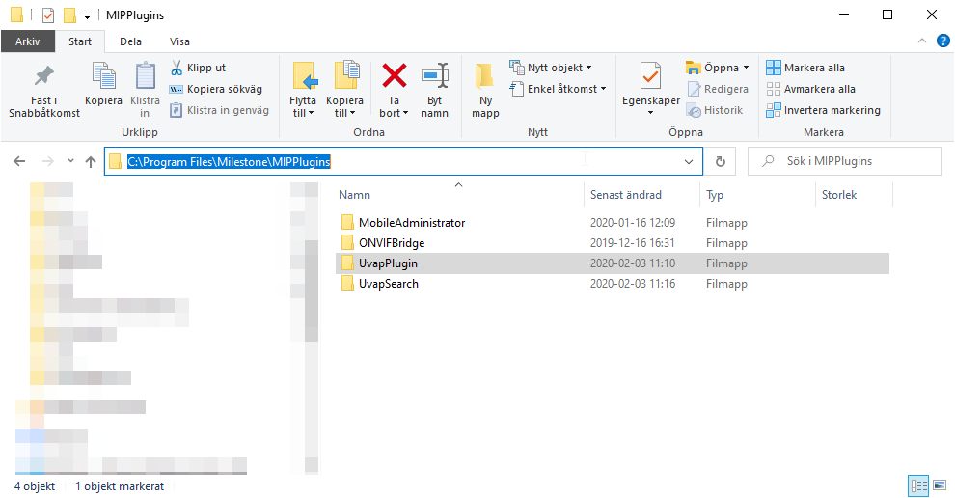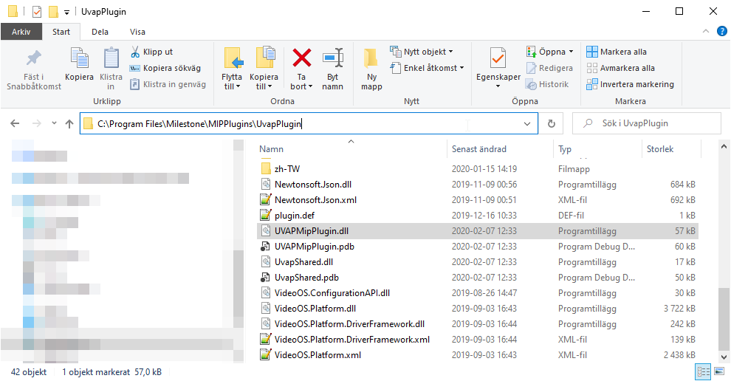

Note: The metadata channel must be related to the camera for this plugin to work. In the Management client, go to Cameras, select the camera, go to the Client tab and select the related metadata channels. See the driver document for more info.

# Settings

This plugin is enabled by default upon install. To disable this plugin, go to the Smart Client settings panel. Expand the “More menu” button on the upper right and press “Settings”.

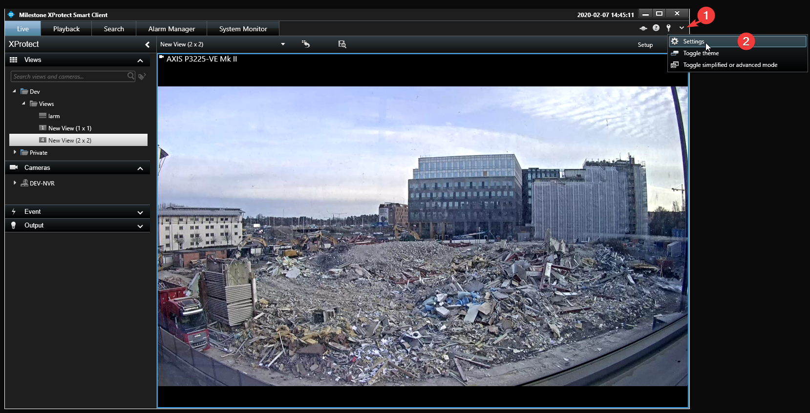

Press the “UVAP overlay setup” button.

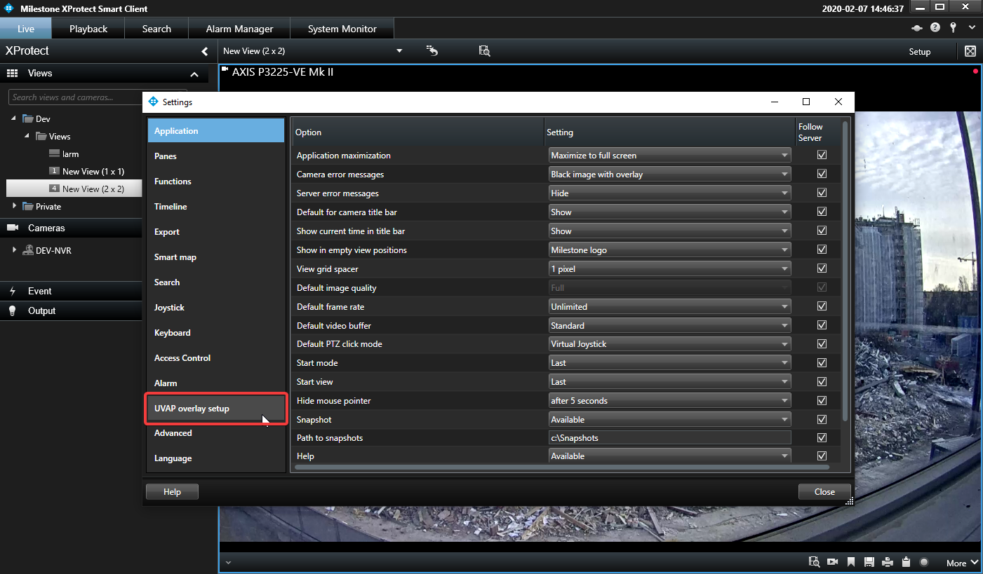

Tick or un-tick the visualzers you wish to enable/disable. The changes will apply the next time you open a new camera view in the application. Press “Close”.

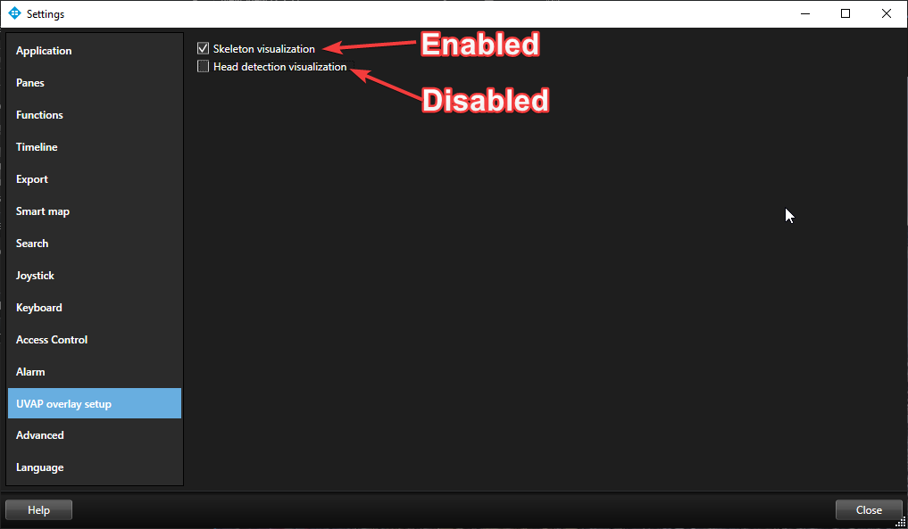

# Dependecies

.NET Framework 4.7 or later (Requires install) <https://dotnet.microsoft.com/>

Newtonsoft.Json 12.0.3 (Included in build) <https://www.newtonsoft.com/json>