**Character Creator**

The Character Creator is no doubt the simplest tool to use. A character in the creator is comprised of a Name, a Description and an Importance.

* Name: The full name of the character. This includes first, middle and last names as well as any base honorifics (Mr, Ms, -san, -sama, etc…) that should be used.

Examples:

* + Minato Arisato
  + Yu Narukami-san
  + Ms Linda Carmichael
  + Classmate
  + Etc…
* Important: The “important” checkbox indicates to the devs that this is a character that needs a sprite in-game. If this checkbox is checked, please make sure to enter a physical description in the “Description” field.
* Description: Any information relevant to the character. Use in story, Persona, attitude, life story, etc… If the character is marked as “Important”, please be sure to give a physical description. If you have no ideas, put something like “artist’s discretion”.

Examples:

* + Classmate: Generic classmate for use in social links.
  + John Cena: Main character of the Strength social link. Persona is “Hulk Hogan”. A headstrong wrestling enthusiast that… He always wears a baseball cap, but rest of design is artist’s discretion. Catch phrase is “You can’t see me!”.

***UI Guide***

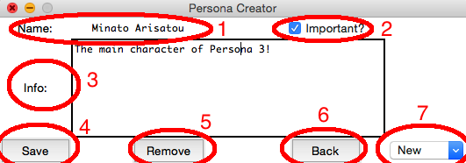

1. Enter character name here.
2. If character needs a sprite, hit this checkbox.
3. Enter any and all information concerning this character.
4. Click “Save” at any time to save changes made to the character you’re currently working on. CAUTION! Current version for OSX will not warn you if you are overriding an existing character! Name cannot be “New” or empty!
5. Click “Remove” to delete the character that is currently open. CAUTION! Current version for OSX will not warn you that this operation is permanent. Be sure!
6. Click “Back” to return to the main page of the Story Creator.
7. This drop-down menu holds all current characters. To edit a character, simply select it from this drop-down menu.

When a character is saved for the first time, it’s name will be added to this list immediately.

**Persona Creator**

The Persona Creator is equally simple in design, but contains a lot more data. Simply fill out all applicable fields and click “Save”.

* *Name*: The Persona’s name. This is a required field.
* *Arcana*: The Persona’s arcana. This is a required field and defaults to “Fool”.
* *Level*: The Persona’s base level. This is a required field and must be whole number.
* *STR*, *MAG*, *END*, *AGI* and *LUCK* are the Persona’s base stats in, respectively, Strength, Magic, Endurance, Agility and Luck. These are all required fields and must be whole numbers.
* *Inherits*: These two types indicate which spells and powers the Persona is most likely to inherit upon creation. There are two tiers of probabilities: High and Low. If no types are selected, the persona has equal chance to inherit anything. CAUTION! To inherit “support” type spells, mention it in the “Info” box for now. This possibility will be added shortly.
* *Initial* *Spells*: These are the spells and abilities that the Persona has by default. To remove one, simply set the spell to empty.
* *Resistance*: The Persona’s resistance to each element. Note that “Survive” and “Endure” do not make much sense unless attributes to Light and Dark.
* *Learned* *Spells*: These are the spells a Persona learns when reaching a certain level. To add one, select the spell to learn and enter the level at which it should be learned. Note that the level must be a whole number that is larger than the Persona’s base level. Then click “+”. To remove a learned spell, select it from the list and click “DEL”.

Functionality:

* *New*: To create a new Persona, click the “New” button.
* *Save*: To Save the current Persona, click the “Save” button. CAUTION! Current version for OSX will not warn you if you are overriding existing data!
* *Edit*: To edit a Persona, select it from the list and click “Edit”. CAUTION! Current version for OSX will not warn you if you are losing unsaved data.
* *Remove*: To remove the current Persona, click the “Remove” button. CAUTION! Current version for OSX will not confirm the deletion. Be sure!
* *Back*: Return to the Story Creator main menu.

***UI Guide***

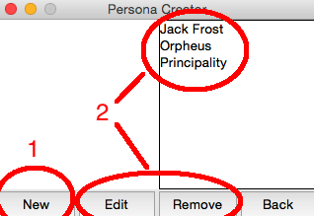

1. Click “New” to create a new Persona.
2. With an existing Persona selected, click “Edit” to edit that Persona or “Remove” to delete it.

To add a Learned Spell:

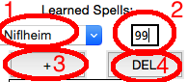

1. Choose the spell to be learned.
2. Enter the level at which the Persona learns this spell.
3. Click “+” to add this spell to the list.
4. With a spell selected in the list, click “DEL” to remove it.

Example of complete Persona

