Name : Tristan Dominic l. Parajes

Offer No.: 80047 Subject Code: SEMTOUR

Instructor: Rochel Mae Victoria S. Nazareno Description:Seminars& Tour
Introduction:
This learning journal presents the experiences and insights gained during the educational plant tour in Iligan City for students taking up Bachelor of Science in Computer Science (BSCS) and Bachelor of Science in Information Technology (BSIT). The activity provided students with the opportunity to witness how technologies, computer systems, and industry practices are applied in actual work environments. Through this experience, students were able to connect classroom discussions with real-world operations and better understand the role of technology in modern industries.
Learning Activity 1: Plant Tour (Cagayan de Oro)
Date: May 20, 2026
Company/Facility Visited: (CEPALCO)Cagayan Electric Power & Light Company
Activity Objectives:
- To gain actual exposure to the operational processes within CEPALCO.
- To observe the use of technology and automation in industrial operations.
- To recognize the relationship between academic concepts and their practical applications in the workplace.

Approaches:
- Attended an orientation conducted by company representatives regarding the company’s operations and systems.
- Participated in a guided facility tour to observe different operational areas.
Engaged in a question-and-answer session with company personnel for further clarification and understanding.
Challenges:
- Staying attentive while taking notes inside a busy and noisy environment.
- Understanding unfamiliar technical terms used by the employees.
Determining how computer science and information technology concepts are applied within the company’s operations.
Lessons Learned:
- Effective organization and workflow management are important for maintaining efficient operations.
- Technology plays a major role in improving productivity, monitoring, and communication within the company.
Continuous learning is necessary to keep up with advancements in technology and industry practices.

Documentation:
- Pictures with captions:
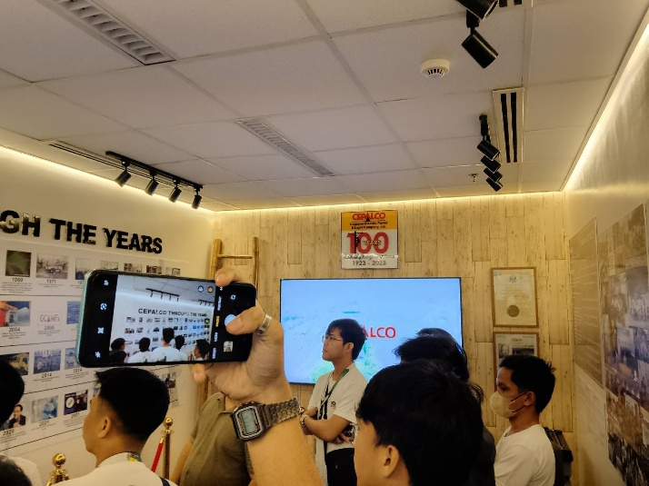
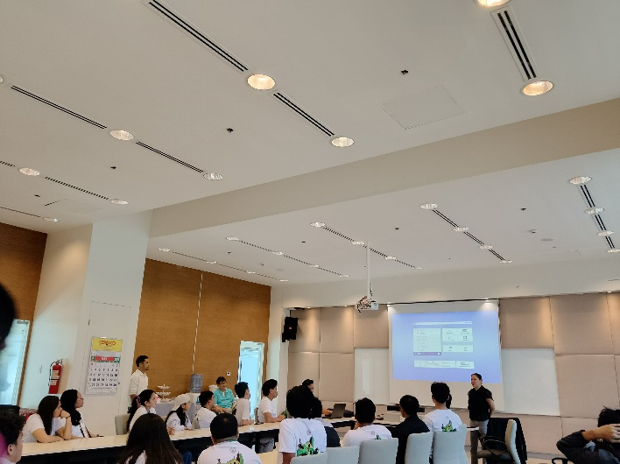
Company Orientation and Introduction
Students were given a tour and orientation about the history and development of CEPALCO. Company representatives discussed how the company started, its growth through the years, and its role in providing reliable electrical services to the community. The discussion also highlighted the technologies and systems used by the company to improve operations and maintain efficient power distribution.
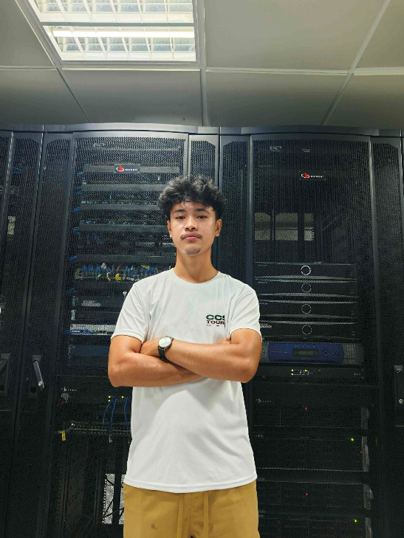

CEPALCO Server Room Observation
Students were given a tour of the server room where the company manages its computer servers, networking equipment, and communication systems. The personnel explained how the servers store and process important operational data used in monitoring and maintaining electrical services. The activity helped students understand the importance of servers, networking infrastructure, and data management in supporting the daily operations of a power distribution company.

Guide Questions:
- How did the pre-tour briefing prepare you for understanding the production process?
The pre-tour briefing introduced the company’s operations, safety guidelines, and the systems involved in power distribution and monitoring. It helped provide background knowledge about the facilities and allowed students to better understand the purpose of each department visited during the tour. The orientation also made it easier to appreciate the technologies and processes observed inside the company.
- Describe a specific technology or practice that surprised you during the tour.
One of the most impressive technologies observed during the tour was the real-time monitoring system inside the control room. The computer systems and large monitoring screens displayed live operational data, allowing personnel to monitor electrical performance and immediately respond to issues. It was interesting to see how technology helps maintain stable and efficient power services.
- Explain how this plant tour relates to the concept of supply chain management.
- The plant tour is connected to supply chain management because CEPALCO manages the organized distribution of electricity from its sources to consumers. The company uses monitoring systems, communication technologies, and proper coordination to ensure uninterrupted services. Similar to supply chain management, efficient planning and monitoring are necessary to maintain smooth operations and reliable service delivery.
- (For BSIT students) How could IT systems be integrated to optimize production at this facility further?
IT systems could further improve operations through advanced data analytics, predictive maintenance systems, and automated reporting tools. Artificial intelligence and cloud-based technologies could help identify possible technical issues before they happen. In addition, centralized databases and mobile communication systems could improve coordination between departments and support faster decision-making.
Conclusion:
The CEPALCO plant tour was a meaningful learning experience that allowed students to witness the practical application of technology, automation, and computer systems within the energy sector. The activity enhanced students’ understanding of how information technology and computer science contribute to efficient operations, communication, and system management in large organizations. Overall, the experience encouraged students to continue developing their technical skills and deepened their appreciation for the role of technology in modern industries.

LEARNING JOURNAL

Name : Tristan Dominic l. Parajes

Offer No.: 80047 Subject Code: SEMTOUR

Instructor: Rochel Mae Victoria S. Nazareno Description:Seminars& Tour
Introduction:
This learning journal summarizes the experiences and knowledge gained during the educational plant tour conducted in Iligan City for students taking up Bachelor of Science in Computer Science (BSCS) and Bachelor of Science in Information Technology (BSIT). The activity was organized to expose students to actual industrial operations and demonstrate how modern technologies, computer systems, and automation are applied in real-world workplaces. The tour also helped students connect theories learned in class with practical applications used by companies today.

Learning Activity 1: Plant Tour (Cagayan de Oro)
Date: May 20, 2026
Company/Facility Visited: Nature Spring
Activity Objectives:
- To experience and observe actual industrial production processes.
- To understand how automation and technology are utilized in manufacturing operations.
To identify how concepts learned in school relate to real industry practices and operational management.
Approaches:
- Participated in an orientation and presentation conducted by company representatives.
- Observed the production workflow through a guided discussion and video presentation.
Asked questions and interacted with company personnel to gain additional knowledge about operations and systems.
Challenges:
- Staying focused while processing large amounts of technical information.
- Understanding unfamiliar industrial and technical terms used during the presentation.
Determining how computer systems and IT concepts are integrated into manufacturing operations.

Lessons Learned:
- Proper organization and systematic workflows are essential for efficient production operations.
- Automation and technology greatly contribute to improving productivity and maintaining product quality.
- Continuous learning is important in adapting to technological advancements and industrial innovations.
Documentation:
- Pictures with captions:
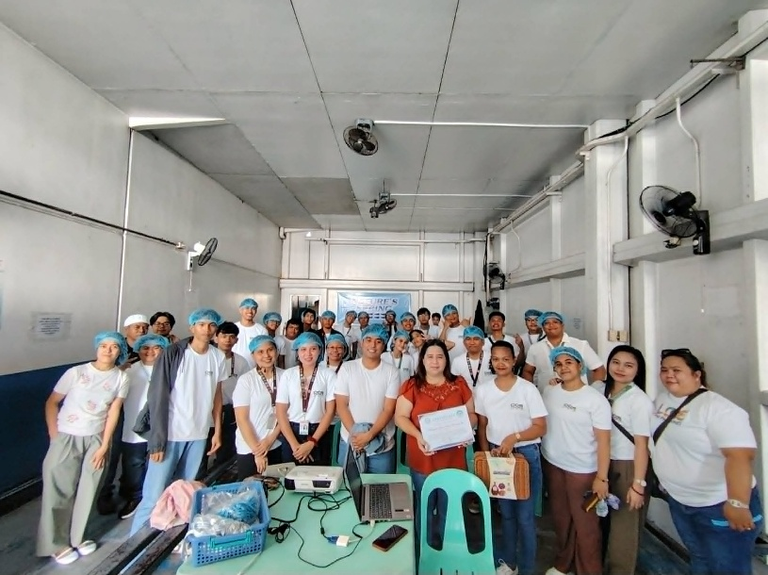

Video Presentation About Nature’s Spring Operations
Students were toured around the factory and were shown how Nature’s Spring mineral water is produced and processed. Company personnel explained the different stages involved in water filtration, purification, bottling, sealing, labeling, and packaging. The tour also highlighted the importance of cleanliness, safety measures, and quality control in ensuring that the products meet health and industry standards. Through the activity, students gained a better understanding of how modern machines and production systems are used to maintain efficient operations and high-quality bottled water products.
Guide Questions:
- How did the pre-tour briefing prepare you for understanding the production process?
The orientation and video presentation provided students with an overview of the company’s operations before discussing the production process in detail. It explained how Nature’s Spring purifies, bottles, and packages water products using advanced machines and automated systems. The briefing made it easier to understand each stage of production and the importance of maintaining quality standards.
- Describe a specific technology or practice that surprised you during the tour.
- One of the most impressive parts of the presentation was the automated bottling and packaging system used by the company. The machines were capable of rapidly filling, sealing, and labeling bottles while ensuring cleanliness and maintaining product quality. It was interesting to learn how automation improves both efficiency and accuracy in production.
- Explain how this plant tour relates to the concept of supply chain management.
- The tour is connected to supply chain management because Nature’s Spring follows a well-organized process from water purification up to packaging and distribution. The company carefully manages production, inventory, and delivery systems to ensure that products reach consumers efficiently while maintaining high-quality standards.
(For BSIT students) How could IT systems be integrated to optimize production at this facility further?
- IT systems could further enhance production by implementing automated monitoring tools, digital inventory management systems, and real-time analytics. These technologies could help monitor machine performance, reduce operational delays, and improve communication between departments. Predictive maintenance systems could also help identify equipment problems before they cause downtime.

Conclusion:
The Nature’s Spring plant tour was an informative and valuable learning experience for students. Through the video presentation and discussions, students gained a better understanding of the bottled water production process and the role of automation and technology in manufacturing industries. The activity highlighted the importance of organization, sanitation, and quality control in maintaining efficient operations. Overall, the experience increased students’ appreciation of how information technology and automated systems contribute to modern industrial processes and encouraged continuous learning about technological innovations in the workplace.

NARRATIVE REPORT

“Educational Tour at CEPALCO and Nature’s Spring”

The College of Computer Studies conducted an educational tour at CEPALCO and Nature’s Spring in Cagayan de Oro City. The activity aimed to provide students with practical knowledge and actual industry exposure related to information technology, business operations, production management, and workplace practices. The educational tour also allowed students to connect classroom learning with real-world applications used by companies and organizations.

During the visit to CEPALCO, the students were introduced to the company’s operations, particularly in the generation and distribution of electricity in Northern Mindanao. The company representatives discussed the importance of technology and innovation in maintaining efficient electrical services. Students learned how computerized systems are utilized in monitoring power distribution, customer management, and operational processes. The discussion also highlighted the significance of cybersecurity, data management, and system reliability in ensuring uninterrupted service to consumers.

Moreover, the representatives explained the company’s commitment to sustainable energy and environmental responsibility. Students gained insights into how technology supports decision-making, improves efficiency, and strengthens communication within the organization. The visit helped the students appreciate the role of information systems and technical professionals in large-scale utility companies.

Afterward, the educational tour continued at Nature’s Spring, where students observed the company’s production and manufacturing processes. The company personnel discussed the procedures involved in water purification, quality assurance, bottling, packaging, and distribution. The students were able to witness how automated machines and modern technologies are used to maintain product quality and operational efficiency.

The visit also emphasized the importance of sanitation, safety standards, and proper management in the production industry. Students learned how information systems and inventory management contribute to smooth business operations. The representatives shared how teamwork, discipline, and innovation play vital roles in maintaining the company’s success and customer satisfaction.

The educational tour provided students with valuable learning experiences and broadened their understanding of how companies apply technology and management practices in their daily operations. It enhanced the students’ appreciation of professionalism, responsibility, and the importance of continuous learning in their chosen field.

In conclusion, the educational tour at CEPALCO and Nature’s Spring was successful in giving students meaningful exposure to real working environments. The activity strengthened their knowledge, inspired them to pursue excellence in their studies, and encouraged them to apply their skills and learning in future careers within the technology and business industries.

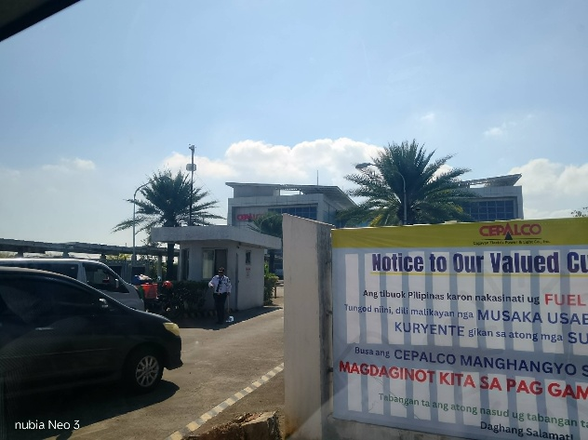
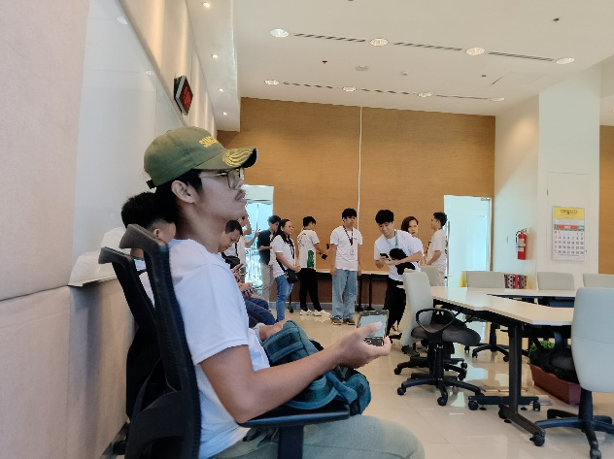

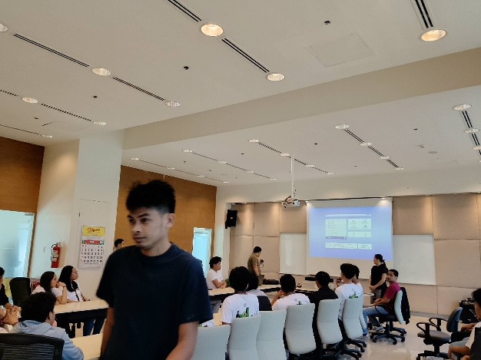
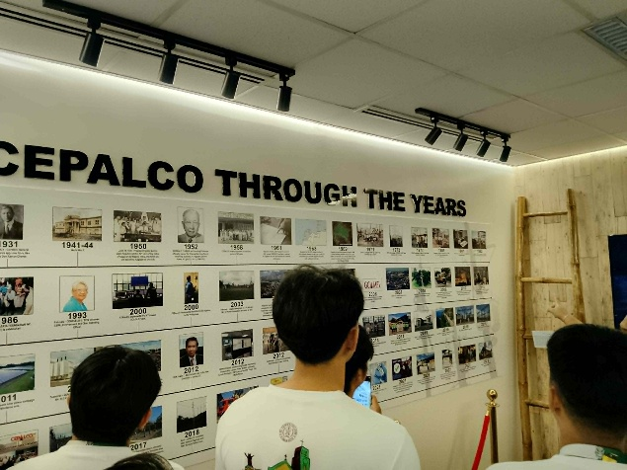

Photo Opportunity documentation during and after the Educational Tour in CEPALCO with graduating CS/IT students.
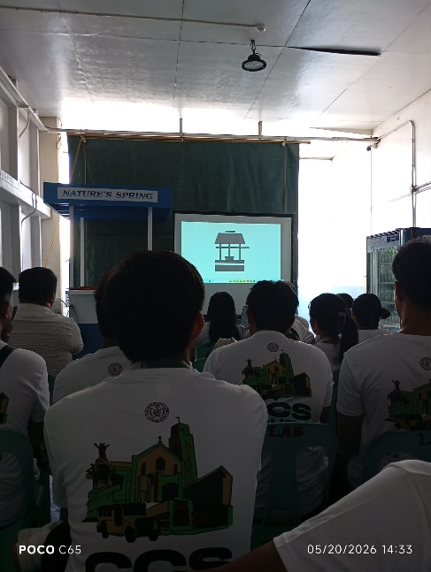
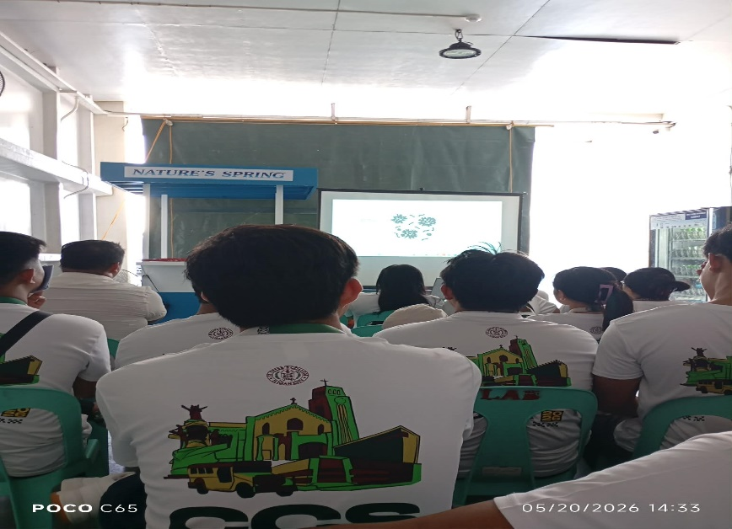

Photo Opportunity documentation during and after the Educational Tour in Nature Spring with graduating CS/IT students.

Prepared by:

TRISTAN DOMINIC L. PARAJES
4th Year Student BS-IT

