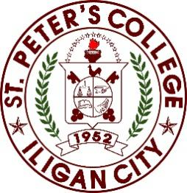

St. Peter’s College
Sabayle St., Iligan City
College of Computer Studies

ON-THE-JOB Training
At
TRIAGLE OUTSOURCING CORPORATION

In Partial Fulfillment
Of the Requirement of the Degree of
Information Technology

Submitted by:
Adrian Dableo

TABLE OF CONTENTS

CHAPTER 1 Brief History/Background of the Company or the Company 3
CHAPTER 2 Weekly Progress Report 4
CHAPTER 3 Assessment of OJT Program 7
- What have I learned from the experience?
- My experience with the people around me.
- The most memorable event during my OJT.
- What I can recommend for the improvement of the OJT Program
- My advice to those who will take their OJT in the future.
CHAPTER 4 Pertinent Documents 9
Application Letter
Resume
Recommendation Letter
Memorandum of Agreement (MOA)
Parent Consent
Medical Certificate
OJT Evaluation (Prelim, Midterm, Pre-Final and Final)
DTR
Certificate of Completion
Workplace Documentation
CHAPTER 1
Brief History/Background of the Company
Triangle Outsourcing Corporation was originally established under the name Pylon with the goal of delivering reliable outsourcing and business support services. Over time, the company became known for maintaining high standards of professionalism and service quality within the industry.
On May 15, 2023, the company officially adopted the name Triangle Outsourcing Corporation as part of its rebranding efforts. This change was made to create a stronger corporate identity, represent its expanding services, and highlight its dedication to innovation and service excellence.
The company offers services such as English as a Second Language (ESL) teaching, virtual assistance, and call center operations. These services are designed to help clients enhance productivity, improve operational processes, and deliver better customer support. By continuously adapting to industry developments and prioritizing customer satisfaction, employee development, and continuous improvement, Triangle Outsourcing Corporation has grown into a respected and dependable outsourcing provider.

CHAPTER 2
Weekly Progress Report

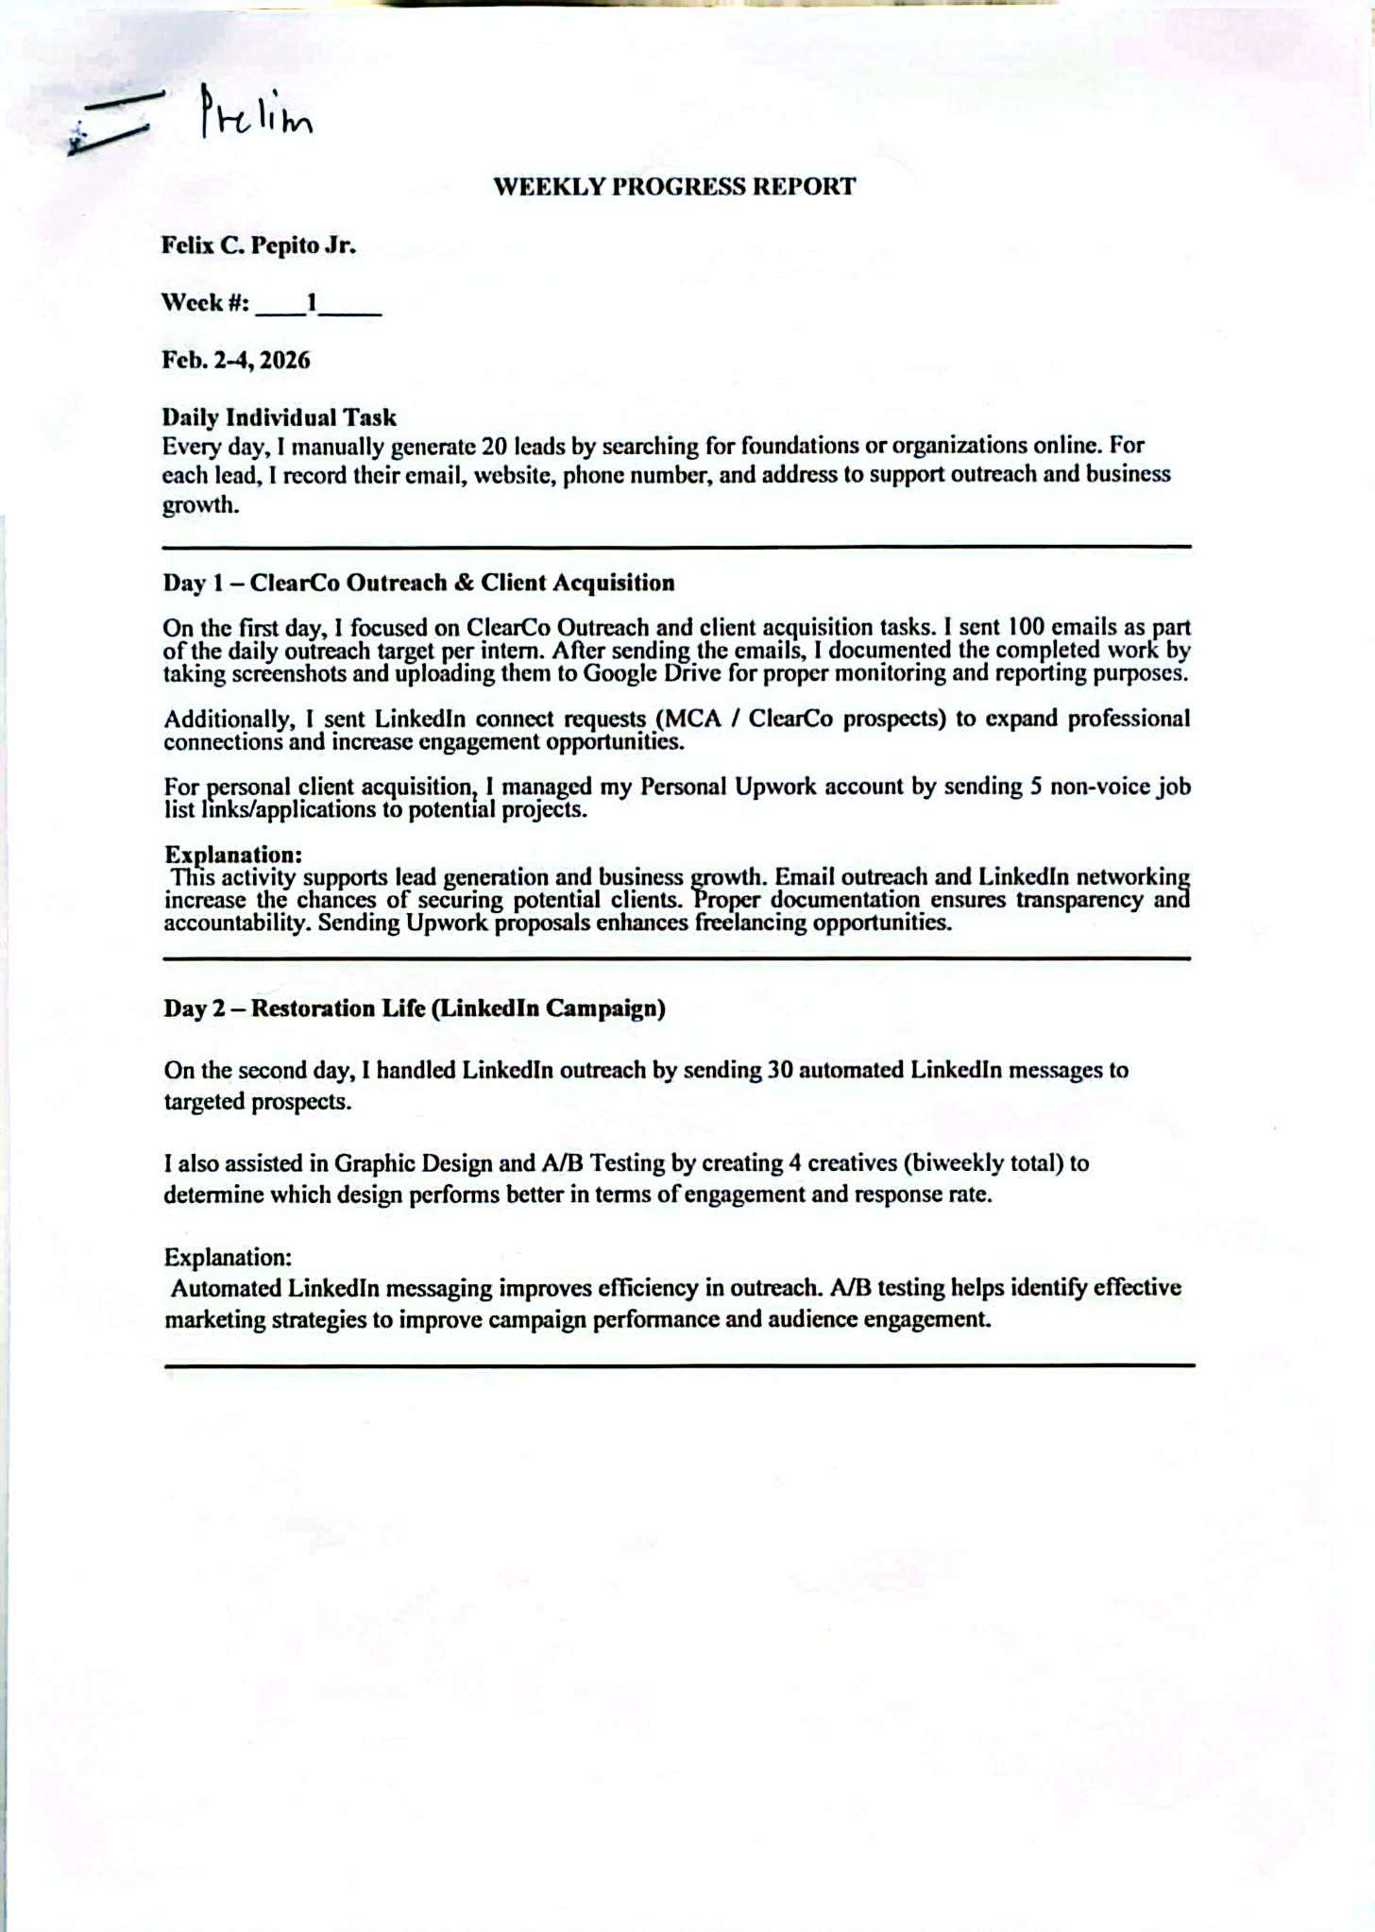



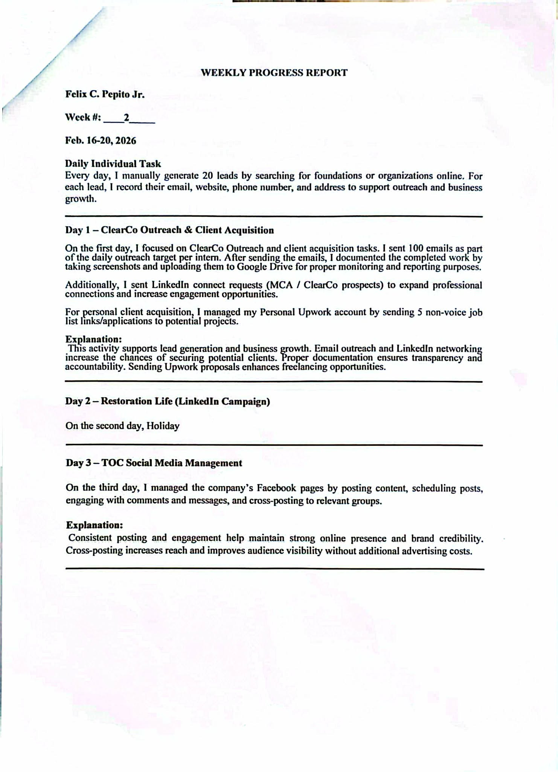

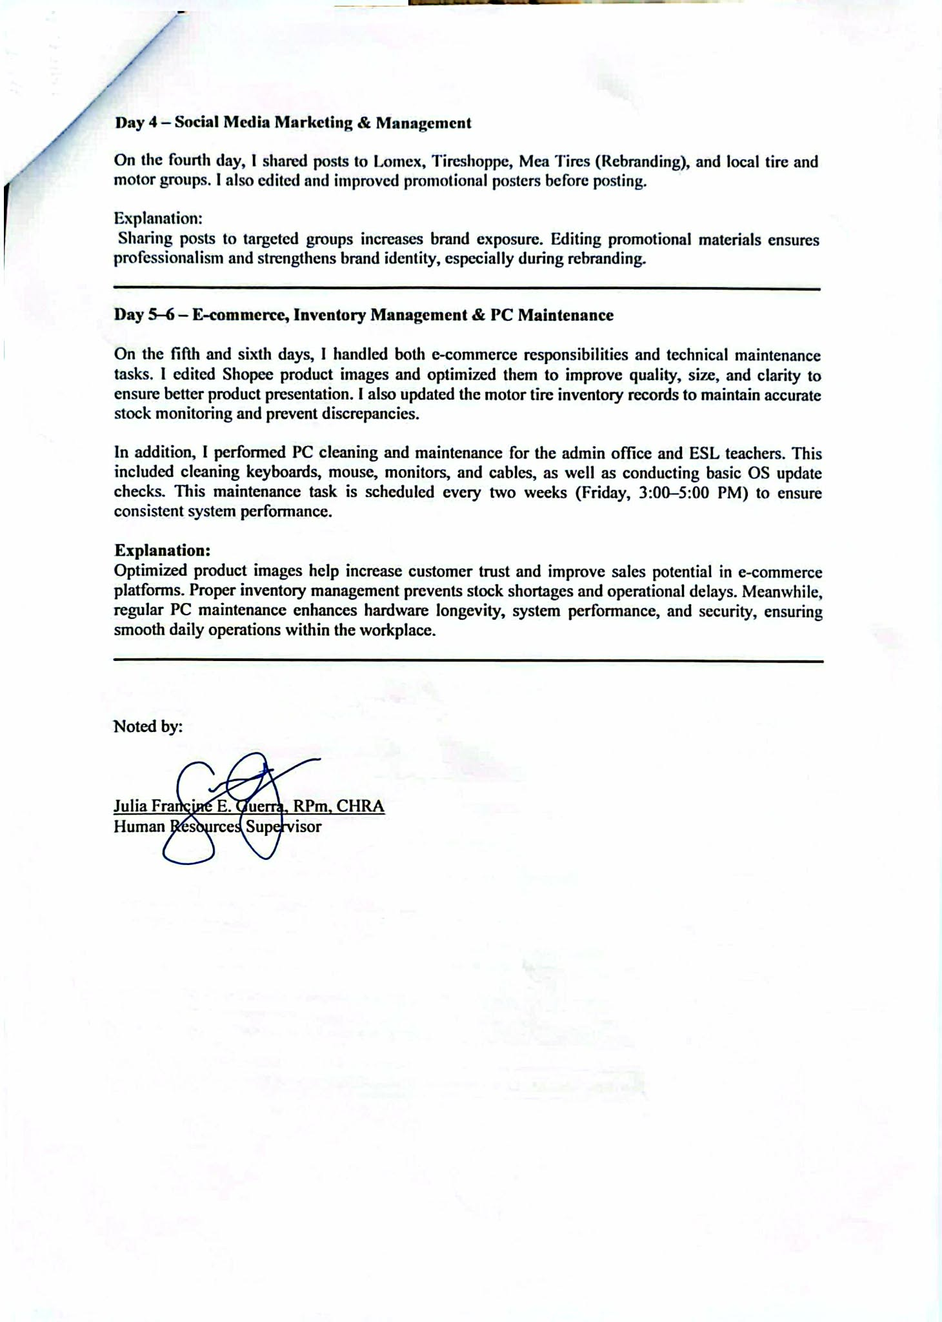
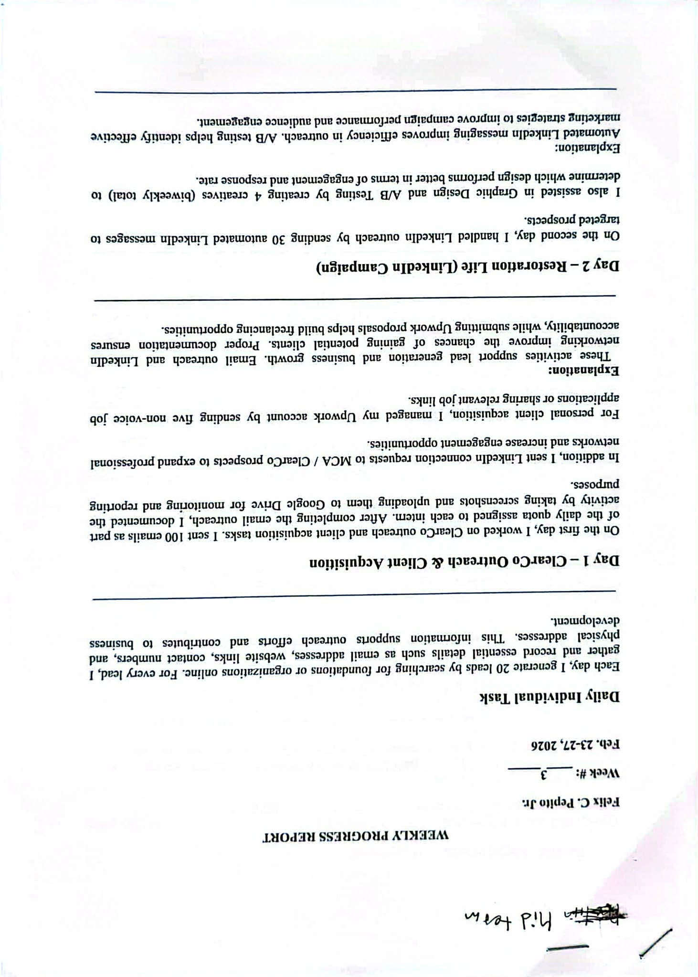
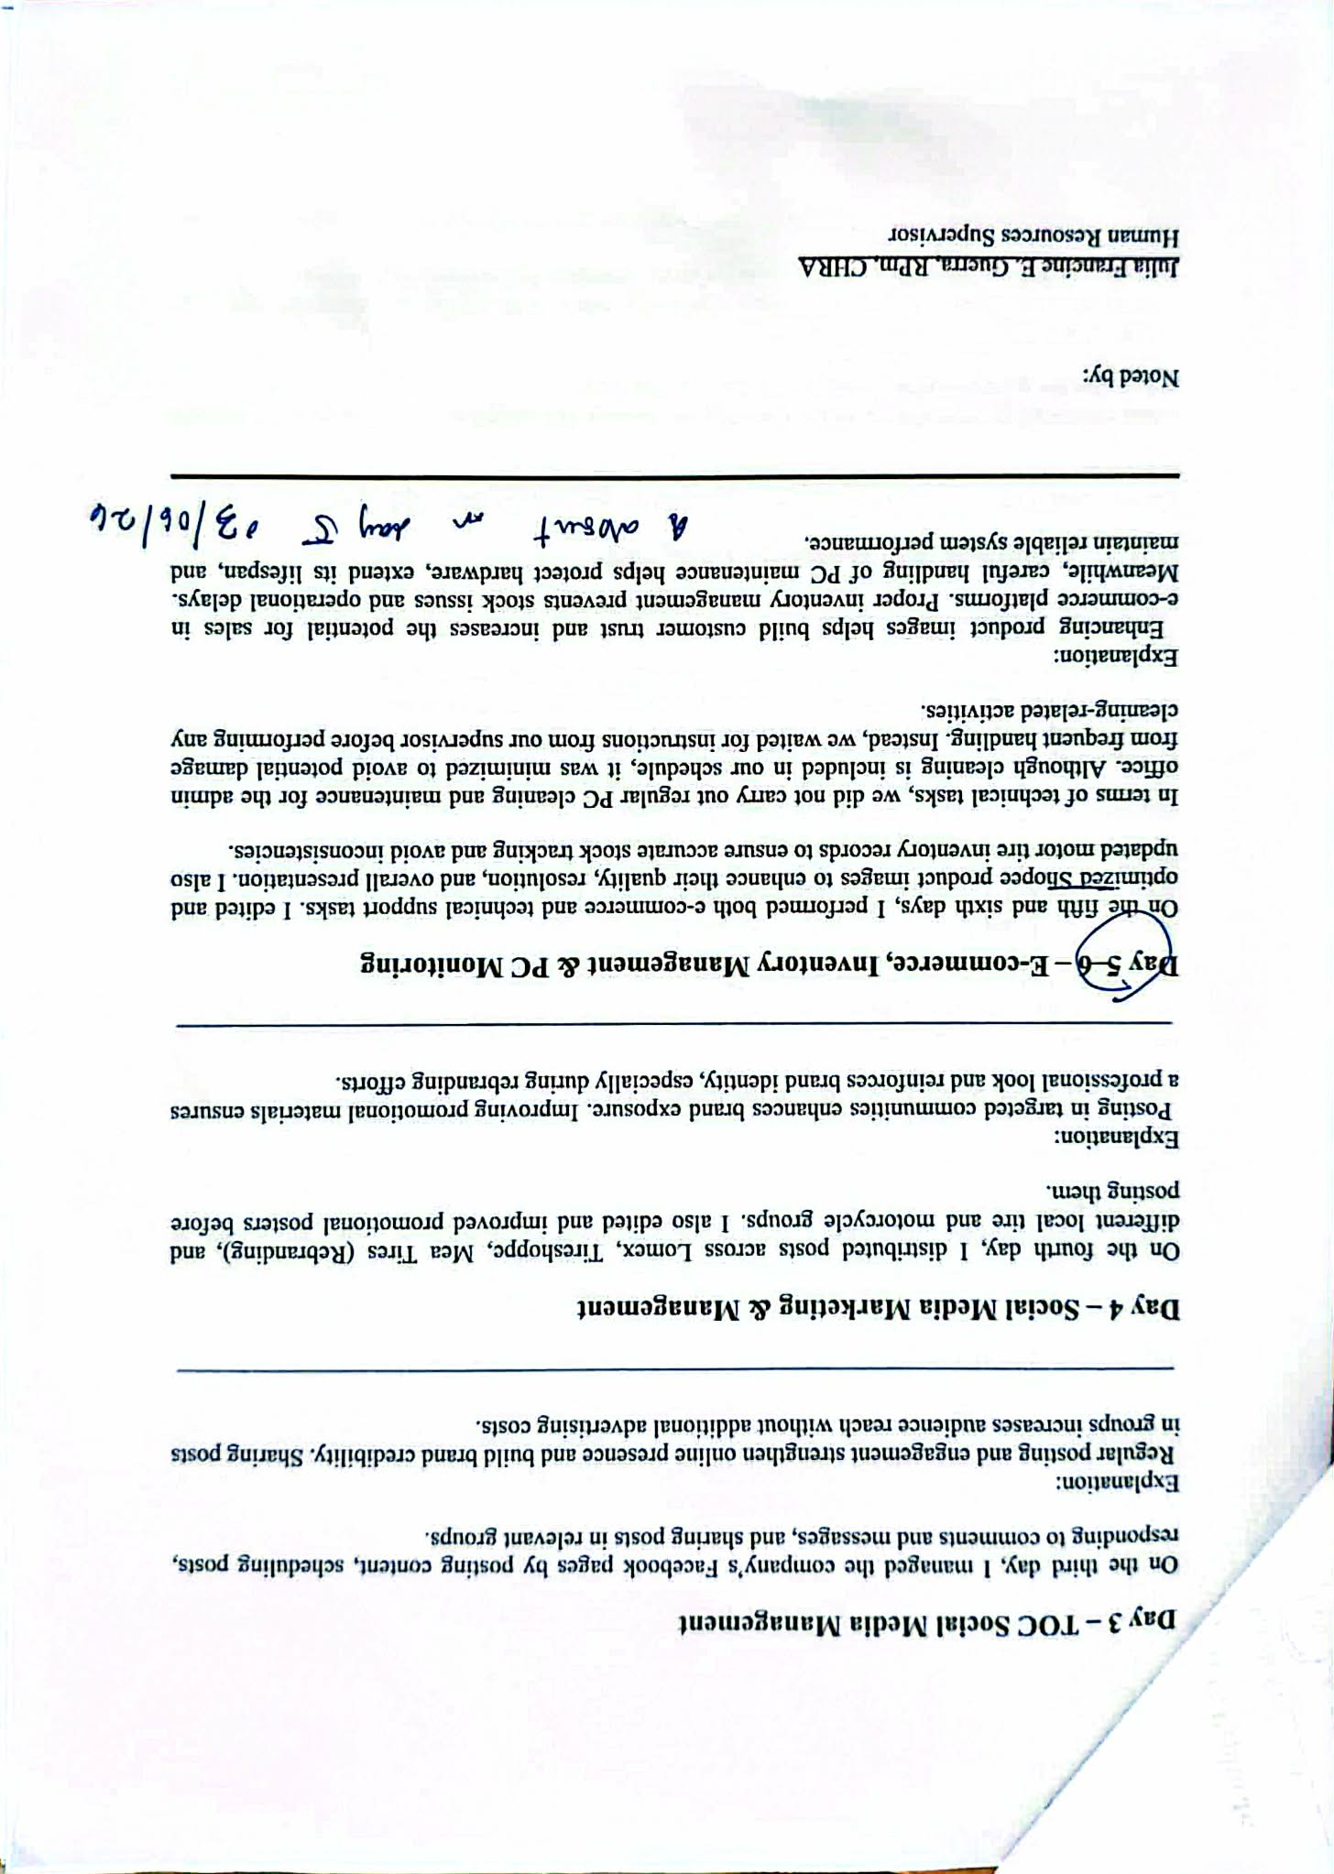
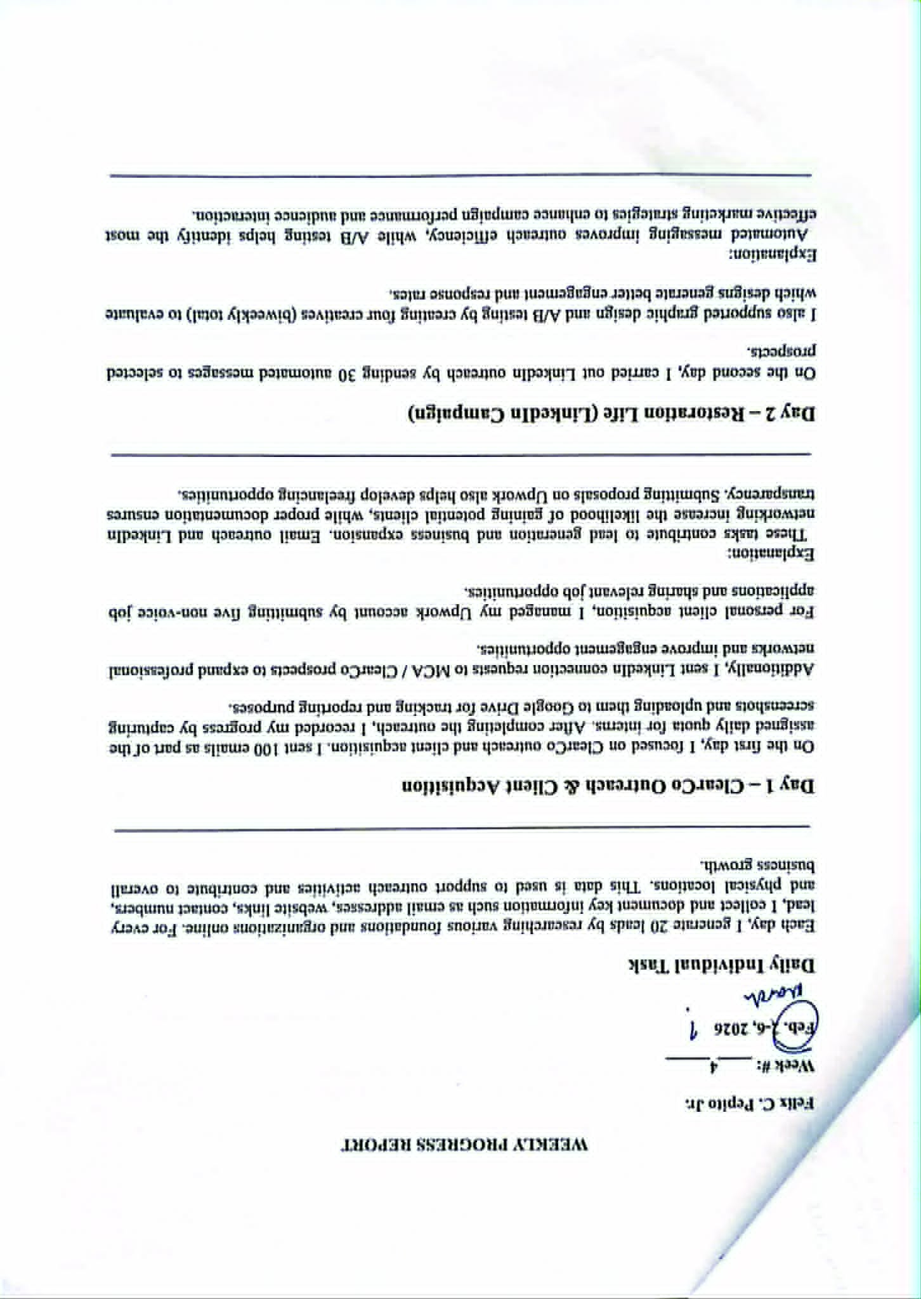
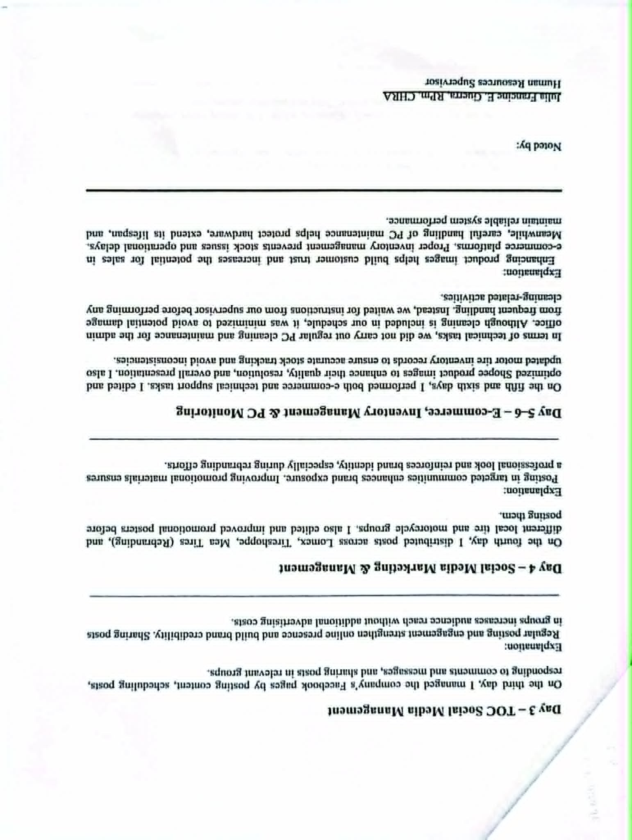
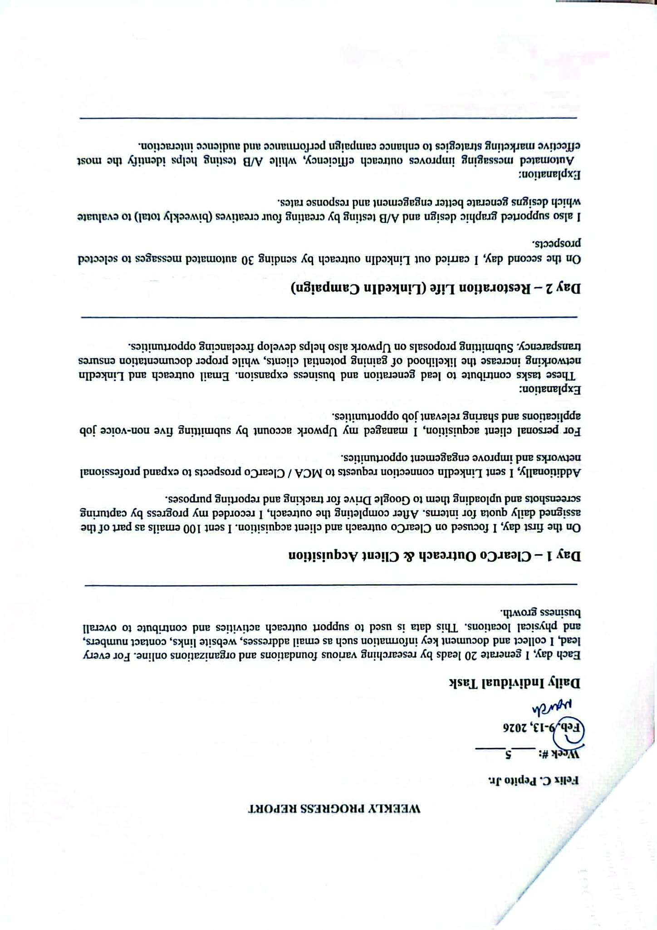

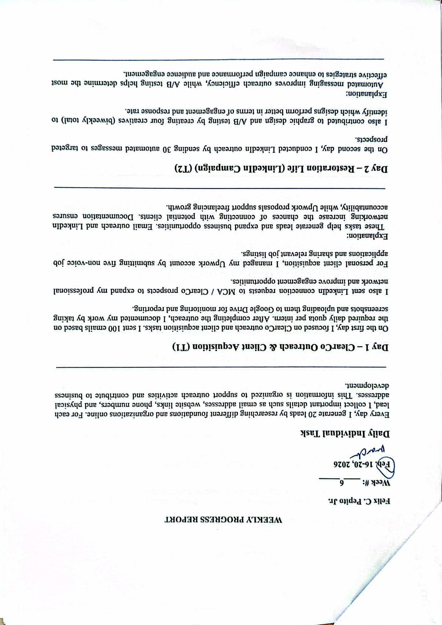
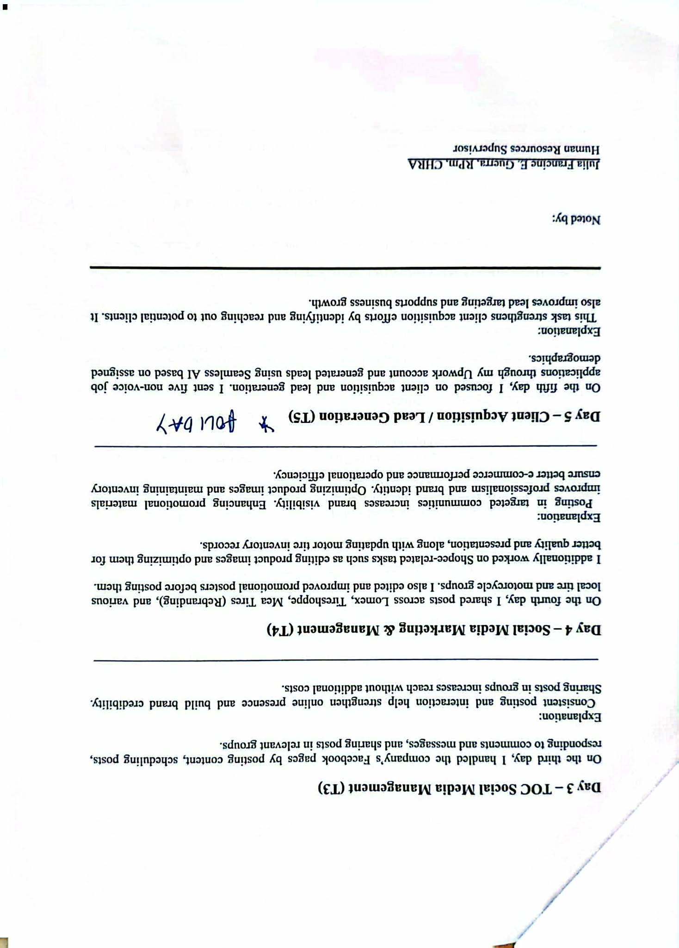
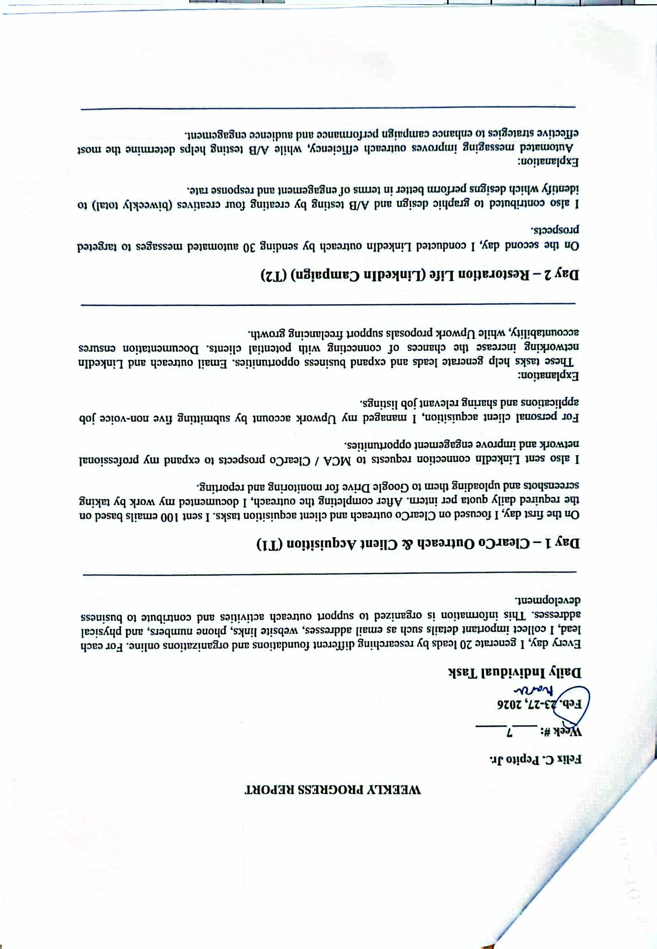
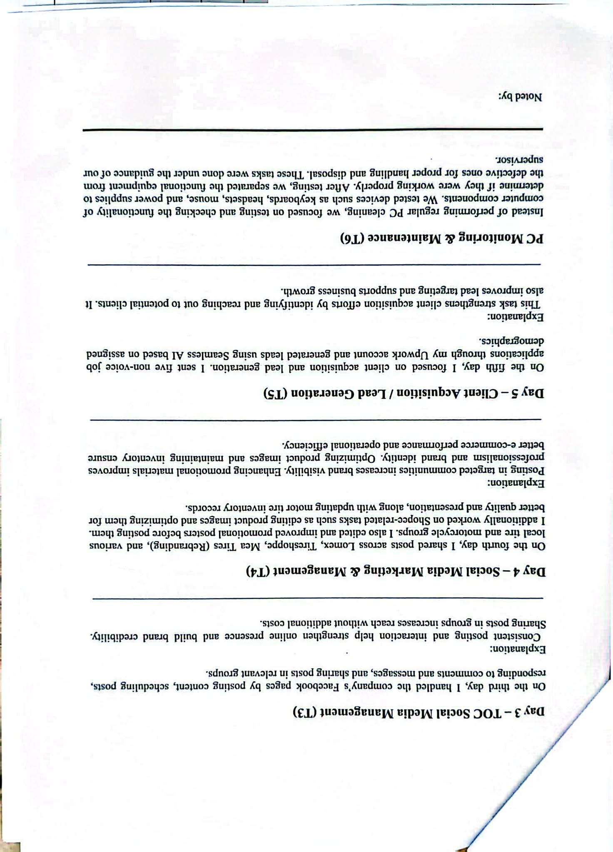
Weekly Report 8-15

CHAPTER 3
Assessment of OJT Program

- What have I learned from the experience? (Technical).
During my internship, I gained important technical knowledge and practical experience related to digital marketing and online management. I learned effective ways of promoting company pages through different online communities and social media groups, which improved my understanding of audience engagement and marketing strategies. I also developed better organizational and communication skills while using various online platforms for promotional purposes. In addition, I acquired basic knowledge in computer maintenance, such as cleaning and organizing PCs. Overall, the internship helped me enhance both my technical abilities and professional skills in the workplace.
- My experience with the people around me.
My internship became more valuable because of the people I worked with every day. The supervisors, employees, and co-interns were approachable, supportive, and friendly. Whenever I faced challenges, they willingly guided and assisted me in completing my tasks. Through teamwork and interaction with them, I improved my communication skills and learned how important cooperation and professionalism are in the workplace. Their encouragement and support made my OJT experience more comfortable, productive, and memorable.
- The most memorable event during my OJT.
One of the most memorable experiences during my internship was spending my final day at the company. On that day, I helped clean computers and assisted in preparing for the company’s upcoming anniversary celebration. Although the activities were simple, they became meaningful because they marked the end of my internship journey. I felt both happy and emotional—happy because I successfully completed my training, and emotional because I would be leaving behind the people and experiences that contributed to my personal and professional growth. It made me realize how much I had improved throughout the internship.
- What I can recommend for the improvement of the OJT Program.
To make the OJT Program more effective, I suggest providing interns with more practical tasks and hands-on experiences that are closely related to their field of study. Regular supervision, evaluations, and constructive feedback would also help students improve their confidence and work performance. In addition, proper orientation sessions and organized schedules can make it easier for interns to adjust to the workplace environment. Conducting workshops and training activities may also help students develop additional practical skills during their internship period.
- My advice to those who will take their OJT in the future.
For future interns, I would advise them to stay responsible, hardworking, and willing to learn throughout their internship. They should not be afraid to ask questions whenever they need guidance because internships are meant to help students gain knowledge and experience. It is also important to show professionalism, respect coworkers, and manage time properly. Every assigned task, even the simplest one, should be appreciated because it contributes to personal growth and career development. Most importantly, they should enjoy the experience, create good relationships with others, and use the opportunity to build their confidence and improve their skills for the future.

CHAPTER 4
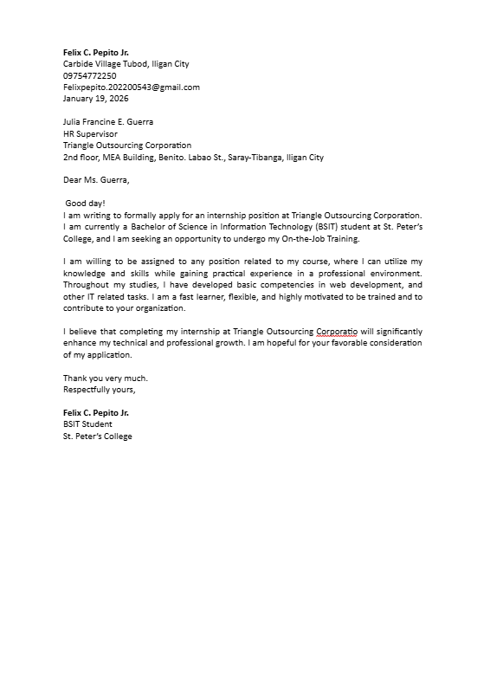
Pertinent Documents

=

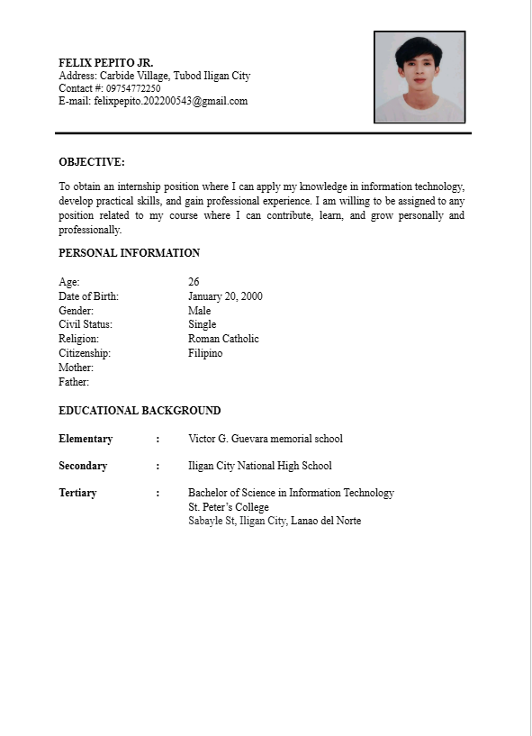
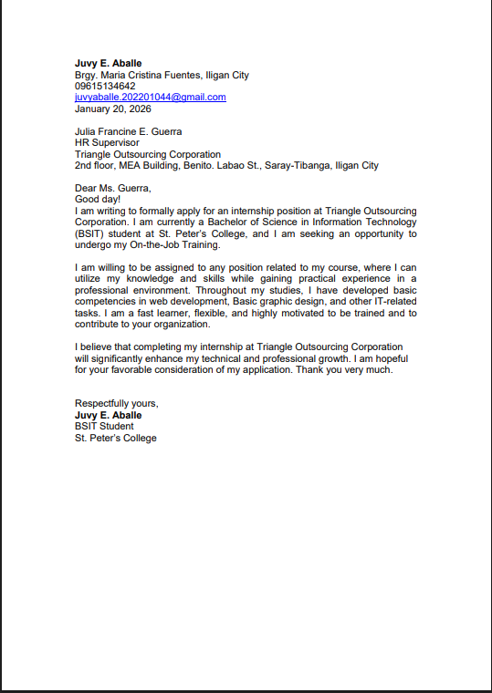
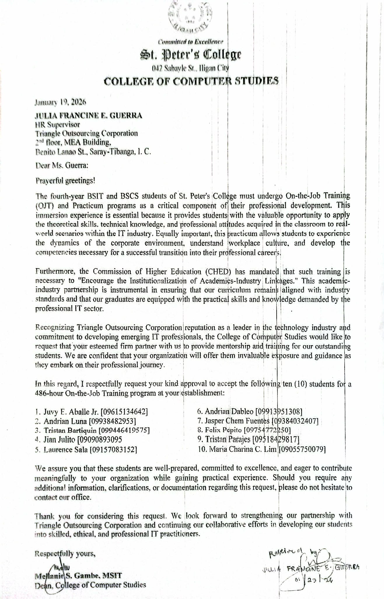

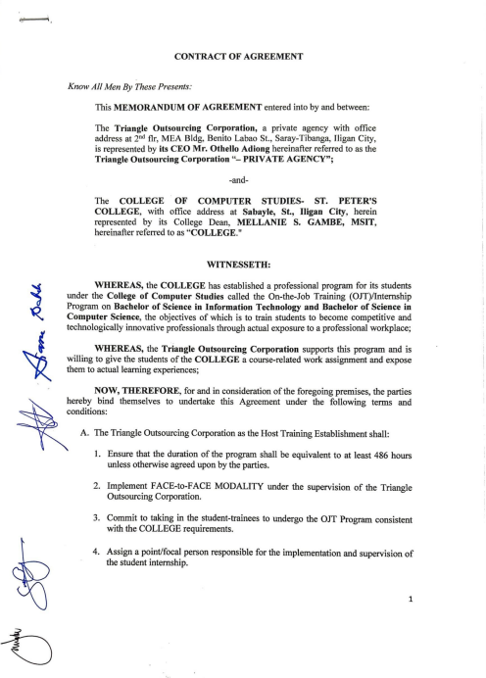

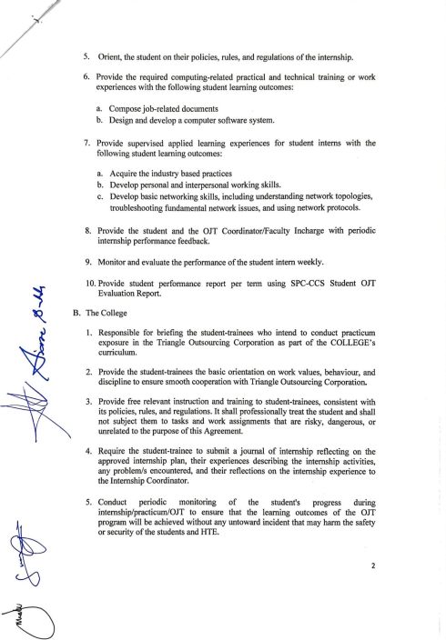

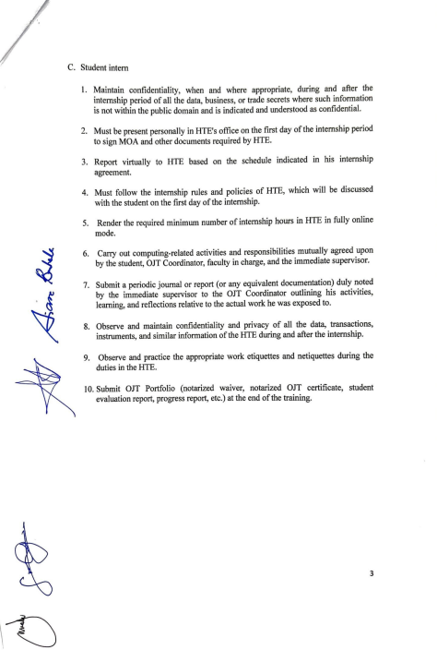
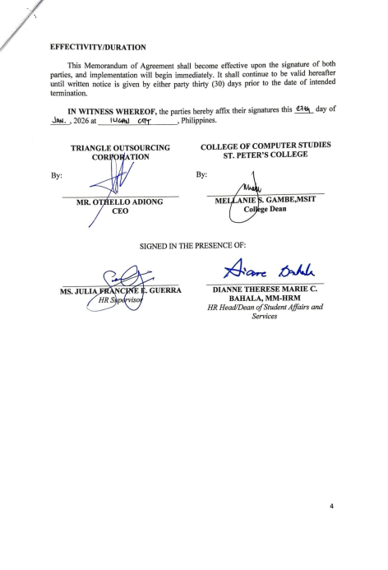
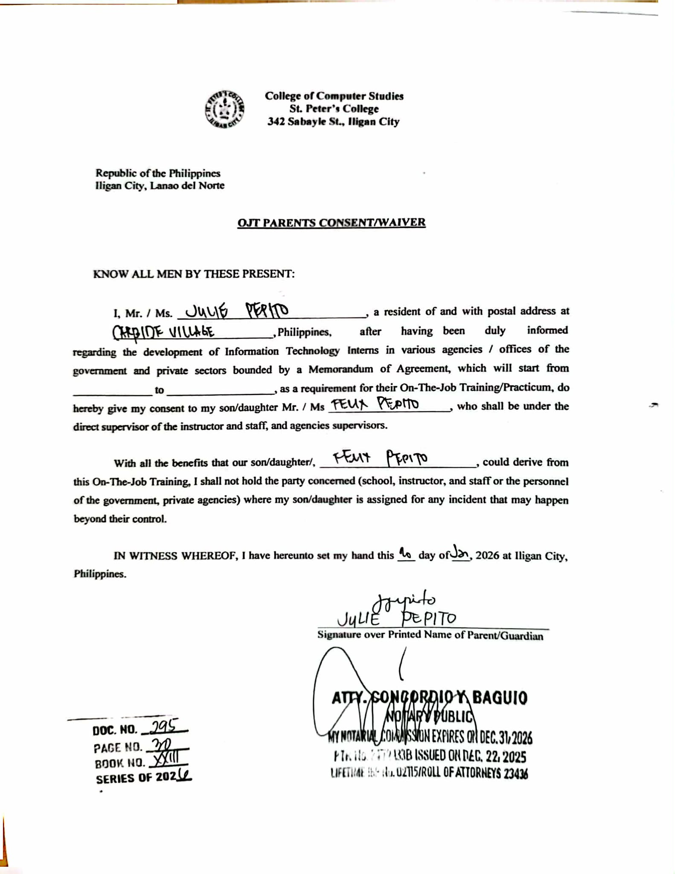
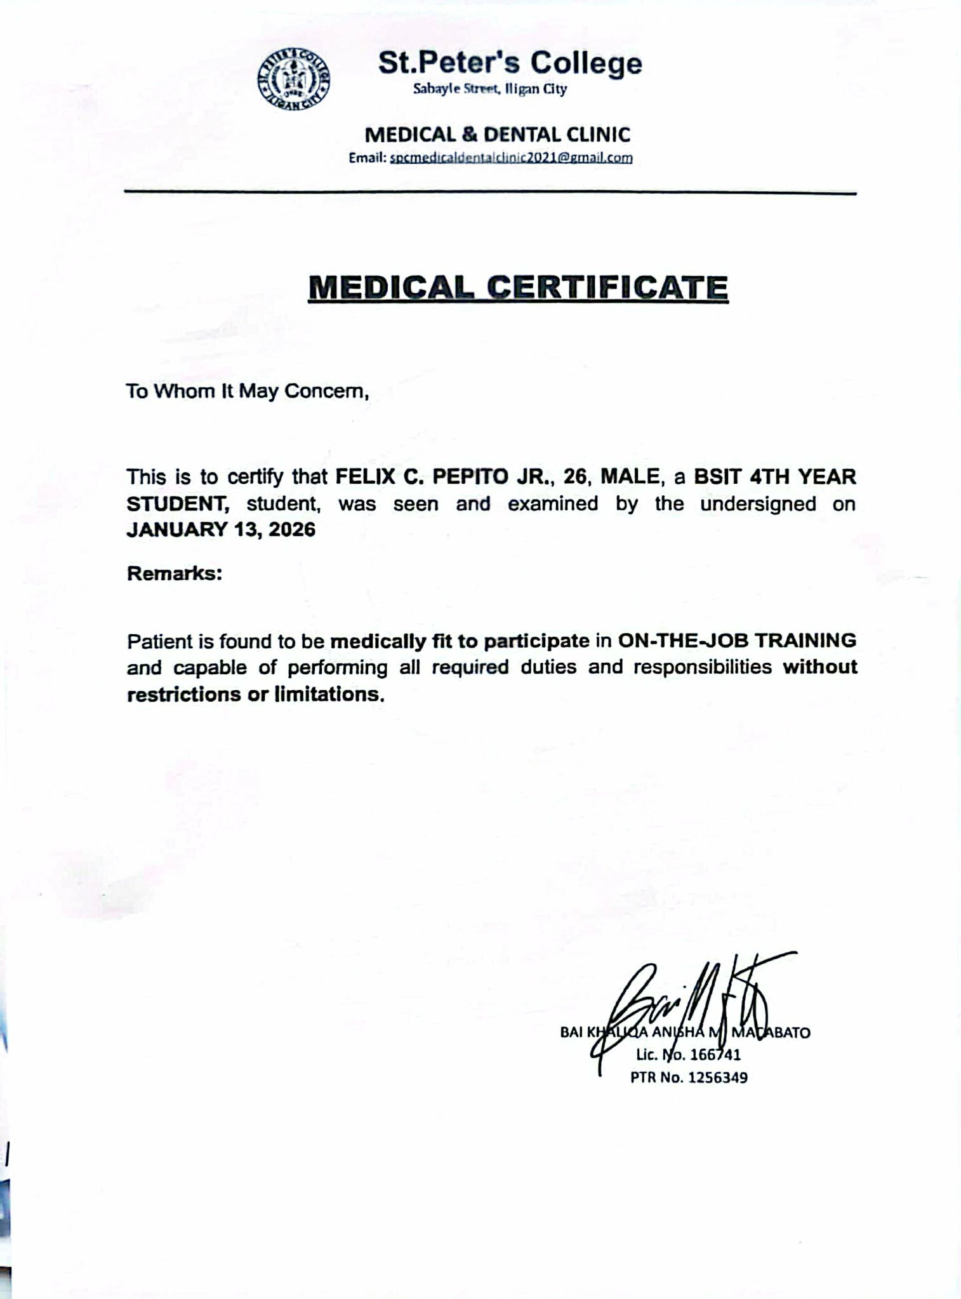

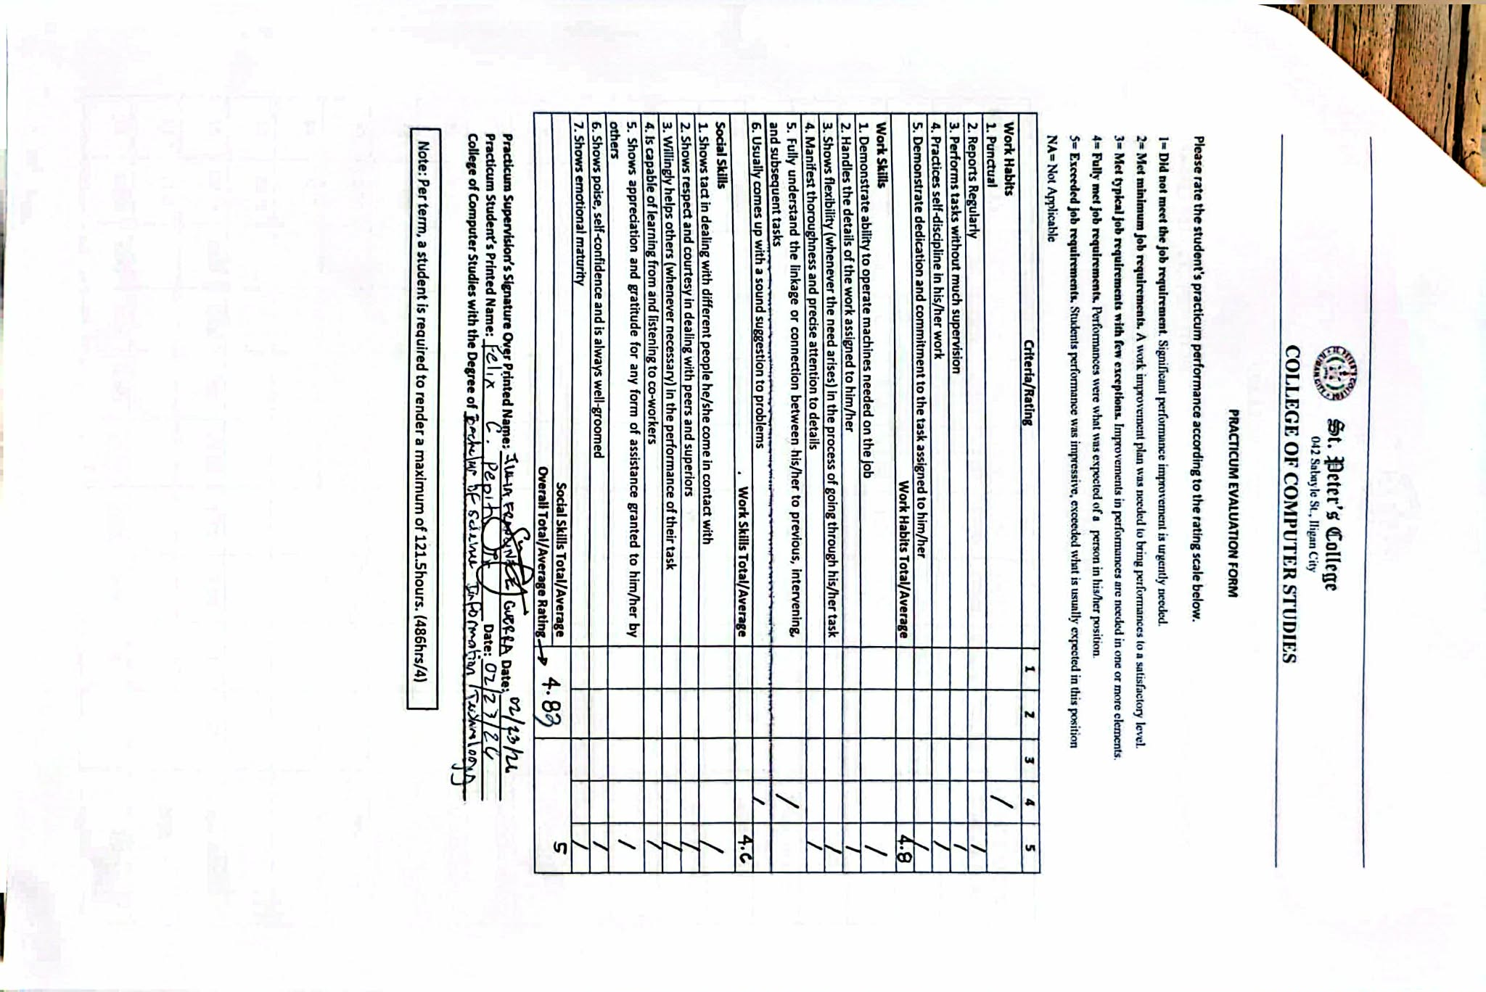

Evaluation Form - March

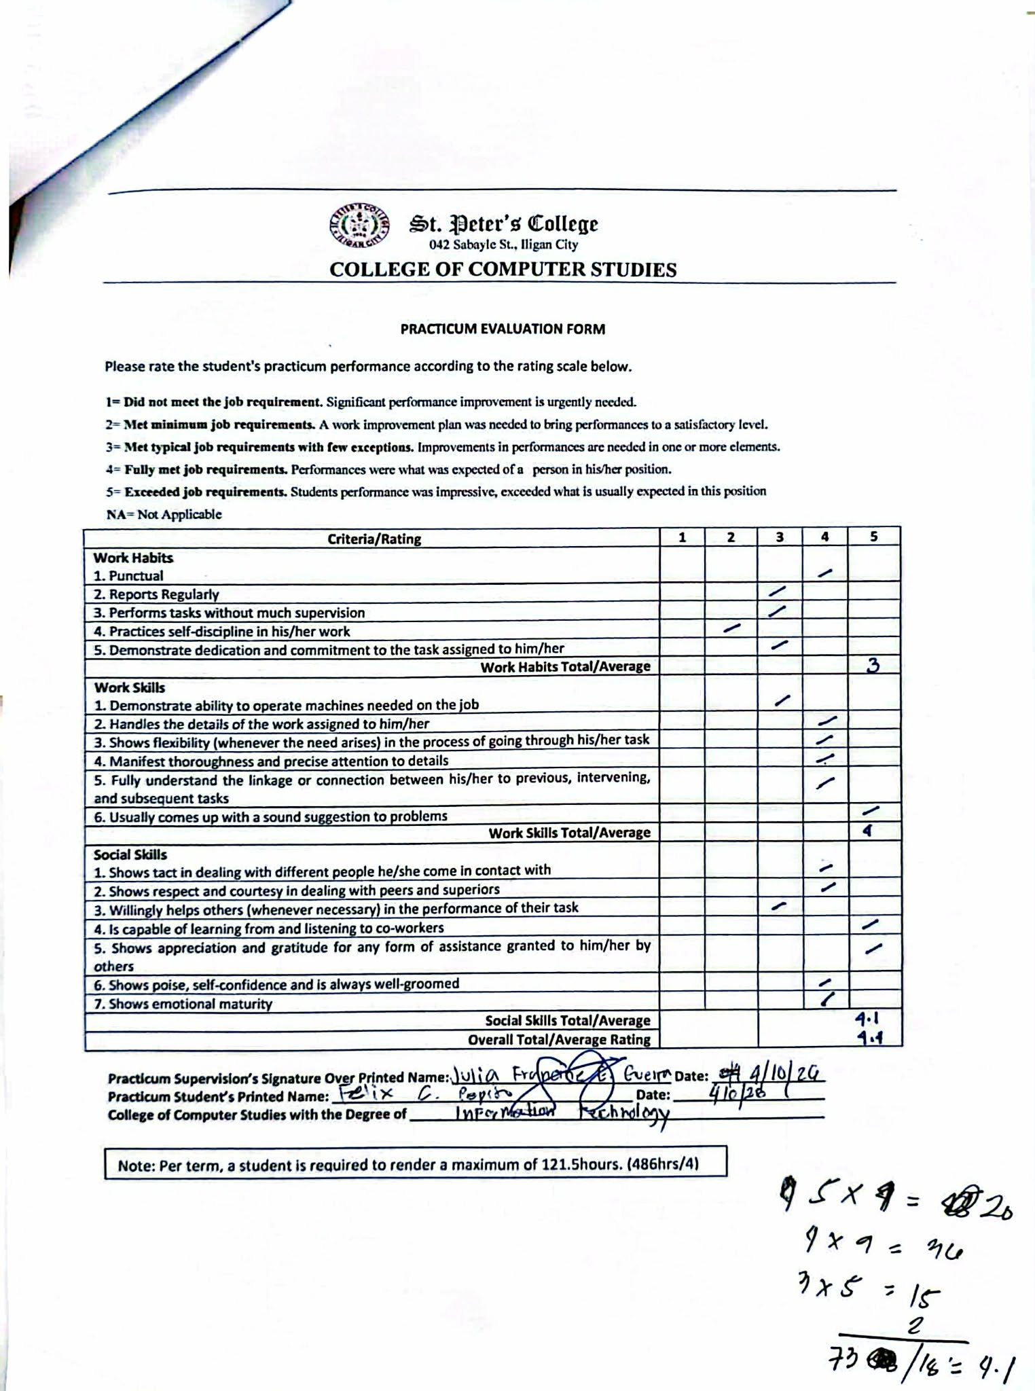

Evaluation Form- May

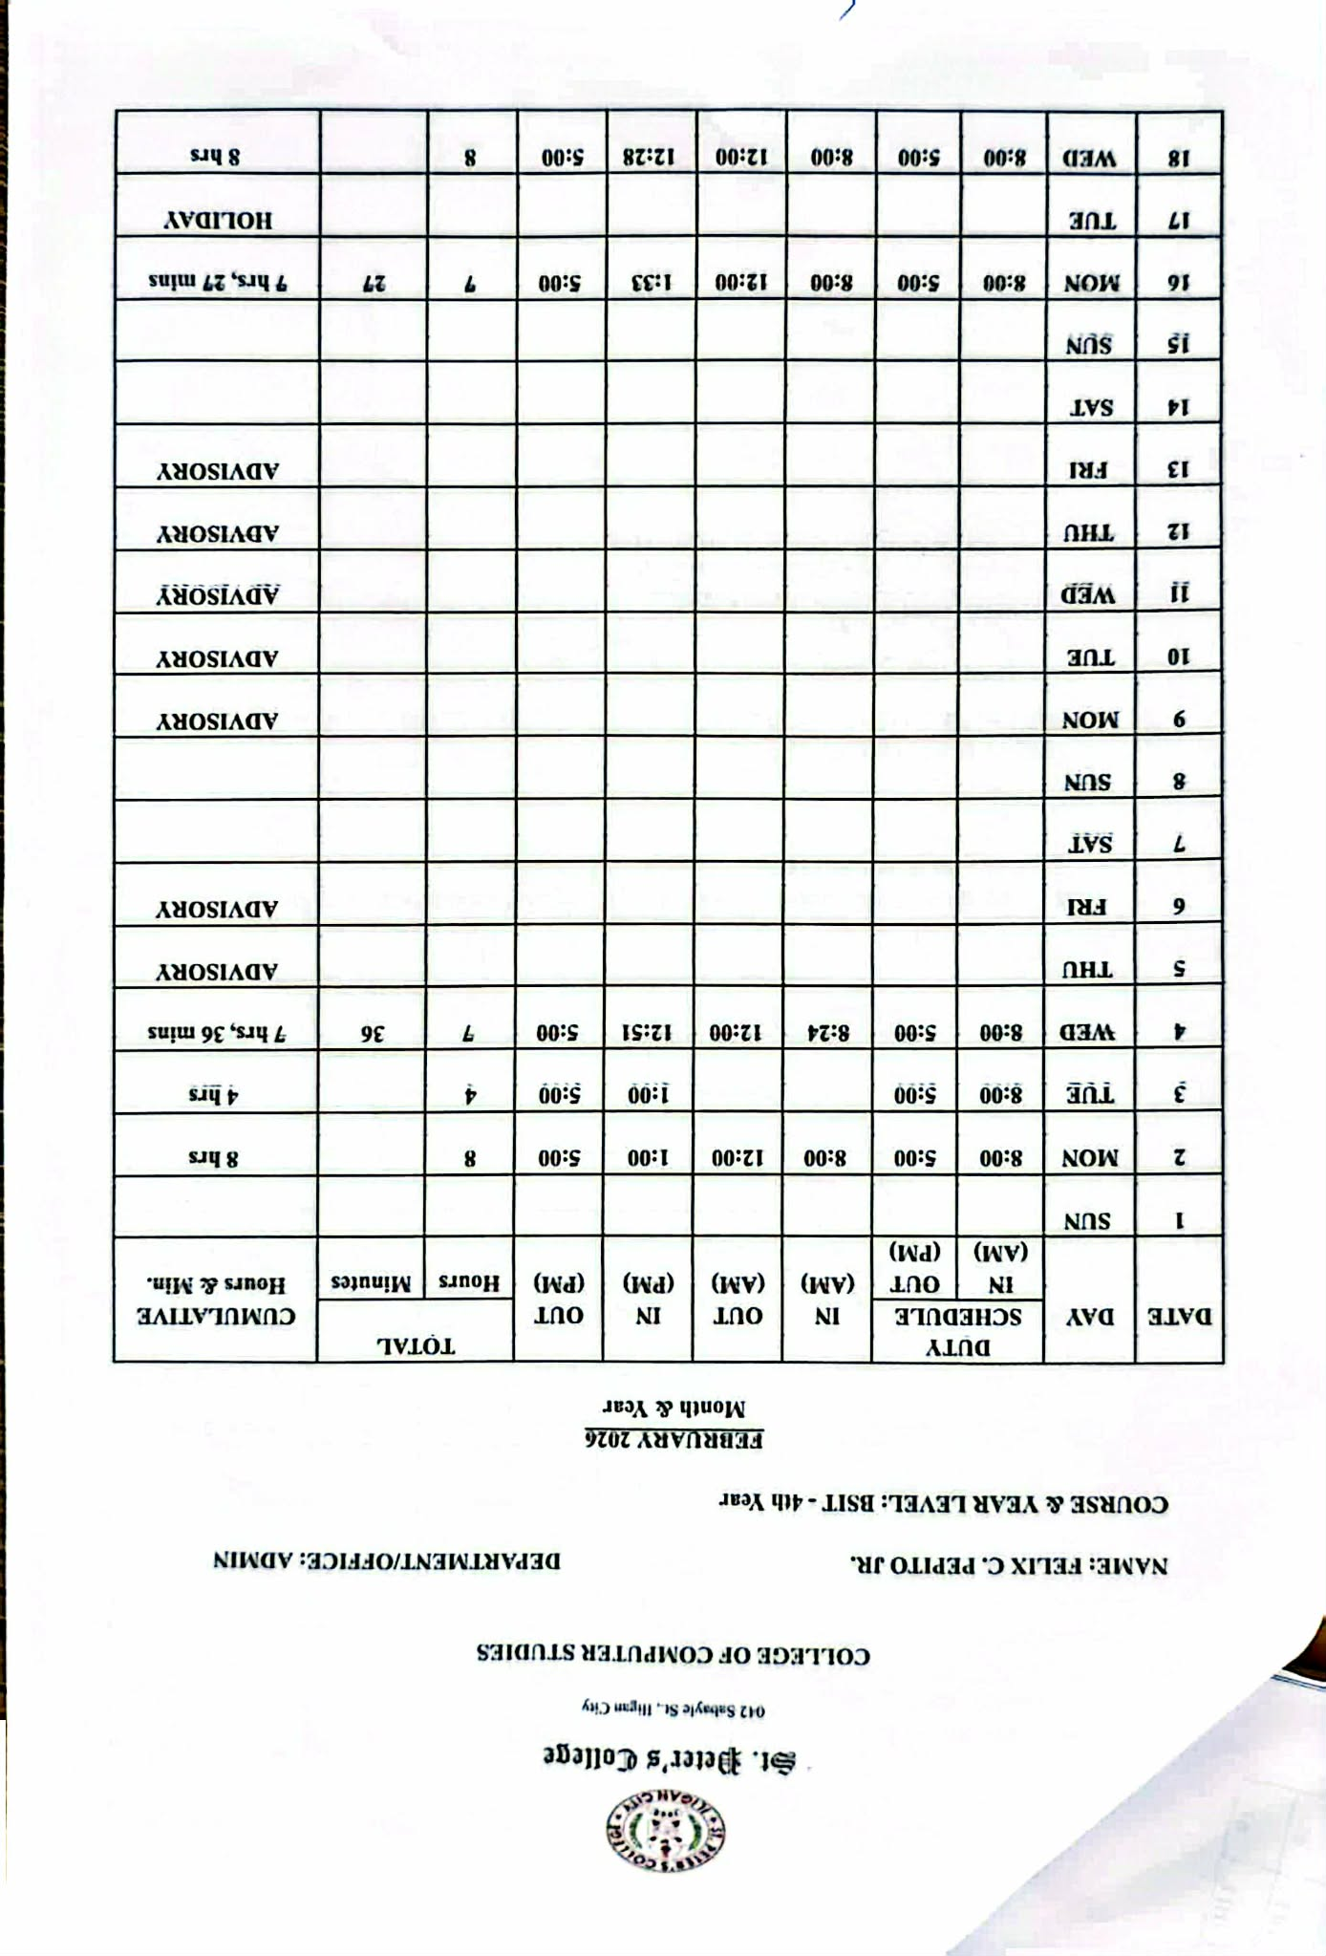

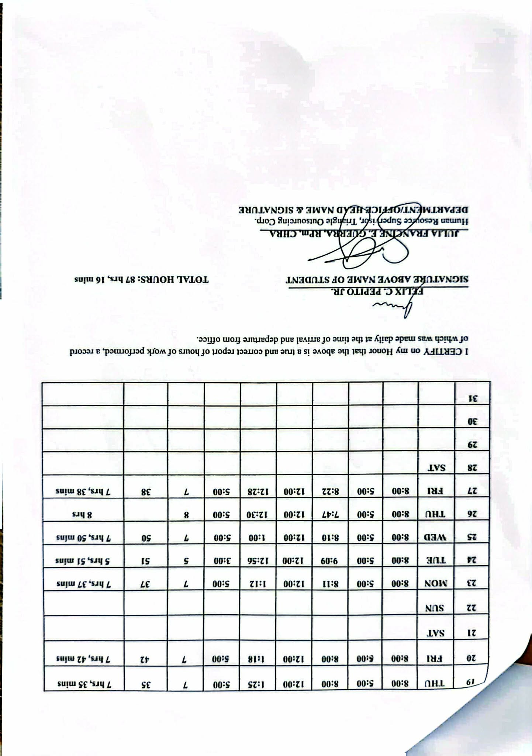

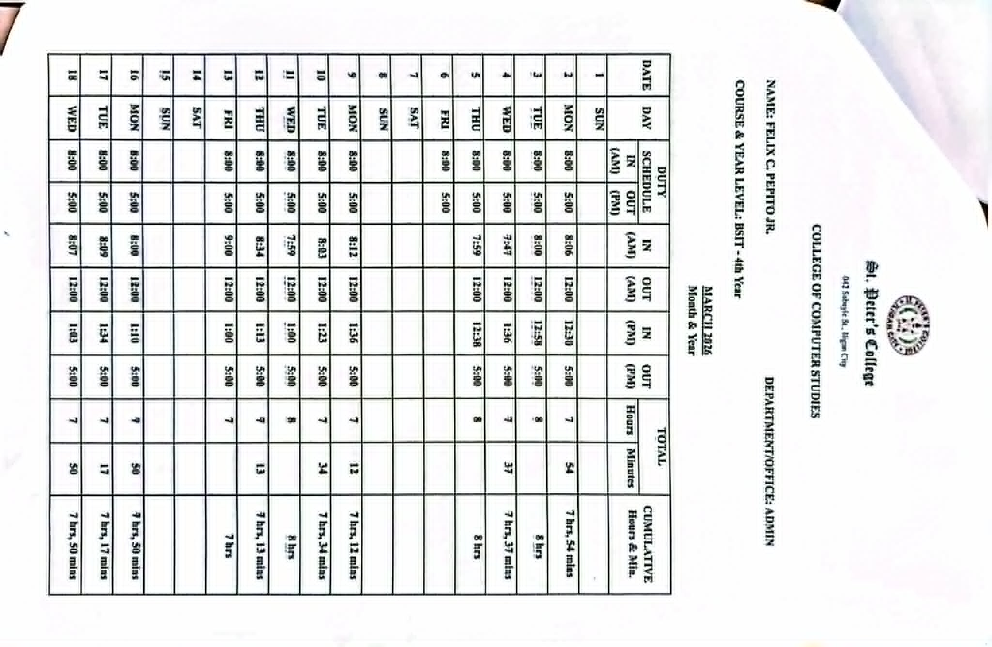

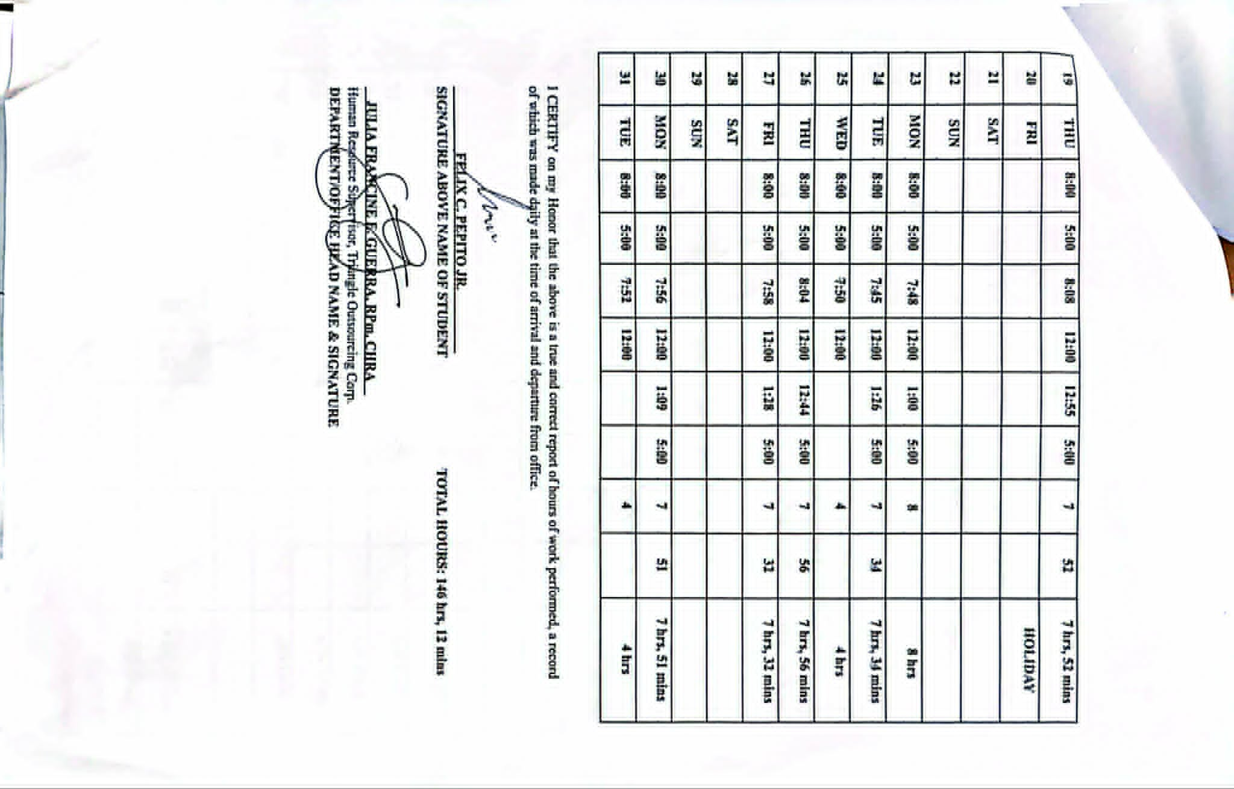

DTR - April

DTR - May

CERTEFICATE

Workplace Documentation

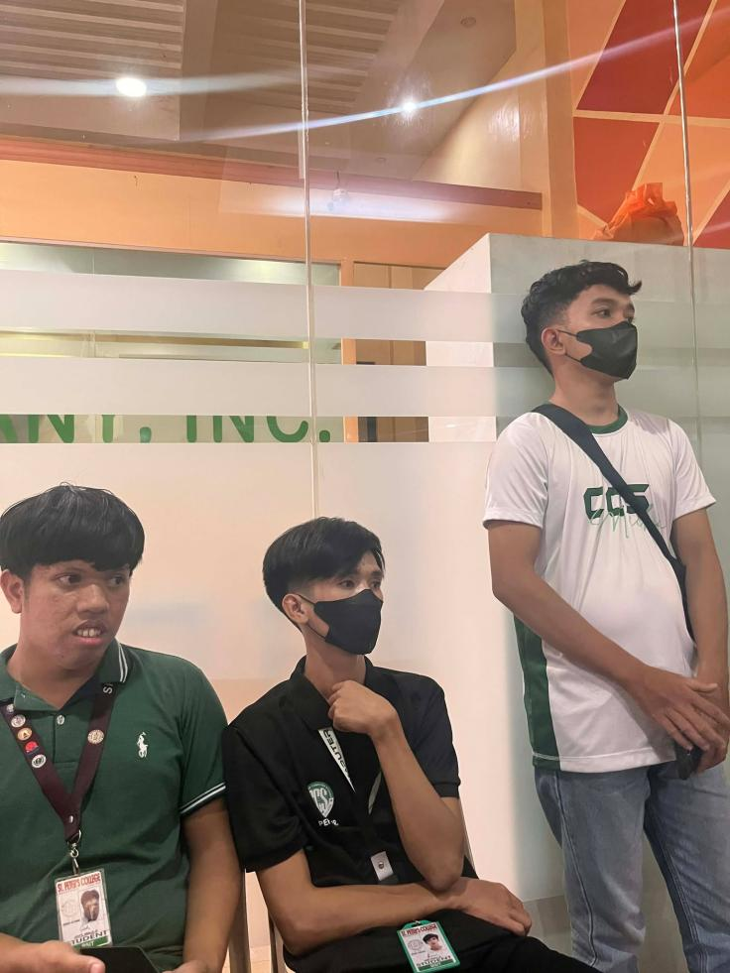

ESL OFFICE

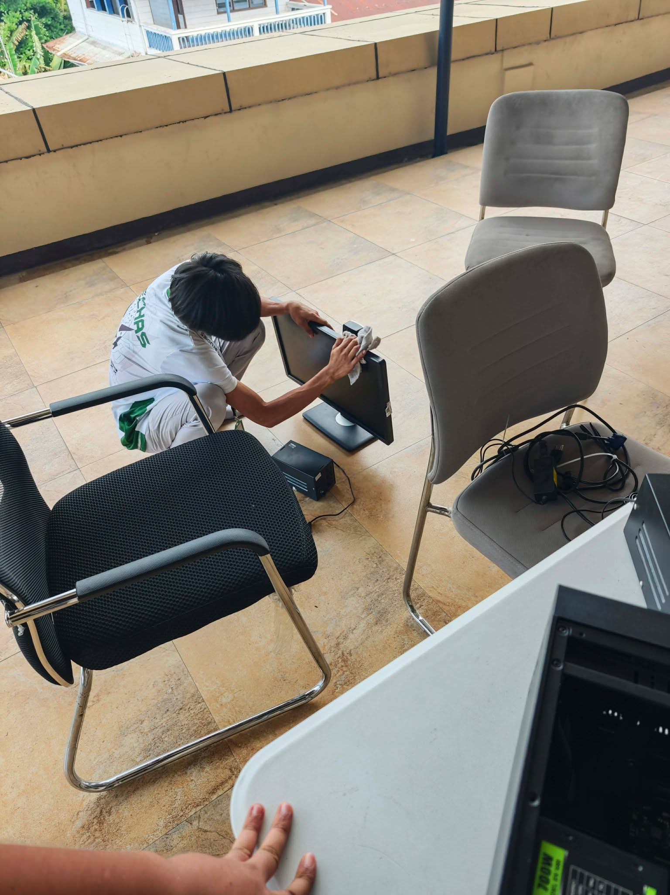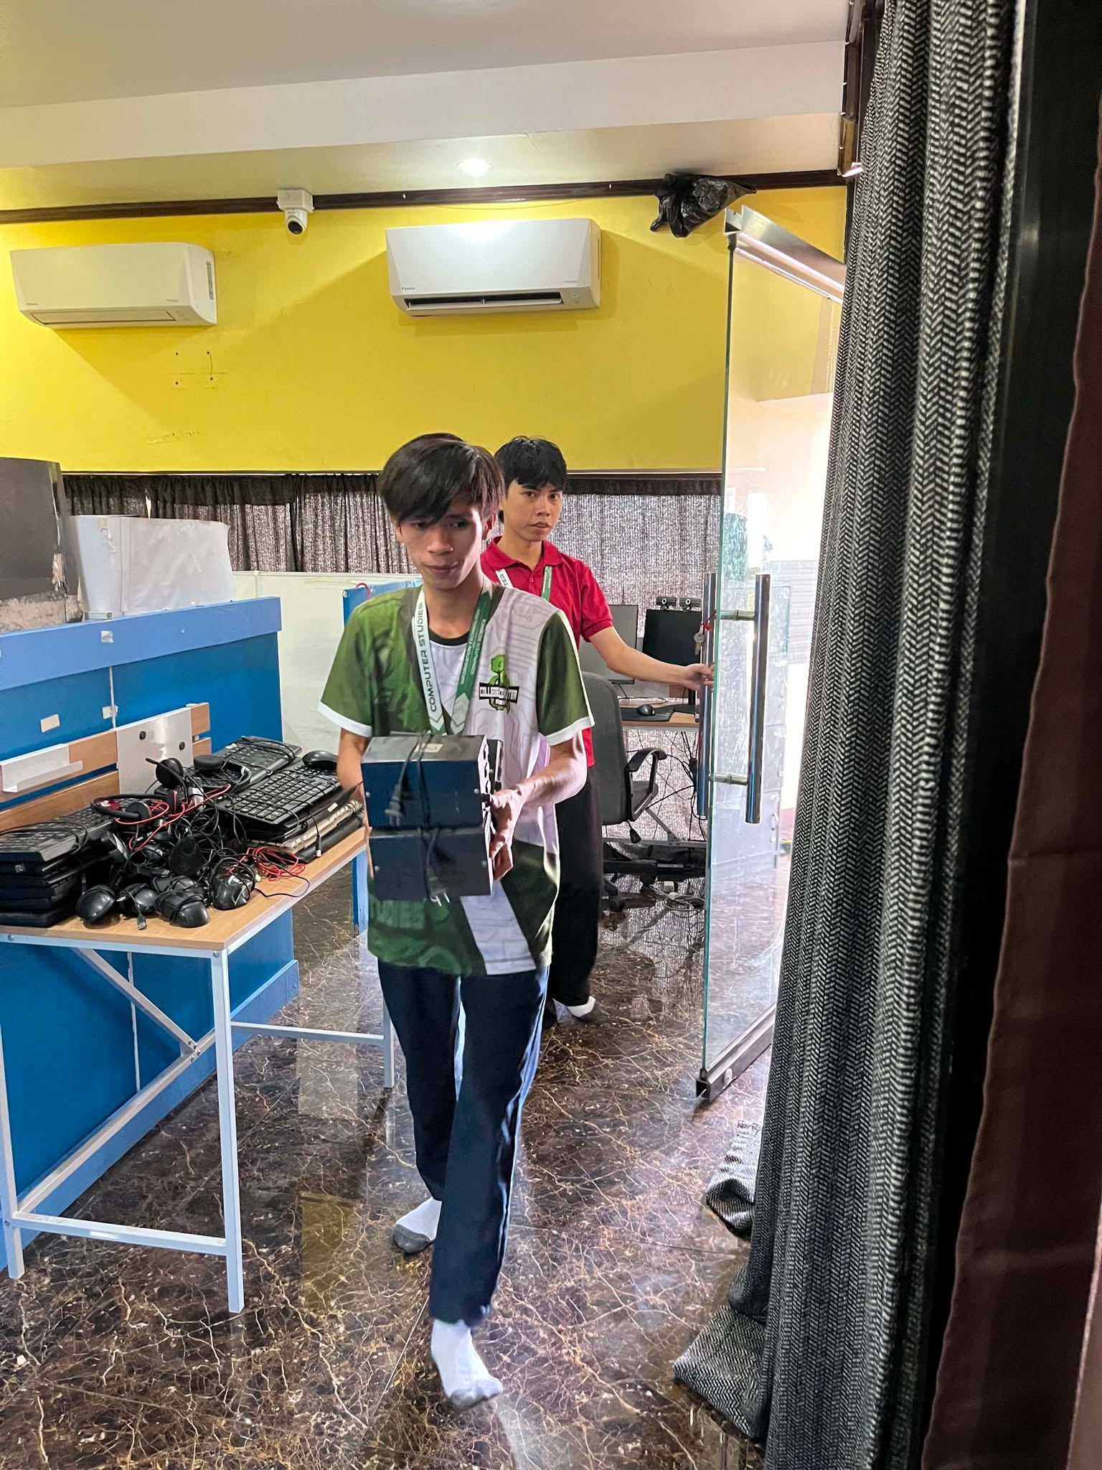

PC Cleaning

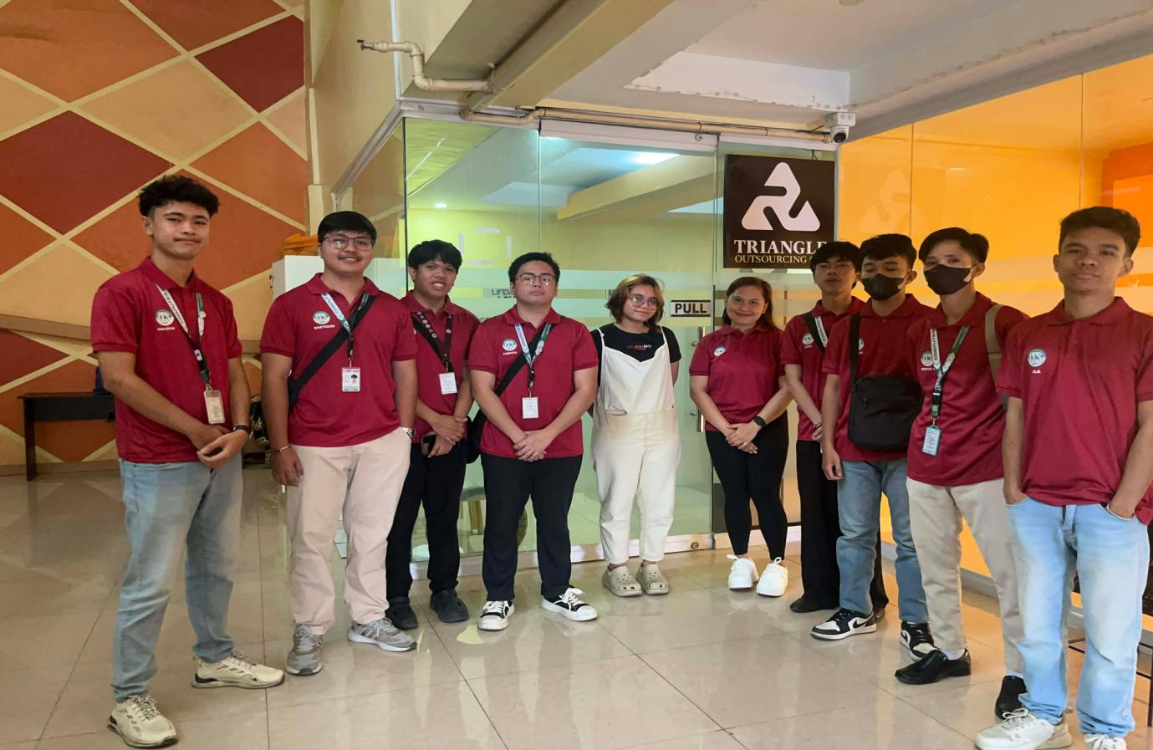

OJT Trainees with TOC HR, Ma’am Julia Francine E. Guerra, RPm, CHRA with the SPC intern

