

Event zone

Introduction

**Project code: EZ**

**Document code: EZ_ProjectIntroduction_v1.0**

Record of change

*A - Added　M – Modified　D – Deleted

|  |  |  |  |  |
| --- | --- | --- | --- | --- |
| Effective Date | Changed Item | A*M, D | Change Description | Revision Number |
| 13/09/2015 | Create new | A | Create document | 1.0 |
|  |  |  |  |  |

Contents

**1.** **Purpose** 4

**2.** **Project Information** 4

**3.** **Project members** 4

3.1. Supervisor 4

3.2. Team members 4

**4.** **Background** 5

**5.** **Literature Review** 7

5.1. sukienhay.com 8

5.2. talktv.vn 8

5.3. Eventbrite.com 9

5.4. Livestream.com 9

**6.** **Proposal of our system** 11

6.1. Our proposal system 11

6.2 Introduction about of proposal system 11

## **Purpose**

This document provides an overview of Event Zone include background information, literature review of existing system and raising a proposal for ideas of improvement.

## **Project Information**

* Project name: Event Zone
* Project code: EZ
* Project group name : EZ Team
* Product type: Website Application
* Timeline: From 7th September 2015 to 19th December 2015

## **Project members**

### **Supervisor**

|  |  |  |  |  |
| --- | --- | --- | --- | --- |
|  | Full name | Phone | E-Mail | Title |
| Supervisor | Trần Bình Dương | 0936168165 | [DuongTB@fpt.edu.vn](mailto:DuongTB@fpt.edu.vn) | Lecturer |

*Table 1.1: Supervisor information*

### **Team members**

|  |  |  |  |  |  |
| --- | --- | --- | --- | --- | --- |
|  | Full name | Student code | Phone | E-mail | Role in Group |
| 1 | Phan Thanh Vũ | SE61276 | 01689241500 | [VuPTSE61276@fpt.edu.vn](mailto:VuPTSE61276@fpt.edu.vn) | Leader |
| 2 | Dương Thị Lan Anh | SE02721 | 01678388747 | [AnhDTLSE02721@fpt.edu.vn](mailto:AnhDTLSE02721@fpt.edu.vn) | Member |
| 3 | Nguyễn Thị Chương | SE02649 | 01673225638 | [ChuongNTSE02649@fpt.edu.vn](mailto:ChuongNTSE02649@fpt.edu.vn) | Member |
| 4 | Nguyễn Văn Cường | SE02837 | 01687388281 | [CuongNVSE02837@fpt.edu.vn](mailto:CuongNVSE02837@fpt.edu.vn) | Member |
| 5 | Nguyễn Sen Hà | SE02665 | 01644699884 | [HaNSSE02665@fpt.edu.vn](mailto:HaNSSE02665@fpt.edu.vn) | Member |
| 6 | Nguyễn Ngọc Dương | SE02205 | 01668094399 | [DuongNNSE02205@fpt.edu.vn](mailto:DuongNNSE02205@fpt.edu.vn) | Member |

*Table 1-2: Team members’ information*

## **Background**

There are tons of events happening every year all round the world. These events range from individuals to organizations, families to politics… These below are few examples of event nowadays:

* Birthday parties to political fundraisers
* Promoting a product
* Anniversaries
* Fashion Shows
* Product Launch
* Conferences
* Graduations and Reunions
* ……

 Events are organized more and more through each year. They make event industry become one of wealthiest and fastest growing industries in the recent times. They almost doubled the expenditure only in 5 years from 2011 to 2015.

+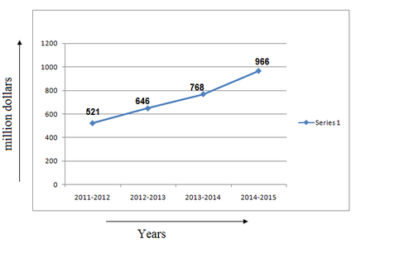

*Event industry expenditure[1]*

As it's growing, demand of people in management and searching event has also increased.

According to statistic of Alexa.com and Similarweb.com about Eventbrite.com – a big website about management and searching events, we know that there are 19.6 million visits each month with global rank are 792 (global) and 246 (United States). However, there are 1.2 million events held per year in this website[2].

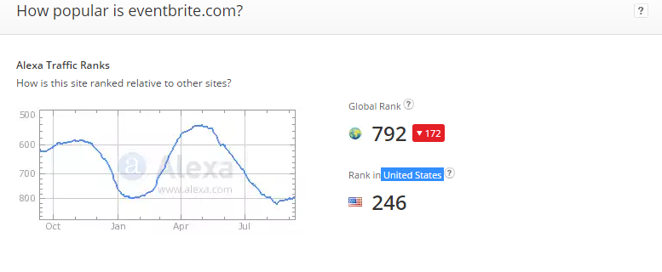

*Ranking of Eventbrite. Com in Alexa.com[3]*

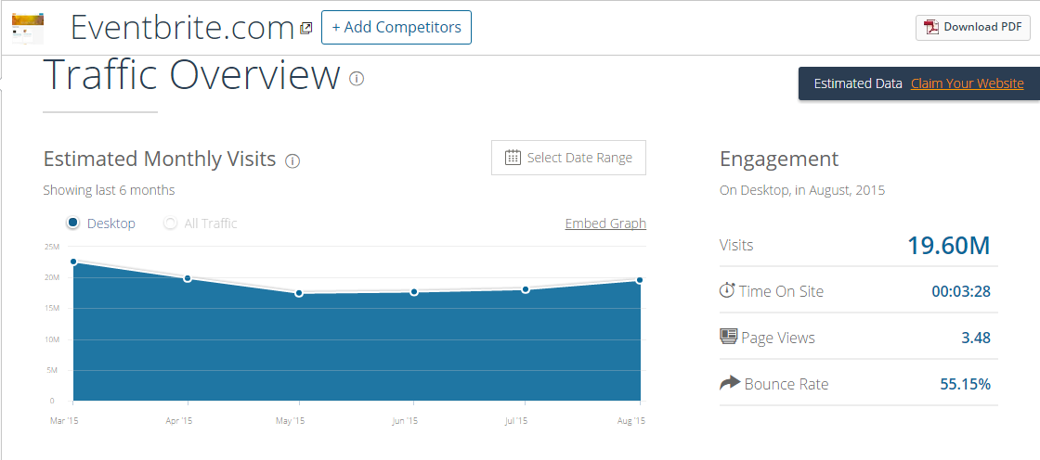

*Traffic overview of EventBrite.com[4]*

Based on those statistics, we came to conclusion that demand about management and searching events are rapidly increasing.

After seeing the demand of user, we research about how people want to watch live event and we got answer that almost people more interesting in watching event online than go to live event.

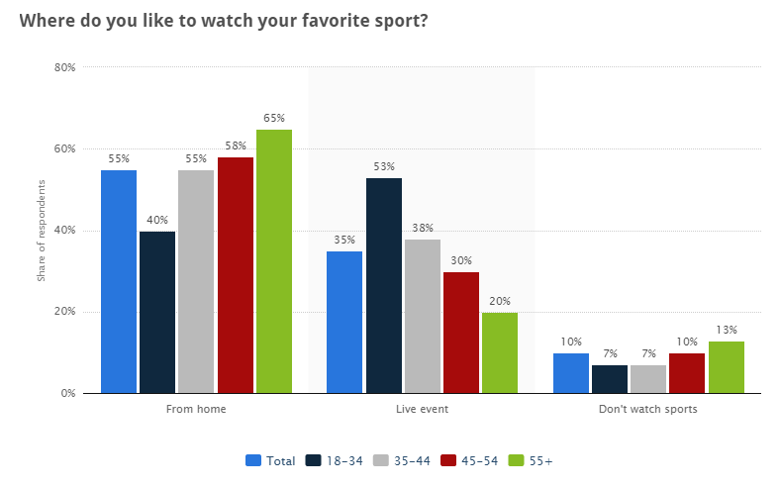

*The places people enjoyed watching their favorite sports in the United States as of November 2013[5]*

Based on all those statistic, we decided to create a website that support people management events (create, edit, live stream…) to promote it or help people easy find out live stream of event which they want to watch. We called it “Easy Zone”

## **Literature Review of Existing System**

By reviewing some events and live streaming website, we already have gotten main details of those:

### **sukienhay.com**



* Scope of website: Events in Vietnam
* Provide almost functions that user need:
  + Can search, create, view, comment, vote or report an event
  + Create organization
  + Create and view blog.
  + Manage tickets of events: Give free tickets, book tickets, reserve seats.
  + Share to social networks
  + Manage events schedule based on Google Calendar
  + Pay online with Baokim
* Huge popularity.
* Advantages:
  + Manage events
  + Location Search
  + Notification

### **talktv.vn**



* A streaming website.
* Scope: In Vietnam
* Focus on game, idol, movie streaming
* Functions:
  + Read news
  + Search videos
  + Share watching videos
  + Free with some function
* Advantage:
  + Streaming Video using tool
  + Have app for mobile

### **eventbrite.com**



* An event website
* Scope: the world
* Functions:
  + Search and view all events all over the world.
  + Search event by location with suggesting
  + Allow user to register and manage their own event.
  + Allow to promote their event by inviting others.
  + Have tools to reach new audiences, connect with social network.
  + Manage tickets, discount, sale by phone or website
  + Free for events which are publishing information on website, charge fee if having tickets.

### **Livestream.com**



* + - * A streaming website
      * Scope: the world
      * Function:
  + Allow user to view live streams of events all over the world.
  + Allow user to create live streams of their own.
  + Charge fees.
  + Support user to streaming
  + Analytic hottest and most-viewed streaming
  + Allow user to follow other users
  + Event Facebook Application
  + Password Protected Event
  + Disable Viewer Count, Chat and Commenting

## **Proposal of our system**

### **Our proposal system**

After reviewing those characteristics of websites, they have their own advantages and disadvantages, so we came to an agreement about which functions our website should support to inherit their strong points and reduce their limitations:

Basic functions:

* Allow user to create and edit account.
* Allow user to watch live stream of events all over the world.
* Allow user to see information of events all over the world
* Allow user to register event and a live stream on Youtube.com for that.
* Allow user to search event based on name or location, have suggestion for user to search.
* Analytic for each events for the owner.
* Allow user to follow event for receive notification about event.
* Allow user to follow category to see upcoming event of that category.
* Set privacy suitable for each event.
* Upload image to event

Out – of – scope functions:

* Manage content.
* Manage schedule for user

|  |  |  |  |  |  |
| --- | --- | --- | --- | --- | --- |
|  | sukienhay.com | talktv.vn | eventbrite.com | livestream.com | EventZone |
| Create Event | X |  | X | X | X |
| Edit Event | X |  | X | X | X |
| Invite Others | X |  | X |  |  |
| View Blog | X |  |  |  |  |
| Search by Location | X |  | X |  | X |
| Manage Tickets | X |  | X |  |  |
| Social Network | X | X | X | X |  |
| Live Streaming |  | X |  | X | X |
| Analytic Event |  |  | X | X | X |
| Free | X |  |  |  | X |

Finally, we use some new approaches to solve the problems stated. Having aware of the emergence of new technologies, we aim at applying them to our project.

### **Introduction about of proposal system**

The core idea of the system is making connection between event managers and event viewers to easier than ever. The information is completely made by user and process by system. Users who want to promote their event to more and more people can register their event here and make a space to for everyone to come and build up information. They can also live streaming their event for people who can’t come to watch online. Users who want to view event can search on their location to find the best fit event for them or search by name. They can also provide information for their watching event by upload their image to event page.

1. <http://www.quora.com/How-big-is-the-market-for-events-management>
2. https://www.eventbrite.com/about/
3. http://www.alexa.com/siteinfo/eventbrite.com
4. http://www.similarweb.com/website/eventbrite.com
5. http://www.statista.com/statistics/316240/sports-watch-location-usa/