Felix Schaefer

App Dev. for Analytics

Prof. Daniels

April 5, 2025

**Use of AI for Assignment 2**

For this 8-question C# programming assignment, I leveraged AI tools—including GitHub Copilot and Visual Studio’s integrated code autofill features—to streamline the development process. These tools were incredibly helpful, particularly because the assignment provided a clear and structured framework for how the answers were to be submitted.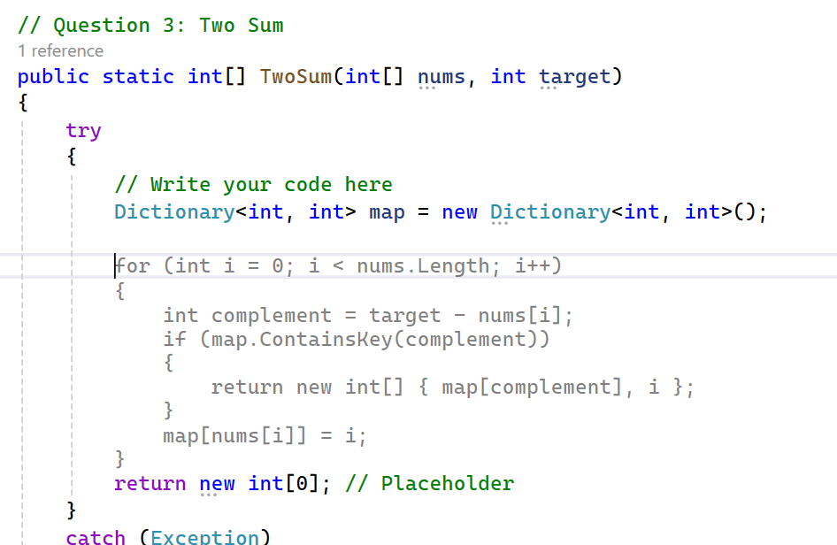

From the moment I started solving a problem, Copilot seemed to anticipate where I was heading. For instance, as shown in the screenshot of the “Two Sum” problem, the autofill suggestions made it easy to quickly populate key logic structures like dictionary creation and loop patterns. The software felt like it was completing my thoughts in code, which not only sped up the process but also helped reinforce best practices.

This experience offered a valuable learning opportunity. By watching how Copilot responded to my keystrokes and logic, I began to craft more targeted prompts and code more efficiently. It taught me how to communicate my intent more clearly—not just to AI, but in my code itself.

AI also played a key role in debugging. As shown in the second screenshot, I encountered a syntax issue while calculating the product of elements in an array. The AI assistant flagged the error (CS0103), explained the issue, and suggested corrections. This kind of feedback was immediate and extremely useful, particularly since I’m still becoming familiar with C# syntax.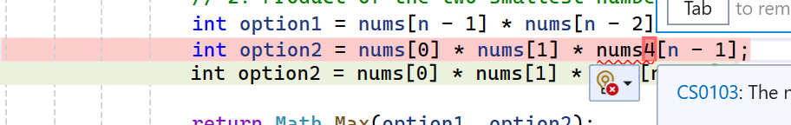

While the logic required to solve each question was not overly complex, I often needed help expressing that logic in C#. In those moments, AI tools acted like a helpful reference or guide. Some sample prompts I used include:

* "Give me three test cases for the above Fibonacci sequence problem."
* "How do I change the order of an array?"
* "Pasted my code—why is this code not working? Debug and highlight the errors."

These prompts helped me move forward when I wasn’t sure how to begin or continue. The AI acted as a tutor pointing me in the right direction without taking over the task.  
  
It also provided support in explaining why the syntax was a certain way. For example, I was unsure how to solve question 2. I prompted, “Explain why left/ right are used when sorting and looping through the array”. Here is part of the response I got.

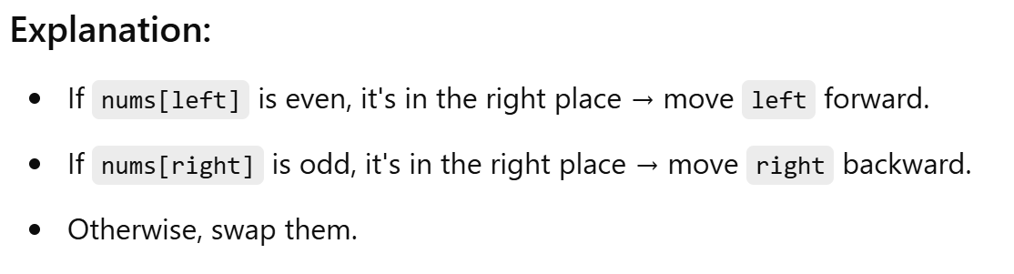

In conclusion, the AI assistant was instrumental in helping with syntax, typing, debugging, and testing. I can also see how these tools might slow down more experienced programmers who already have command of the language. Suggestions made by Copilot weren’t always accurate, and they always required double-checking. For more complex problems, the AI's assistance may introduce an extra layer of interpretation that can slow down the process rather than speed it up.

Nonetheless, for someone at my level, AI offered both technical assistance and learning support—making this assignment a productive and insightful experience.