ELEC 522 PROJECT 2 REPORT
Felix Tse, MECE, Fall 25
Design Overview

This project aims to design a hardware accelerator block for 4x4 matrix multiplication. To maximize parallelism, the design aims to implement a systolic array to load, compute, and unload data. The design consists of 16 processing elements (PE), which are each responsible for calculating the corresponding value of the output matrix. The input data type is 16-bit two’s complement, 0 bit binary point. A single PE is shown below in Figure 1. Overall, this design achieves a clock cycle of 404.7MHz, utilizes 199 I/O pins, and requires 16 clock cycles for a single calculation (compute and unload). Data is unloaded to the right. To achieve pipelined matrix multiplications, subsequent matrix multiply calculations happen immediately during unloading of data, which means that each PE is fully utilized and performing multiply and accumulate on all cycles. For a single calculation, the flow for matrix - matrix multiplication is as such: load data (3 cycles of latency, first elements loaded and computed on cycle 4), compute (final computation at cycle 13), unload and reset each column of PE beginning from the leftmost column (unload final element at cycle 16), and immediately begin loading data for subsequent calculations once the columns are empty (new data loading begins on cycle 13).

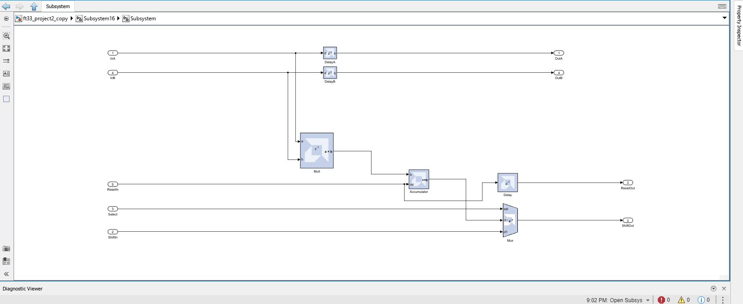
Figure 1: Processing Element

A single PE consists of a multiplier, an accumulator, a 2-input multiplexer, and several delay blocks. Inputs are the values from A and B, a select signal, a reset signal, and a shift in value from a neighboring element. Outputs are values from A and B, the shift out value to a neighboring element, and the select signal. The inputs from A and B are immediately loaded into the multiplier, while a separate datapath carries them to delay blocks so they can be loaded into their neighboring PE. A 2-input multiplexer is used to select between the value of the accumulator in the current PE, or to pass on a value from the neighboring element. Once all values have finished computing (on clock cycle 13), the select signal is immediately asserted for four cycles (13, 14, 15, 16) to unload data from column 4, 3, 2, and 1 respectively in the array.

Matrix-vector mode is coded in software with a flag indicating whether matrix multiplication mode (MMM) or matrix vector mode (MVM) should be used. If MVM, the MATLAB code directly generates a 4x1 column vector, and instead sets the select signal to immediately begin unloading data at cycle 10 (the first column of processing elements finishes computing at this time) by asserting the select signal for cycle 10, 11, 12, 13. Reset signal is asserted on cycle 13 and new data begins loading in. In other words, no hardware changes are necessary: the timing and logic is the exact same as matrix-matrix multiplication, just 4 cycles more efficient.

Input and Output Architecture Tradeoffs

The biggest advantage of this design is maximum possible throughput. Once initial PE latency is overcome, the array is constantly performing useful work due to subsequent loading and computing overlapping with previous calculations unloading cycles. Each PE has a latency of 3 cycles (1 from the multiplier, 1 from the accumulator, and 1 from the mux). The accumulator requires a cycle of latency due to its usage as a register to store previous values, while the mux requires a cycle of latency, since the initial shift in values are 0’s: if the mux has no latency, these 0’s are immediately loaded into the first column during unloading, which overwrites the values stored in the accumulator. The multiplier latency was increased to 1 cycle to pipeline computation and reduce the critical path. To properly unload and pipeline multiple matrix multiplications, the reset signal is asserted on the leftmost column of PE’s and passed systolically through subsequent elements. This ensures that columns are cleared as their value is being unloaded, allowing new data to come in and subsequent computations to begin. Another advantage of the design is that the PE logic is incredibly simple. It simply computes, passes A and B, and unloads data based on the select signal. It also uses the exact same logic for both MMM and MVM, just with different select/reset assertion times. No state machines, buffers, counters, excess memory elements, large multiplexers, or complex control signals are required to accept, compute, and unload data.

The main disadvantage of this design is the high I/O pin count due to the design requiring 10 input data buses and 4 output buses, which uses 199 of 200 available I/O pins. For wider data bit widths (e.g. 32, 64-bit), a different FPGA board will need to be used. While throughput of the design is high, there is also high latency for a single calculation (16 total clock cycles). A system requiring a single calculation would be better served by a different architecture. Additionally, some post-processing is required to sort the output matrix C (requires buffering and reordering).

Model Composer Screenshots

A screenshot of the single PE is shown above. Screenshots of the full array and subsystem are shown below in Figure 2 and Figure 3.
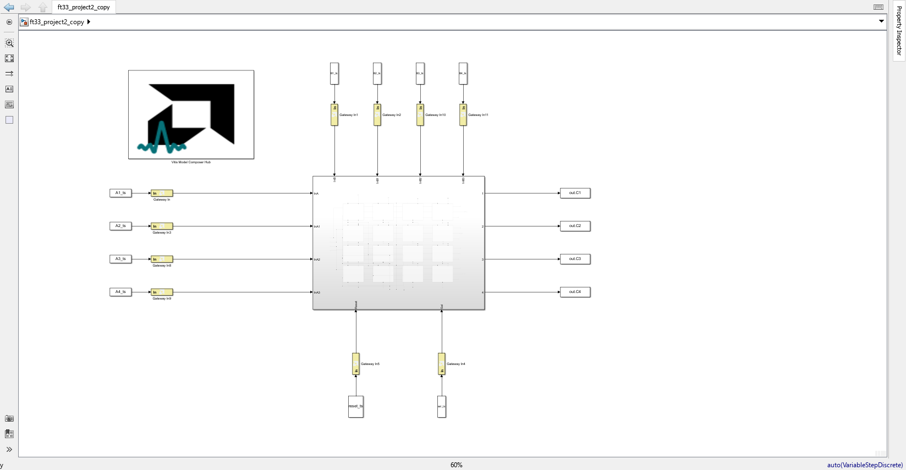
Figure 2: Full Array
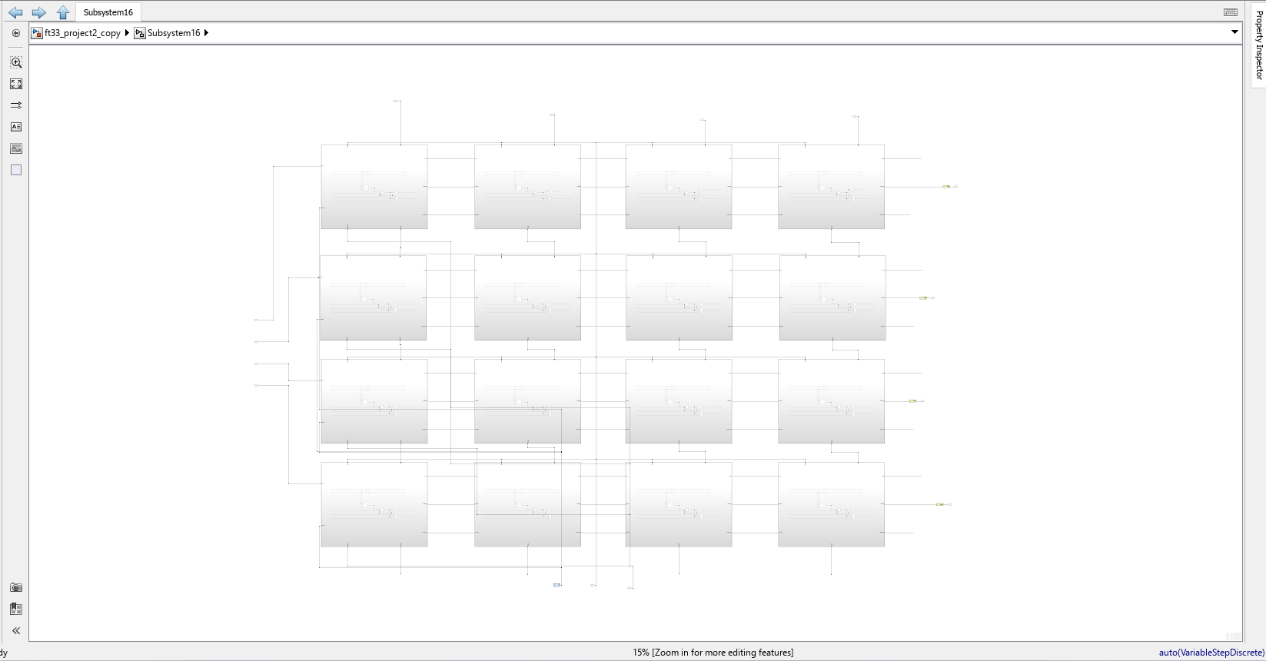
Figure 3: Subsystem Layout

Simulation Results
Below are the results for a series of 2 matrix-matrix multiplications and a series of 2 matrix-vector multiplications.

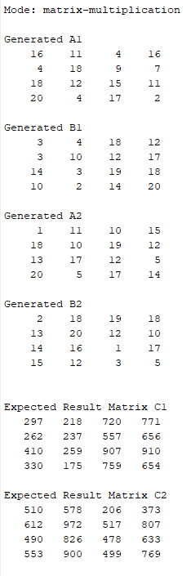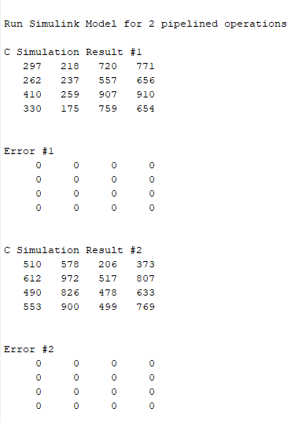
Figure 4: Simulation Results for Matrix-Matrix Multiplication

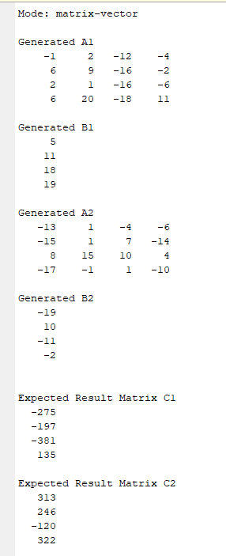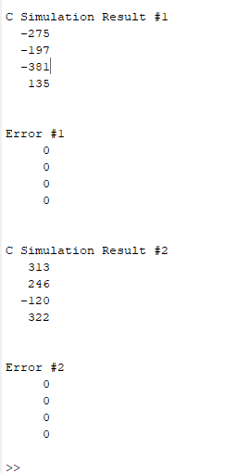
Figure 5: Simulation Results for Matrix-Vector Multiplication

Resource and Timing Analysis

Screenshots of resource utilization and timing analysis are shown below in Figure 6, Figure 7, and Figure 8. The worst delay was 2.4710 ns, which corresponds to a clock speed of 404.7 MHz. It can be seen that 16 DSPs have been used, which correspond to the 16 multipliers used in the design. Additionally, from Vivado, it can be seen that 199 I/O pins out of 200 available were used, showing that our design is implementable on a resource-constrained FPGA such as the Zedboard Zynq.
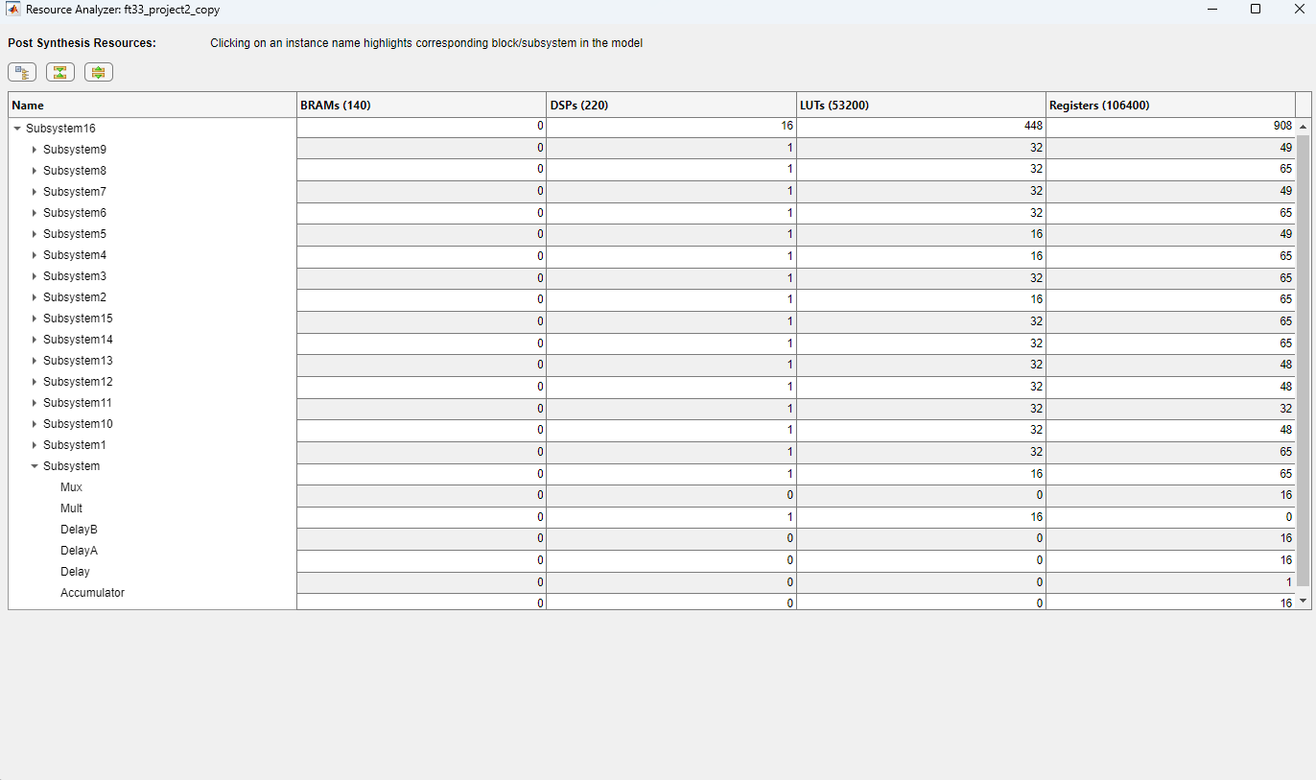
Figure 6: Resource Utilization
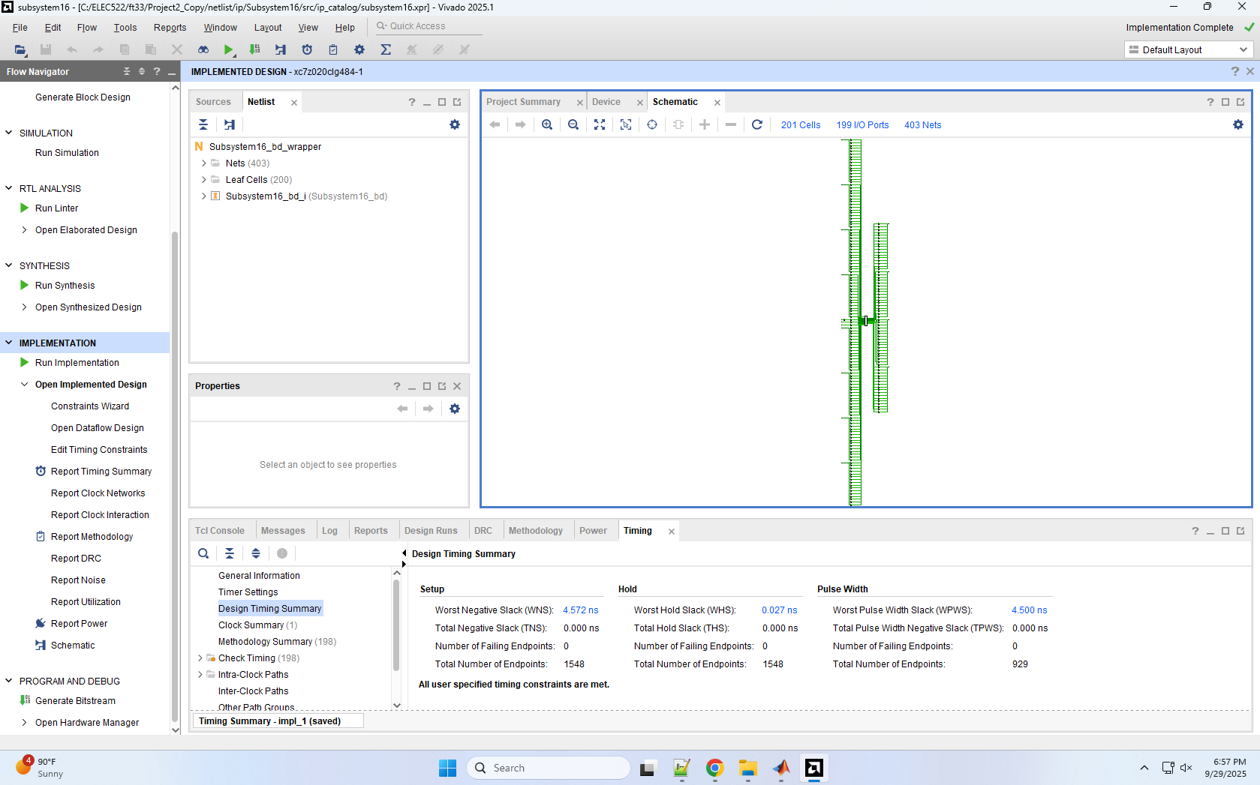
Figure 7: Vivado Implementation Schematic: I/O Pin Usage

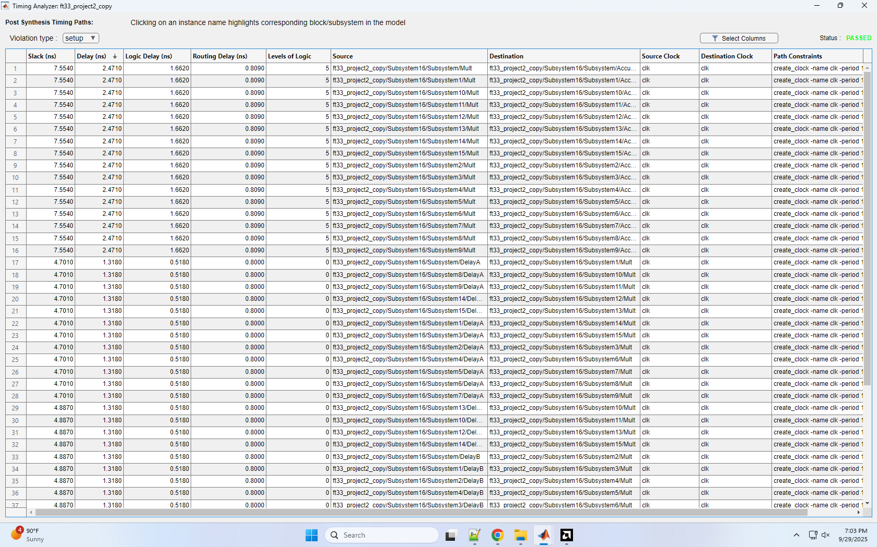
Figure 8: Timing Analysis
Design Scalability Analysis

This design scales reasonably well with larger size matrix multiplications. Only the select signal is globally required by all PE’s: all other signals, inputs, and outputs are passed through the array systolically. As mentioned above, each processing element requires 3 cycles of latency to pipeline the multiplier with one cycle, accumulator with one cycle, and mux with one cycle, along with a single cycle of delay to move inputs from A and B to neighboring elements. Total compute and unloading time is 16 cycles, while subsequent multiplications begin once data begins unloading. The maximum clock frequency is 404.7 MHz. The accumulator requires a cycle of latency due to its usage as a register to store previous values, while the mux requires a cycle of latency, since the initial shift in values are 0’s: if the mux has no latency, these 0’s are immediately loaded into the first column during unloading, which overwrites the values stored in the accumulator. The multiplier latency was increased to 1 cycle to pipeline computation and reduce the critical path. All processing elements are constantly loading, computing, and unloading, with unloading of previous computations and loading of new data occurring at the same time. This occurs regardless of MMM or MVM.

Testing Methodology

To test the design, MATLAB code was written to randomly generate 4x4 matrices with values from -20 to 20. The code calculated the actual C matrix output, found the difference between the design’s generated output and the calculated output, and generated an error matrix: if the error matrix showed all 0’s, the design and calculated output were identical. Twenty different iterations were tested, each with varying matrix values and number of calculations per iteration (varying from 1 to 5), with a success rate of 100%. A similar test was run for matrix - vector mode, also with 100% success rate. Additionally, the design was proven to be more efficient than matrix - matrix mode by checking the total cycles of time series: for 2 calculations of matrix - matrix multiplication, the total number of cycles was 29 cycles (16 cycles for first one, plus 16 - 3 for second), while for 2 calculations of matrix - vector multiplication, the total number of cycles was 23 (13 for first calculation, plus 13 - 3 for second), which proves that matrix - vector mode is indeed optimizing the design for max efficiency and not waiting for the other 12 processing elements to compute. Example runs for matrix-matrix and matrix-vector multiplication iterations for two calculations are shown above in Figure 4 and Figure 5.

