New Game!

I'd like to introduce my latest game for Android. It's called Astronomo and it's Asteroids refreshed for touch.

Sporting a unique control system, silky post-retro graphics, and game play that moves seamlessly from entrancing to adrenal the game presents classic game play in a sexy, modern, social, mobile wrapper, including...

- 40 waves of mayhem
- 27 unique types of enemy
- 5 pumping tunes
- 4 terrifying bosses
- 1 unlockable mini-game
- and bar code scanning goodness

Free Copy

Click below to grab the game from the Google Play Store.



Your promo code is ab49f. Please keep it to yourself.

1 UP

This free friend code will give you an extra life!

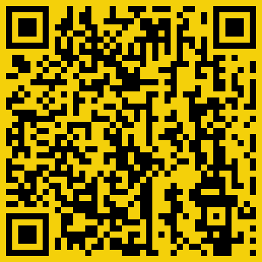

ME

I am MonkeySonnet, an indie developer working out of a bedroom in South London.

I'd be happy to answer any questions you may have! Send them to monkeysonnet@gmail.com.

