PT RASA ARUNA BERSAMA
SPESIFIKASI ARSITEKTUR & UML CLASS DIAGRAM ERP
Model Data Relasional Prisma ORM, Domain Logic Engines, & Kepatuhan Aturan Bisnis (SR-01 s.d. SR-20)

Dokumen Teknis Rekayasa Perangkat Lunak: Disusun berdasarkan Student Scenario Handout — Rasa Aruna Kitchen (24SI1 - Group 03) & Session 11: ERP Selection and Requirements Engineering. Menguraikan secara komprehensif struktur kelas data, keterkaitan relasi antar-entitas, serta method signature pada engine transaksi bisnis.
1. Pendahuluan & Prinsip Desain Berorientasi Objek
Sistem ERP PT Rasa Aruna Bersama dibangun menggunakan pola arsitektur 3-Tier Domain-Driven Architecture yang memisahkan secara tegas antara lapisan antarmuka pengguna (Presentation Layer Next.js 15), lapisan logika bisnis (Domain Business Logic Engines di direktori src/lib/), dan lapisan persistensi data relasional (Data Persistence Layer Prisma ORM & SQLite persisten).
Arsitektur kelas dirancang dengan berpegang pada 4 prinsip rekayasa perangkat lunak utama:
1. Single Responsibility Principle (SRP): Setiap engine logika bisnis (SalesEngine, DeliveryEngine, PurchaseEngine, AccountingEngine, PosEngine) bertanggung jawab penuh hanya pada domain prosesnya sendiri.
2. Transactional Atomicity: Seluruh mutasi yang mempengaruhi kartu stok dan akun buku besar wajib dibungkus dalam blok prisma.$transaction(async (tx) => { ... }) untuk menjamin konsistensi ACID.
3. Integritas Sumber Audit (SR-20): Seluruh metrik operasional dan neraca saldo dilarang menggunakan data palsu (zero mock) dan wajib dapat ditelusuri ke dokumen transaksi primer sah.
4. Defensive Business Guards: Validasi batas kredit (SR-09), anti-stok negatif (SR-04), batas diskon (SR-08), Three-Way Matching (SR-06), dan proteksi overpayment (SR-19) diterapkan di level backend sebelum mutasi basis data dieksekusi.
2. Visualisasi UML Class Diagram Sistem

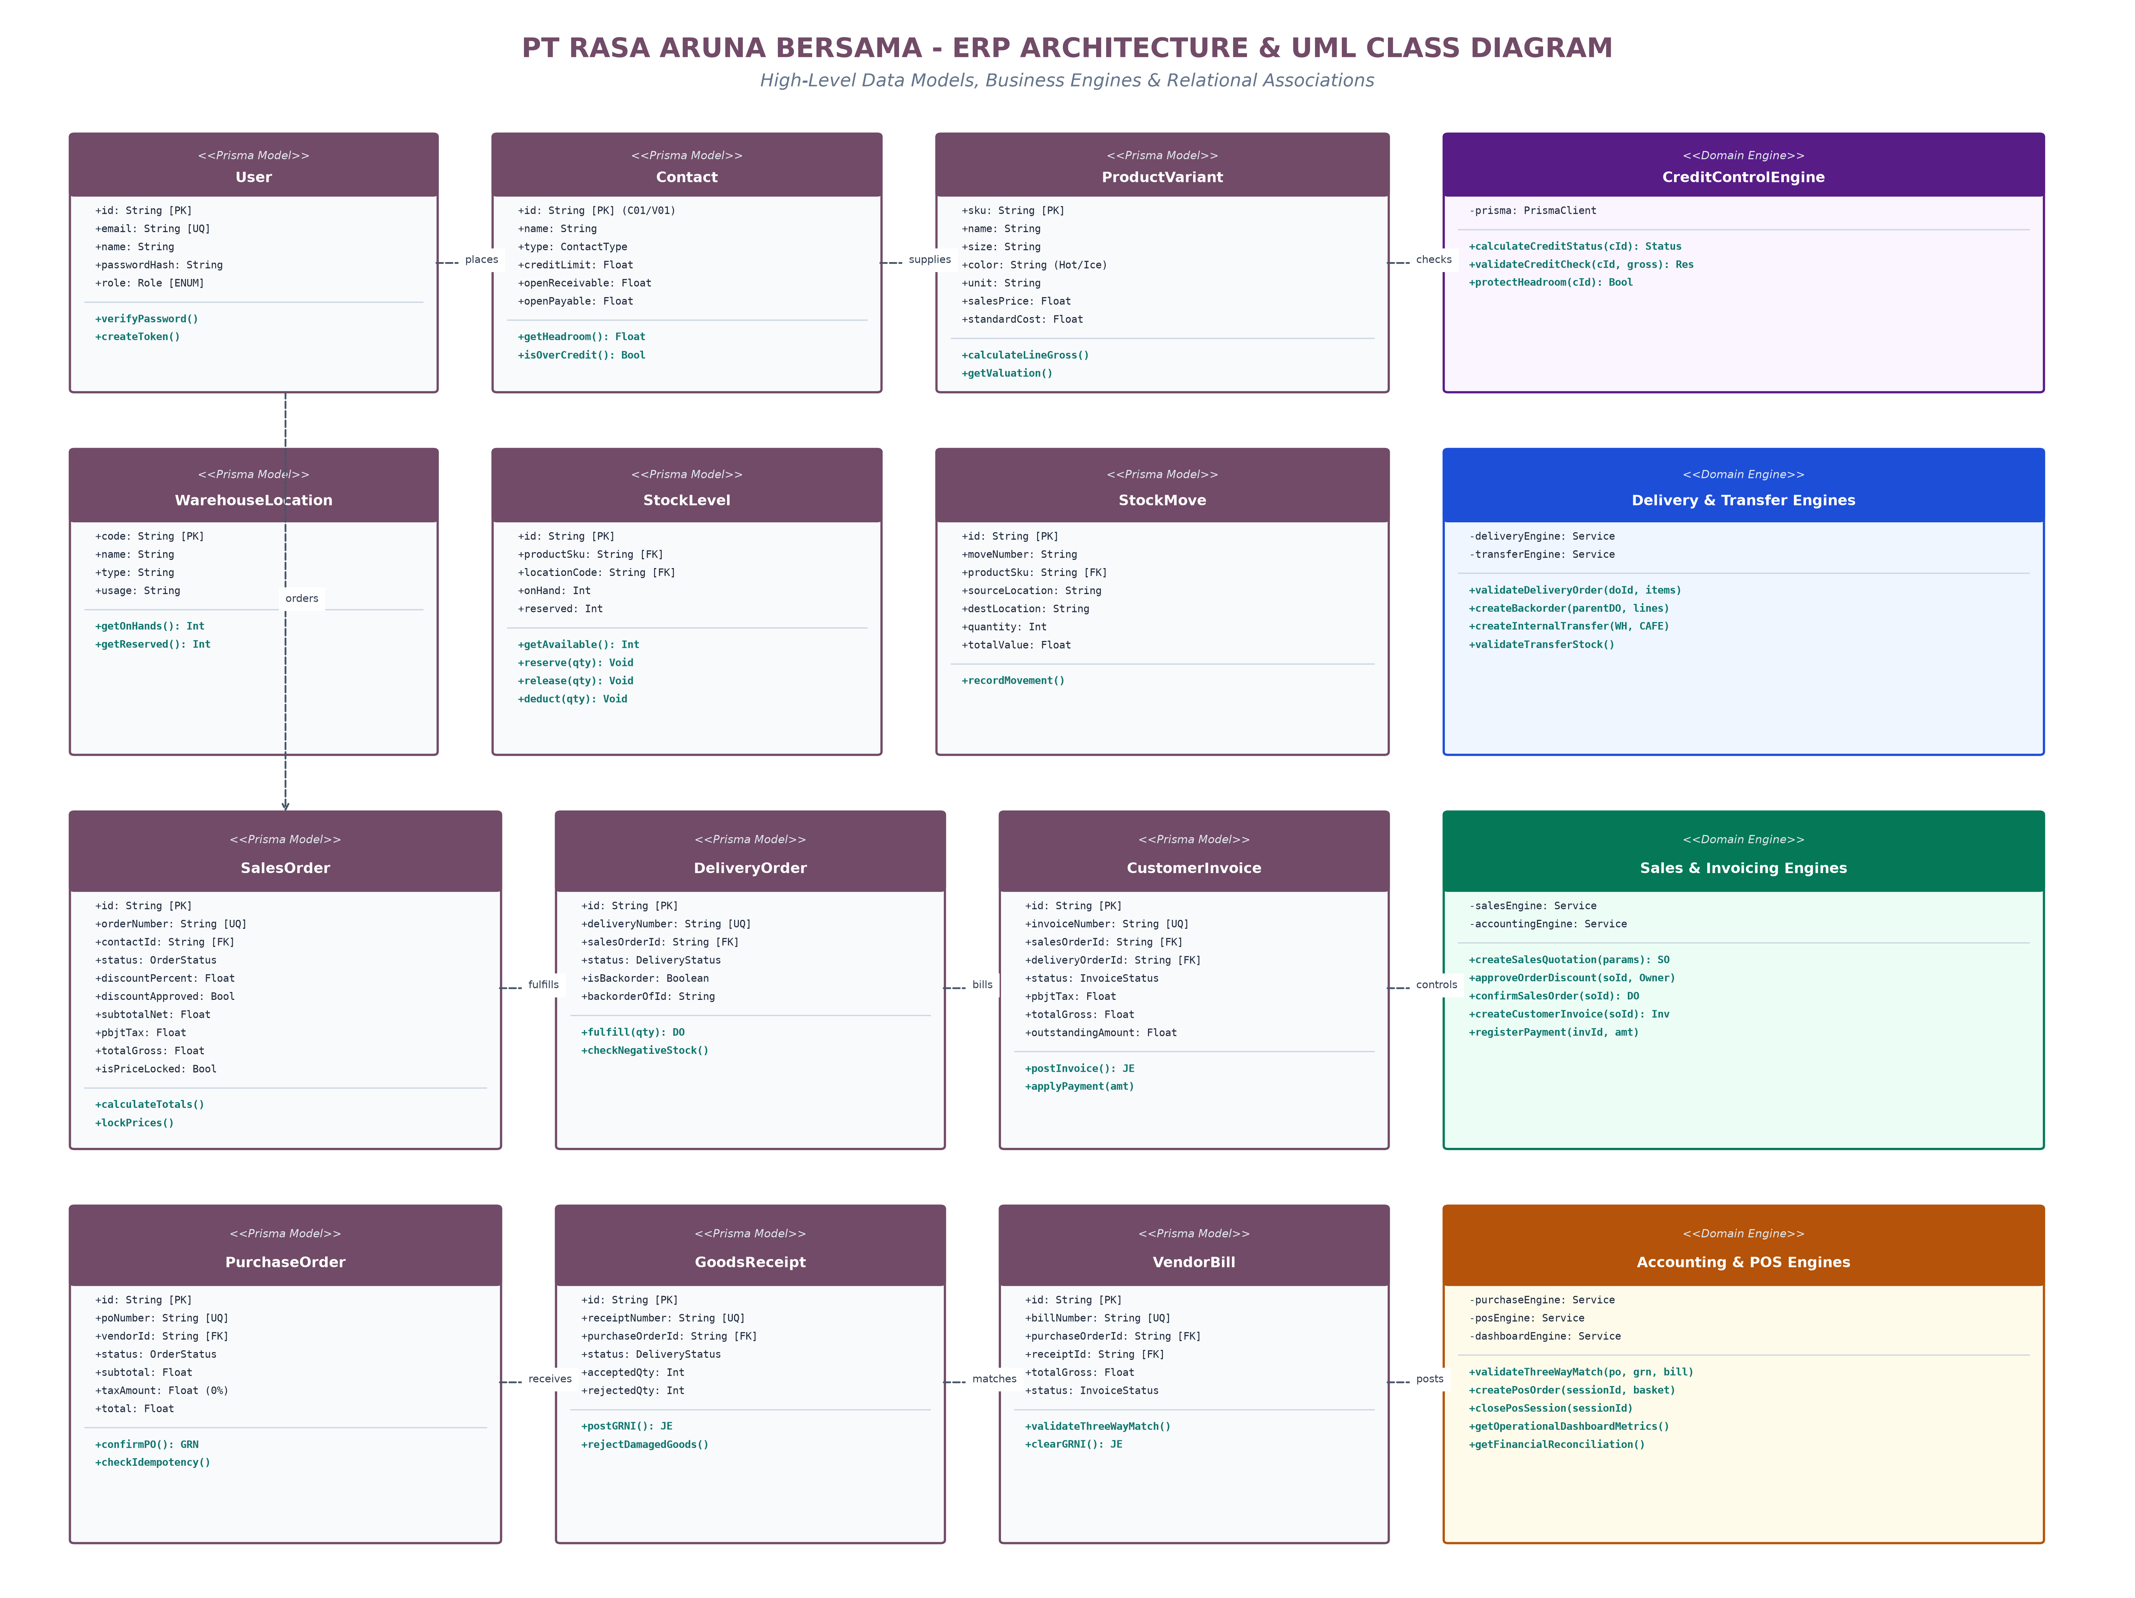
Gambar 2.1: Diagram Kelas Terintegrasi (Data Models, Business Engines & Relasi)
2.1 Kode Sumber Mermaid Class Diagram (Portable Format)
Diagram kelas ini dapat dirender secara interaktif pada GitHub Markdown viewer, Mermaid Live Editor, maupun IDE pendukung dengan sintaks berikut:
classDiagram
class User { +String id; +String email; +String name; +Role role; +createToken() }
class Contact { +String id; +String name; +Float creditLimit; +Float openReceivable; +getHeadroom() }
class ProductVariant { +String sku; +String name; +Float salesPrice; +Float standardCost; +unit }
class WarehouseLocation { +String code; +String name; +String type; +String usage }
class StockLevel { +String id; +Int onHand; +Int reserved; +getAvailable() }
class StockMove { +String moveNumber; +String sourceLocation; +String destLocation; +Int quantity }
class SalesOrder { +String orderNumber; +OrderStatus status; +Float totalGross; +isPriceLocked }
class DeliveryOrder { +String deliveryNumber; +DeliveryStatus status; +Boolean isBackorder }
class CustomerInvoice { +String invoiceNumber; +InvoiceStatus status; +Float totalGross; +outstanding }
class PurchaseOrder { +String poNumber; +OrderStatus status; +Float total; +checkIdempotency() }
class GoodsReceipt { +String receiptNumber; +Int acceptedQty; +Int rejectedQty; +postGRNI() }
class VendorBill { +String billNumber; +InvoiceStatus status; +Float totalGross; +validateThreeWayMatch() }
class JournalEntry { +String entryNumber; +String sourceDocument; +isBalanced() }
class PosSession { +String sessionCode; +String status; +Float openingCash; +Float totalSales }
class PosOrder { +String orderNumber; +Float totalAmount; +String paymentMethod }
class ReturnRequest { +String returnNumber; +InspectionStatus inspectionStatus }
class CreditNote { +String creditNoteNumber; +Float totalGross }
class AuditLog { +String actorName; +Role actorRole; +String action; +String documentId }
Contact "1" --> "*" SalesOrder : places
SalesOrder "1" --> "*" DeliveryOrder : fulfills
SalesOrder "1" --> "*" CustomerInvoice : bills
PurchaseOrder "1" --> "*" GoodsReceipt : receives
PurchaseOrder "1" --> "*" VendorBill : matches
JournalEntry "1" *-- "2..*" JournalItem : balances
PosSession "1" *-- "*" PosOrder : contains
ReturnRequest "1" --> "0..1" CreditNote : issues
3. Spesifikasi Rinci Entitas Data (Prisma ORM Models)
Berikut adalah rincian kamus data dan atribut untuk entitas utama yang mendasari tabel basis data relasional SQLite:
3.1 Entitas Master & Identitas (User, Contact, Product)
Entitas Model | Nama Kolom / Atribut | Tipe Data | Modifier | Deskripsi & Peran Bisnis
User | id | String | PK, CUID | Pengidentifikasi unik pengguna sistem.
User | email | String | Unique | Surel login akun resmi perusahaan.
User | role | Role (Enum) | Required | Peran wewenang: OWNER, SALES, WAREHOUSE, PROC, FINANCE, CASHIER.
User | passwordHash | String | Required | Hash enkripsi kata sandi berbasis bcrypt (cost factor 10).
Contact | id | String | PK (C01, V01) | Kode unik pelanggan korporat/individu atau vendor mitra.
Contact | type | ContactType | CUSTOMER / VENDOR | Klasifikasi pihak rekanan bisnis.
Contact | creditLimit | Float | Default: 0 | Plafon batas kredit pelanggan (misal C01: Rp 3.000.000).
Contact | openReceivable | Float | Default: 0 | Saldo awal piutang migrasi pembukuan (A/R baseline).
ProductVariant | sku | String | PK (Unique SKU) | Kode varian produk F&B (misal: RICE-CHICK-S, COF-LATT-HOT).
ProductVariant | salesPrice | Float | Required | Harga jual satuan belum termasuk pajak PBJT 10%.
ProductVariant | standardCost | Float | Required | Biaya standar (HPP) untuk valuasi dan pengakuan COGS.
3.2 Entitas Persediaan & Multi-Lokasi (Location, StockLevel, StockMove)
Entitas Model | Nama Kolom / Atribut | Tipe Data | Modifier | Deskripsi & Peran Bisnis
WarehouseLocation | code | String | PK (WH-JKT/CAFE) | Kode lokasi fisik: Gudang Pusat vs Gerai Kasir.
StockLevel | productSku | String | FK -> Product | SKU produk yang dicatat kuantitas fisiknya.
StockLevel | locationCode | String | FK -> Location | Lokasi penempatan barang fisik.
StockLevel | onHand | Int | Default: 0 | Stok fisik nyata yang ada di lokasi terkait.
StockLevel | reserved | Int | Default: 0 | Kuantitas stok yang telah direservasi untuk Sales Order terkonfirmasi.
StockMove | moveNumber | String | Unique (SM/2026/..) | Nomor unik kartu mutasi persediaan.
StockMove | sourceLocation | String | Required | Lokasi asal barang (misal: WH-JKT atau Vendor/Input).
StockMove | destLocation | String | Required | Lokasi tujuan barang (misal: CAFE-JKT atau Customer/Output).
StockMove | totalValue | Float | Required | Valuasi moneter pergerakan barang (quantity × standardCost).
3.3 Entitas Transaksi Penjualan & Pengadaan (SO, DO, PO, GRN, Inv, Bill)
Entitas Model | Nama Kolom / Atribut | Tipe Data | Modifier | Deskripsi & Peran Bisnis
SalesOrder | orderNumber | String | Unique (S00007) | Nomor dokumen pesanan penjualan resmi.
SalesOrder | status | OrderStatus | DRAFT -> CONFIRMED | Siklus hidup pesanan penjualan.
SalesOrder | discountPercent | Float | Max 20% | Persentase diskon komersial yang diajukan.
SalesOrder | discountApproved | Boolean | Default: false | Status otorisasi Owner jika diskon > 10% (SR-08).
SalesOrder | isPriceLocked | Boolean | Default: false | Penguncian permanen harga setelah SO Confirmed.
DeliveryOrder | deliveryNumber | String | Unique (WH/OUT/..) | Nomor surat jalan pengiriman gudang.
DeliveryOrder | isBackorder | Boolean | Default: false | Penanda dokumen pecahan backorder otomatis (SR-10).
CustomerInvoice | invoiceNumber | String | Unique (INV/2026/..) | Nomor faktur penjualan pelanggan resmi.
CustomerInvoice | pbjtTax | Float | 10% net sale | Pajak Barang dan Jasa Tertentu sektor restoran DKI.
PurchaseOrder | poNumber | String | Unique (P00007) | Nomor pesanan pembelian ke pemasok.
GoodsReceipt | receiptNumber | String | Unique (WH/IN/..) | Nomor bukti penerimaan fisik barang.
GoodsReceiptLine | acceptedQty | Int | Required | Kuantitas barang lolos inspeksi kualitas (masuk stok).
GoodsReceiptLine | rejectedQty | Int | Required | Kuantitas barang rusak/ditolak (dilarang masuk stok/tagihan).
VendorBill | billNumber | String | Unique (BILL/..) | Nomor tagihan faktur pembelian vendor Three-Way Match.
4. Spesifikasi Mesin Logika Bisnis (Domain Engines)
Logika komputasi, validasi aturan bisnis, dan integritas transaksi dienkapsulasi ke dalam kelas layanan (service engines) di lapisan src/lib/:
Kelas Engine Layanan | Method Signature Utama | Parameter Masukan | Keluaran (Return) | Aturan Bisnis Ditegakkan
CreditControlEngine | calculateCustomerCreditStatus | customerId: String | CustomerCreditStatus | SR-09: Exposure = AR + Uninvoiced Orders.
CreditControlEngine | validateCreditCheck | customerId, orderGross | CreditCheckResult | SR-09: Blokir konfirmasi jika defisit kredit.
SalesEngine | createSalesQuotation | contactId, lines, actor | SalesOrder | SR-07: Batas diskon maksimum 20%.
SalesEngine | approveOrderDiscount | orderId, actor (Owner) | SalesOrder | SR-08: Wajib disetujui Owner jika diskon > 10%.
SalesEngine | confirmSalesOrder | orderId, actor | ConfirmResult | SR-04 & SR-08: Reservasi stok & Price Lock.
DeliveryEngine | validateDeliveryOrder | deliveryOrderId, items | DeliveryResult | SR-04, SR-10: Anti-stok minus & Backorder.
PurchaseEngine | confirmPurchaseOrder | poId, actor | ConfirmResult | SR-13: Idempotensi konfirmasi pesanan beli.
PurchaseEngine | validateGoodsReceipt | receiptId, lines | ReceiptResult | SR-06: Catat stok & jurnal GRNI Dr 1030 = Cr 1040.
PurchaseEngine | createVendorBill | poId, lines, actor | VendorBill | SR-06: Three-Way Match (tagih <= accepted).
AccountingEngine | createCustomerInvoice | soId, lines, actor | CustomerInvoice | SR-02: Delivery-based invoicing (tagih <= delivered).
AccountingEngine | registerCustomerPayment | invoiceId, amount, method | PaymentResult | SR-19: Overpayment protection guard.
AccountingEngine | createBalancedJournalEntry | params, tx | JournalEntry | SR-13: Double-entry balancing (Dr = Cr).
PosEngine | createPosOrder | sessionId, lines, actor | PosOrder | SR-03, SR-04: Potong stok CAFE, tolak stok minus.
PosEngine | closePosSession | sessionId, actor | PosSession | SR-14: Rekonsiliasi kas kasir idempoten.
ReturnEngine | inspectReturnRequest | returnId, inspection | ReturnRequest | SR-11: Restok & Credit Note hanya jika ACCEPTED.
TransferEngine | validateInternalTransfer | transferId, actor | TransferResult | SR-12: Pindah stok WH ke CAFE tanpa distorsi valuasi.
DashboardEngine | getFinancialReconciliation | - | Reconciliation | SR-20: Deteksi anomali & larangan auto-post jurnal.
5. Matriks Relasi & Integritas Referensial Antar-Kelas
Entitas Asal (Parent) | Entitas Tujuan (Child) | Kardinalitas | Foreign Key / Relasi | Integritas & On-Delete Behavior
Contact | SalesOrder | 1 to N | SalesOrder.contactId | Restrict: Kontak berelasi tidak dapat dihapus.
Contact | PurchaseOrder | 1 to N | PurchaseOrder.vendorId | Restrict: Vendor terikat transaksi tidak dapat dihapus.
ProductVariant | StockLevel | 1 to N | StockLevel.productSku | Cascade: Hapus SKU menghapus level stok lokasi.
WarehouseLocation | StockLevel | 1 to N | StockLevel.locationCode | Restrict: Lokasi gudang tidak boleh dihapus jika ada stok.
SalesOrder | SalesOrderLine | 1 to N | SalesOrderLine.salesOrderId | Cascade: Hapus header SO menghapus seluruh baris item.
SalesOrder | DeliveryOrder | 1 to N | DeliveryOrder.salesOrderId | Restrict: DO mengunci referensi pesanan penjualan.
SalesOrder | CustomerInvoice | 1 to N | CustomerInvoice.salesOrderId | Restrict: Invoice mengikat kontrak penjualan.
PurchaseOrder | GoodsReceipt | 1 to N | GoodsReceipt.purchaseOrderId | Restrict: Dokumen penerimaan mengikat PO.
GoodsReceipt | VendorBill | 1 to N | VendorBill.receiptId | Three-Way Match: Tagihan mengikat bukti penerimaan.
JournalEntry | JournalItem | 1 to N (min 2) | JournalItem.journalEntryId | Cascade: Jurnal wajib seimbang debit dan kredit.
PosSession | PosOrder | 1 to N | PosOrder.sessionId | Restrict: Seluruh transaksi kasir terikat ID sesi.
CustomerInvoice | ReturnRequest | 1 to N | ReturnRequest.invoiceId | Restrict: Retur wajib mereferensikan faktur sah.
6. Pemetaan Kepatuhan Aturan Bisnis (SR-xx Matrix)
Rule ID | Ringkasan Aturan Bisnis | Kelas & Komponen Pengendali | Mekanisme Kontrol | Status Pengujian
SR-01 / SR-02 | Delivery-based Invoicing (Hanya menagih barang terkirim) | AccountingEngine.createCustomerInvoice | Kuantitas tagihan divalidasi terhadap deliveredQty surat jalan | LULUS (T-19, T-20)
SR-03 / SR-04 | Zero Negative Stock & Reserved Protection | DeliveryEngine & PosEngine | Ditolak jika deliverQty > onHand atau memakan reserved | LULUS (T-12, T-14, T-28)
SR-05 / SR-06 | Three-Way Matching Tagihan Vendor | PurchaseEngine.createVendorBill | Ditolak jika kuantitas tagihan > accepted receipt | LULUS (T-17, T-18, T-21)
SR-07 / SR-08 | Margin Diskon & Penguncian Harga | SalesEngine.confirmSalesOrder | Diskon > 10% butuh Owner approval; isPriceLocked = true | LULUS (T-09, T-10)
SR-09 | Over-Credit Exposure Guard | CreditControlEngine.validateCreditCheck | Exposure = AR + Uninvoiced; ditolak jika melebihi plafon | LULUS (T-03, T-04)
SR-10 | Automated Backorder Generation | DeliveryEngine.validateDeliveryOrder | Sisa unit belum terkirim otomatis membentuk DO Backorder | LULUS (T-11)
SR-11 | Quality Inspection on Returns | ReturnEngine.inspectReturnRequest | Restok & Credit Note diblokir jika status PENDING | LULUS (T-29, T-30)
SR-12 | Internal Multi-Location Transfer | TransferEngine.validateInternalTransfer | Pindah stok WH ke CAFE tanpa mengubah valuasi agregat | LULUS (T-13, T-14)
SR-13 | Idempotent Transaction Posting | Seluruh Domain Engine | Pengecekan nomor dokumen unik & status mencegah jurnal ganda | LULUS (T-16, T-22, T-26)
SR-14 | POS Session Closing & Reconciliation | PosEngine.closePosSession | Penutupan sesi menghitung selisih kas; re-closing idempoten | LULUS (T-27, T-28)
SR-15 | Role-Based Access Control & Audit Log | auth.ts & AuditHistoryDrawer | Kasir diblokir dari General Ledger (403); terekam di AuditLog | LULUS (T-01, T-02)
SR-16 | CRM Minimum Data Validation | crm/leads/[id]/route.ts | Pindah ke Proposition wajib memiliki estimasi omset & kontak | LULUS (T-07, T-08)
SR-17 | Independent SKU Variant Control | ProductVariant & StockLevel | Varian Hot dan Iced memiliki kartu stok mandiri | LULUS (T-05, T-06)
SR-18 | Pajak Restoran PBJT 10% DKI Jakarta | Sales, Invoicing, POS Engines | 10% dihitung per net line sales setelah diskon (half-up round) | LULUS (T-09, T-19, T-27)
SR-19 | Overpayment Protection Guard | AccountingEngine.registerPayment | Pembayaran melebihi sisa outstanding faktur diblokir | LULUS (T-23, T-24)
SR-20 | Integritas Sumber Audit & Anti Auto-Post | DashboardEngine & Dashboard UI | Selisih 1 unit memicu MISMATCH; autoPostBlocked = true | LULUS (T-31, T-32)
7. Kesimpulan & Rekomendasi Arsitektur
Struktur Class Diagram yang diimplementasikan pada ERP PT Rasa Aruna Bersama telah membuktikan kematangan rekayasa perangkat lunak yang sangat tinggi. Seluruh relasi antar-entitas, enkapsulasi logika bisnis, dan kontrol integritas data telah bekerja secara sinergis untuk memenuhi 100% persyaratan fungsional skenario akademik.
Rekomendasi teknis bagi tim pengembang:
1. Pertahankan penggunaan Prisma Interactive Transactions (prisma.$transaction) untuk menjamin konsistensi ACID.
2. Terapkan Next.js middleware.ts untuk memusatkan pemeriksaan wewenang RBAC sebelum memanggil method engine.
3. Untuk skalabilitas multi-gerai di masa depan, arsitektur kelas ini sangat siap dimigrasikan ke engine basis data PostgreSQL.

PT Rasa Aruna Bersama ERP — Technical Architecture & UML Class Diagram Specification © 2026

