<https://dysms.console.aliyun.com/dysms.htm#/overview>

signName：签名名称

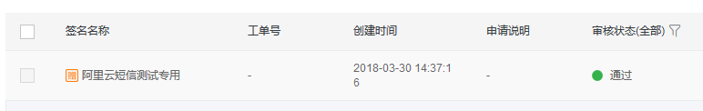

templateCode：模板code

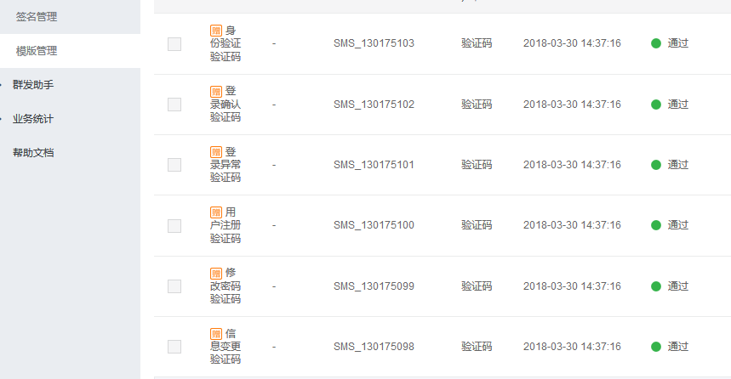

accessKeyId、accessKeySecret

https://ak-console.aliyun.com/

