Attention: ALL LKC FES STUDENTS

RE: UTAR STUDENT'S ONLINE SURVEY (May 2018 Trimester)

Kindly complete the evaluation survey within the survey duration as stated below. Your answers and comments will be kept strictly confidential. Your feedback will be useful to the lecturers in future trimesters and to help us improve our services.

Survey Period:
16 July 2018 (Monday) to 19 August 2018 (Sunday)

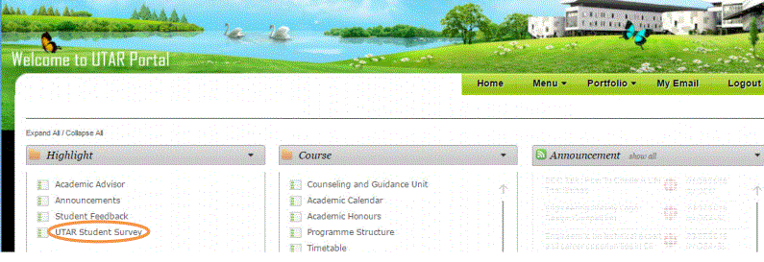

Thank you for your cooperation.

Faculty General Office
Lee Kong Chian Faculty of Engineering and Science

Note:
- This notice has been released to all students via UTAR Intranet Announcement / Faculty Notice Board / LKC FES Website / LKC FES Facebook on 13 July 2018.
- Lecturers will NOT be able to know the name of students who provide answers/comments in the survey. The results of the survey will be released to lecturers AFTER the examination results were released.

