Case Study Report
Staying Above the Skyline: Airbnb Market Analysis in Hong Kong

Yuzhen Yang
School of Social Policy and Practice, University of Pennsylvania
MSSP 6070: Practical Programming for Data Science
Instructor: Dr. Richard Hartwell
December 11, 2025

Executive Summary
This report analyzes the Airbnb short-term rental market in Hong Kong, China, aiming to help Airbnb hosts, property management companies, and prospective real estate investors understand the determinants of annual revenue, spatial market patterns, seasonality, and the role of amenities and host characteristics.
Using the listing-level and calendar-level datasets provided by AirROI, the analysis first conducts data cleaning, variable construction, and descriptive exploration. Further analysis identifies spatial clustering, seasonal patterns, room type, and popular amenities.
A regression model is then estimated to quantify the marginal effects of key property features, particularly the presence of an elevator and Superhost status. Results show that both elevator access and Superhost designation are associated with significantly higher revenue.
Based on these findings, the report provides actionable recommendations for pricing, renovation, and investment strategies.
1. Introduction
The sharing economy has fundamentally reshaped the global hospitality landscape, challenging traditional hotel industries by providing decentralized accommodation options (Einav et al., 2016; Zervas et al., 2017). Airbnb previously operated across Mainland China, but following its decision to close its domestic business in 2022, Hong Kong remains one of the only Airbnb markets in China with stable, publicly accessible listing data.
Despite the opportunities, a key challenge for hosts and investors is determining which specific attributes, such as location, building facilities, or host reputation, translate into tangible revenue gains. Without systematic analysis, hosts may risk mispricing their assets, and investors may misallocate capital into underperforming properties.
The primary objective of this report is to evaluate the supply patterns, revenue structures, seasonal trends, and key drivers of the Hong Kong short-term rental market. The findings are intended to serve three primary audiences: Airbnb hosts seeking to improve listing performance, property management firms making operational decisions, and real estate investors identifying high-yield real estate opportunities.
The remainder of this report is organized as follows: Section 2 details the data sources, cleaning procedures, and methodology. Section 3 presents an Exploratory Data Analysis of key variables and distributions. Section 4 analyzes specific market features such as seasonality, room type, and popular amenities. Section 5 presents the results of the OLS regression analysis. Section 6 presents conclusions and strategic recommendations, followed by limitations and directions for future research in Section 7. Figure 1 presents a brief overview of the main analytical workflow of the report.
Figure 1: Main Analytical Workflow
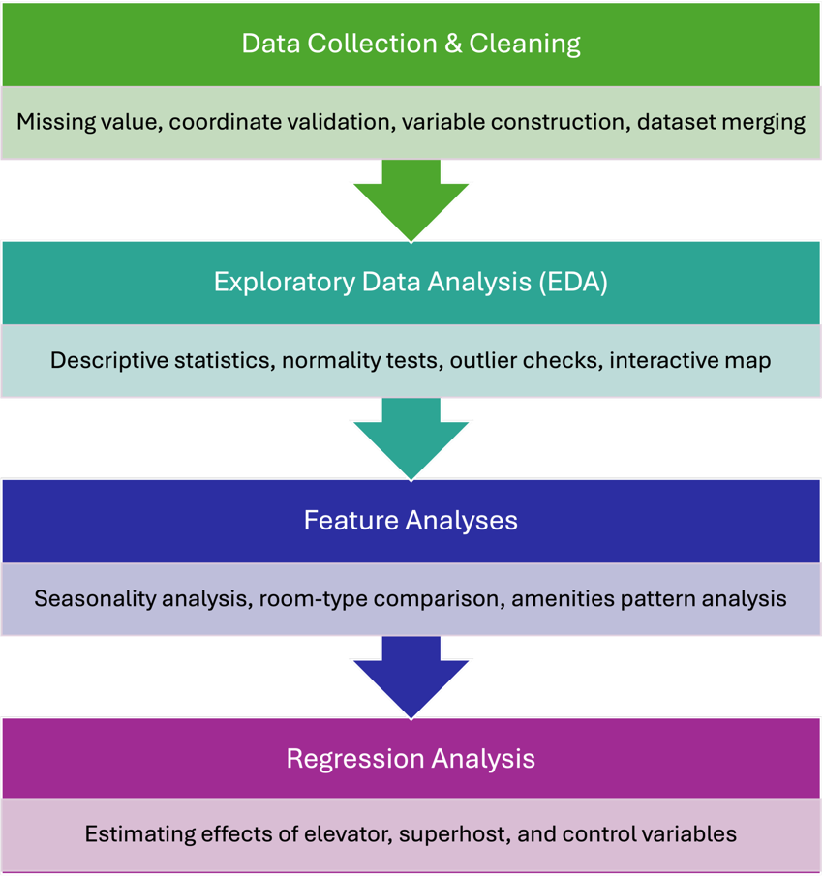
2. Data and Methodology
2.1 Original Data Description
Listings Data
The analysis draws on listing-level and calendar-level Airbnb datasets from November 2024 to October 2025. Since Airbnb does not publicly release transaction data, the data used in this report are obtained from AirROI, a third-party platform that aggregates comprehensive Airbnb information. The raw data is segmented into two primary regions: Hong Kong Island and Kowloon, reflecting differences in housing stock, density, and tourism activity. For each region, two distinct datasets were utilized:
Listing-Level Dataset: The listing dataset contains static attributes for each property, including location coordinates, amenities, room type, and host information. Key metrics such as total revenue serve as the foundation for the regression analysis. These variables support analyses of revenue structure, room type patterns, and the roles of host and property characteristics.
Calendar-Level Dataset: The calendar dataset provides monthly performance metrics, including revenue, occupancy rate, average daily rate, booking lead time, and length of stay. This dataset is essential for identifying seasonal trends and occupancy fluctuations.
Geospatial Data
To facilitate spatial analysis, administrative boundary shapefiles for Hong Kong’s districts were obtained from the Hong Kong Lands Department, enabling precise mapping of listing coordinates to specific administrative districts.
It is critical to acknowledge the limitations inherent in the listing and calendar-level datasets. First, because Airbnb does not officially release granular transaction data, the AirROI dataset may not capture all active listings. Second, the dataset includes only properties that were active during the data collection period. Nevertheless, the datasets provide sufficient information to conduct region-level and property-level analysis.
2.2 Data Cleaning Process
Cleaning began by removing listings lacking essential identifiers or coordinates. Observations missing listing ID, latitude, or longitude were excluded because they could not be reliably linked to other datasets or mapped to spatial boundaries. Additional missingness checks were conducted for revenue and occupancy to ensure that the analytical dataset included only listings with sufficient information for descriptive and regression analyses.
Geographic coordinates were validated to confirm that all listings fell within Hong Kong’s administrative boundaries. The coordinates were then converted into geometric points and overlaid onto the district boundary shapefile to support mapping. Calendar data were inspected for invalid or duplicated records to ensure that monthly revenue and occupancy calculations reflected actual listing activity.
After cleaning, the final listing dataset contains 501 unique properties, and the calendar dataset includes 5,617 observations of those properties from November 2024 to October 2025.
2.3 Variable Construction
To prepare the data for further analysis, several key variables were constructed and transformed:
Log Transformation
The distribution of total revenue (ttm_revenue) exhibits substantial right-skewness, driven by a small number of high-earning luxury listings. To improve normality, homoskedasticity, and reduce the influence of outliers, the natural logarithm of trailing-twelve-month revenue was constructed as log_ttm_revenue. This transformed variable is used in the regression model.
Binary Variables
Location dummy (kowloon): $kowloon=1$ for listings in Kowloon; 0 for Hong Kong Island. This allows comparison between the two major submarkets.
Elevator: Extracted from the amenities string column, $elevator=1$ if the listing explicitly mentions an elevator and 0 otherwise. Since many older buildings in Hong Kong lack elevators, this feature may influence both guest demand and pricing power.
Superhost: This concept is adopted from Airbnb’s official designation system. Airbnb awards Superhost status to hosts who maintain a high rating, a low cancellation rate, and a minimum number of completed stays. This indicator captures host quality and service reliability.
Room Type: Categorical variables for entire home, private room, hotel room, and shared room categories are used to measure variations in revenue by accommodation type.
These variables allow the regression model to isolate the marginal effects of physical and host attributes on revenue.
2.4 Data Merging
Because the original AirROI datasets in Hong Kong separate Hong Kong Island and Kowloon, both the listing-level and calendar-level files were first cleaned independently and then combined into unified datasets. The merged listings dataset is used for the descriptive statistics, geospatial mapping, and the core regression analysis. The merged calendar dataset is used for seasonal trend analysis and understanding monthly demand variation.

3. Exploratory Data Analysis
3.1 Descriptive Statistics and Normality Check
To build an initial understanding of Hong Kong’s Airbnb market, this section summarizes the distribution of key variables related to listing performance and host or property characteristics. Tables 1 and 2 present definitions and descriptive statistics for key variables.
Table 1: Key Variable Descriptions
Variable | Description | Type
ttm_revenue | Trailing 12-month revenue (USD) | Numeric
log_ttm_revenue | Log of trailing 12-month revenue | Numeric
ttm_occupancy | Trailing 12-month occupancy rate | Numeric
bedrooms | Number of bedrooms | Numeric
Superhost | 1 if the host is a Superhost, 0 otherwise | Binary
elevator | 1 if the listing has an elevator, 0 otherwise | Binary
kowloon | 1 if the listing is in Kowloon, 0 if in Hong Kong Island | Binary
room_type | Room type | Categorical

Table 2: Descriptive Statistics for Key Variables
Variable | Count | Mean | StdDev | Min | Median | Max
ttm_revenue | 501 | 9,996 | 10,526 | 421 | 6,747 | 73,031
log_ttm_revenue | 501 | 8.71 | 1.06 | 6.05 | 8.82 | 11.20
ttm_occupancy | 501 | 0.27 | 0.18 | 0.03 | 0.24 | 0.95
bedrooms | 498 | 1.13 | 0.72 | 0 | 1 | 5
Superhost | 501 | 0.34 | / | 0 | / | 1
elevator | 501 | 0.74 | / | 0 | / | 1
kowloon | 501 | 0.56 | / | 0 | / | 1

The mean revenue is approximately 9,996 USD, but the standard deviation is exceptionally high (10,526 USD). This high coefficient of variation indicates extreme volatility in property performance. The median revenue (6,747 USD) is significantly lower than the mean, indicating a long right tail in which high-earning properties pull the mean up.
After the log transformation, the standard deviation of log_ttm_revenue decreases substantially (1.06), and the mean (8.71) becomes much closer to the median (8.82), indicating that the right-skewness has been effectively reduced. Figure 2 and Figure 3 present the histograms and Q-Q plots of ttm_revenue and log_ttm_revenue, respectively. Compared with the original revenue distribution, the distribution of log_ttm_revenue is visibly closer to normal.
Figure 2: Distribution and Q-Q Plot of Annual Revenue
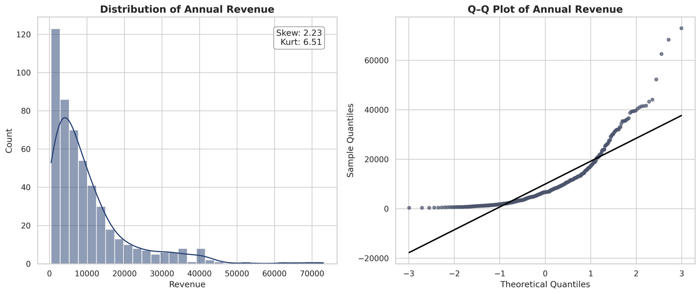
Figure 3: Distribution and Q-Q Plot of Log-transformed Annual Revenue
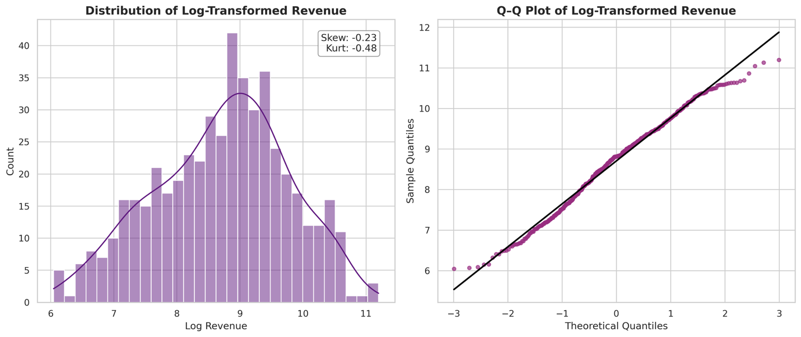
Appendix Tables 1 and 2 present the definitions and descriptive statistics of the remaining listing performance variables, such as listing ratings and occupancy, which also reflect listing quality to some extent. Appendix Figure 1 illustrates the relationships between ratings, occupancy, and revenue. As expected, these variables exhibit positive correlations. Because the rating and occupancy variables deviate substantially from normality (see Appendix Figure 2) and are not suitable for log transformation, and because revenue remains the primary outcome of interest for hosts and investors, the subsequent analysis focuses primarily on listing revenue.
3.2 Outlier Detection
Using the interquartile range (IQR) method, an examination of ttm_revenue identified 41 high-value outliers, with the maximum annual revenue reaching approximately 73,031 USD, more than 10 times the median. Rather than removing these outliers, they were retained in the dataset. In the Airbnb market, these outliers typically represent legitimate, high-performing luxury properties rather than data-entry errors. Removing them would artificially truncate the upper market segment. Instead, the log-transformation serves as the primary method for mitigating their leverage on the statistical models without discarding valuable market information. Figure 4 presents the boxplots for ttm_revenue and log_ttm_revenue. The upper plot shows outliers in the raw revenue data. After the log transformation, no observations fall outside the bounds, indicating that the outlier issue has been effectively resolved.
Figure 4: Boxplot of Airbnb Annual Revenue in Hong Kong
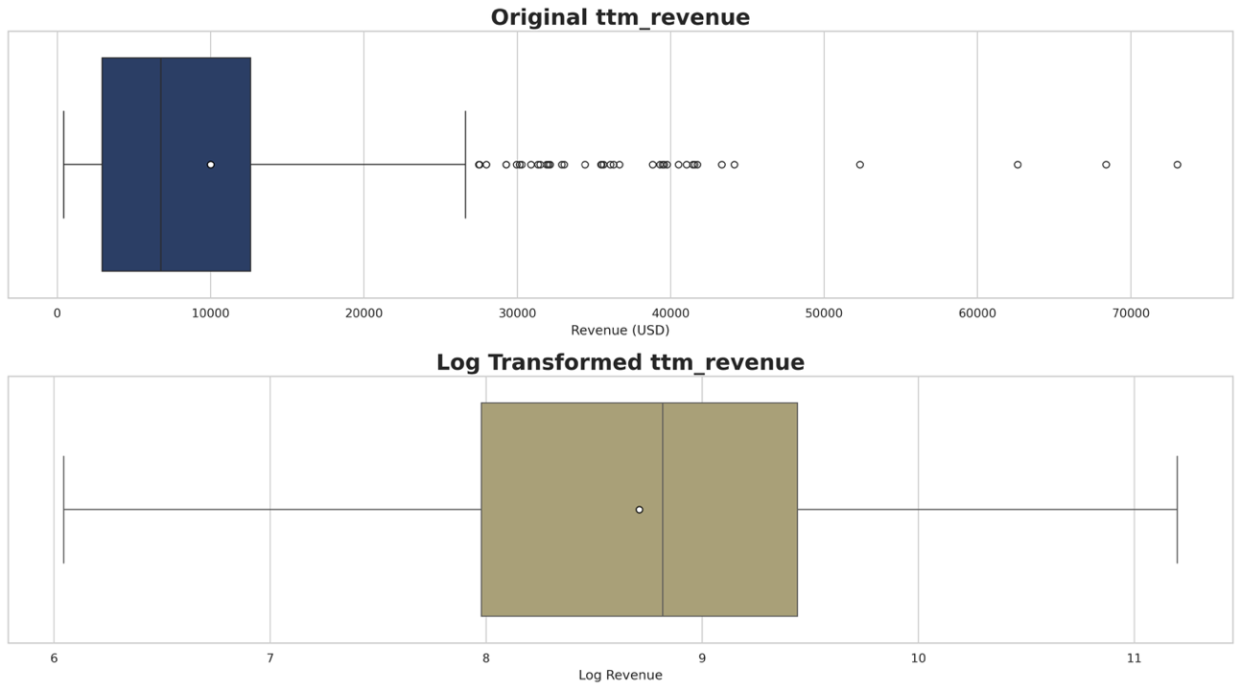
3.3 Geospatial Analysis
Using the listings’ coordinates, an interactive map was constructed to visualize the spatial distribution of listings across the territory (readers can browse the interactive map via the attached HTML link or IPYNB code file). In this map, point color reflects the overall rating, and point size corresponds to annual revenue.
Figure 5 reveals clear geographic clustering. High-revenue units tend to concentrate in areas with strong tourism infrastructure, such as Sheung Wan, Wan Chai, Tsim Sha Tsui, and Mong Kok. These neighborhoods combine high visitor traffic, convenient transportation, and proximity to commercial centers, which likely contributes to their occupancy and revenue levels.
Figure 5: Airbnb listings in Hong Kong
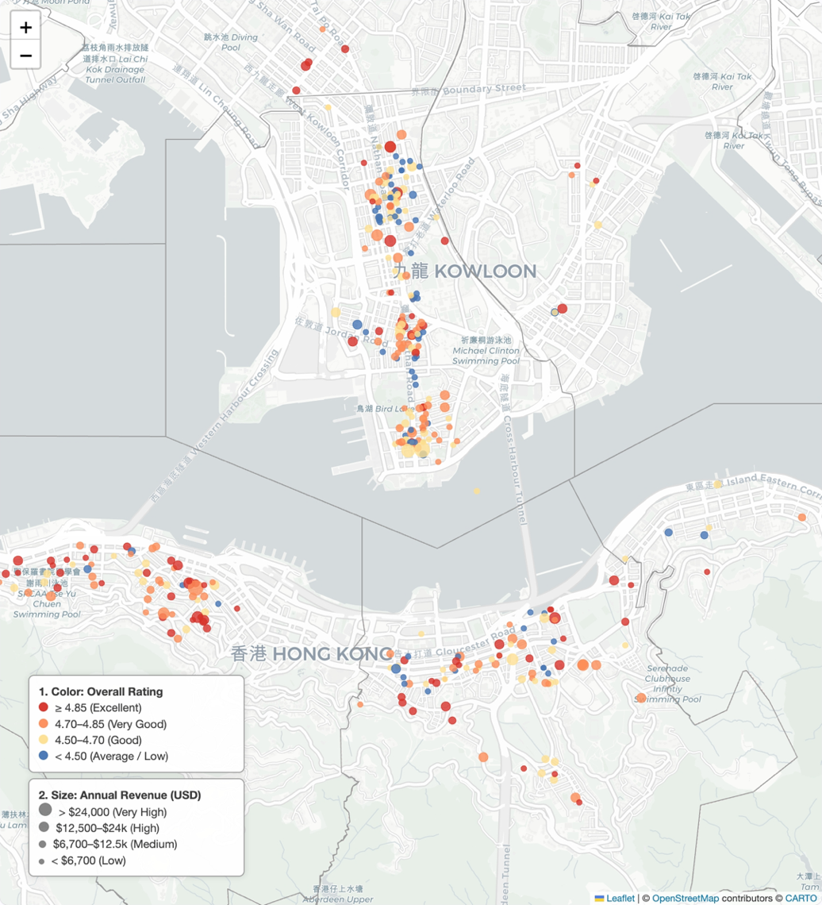
4. Other Feature Analysis
4.1 Seasonal Trend Analysis
To understand the temporal dynamics of the Hong Kong market, monthly revenue and occupancy rates were aggregated from the calendar dataset for the period from November 2024 to October 2025.
Figures 6 show the seasonal trends. The market exhibits a distinct peak season during the winter months, specifically from November to January. December records the highest average monthly revenue (~1,742 USD) and occupancy rates remain robust (~51%), likely driven by holiday tourism and cooler, more comfortable weather. Conversely, a significant dip occurs from June to September. This period coincides with Hong Kong’s hot, humid summer and typhoon season, which likely deters short-term visitors.
Figure 6: Seasonal Trends of Airbnb listings in Hong Kong
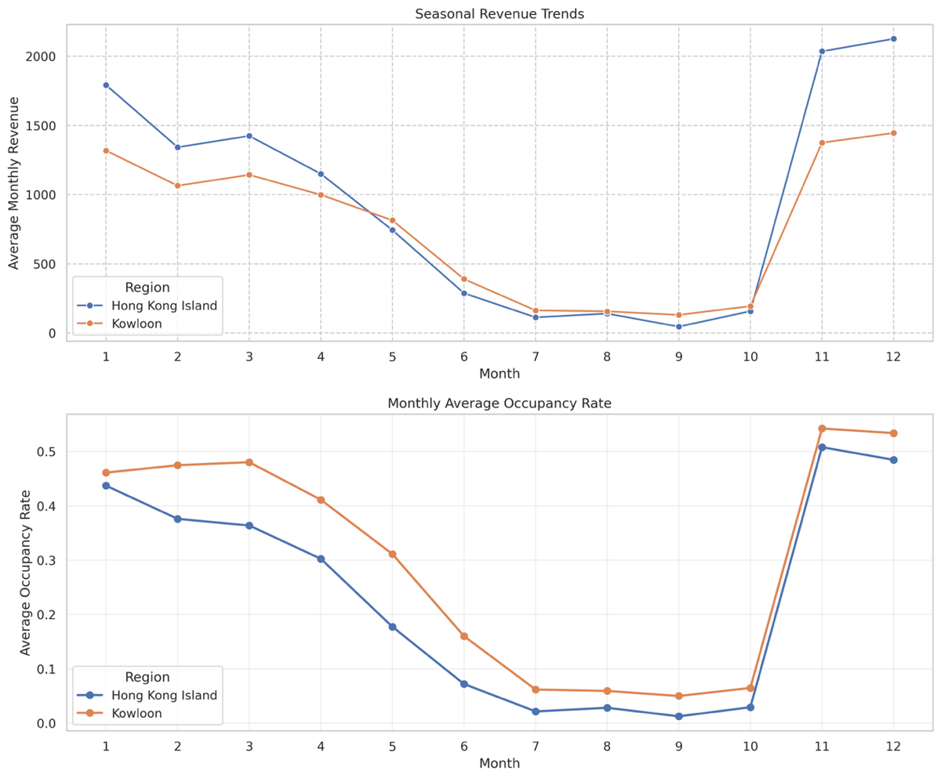
4.2 Room Type Analysis
Room type acts as a fundamental segmentation variable in the short-term rental market. as it directly reflects the level of privacy and space available to guests. The listing-level dataset shows that Hong Kong’s Airbnb supply is dominated by private rooms and entire homes, with shared rooms representing only a small fraction of the market.
Figure 7 compares revenue across room types. Entire homes command the highest premium, with an average annual revenue of approximately 15,469 USD, more than twice that of Private rooms (~6,145 USD). Shared rooms generate the least revenue (~2,396 USD).
While Private rooms constitute the largest segment by count, the revenue potential per unit is significantly skewed towards entire properties. This distinction provides insight into asset selection: investors seeking higher returns should prioritize entire homes, whereas individual hosts may find private-room rentals more feasible but should adjust expectations accordingly.
Figure 7: Revenue by Room Type
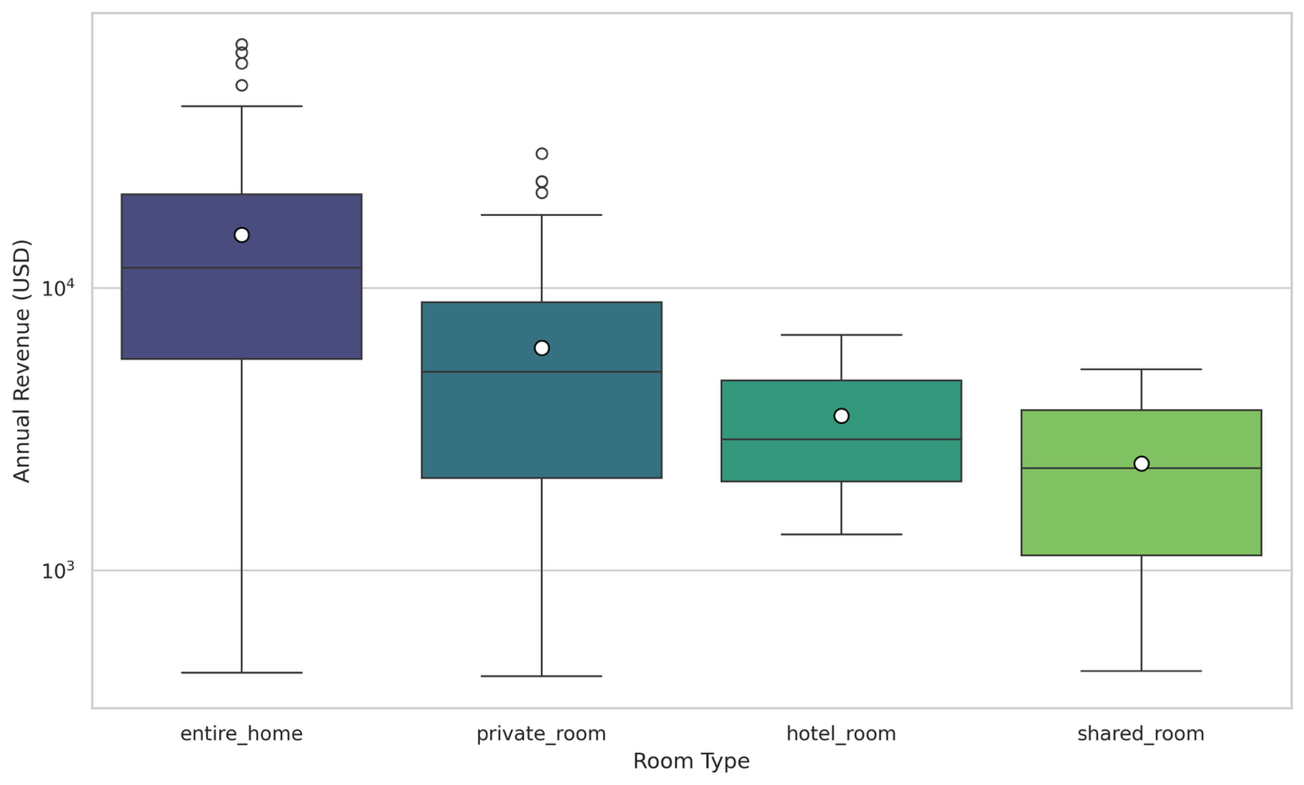
4.3 Popular Amenities Analysis
An analysis of the most frequently occurring amenities reveals the standard versus value-add features in the Hong Kong market.
Standard Amenities: Certain features have reached near-universal adoption. Wi-Fi, Air conditioning, and Hot water are present in 100% of listings, whereas kitchens, heating, and washers appear in over 99%. These are considered baseline expectations; their absence would likely result in severe penalties in booking conversion.
Differentiating Amenities: The Elevator appears in 74.3% of listings (ranked 15th). In a city defined by high-rise living, the absence of an elevator is a significant differentiator that likely impacts price sensitivity and guest satisfaction.
These descriptive patterns motivate the subsequent regression analysis, which formally evaluates whether elevator access, which is not universally available in older Hong Kong buildings, has a measurable impact on revenue when controlling for other listing characteristics.
Figure 8: Popular Airbnb Amenities in Hong Kong
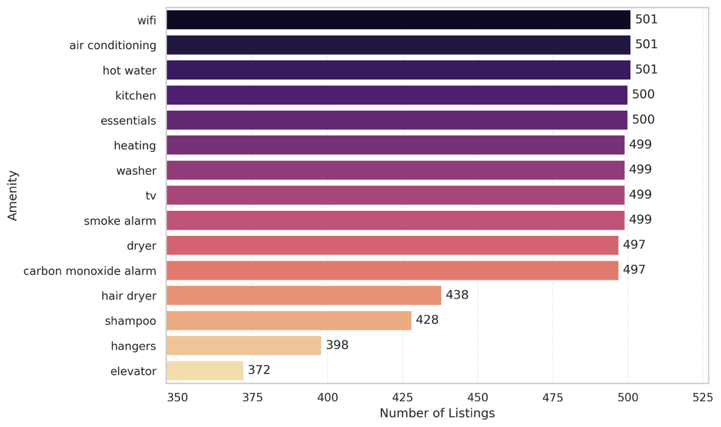
5. Regression Analysis
4.1 Model Specification
To isolate the specific marginal contribution of listings’ attributes to revenue, an OLS regression model was constructed:
$$log⁡({ttm_revenue}_{i})=β_{0}+β_{1}{elevator}_{i}+β_{2}{superhost}_{i}$$
$$\begin{aligned}+β_{3}{bedrooms}_{i}+β_{4}{roomtype}_{i}+β_{5}{kowloon}_{i}+ε_{i}\#\left(1\right)\end{aligned}$$
Where the dependent variable $log⁡({ttm_revenue}_{i})$ is the natural logarithm of the trailing twelve-month revenue. The main explanatory variables ${elevator}_{i}$ and ${superhost}_{i}$ represent meaningful structural and service-related aspects of listing quality. Three control variables were included in the model: ${bedrooms}_{i}$ controls for the size and capacity of the property; ${roomtype}_{i}$ controls for the unit type; ${kowloon}_{i}$ controls for geographic variation across the two major submarkets. Appendix Figure 3 also displays the raw correlations among key variables without holding other factors constant.
The detailed regression results are presented in Table 3. According to the results, the model achieved an Adjusted R² of 0.401, indicating that the selected variables explain approximately 40.1% of the variation in listing revenue. Holding all other factors constant, listings with elevator access generate approximately 19.3% higher revenue than those without, underscoring the value of accessibility in Hong Kong's high-density vertical environment. What’s more, achieving Superhost status is associated with an approximate 55.3% increase in annual revenue. Consistent with previous findings, the Superhost badge has a substantial effect and underscores the economic value of reputation, reliability, and service quality (Liang et al., 2017). The control variables behave as expected, confirming that larger, more private spaces command higher prices.
Table 3: Effect of Elevator and Superhost Status on Annual Revenue
 | Dependent variable: log_ttm_revenue
 | (1)
elevator | 0.193**
 | (0.089)
Superhost | 0.553***
 | (0.080)
bedrooms | 0.432***
 | (0.054)
kowloon | 0.238***
 | (0.091)
room_type (private_room) | -0.745***
 | (0.094)
room_type (shared_room) | -1.919***
 | (0.196)
room_type (.hotel_room) | -1.032***
 | (0.246)
Intercept | 8.233***
 | (0.108)
Observations | 498
R² | 0.409
Adjusted R² | 0.401
Residual Std. Error | 0.817 (df=490)
F Statistic | 48.516*** (df=7; 490)
Note: | *p<0.1; **p<0.05; ***p<0.01

6. Conclusion and Recommendations
This report provides an integrated analysis of the Airbnb short-term rental market in Hong Kong using listing-level and calendar-level data from AirROI. The findings demonstrate substantial heterogeneity in listing performance, driven by differences in room type, size, amenities, host quality, and geographic location. Revenue exhibits strong right skewness, pronounced spatial clustering, and clear seasonal fluctuations, peaking from November through January. Entire-home listings consistently earn more than private or shared rooms, while amenity-rich properties attract higher demand. The regression analysis quantifies the effect of key structural and host-related characteristics. Elevator access increases annual revenue by approximately 19.3%, underscoring the importance of building accessibility. Superhost listings earn approximately 55.3% more than comparable non-Superhost units, indicating the substantial economic value of reputation, service quality, and reliability.
Based on the empirical findings, the following strategic recommendations are proposed. For hosts, maintaining consistent service quality and communication is essential for obtaining or retaining Superhost status, which confers a substantial revenue advantage. Hosts should also consider gradual amenity improvements, particularly in categories that enhance comfort and convenience.
For property management firms, prioritizing buildings with elevator access or newer developments where such infrastructure is standard. Given the strong seasonal pattern identified in the calendar data, managers should adopt dynamic pricing strategies that adjust rates upward during peak months and incorporate promotional pricing during off-peak seasons to stabilize occupancy.
For investors, the clear revenue premiums associated with entire homes, additional bedrooms, and properties indicate that these asset types offer higher earning potential. Investors evaluating new acquisitions should consider the long-term value of properties with structural accessibility and recognize that improvements in listing quality can generate substantial returns independent of the physical unit.
7. Limitations and Directions for Future Research
Although the dataset provides a rich foundation for analyzing the Hong Kong market, several limitations must be acknowledged. First, as Airbnb does not officially publish transaction data, the dataset may not capture the entire universe of Hong Kong listings or real-time booking changes. Second, the analysis focuses on a single twelve-month period, which may capture short-term fluctuations but does not reflect longer-term shifts in tourism, regulatory changes, or macroeconomic conditions. Third, the cross-sectional regression model identifies associations but cannot fully establish causality; for example, Superhost status may both influence revenue and be influenced by past performance.
Future research could incorporate longer time horizons, apply panel-data methods to distinguish between persistent listing characteristics and short-term shocks, or explore price elasticity through dynamic pricing models. Additionally, the integration of neighborhood-level socioeconomic data or transportation accessibility metrics may further refine our understanding of spatial variation in revenue.
Despite these limitations, the findings in this report provide a data-driven assessment of revenue drivers in Hong Kong’s short-term rental market and offer practical guidance to improve listing performance and inform investment decisions.
References
Einav, L., Farronato, C., & Levin, J. (2016). Peer-to-Peer Markets. Annual Review of Economics, 8(Volume 8, 2016), 615–635. https://doi.org/10.1146/annurev-economics-080315-015334
Liang, S., Schuckert, M., Law, R., & Chen, C.-C. (2017). Be a “Superhost”: The importance of badge systems for peer-to-peer rental accommodations. Tourism Management, 60, 454–465. https://doi.org/10.1016/j.tourman.2017.01.007
Zervas, G., Proserpio, D., & Byers, J. W. (2017). The Rise of the Sharing Economy: Estimating the Impact of Airbnb on the Hotel Industry. Journal of Marketing Research, 54(5), 687–705. https://doi.org/10.1509/jmr.15.0204
Appendix
Appendix Table 1: Variable Descriptions (continued)
Variable | Description | Type
ttm_occupancy | Trailing 12-month occupancy rate | Numeric
num_reviews | Number of reviews received | Numeric
rating_overall | Overall rating (1–5) | Numeric

Appendix Table 2: Descriptive Statistics for Variables (continued)
Variable | Count | Mean | StdDev | Min | Median | Max
ttm_occupancy | 501 | 0.27 | 0.18 | 0.03 | 0.24 | 0.95
num_reviews | 501 | 80.94 | 95.78 | 0 | 42 | 765
rating_overall | 501 | 0.27 | 0.18 | 0.03 | 0.24 | 0.95

Appendix Figure 1: Correlation Among Listing Performance Indicators
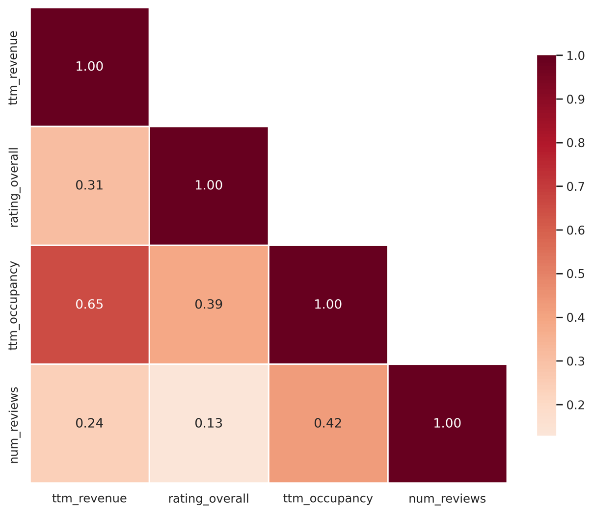

Appendix Figure 2: Distribution of Listing Performance Indicators
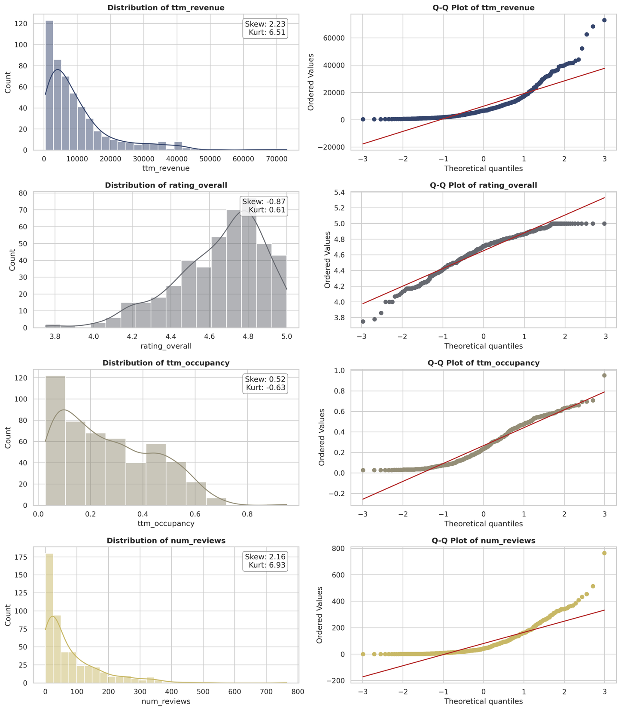

Appendix Figure 3: Correlation Among Key Variables
