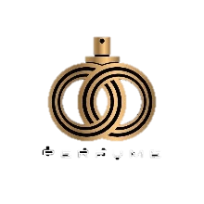

Unveiling Luxury

Initio Oud

 Elevate Your Senses

Welcome to Initio Oud, where luxury meets fragrance in a league of its own.

Distinctive Elements

Immerse the unique blend of rare agarwood, unveiling a fragrance that captivates with every note.

 Elegance Redefined

Experience sophistication in every bottle – Initio Oud is not just a scent; it’s a statement.



Limited Edition

Join influencers and celebrities in embracing the allure of Initio Oud. A fragrance that resonates with the discerning few.

 Accessible opulence

Indulge at your convenience. Initio Oud is available at select luxury retailers and online.

Your Signature Scent 

Elevate your signature scent with Initio Oud where every drop is an expression of luxury.

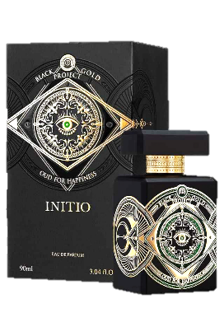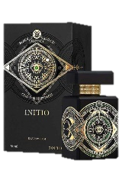

Connect with Luxury

Engage with us. Any question? Let’s explore the

world of Initio Oud together.