Switching from Control File-Executable DMI to Trace Directory DMI

For the April Official run, four Control File-Executable DMIs were switched to Trace Directory DMIs so that Perl is no longer needed to load the hydrology into the model. The DMIs that were changed were:

1. NaturalFlowSaltInput
2. Input Evaporation Coefficients
3. VICNaturalFlowInput
4. VIC Evap

The following are the steps used to make this change:

**1) Create a new DMI.** Open the DMI manager and select DMI -> New DMI -> Trace Directory DMI.

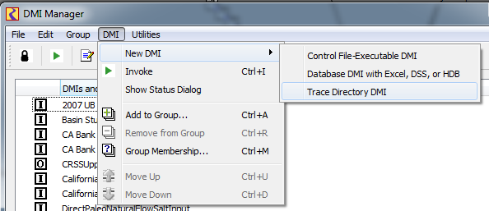

**2) Set the top directory file path.** This is the location that holds the trace folders the DMI will be accessing. This information is found in the existing Control File-Executable DMIs “Executable” field. It is the path to the Perl script truncated before the “Scripts” folder. Ex: $CRSS_DIR/dmi/NFSinput/ for the NaturalFlowSaltInput DMI.

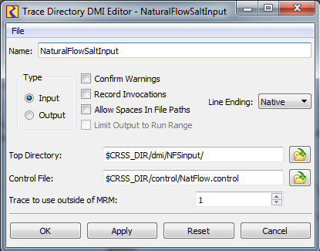

**3) Set the control file and associated file path.** The Trace Directory DMI can use the same control file that was used for the Control File-Executable DMI.

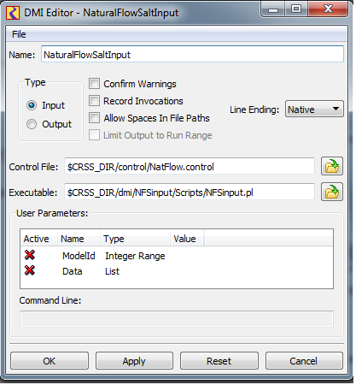

**3) Delete the old DMI.** If using the same DMI name, delete the old Control File-Executable DMI. The “Scripts” folder in the folder that contains the DMI data can also be deleted.

**4) Add the new DMI to desired DMI groups.** The Trace Directory DMI will need to be added to the same groups that the Control File-Executable DMI belonged to. Right click on the new DMI and select Add to Group. In the menu that appears, select the DMI group you want to add the new DMI to and click OK.

