SetPrinter.exe
SetPrinter.exe does print spooler things using the win32 SetPrinter() function.

SetPrinter.exe -n <printername> -c <command>
-n <printername>. Required. Try -n "XPS Card Printer".
-c <command>. Required. One of 'pause', 'purge', 'resume', 'set_status'

SetPrinter.exe -n "xps card printer" -c pause

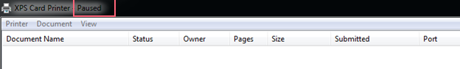

tngtestpage 100
creating 100 windows test pages...

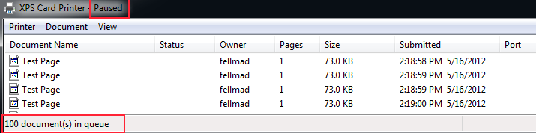

SetPrinter.exe -n "xps card printer" -c resume

SetPrinter.exe -n "xps card printer" -c purge

