Pictures
An inline PNG, 3 inches wide:
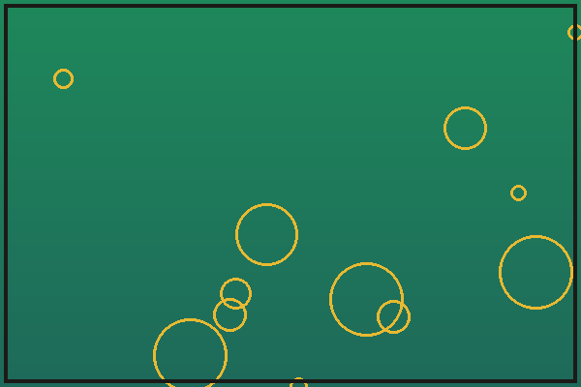
Figure 1. A generated gradient with rings.
An inline JPEG, 2 inches wide, inside running text:
Before the picture  after the picture.

