Getting Started

Prerequisites & Installation

* JDK 1.8+
* Maven
* Eclipse IDE

Required Eclipse Plugins:

* Maven
* Cucumber
* TestNG

Required JAVA libraries

* cucumber-java
* selenium-java
* cucumber-testng
* testing
* webdrivermanager

The Page Object Model Design Pattern

With this pattern, the UI elements of web application are modeled as objects within the test code. The Page Object pattern provides a solution by centralizing these selectors in separate .java files, where you can manage them along with the associated methods.

By using the Page Object pattern, test files will only call the test methods, while the selectors and reusable methods reside in the corresponding Page Objects. This approach helps maintain a separation of concerns and ensures that when a test fails, it fails on an individual step.

Running Tests

To run the tests, right click on project in Solution Explorer -> Run As -> TestNG Test

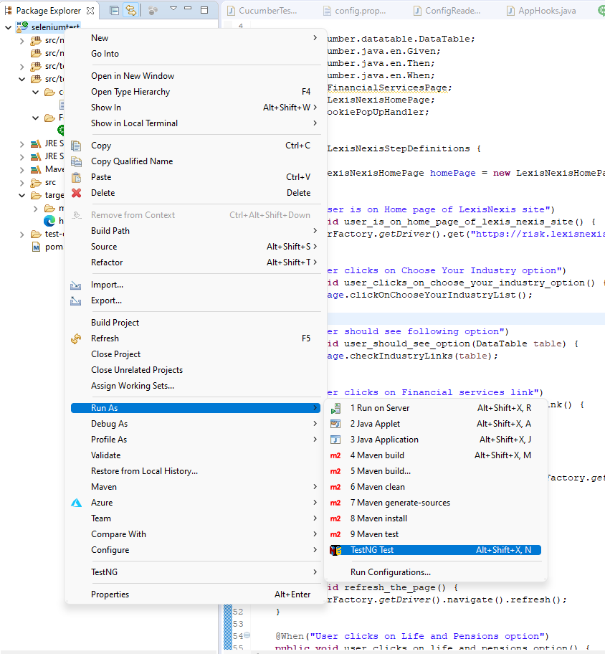

Reporting

Report can be found as htmlreport.html under 'target' folder.

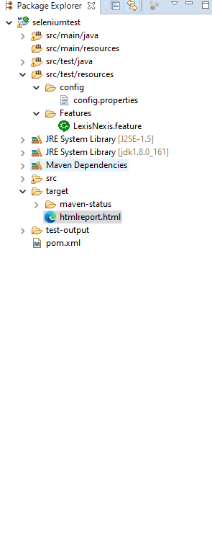

Note: 1 test is failed intentionally so show log trace and screenshot captured

Sample report  
