**ARCHITECTURE**

The Web App was built in Ionic, which is an HTML5 mobile app development framework targeted at building hybrid mobile apps. Hybrid apps are essentially small websites running in a browser shell in an app that have access to the native platform layer. Hybrid apps have many benefits over pure native apps, specifically in terms of platform support, speed of development, and access to 3rd party code.

Sequence Diagram:

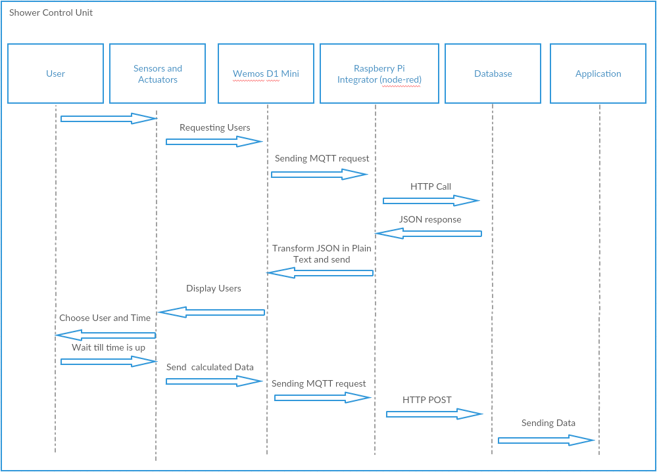

The Sequence diagram shows how the Shower Control Unit works and requests the users of the system and sends the data back after the time which the user requested is up.

A picture containing text, map

Description generated with very high confidence

**Use-case diagram**

The use-case diagram shows, how the user can control the Shower Control Unit and the Toilet Paper Counter. And the Sensors are automatically sending data to the Node-Red Integrator whenever their data is changing. The Node-Red sends the received Data of the Sensors and Actuators to the Database and the User can watch the statistics in the Application.

**State diagram**

**A screenshot of a cell phone

Description generated with very high confidence**

The state chart/diagram shows how the Shower Control Unit is used and how to finish the usage of it.

A close up of text on a white background

Description generated with high confidence

The above diagram shows how the Connection between the Hardware is working. The Sensors are connected to the Wemos D1 Mini, the D1 Mini connects over the Raspberry Pi, which has a running Node-Red Integrator on it to the Database and the Database delivers the data to the Application.