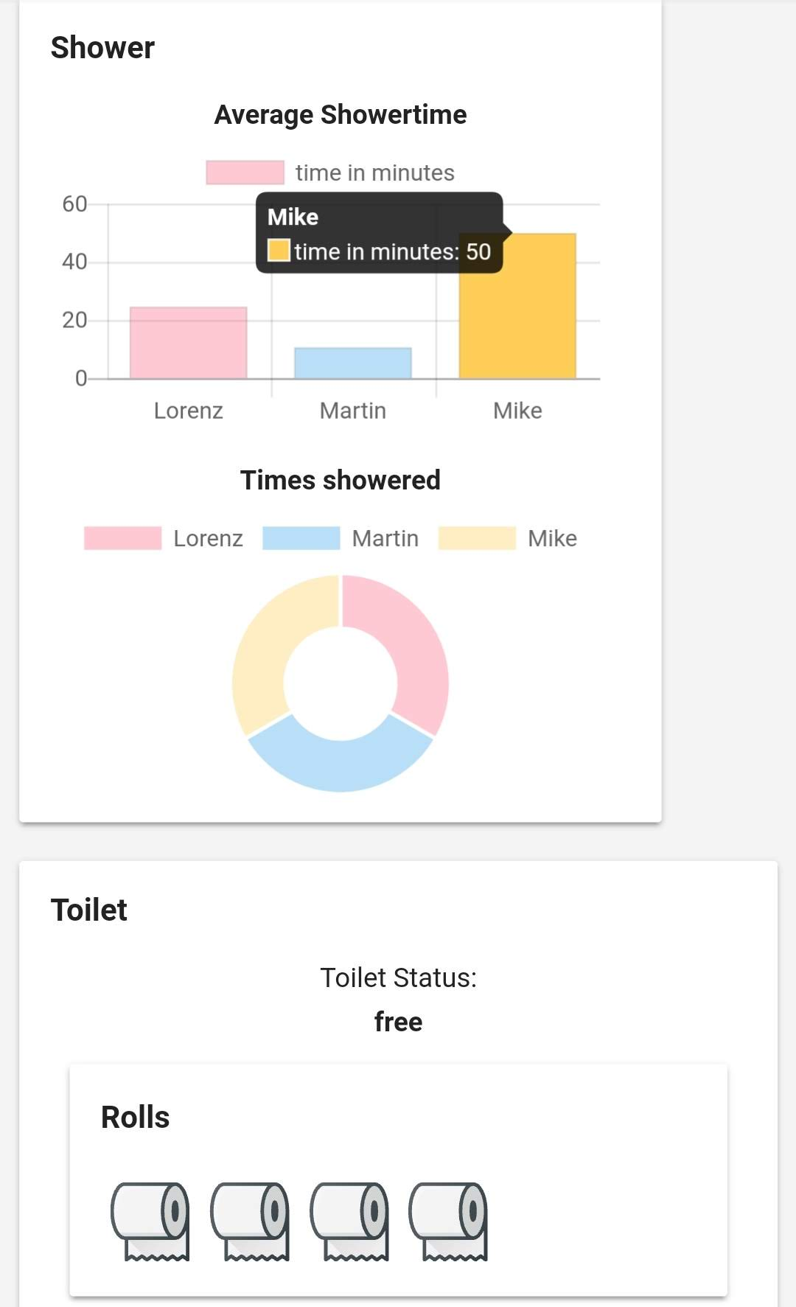That’s how we use the Internet of Things –

An Analysis of the various usages of the IoT

The Internet of Things (IoT) is the network of physical devices, vehicles, home appliances, and other items embedded with electronics, software, sensors, actuators, and connectivity which enables these things to connect and exchange data.

Discover the Internet

To show what is possible in today’s home automation system, this project discovers some possibilities of how it easy is to implement your own automation system.

Your morning routine

Make your morning routine as easy as possible. Wake up and look at your phone, open the app and you see everything you need to know to start in the new day, like the Temperature, Humidity and rain outside. Or discover for your daily needs if the toilet is currently occupied and if there is toilet paper left in your bathroom. If you ever have stress with your roommates, discover how long everyone is showering and how much water they are using on average.