Numerical analysis of the rock deformation in deep twin tunnels with transverse gallery considering plasticity and time-dependent constitutive models

Quevedo, F. P. M.

Colombo, C. A. M. M.

Bernaud, D.

Maghous, S.

Abstract

Resorting to a three-dimensional finite element framework, the paper investigates the instantaneous and long-term deformation in twin tunnels with connecting transverse gallery. Particular emphasis is dedicated to assessment of combined effects induced by time-dependent constitutive behavior of the material constituents and twin tunnels proximity, on the convergence profile. At the material level, the rock material mechanical behavior is formulated within the context of coupled plasticity–viscoplasticity, which proves relevant to the modeling and simulation of tunnel deformation in deep clayey rocks. A fundamental aspect of modeling the rock/support structure mechanical interaction is related to the proper consideration of time-dependent properties of the lining concrete material. In that respect, the concrete creep deformation is addressed by means of an aging viscoelastic model relying on the Bažant and Prasannan Solidification Theory, whereas shrinkage deformation component is accounted for by means of the formulation proposed in CEB-FIP MC90 standard. At the structure level, the deactivation-activation technique is employed in the three-dimensional computational model to simulate the excavation/advancing face and lining installation processes. The accuracy of the finite element predictions is assessed through comparisons with available analytical stress solutions formulated within a simplified setting for the twin tunnels configuration. The computational model is applied to analyze the short-term and long-term convergence profiles in a fully 3D twin tunnels configuration. A series of simulations varying some relevant parameters defining the structure geometry and constituents behavior are undertaken with the aim to give preliminary insight into the multiple interactions rising from twin tunnel proximity, intersecting transverse gallery and lining support. Numerical simulations have notably emphasized the deformation anisotropy induced by tunnels proximity as well as that peak convergence values are observed within a localized extension region close to tunnel-gallery intersection. Finally, the crucial role of time-dependent properties of concrete lining and related instantaneous stiffness in controlling the tunnel deformation is also studied.

Keywords: twin tunnels, transverse gallery, coupled plasticity-viscoplasticity coupling, viscoelastic lining, finite element model

Graphical Abstract

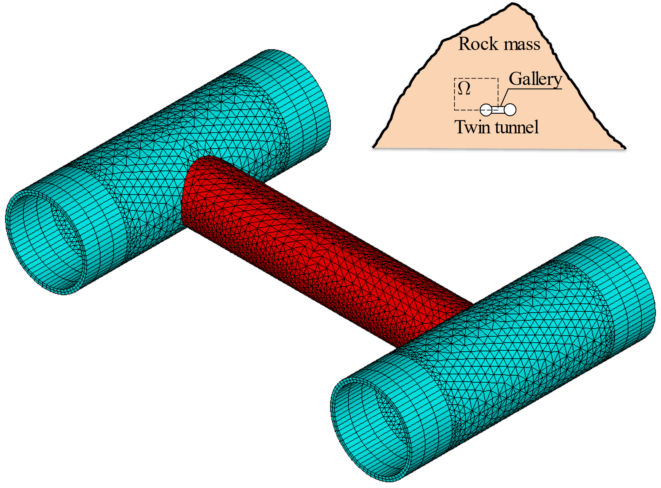

Highlights

* Rock deformation in twin tunnels with transverse gallery is addressed by 3D computational
* The irreversible behavior of the rock material is formulated in the context of coupled plasticity-viscoplasticity
* Creep deformation o lining concrete is addressed by aging viscoelastic model
* Numerical simulations emphasize the tunnel deformation anisotropy induced by twin tunnels proximity
* High lining instantaneous stiffness can predominately control tunnel convergence and restrict interaction effects