Numerical analysis of the rock deformation in twin tunnels with transverse gallery considering plasticity and time-dependent constitutive models

Quevedo, F. P. M.

Colombo, C. A. M. M.

Bernaud, D.

Maghous, S.

Abstract

Resorting a three-dimensional finite element analysis, this paper investigates the instantaneous and long-term implications induced by the time-dependent constitutive behavior of constituents on the convergence profile of twin tunnels linked with transverse galleries. Several constitutive models for rock mass mechanical behavior are examined at the material level, encompassing elastoplasticity, viscoplasticity, or coupled elastoplasticity-viscoplasticity frameworks. Plasticity state equations are based on a Drucker-Prager yield surface with an associated flow rule, while the viscoplasticity formulation relies on the Perzyna model with a Drucker-Prager flow surface. Tunnel lining behavior is modeled using either elastic or viscoelastic constitutive models. The viscoelastic behavior is described by a Generalized Kelvin rheological model based on Bazant and Prassanann’s Solidification Theory, with model parameters derived from CEB-FIP MC90 formulations. From a computational viewpoint, the deactivation-activation method is employed to simulate the excavation process and lining installation. The accuracy of finite element predictions is assessed through comparisons with available analytical solutions formulated in a simplified setting for the twin tunnels’ configuration. A parametric study delves into the mutual interaction induced by tunnels proximity, emphasizing the crucial role of concrete lining stiffness in twin tunnels’ deformation. Numerical simulations indicate a highly localized influence of a transverse gallery on twin tunnels deformation, extending up to four radii from each side of the gallery axis. Finally, the paper investigates the effects of twin tunnels proximity and those induced by an interconnecting gallery on the instantaneous and long-term convergence of tunnels, contrasting these outcomes with the convergence of a single tunnel.

Keywords: twin tunnels ,transverse gallery ,elastoplasticity-viscoplasticity coupling ,viscoelastic lining ,finite element method

Graphical Abstract

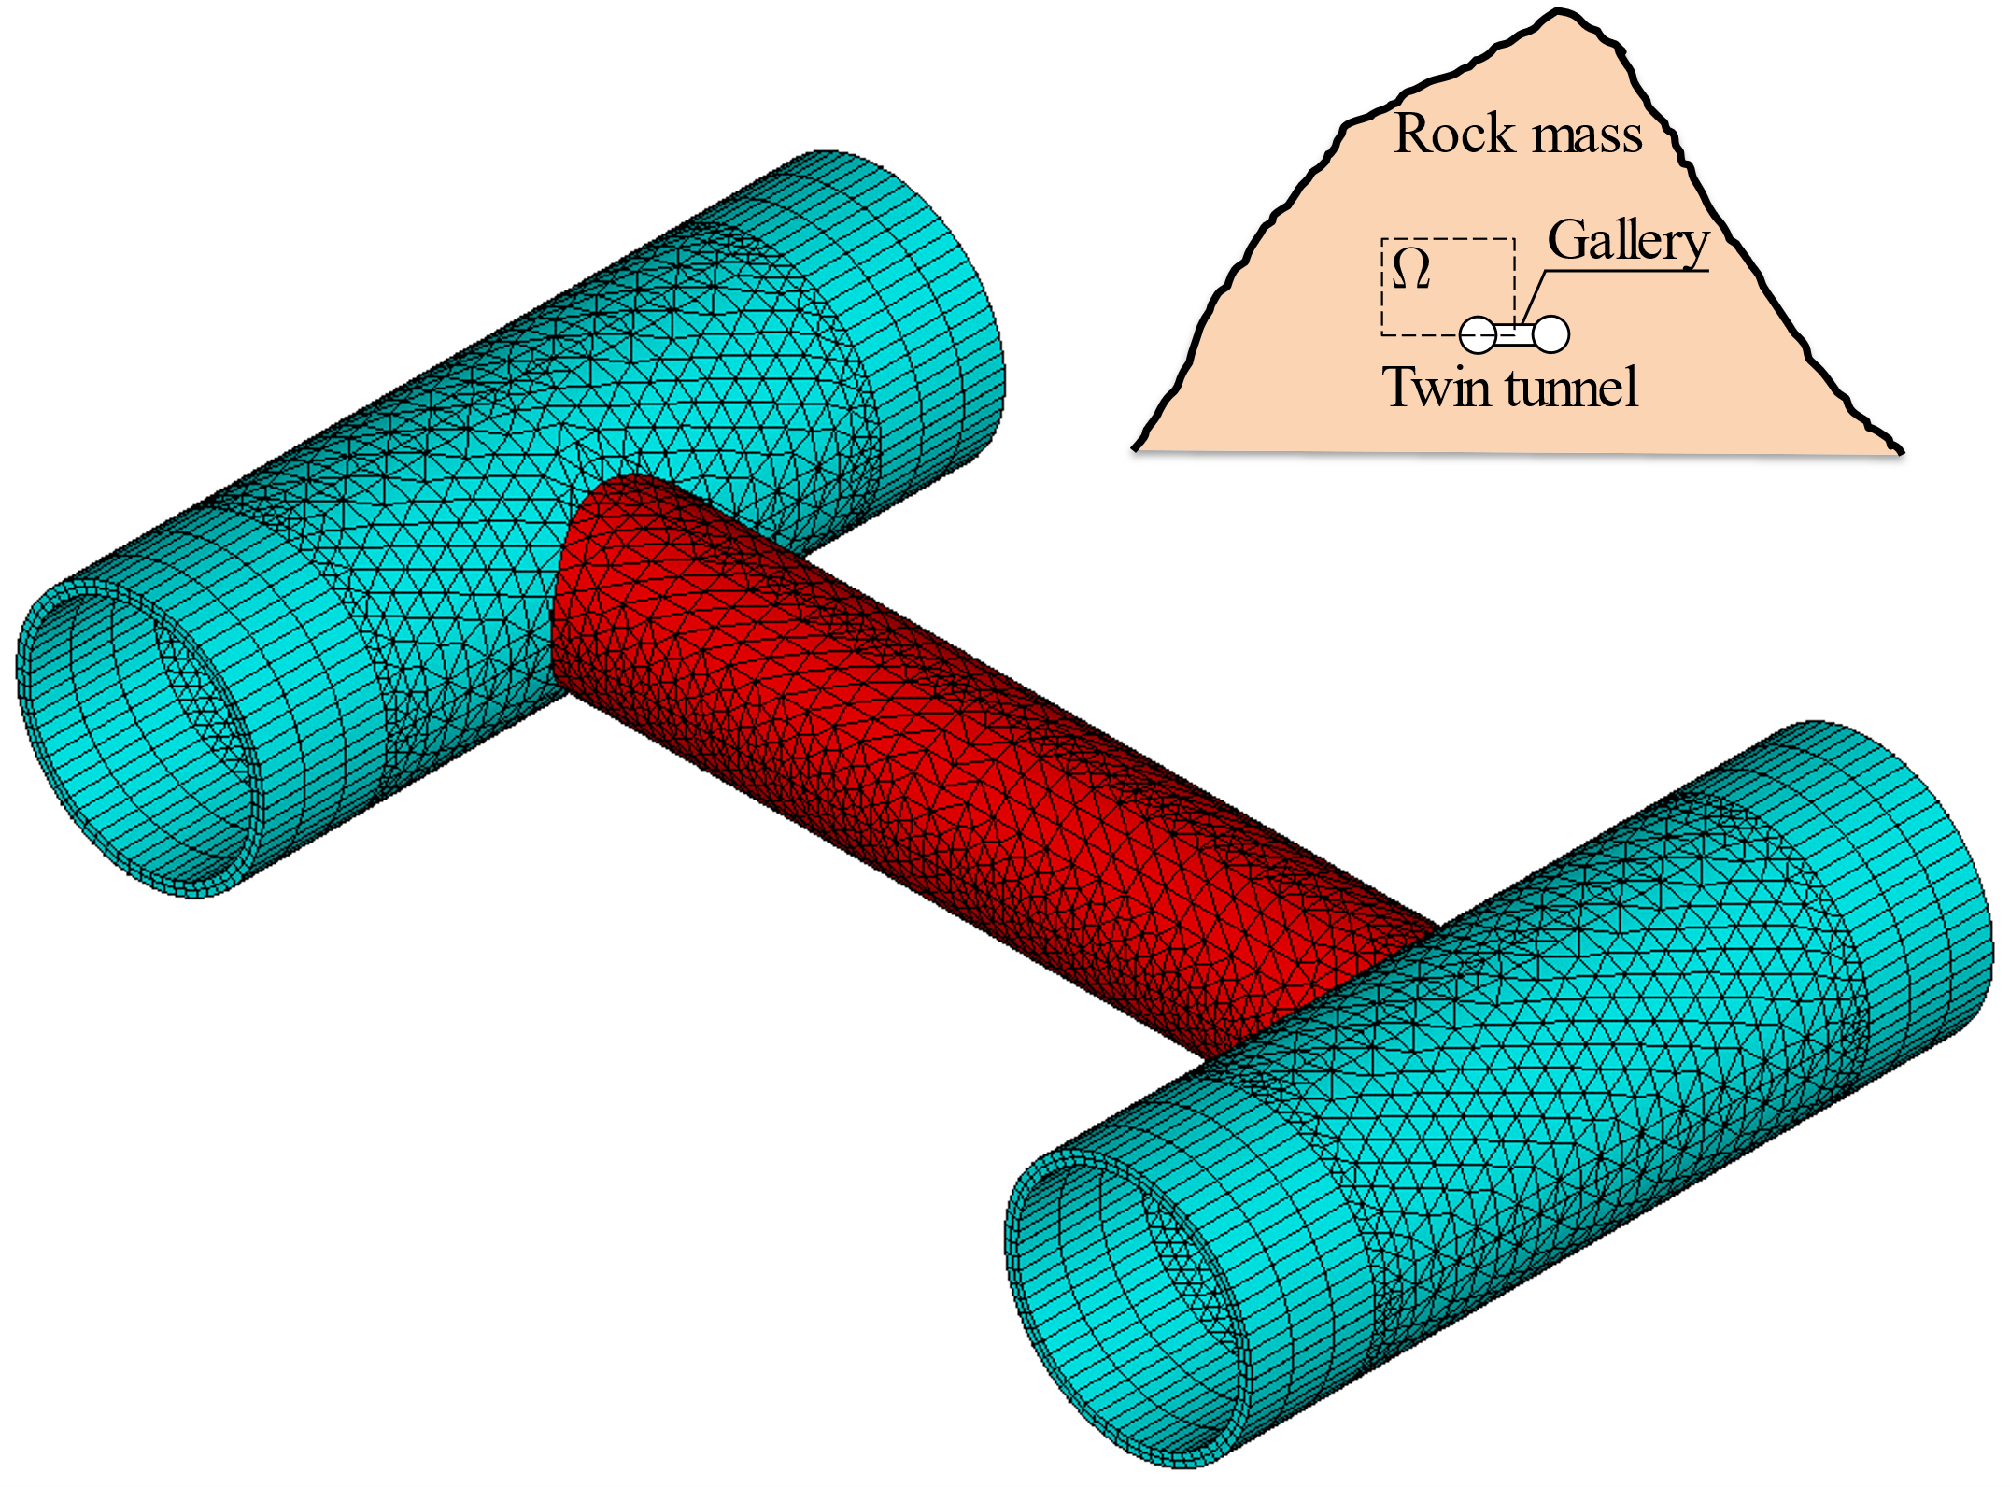

Highlights

* The stiffness of the lining restricting viscous effects in the interaction of tunnels
* Interaction between the tunnels becomes significant at a span distance of 4 radii
* The viscous of the concrete lining can be important in the tunnel convergence
* The effect of the gallery extends into the tunnel up to 4 radii from its axis
* The proximity of the tunnels induces the ovalization of the tunnel wall

# Introduction

Many design methods often focus on single tunnels, but twin tunnels are a common occurrence. The interaction between tunnels can be significant, especially when the spacing between them is minimal. Additionally, many twin tunnels incorporate transverse galleries, introducing a localized effect on displacements and stresses. Also, the rheological behavior of the rock mass and lining plays a crucial role in how stress and displacements fields evolve over time. Some recent studies on deep twin tunnels can be found at [, , , , , , , ].

Chortis and Kavvadas [] considered the calculation of the axial forces acting on the primary support in the intersection zone before, during, and after the construction of a perpendicular tunnel intersection. The results of the analysis indicated that the zone of influence extends approximately two diameters from the main tunnel to each side from the center of the intersection and that the interaction effects are practically eliminated when they exceed this influence zone.

In another study, Chortis and Kavvadas [] carried out parametric 3D finite element analyses to verify the interaction between deep twin tunnel, with circular and non-circular cross-section, supported by a shotcrete elastic linear lining. Was considering the rock mass with linear elastic behavior and perfectly plastic, with Mohr-Coulumb failure criteria. The study investigates the axial forces that develop in the primary lining of the twin tunnels as a function of the main geometric and geomaterial parameters, but without considering the potential time-dependent deformations (creep effect) that occur in some types of rock masses.

Chen et al. [], through analytical solutions in elasticity using complex variables, Fourier transformation, and the alternating Schwarz method, demonstrate that the mutual interaction between twin tunnels disappears if the spacing between the tunnels is greater than six times the tunnel radius. The lining effectively reduces the stress concentration, especially at high lateral stress coefficients.

Guo et al. [] develop an elastic analytical solution for the stress field around twin circular tunnels with hydrostatic pressure using the complex variable and the superposition principle. They found that stress concentration in tunnel wall increased as the distance between the parallel tunnels decreased and the supporting pressure leads to the radial stress increasing and the tangential stress decreasing.

Ma et al. [] proposed an analytical method, verified by a numerical solution using FLAC3D software for determining the plastic zones around deep circular twin tunnels without linings, restricting themselves where there is no overlap between the two plastic zones. In this case, the authors adopted the elastoplastic perfectly constitutive model for the homogeneous and isotropic rock mass, with the Mohr-Coulomb criterion. Also carried out parametric studies to understand the influence of the distance between the twin tunnels, cohesion, the angle of internal friction, and the vertical and horizontal initial stresses acting on the shape and depth of the plastic zones. These authors stated that the plastic zone around the tunnel provides a relevant theoretical basis for defining and designing the support. In that respect, an excessive plastic zone would significantly affect the stability and functionality of a tunnel. Reducing the extension of the plastic zone around tunnels is, therefore, of great importance in engineering tunnel design projects.

Using parametric three-dimensional numerical analyses, Chortis and Kavvadas [, ] investigated the effect of building a transverse tunnel that intersected deep twin tunnels perpendicularly, focusing the study on the axial forces and the circumferential and longitudinal bending moments acting on the primary support of the intersection regions, respectively. According to the authors, the potential interaction between deep twin tunnels lined with shotcrete must be taken into account, especially when the distance between them is less than or equal to twice their diameter.

According to Fortsakis [], in a realistic construction context, twin tunnels are excavated and supported with a delay, so that the second tunnel is usually built after the first one has advanced enough to maintain a longitudinal separation distance between the faces. The advance of the subsequent tunnel mobilizes the redistribution of stresses and deformations in the zone between the tunnels, resulting in additional loading of the preceding tunnel.

As for transverse tunnels, these are generally built far enough behind the advanced face of the main tunnel to ensure that their excavation has virtually no effect during the construction of the junction tunnel []. The interaction at the intersection, between the main tunnel and the transverse tunnel, significantly modifies the stress state of the primary support and that of the surrounding rock mass in these areas, compared to that of the singular tunnel, making three-dimensional finite element analyses essential for developing a realistic and safe design for tunnel junctions [].

During the construction of the transverse tunnel, the surrounding rock mass is subjected to a redistribution of stresses, causing an additional load on the main tunnel, precisely in the intersection zone. If these additional loads exceed the load capacity of the primary support of the main tunnel, a potentially unstable region can develop, leading to failure, especially in adverse geotechnical conditions [].

While the simulation of tunnel convergence in single tunnels has been widely investigated and reported in published literature, few works have addressed the computational evaluation of deformation in twin tunnels. Less attention has been dedicated to assessing the mutual mechanical interaction induced by the excavation of the transverse gallery connecting the twin tunnels.

In this context, the main contributions of this paper may be summarized at both the material and tunnel analysis levels. At the material level, the constitutive state equations of the rock mass are formulated within the framework of coupled plasticity-viscoplasticity, which is relevant for clayey rocks. Such a framework allows capturing the irreversible instantaneous tunnel response (plasticity) as well as the delayed irreversible response (viscoplasticity). As regards the mechanical behavior of concrete material defining the lining, which is classically modeled through linear elastic relationships, the present analysis considers an aging viscoelastic rheological model relying upon the Bažant and Prasannan Solidification theory []. At the structure analysis level, the simulation of deformation in the highly interacting material system components (namely, rock mass and lining), resulting from the excavation process of twin tunnels and transverse gallery, is handled using finite element simulations performed in a three-dimensional setting. From the computational viewpoint, the excavation process and lining placement are simulated by means of the activation/deactivation technique. The constitutive models formulated for the rock mass and lining constituent as well as the related numerical integration schemes are implemented into the same procedure UPF/USERMAT customization tool [] of ANSYS standard software. The three-dimensional finite element analysis developed in this paper is specifically devised for addressing the three-dimensional interaction induced by the construction process, twin tunnels proximity, and the presence of the transverse gallery.