## 5. Spatial and time discretization of the domain

The geometric layout of the modeled domain Ω consists of a twin deep tunnel with a transverse gallery, as shown

in Fig. 3.

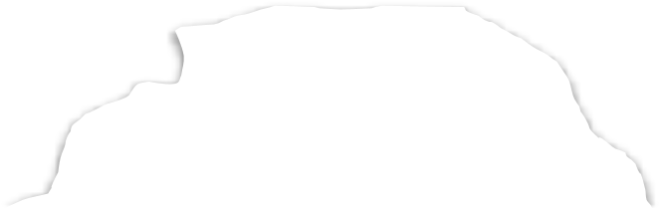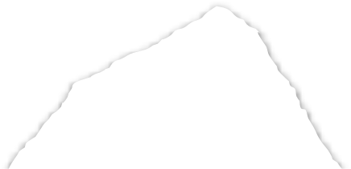

Rock mass

Gallery

Rock mass

Twin tunnel

Gallery

Section

Twin tunnel

direction of

excavation

Figure 3: Geometric layout of the domain

This domain is parameterized based on the radius of the longitudinal tunnel *𝑅𝑖*. The geometric parameters and boundary conditions for the domain problem are shown in Fig. 4. We considered front, side, and bottom symmetry to reduce computational cost. In this domain, *𝑑*1 is the distance between longitudinal tunnels axes, *𝐿*2 total excavated length, *𝑑*3 domain height, *𝐿*1 length of the unexcavated region, *𝐿*3 transversal length of the domain, *𝐿𝑝* step length of the excavation process, *𝑑*2 position of the gallery along the longitudinal tunnel. Together with boundary pressure

*𝜎𝑥, 𝜎𝑦* and *𝜎𝑧*, we apply the initial stress condition ***𝝈***0 = −*𝜎𝑥****𝒆****𝑥 ⊗* ***𝒆****𝑥* − *𝜎𝑦****𝒆****𝑦 ⊗* ***𝒆****𝑦* − *𝜎𝑧****𝒆****𝑧 ⊗* ***𝒆****𝑧* at all integration points to simulate the initial state of the rock mass. The spatial discretization in Fig. 4 corresponds to a mesh with trilinear hexahedral elements (SOLID 185, 8 nodes), except in the gallery region, which uses higher-order tetrahedral elements (SOLID186, 10 nodes). We divided the mesh into two regions: one near the tunnel (light gray), which we refined more,

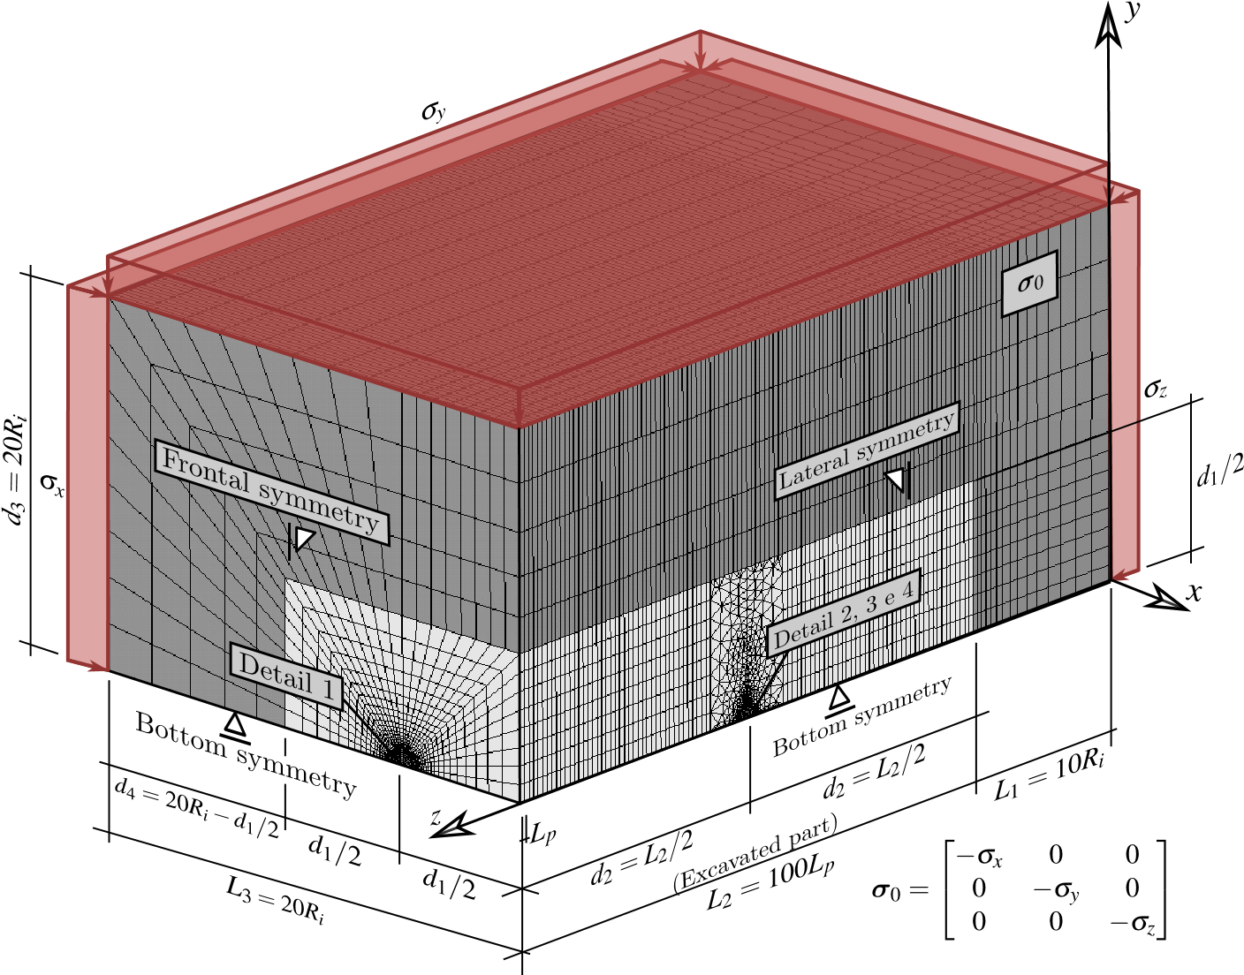

Figure 4: Mesh, dimensions and boundary conditions of the 3D twin tunnel domain

and a region farther away (dark gray), which we increased the aspect ratio to minimize the number of elements in that region. Due to the low deformation gradient away from the tunnel wall, elements in this area can be considerably larger than in other regions. Fig. 5 presents the mesh at the cross-section of the longitudinal tunnel, with *𝑒* representing the thickness of the lining.

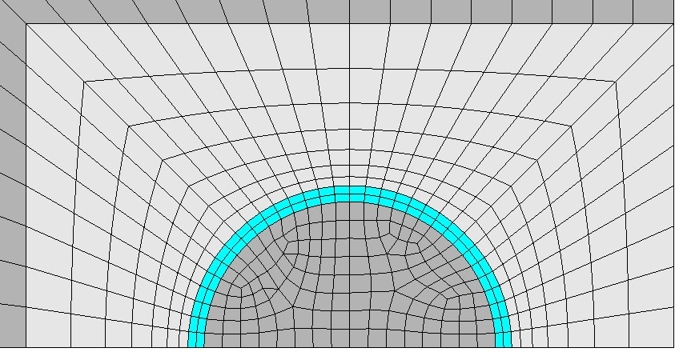

*d*

*1*

2

*x*

*y*

Figure 5: Detail 1 - Mesh in longitudinal tunnel cross-section with spacing *𝑑*1 =4*𝑅𝑖*

One of the aspects investigated in this work is the influence of the spacing *𝑑*1 in the convergence of the longitudinal twin tunnel. Fig. 6 and Fig. 7 illustrate the spatial discretization in the gallery region and its connection with the longitudinal tunnel considering spacings *𝑑*1 = 16*𝑅𝑖,* 8*𝑅𝑖* and 4*𝑅𝑖*, respectively. We adopt the radius of the gallery as 2∕3*𝑅𝑖*, and its lining has the same material and thickness as the longitudinal tunnel. The dimensions *𝑑*5 and *𝑑*1 define the size of the transition region comprising tetrahedral elements between the gallery and the rest of the domain. Fig. 8 shows half of this transition region inside the rock mass.

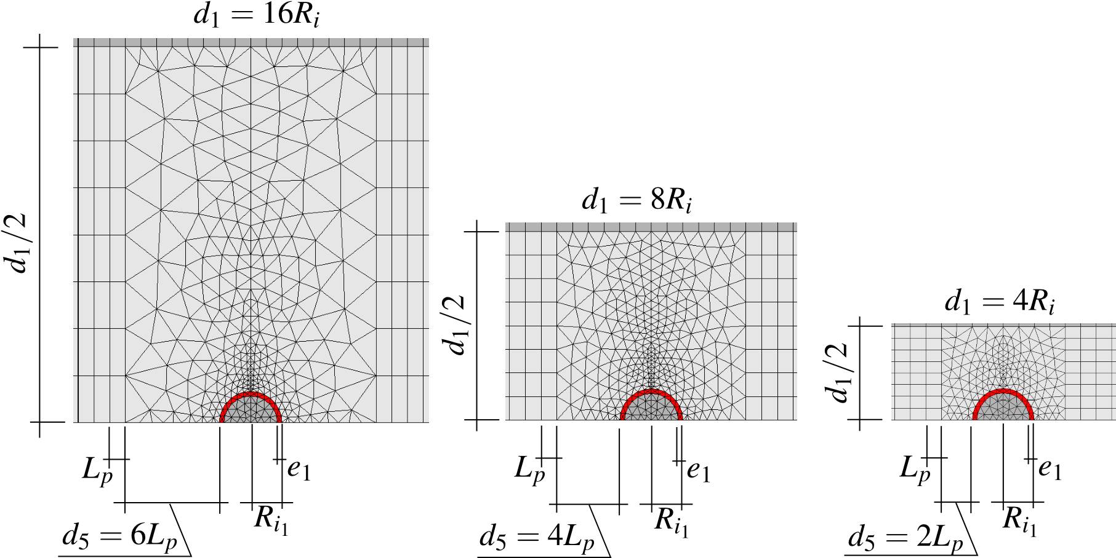

Figure 6: Detail 2 - Side view of the mesh in gallery region with *𝑑*1 =16*𝑅𝑖*, *𝑑*1 =8*𝑅𝑖* and *𝑑*1 =4*𝑅𝑖*

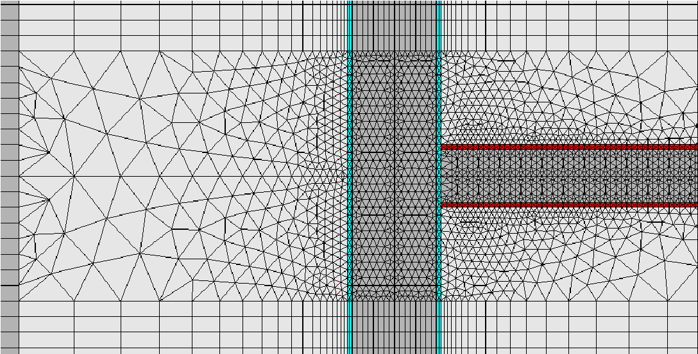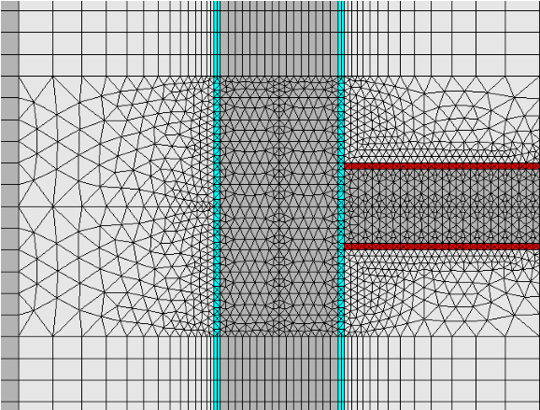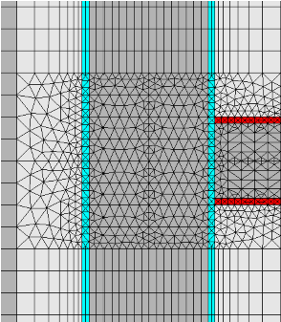

Figure 7: Detail 3 - Bottom view of the mesh in gallery region with *𝑑*1 =16*𝑅𝑖*, *𝑑*1 =8*𝑅𝑖* and *𝑑*1 =4*𝑅𝑖*

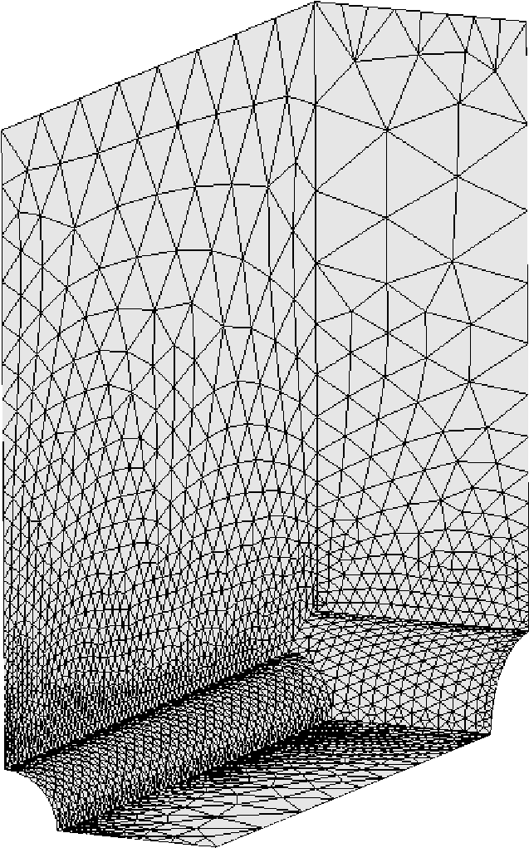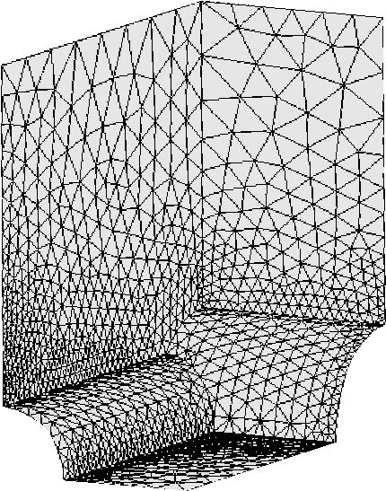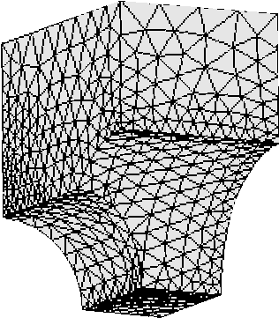

Figure 8: Detail 4 - Isometric view of the portion of the mesh in gallery transition region *𝑑*1 =16*𝑅𝑖*, *𝑑*1 =8*𝑅𝑖* and *𝑑*1 =4*𝑅𝑖*

Fig. 9 shows the mesh of the lining at the junction of the gallery and the longitudinal tunnel for *𝑑*1 = 4*𝑅𝑖,* 8*𝑅𝑖,* and 16*𝑅𝑖*. One noteworthy characteristic of this mesh is that it confines the tetrahedral elements within the contour of every excavation step.

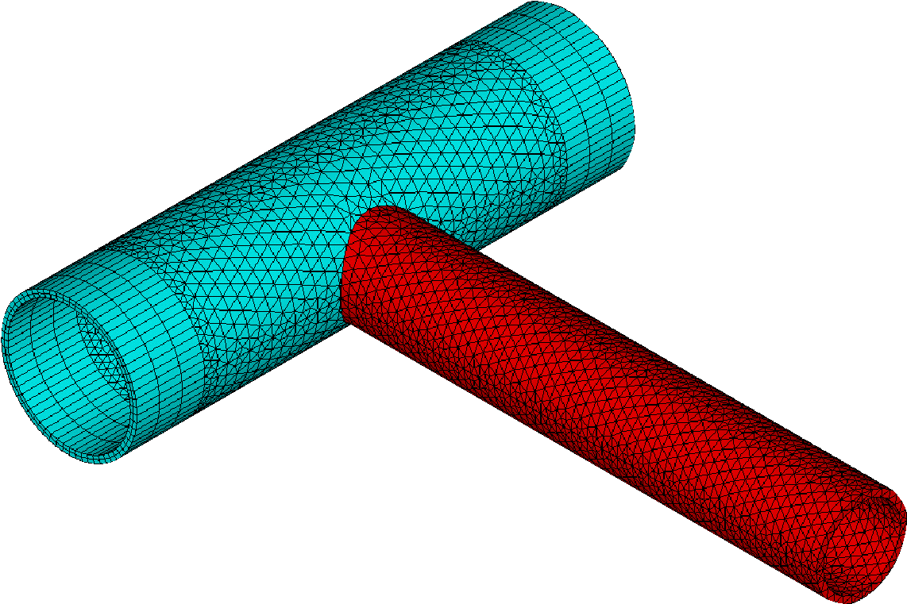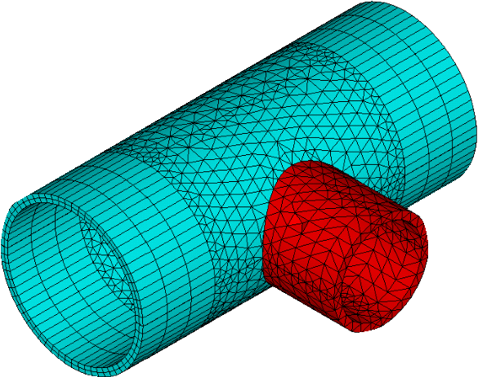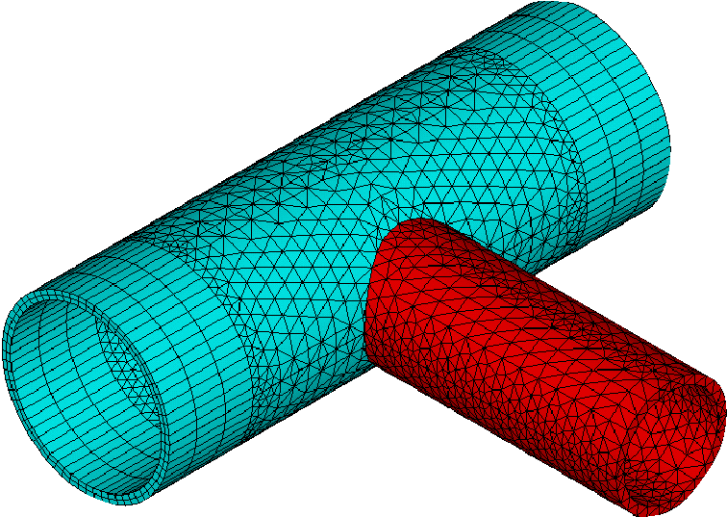

Figure 9: Isometric view of the lining at the intersection for *𝑑*1 =16*𝑅𝑖*, *𝑑*1 =8*𝑅𝑖* and *𝑑*1 =4*𝑅𝑖* - expansion of symmetry in the *𝑥𝑧* plane

The construction process is simulated through the deactivating and activating method, i.e., in each step of excavation, reducing the stiffness of the excavated element (multiply by 1E-8) and active the lining elements at a distance *𝑑*0 from the excavation face (unlined length). With each excavation step, we execute the solution, and time advances based on the expression *𝑡𝑝* = *𝐿𝑝*∕*𝑉𝑝*, where *𝐿𝑝* represents the length of the excavation step, and *𝑉𝑝* is the speed of the excavation face. Fig. 10 illustrates a schematic of the excavation process where *𝑛𝑝* is the number of excavation steps. In this Figure, *𝑛𝑝𝑖𝑔* represents the number of steps excavated in the longitudinal tunnel that starts gallery excavation. Once reaching this step, we pause the excavation of the longitudinal tunnel, and the gallery excavation begins. In the gallery, *𝐿𝑝*1 is the step length of the gallery excavation, *𝑉𝑝*1 is the speed of the gallery excavation, and *𝑑*01 is the unlined length of the gallery. After completing the gallery excavation, the longitudinal tunnel excavation resumes. These parameters related to the geometry domain, excavation and installation of the lining are shown in Table 1.

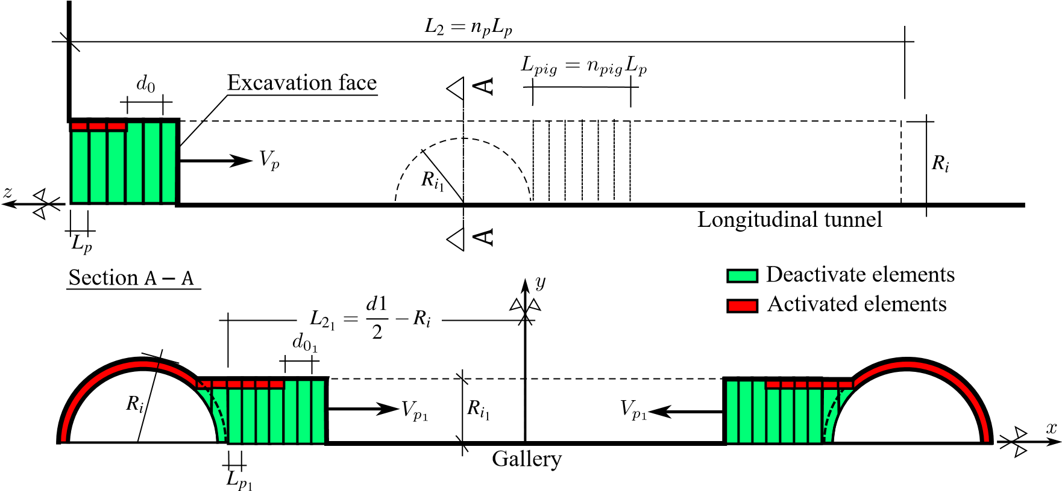

Figure 10: Schematic of the excavation process

Table 1

Parameters related to the geometry of the domain, excavation and installation of the lining

|  |  |  |  |  |  |  |
| --- | --- | --- | --- | --- | --- | --- |
| PARAMETERS SYMBOL | | | UNIT |  | VALUES | |
| Longitudinal tunnels | | |  |  |  | |
| Radius of the longitudinal tunnel | *𝑅𝑖* | | m |  | *𝑅𝑖* | |
| Thickness of the lining | *𝑒* | | m |  | 0*.*1*𝑅𝑖* | |
| Step length of the excavation process | *𝐿𝑝* | | m |  | 1∕3*𝑅𝑖* | |
| Unlined length | *𝑑*0 | | m |  | 2*𝐿𝑝* | |
| Speed of the excavation face | *𝑉𝑝* | | m/day |  | 12.5 | |
| Excavation step time | *𝑡𝑝* | | day |  | *𝐿𝑝*∕*𝑉𝑝* | |
|  | Gallery | |  |  |  | |
| Radius of the gallery | *𝑅𝑖*1 | | m |  | 2∕3*𝑅𝑖* | |
| Thickness of the concrete lining | *𝑒*1 | | m |  | 0*.*1*𝑅𝑖* | |
| Step length of the excavation process 1 | *𝐿𝑝*1 | | m | 0*.*3*𝑅𝑖*1 | 0*.*3214*𝑅𝑖*1 0*.*3387*𝑅𝑖*1 | |
| Unlined length | *𝑑*01 | | m |  | | 2*𝐿𝑝*1 |
| Speed of the excavation face | *𝑉𝑝*1 | | m/day |  | | 12.5 |
| Number of steps that starts gallery excavation | | *𝑛𝑝𝑖𝑔* | un |  | | 15 |
| Rest of domain | | |  |  | |  |
| Distance between longitudinal tunnel axes | | *𝑑*1 | m | 4*𝑅𝑖* | | 8*𝑅𝑖* 16*𝑅𝑖* |
| Length of the unexcavated region | | *𝐿*1 | m |  | | 10*𝑅𝑖* |
| Total excavated length | | *𝐿*2 | m | 100*𝐿𝑝* | | |
| Domain height | | *𝐿*3 | m | 20*𝑅𝑖* | | |

1

During tunnel construction, we determine the initial time increment for solution steps as0*.*5*𝑡𝑝*1 (for the transverse gallery). ANSYS manages the time increment using the bisection method, halving0*.*5*𝑡𝑝* (for the longitudinal the time step if there is no equilibrium convergence.

After tunnel excavation, in time-dependent constitutive models, time continues to progress to capture long-term viscous effects. In this stage, each time step lasts 100 days, with an initial increment of 50 days. This increase, compared to the excavation time increments, is facilitated by the semi-implicit scheme in the viscoplasticity solution. The explicit scheme, as indicated in [30], requires a smaller time increment to the precision of the solution.