**Supporting tables**

**Table Sx. Relative (%) changes in precipitation, temperature, and vapor pressure deficit during drought in spring versus summer.**

|  |  |  |  |  |  |  |  |
| --- | --- | --- | --- | --- | --- | --- | --- |
|  |  |  | **Spring** |  |  | **Summer** |  |
|  |  | *50th* | *1st* | *99th* | *50th* | *1st* | *99th* |
|  | Precipitation (%) | -70.8 | -100 | -7.5 | -59.2 | -98.1 | -13.7 |
| **Shortgrass steppe** | Temperature (%) | 7.7 | -5.3 | 45.6 | 9.1 | -0.5 | 15.1 |
|  | Vapor Pressure Deficit (%) | 22 | -4 | 49 | 28 | -0.3 | 57 |
|  | Precipitation (%) | -47.9 | -82.4 | 8.1 | -57.6 | -96.5 | -4.2 |
| **Northern mixed prairies** | Temperature (%) | 21.4 | -17.5 | 60.3 | 6.81 | -9.6 | 11.5 |
|  | Vapor Pressure Deficit (%) | 14 | -6.7 | 52 | 22 | -7.3 | 54.7 |

**Table Sx. Absolute changes in precipitation, temperature, and vapor pressure deficit during drought in spring versus summer.**

|  |  |  |  |  |  |  |  |
| --- | --- | --- | --- | --- | --- | --- | --- |
|  |  |  | **Spring** |  |  | **Summer** |  |
|  |  | *50th* | *1st* | *99th* | *50th* | *1st* | *99th* |
|  | Precipitation (mm) | -75.4 | -158.6 | -8.4 | -106.2 | -204.3 | -23.7 |
| **Shortgrass steppe** | Temperature (oC) | 1 | -0.5 | 3.2 | 2 | -0.1 | 4 |
|  | Vapor Pressure Deficit (hPa) | 4.4 | -0.6 | 8 | 9.7 | -0.02 | 20.3 |
|  | Precipitation (mm) | -71.2 | -132.7 | 12.1 | -80.9 | -237.3 | -5.9 |
| **Northern mixed prairies** | Temperature (oC) | 1.3 | -1.1 | 3.9 | 1.3 | -1.9 | 2.4 |
|  | Vapor Pressure Deficit (hPa) | 1.5 | -0.8 | 7 | 6.2 | -2.2 | 13 |

**Supporting Figures**

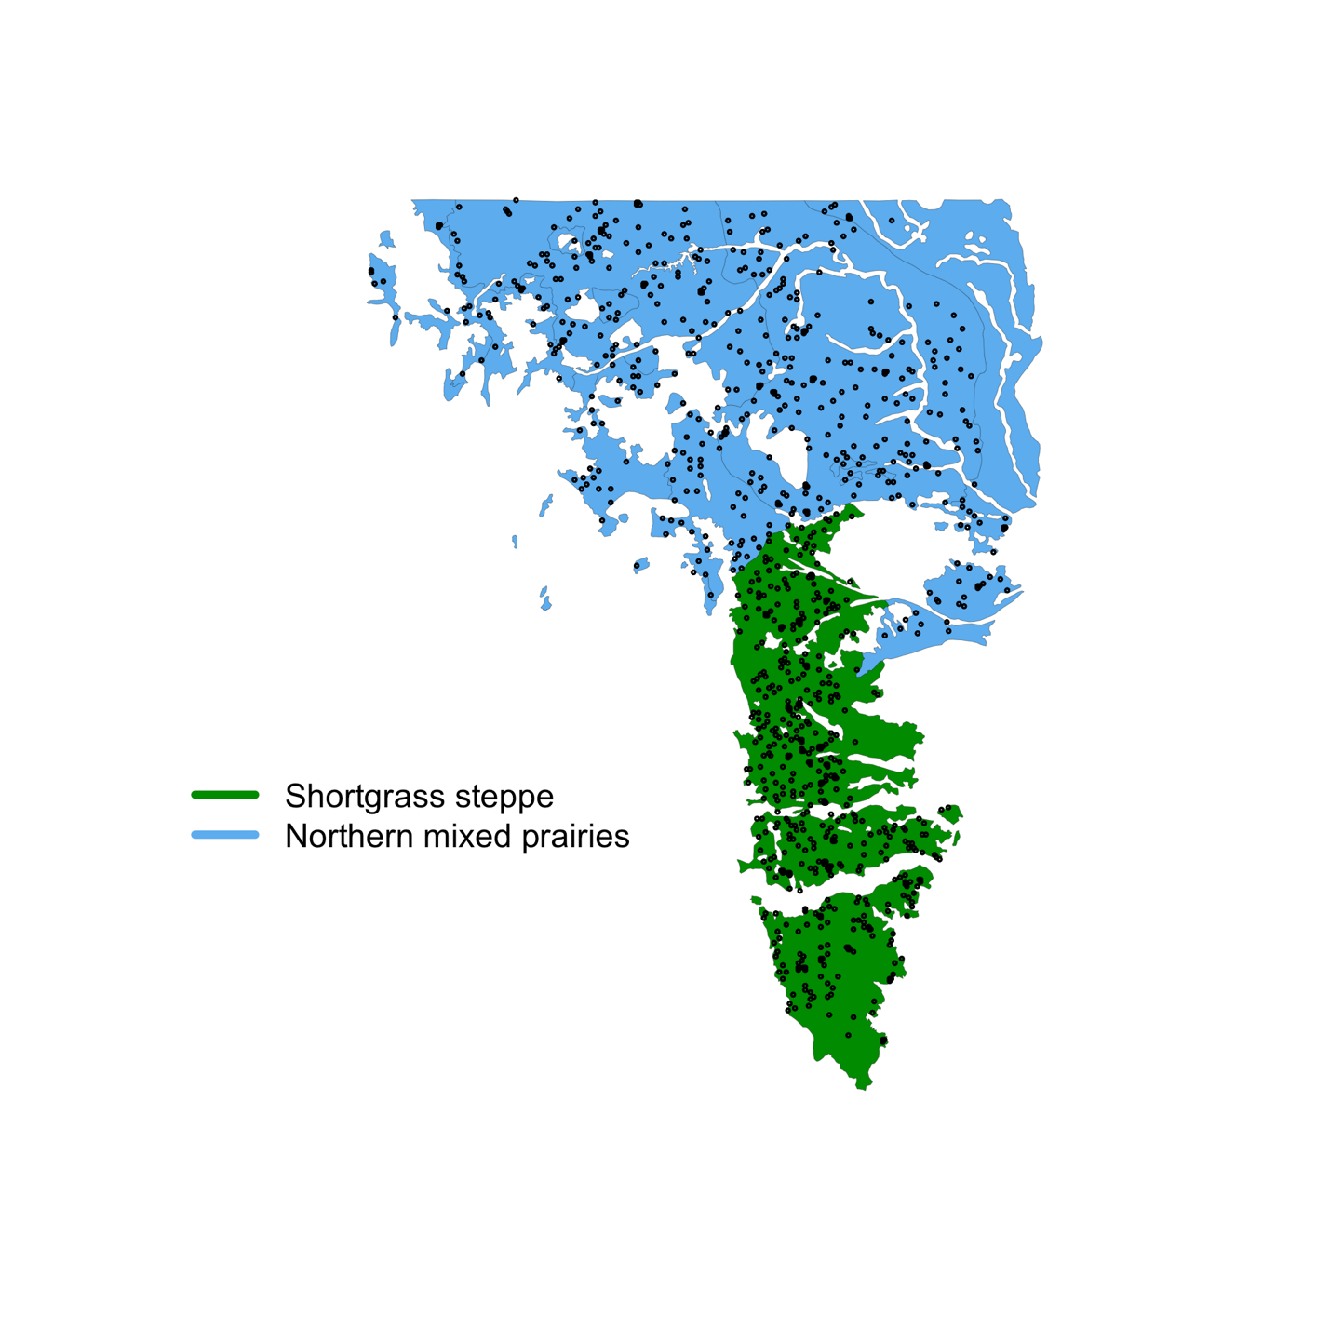

**Figure S1. Distribution of randomly-selected subset of sites used for the seasonal vapor pressure deficit analysis across the two ecoregions.**

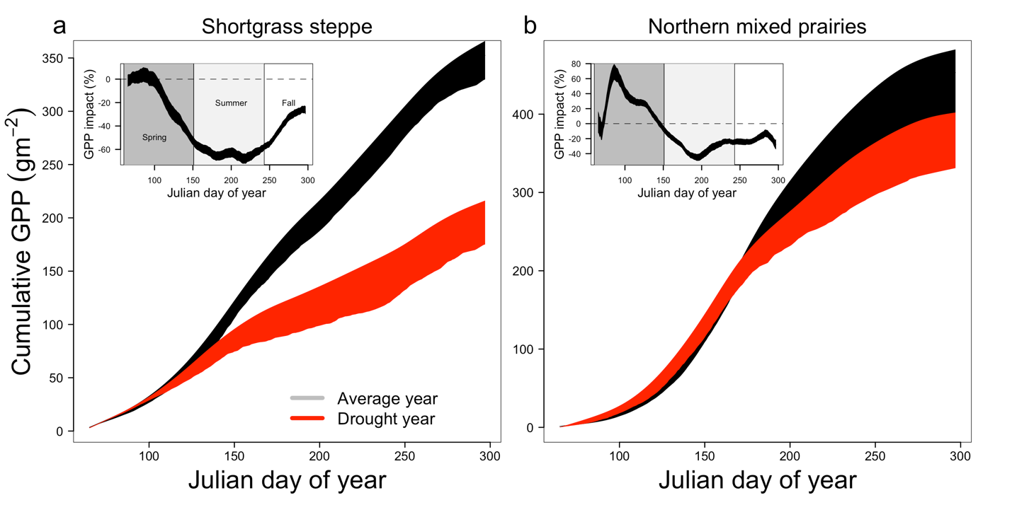

**Figure S2. Analysis of the temporal evolution of relative drought effects to grassland gross primary productivity on a subset of sites at 1 km spatial resolution.**

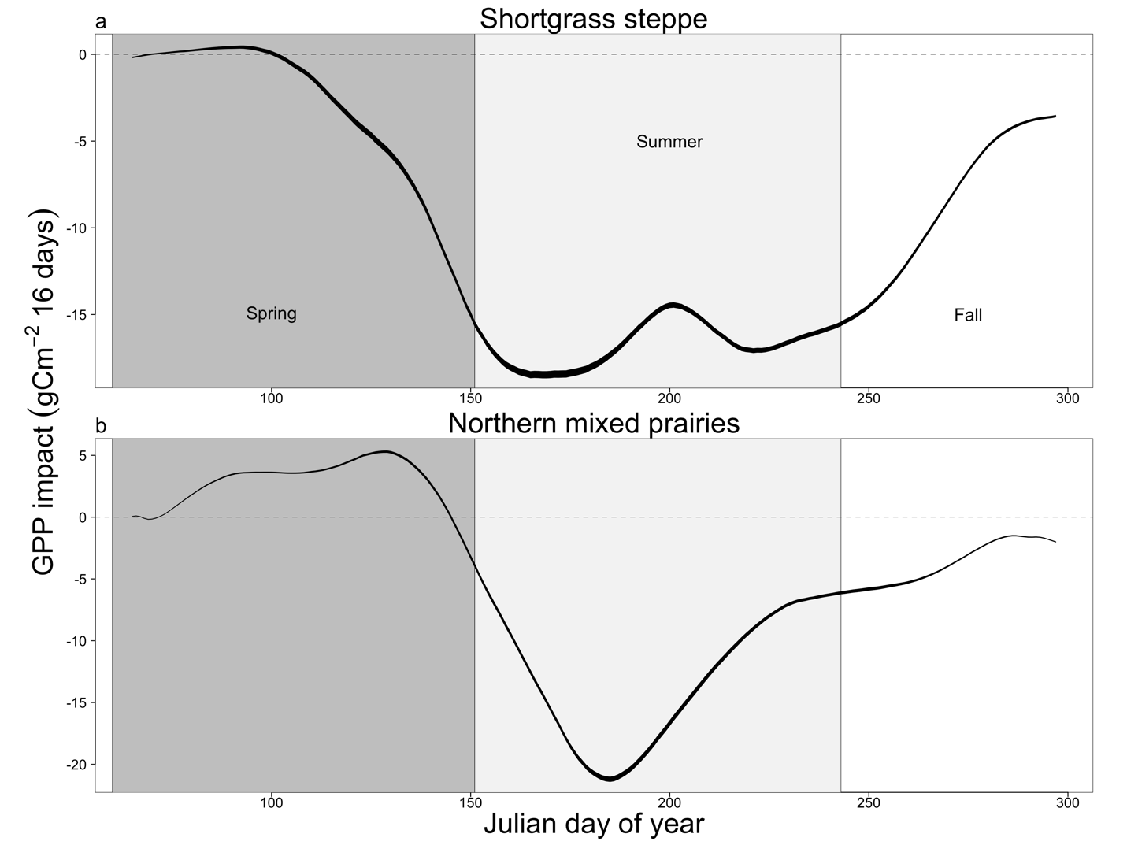

**Figure S3. Temporal evolution of gross primary productivity responses to drought.**

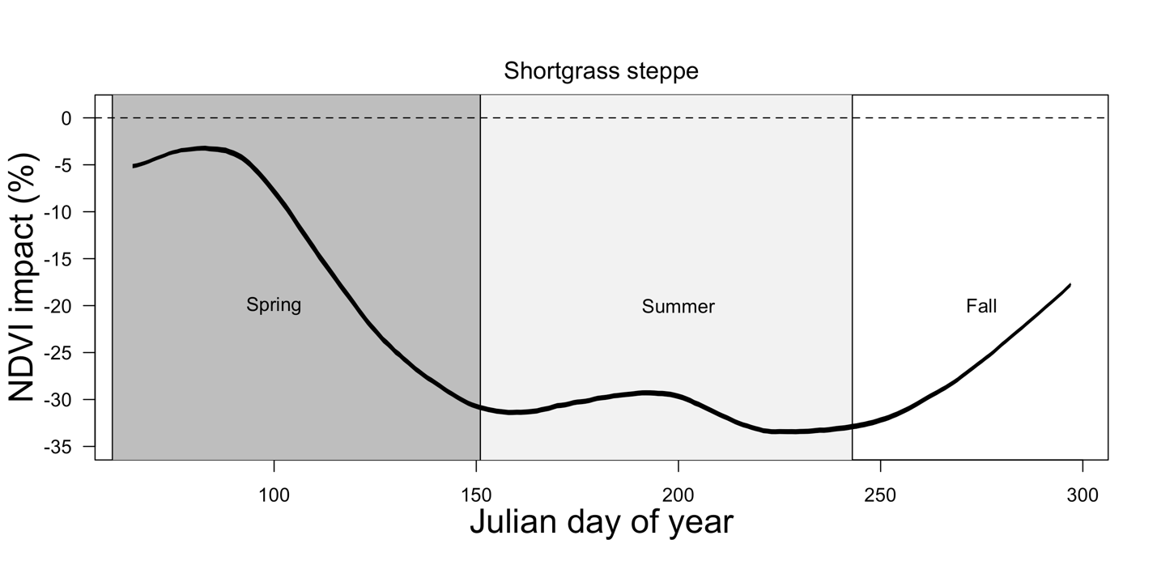

**Figure S4. Temporal evolution of drought effects to grasslands NDVI (greenness).**

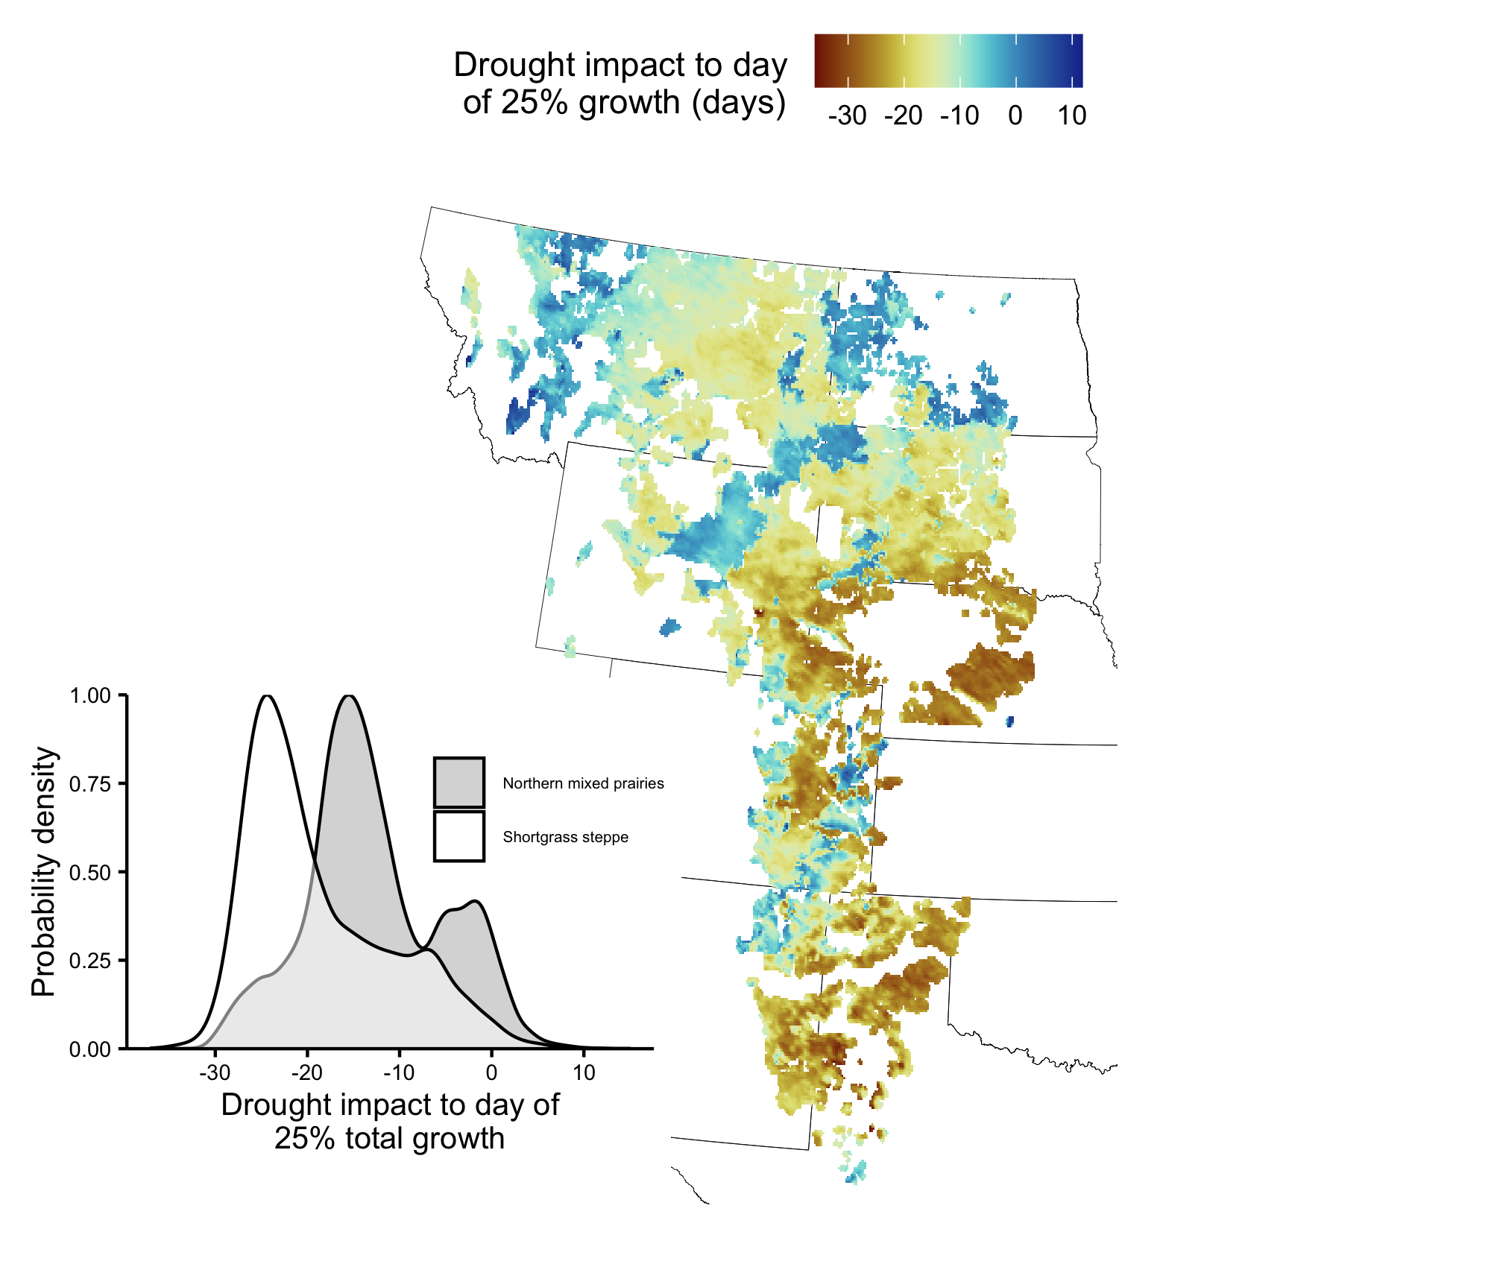

**Figure S5. Drought consistently advances the day at which 25% of total gross primary productivity is reached.**

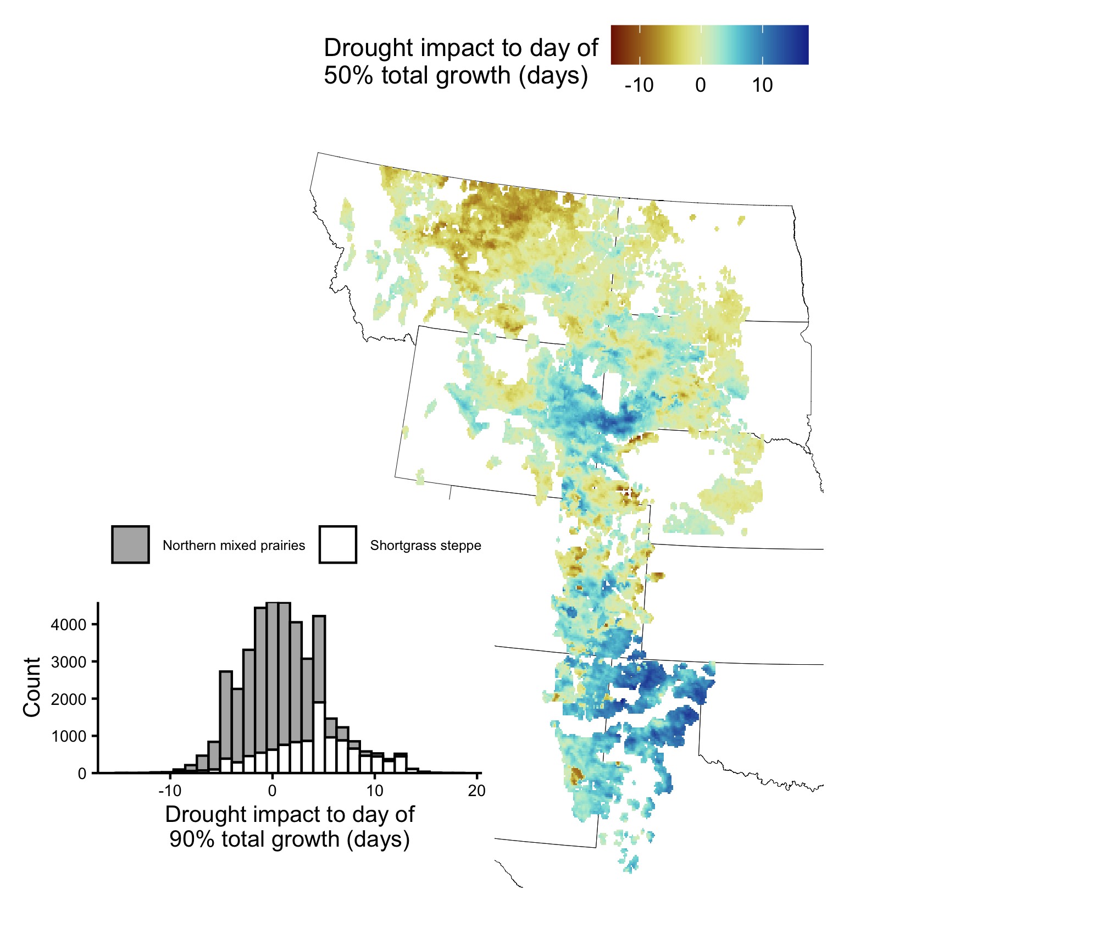

**Figure S5. Inconsistent effects of drought on the day at which 90% of total gross primary productivity is reached.**

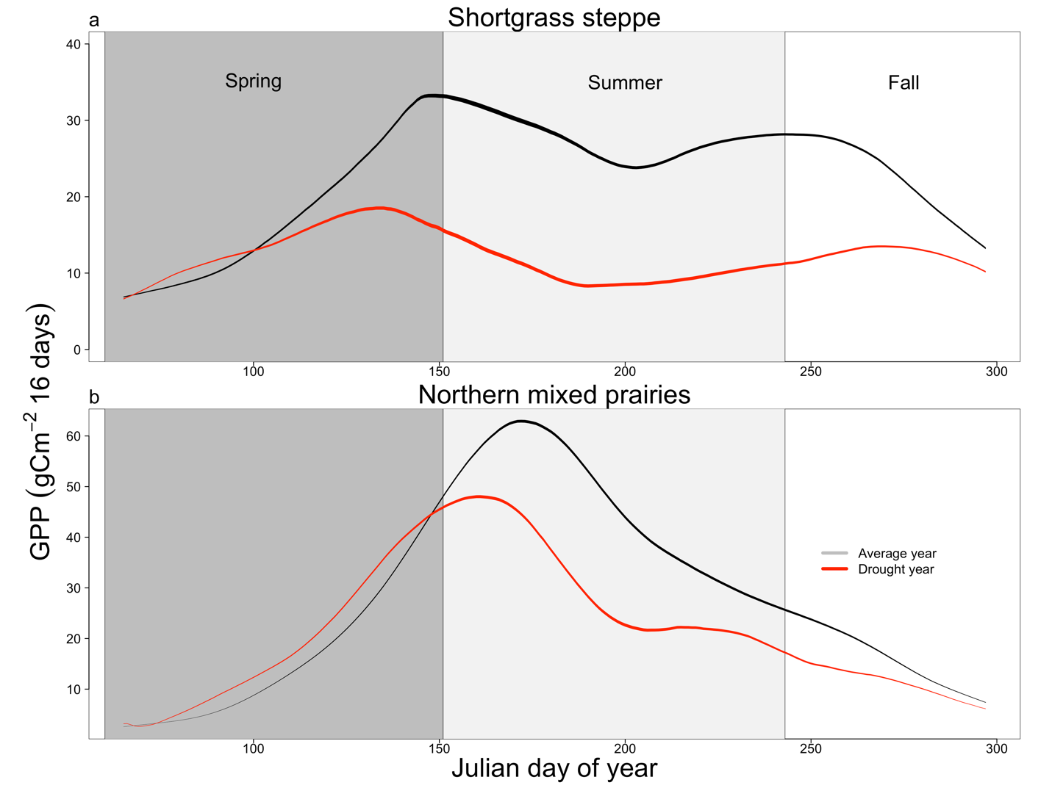

**Figure SX. Growth cycles of gross primary productivity in typical versus dry years.**