A

Project Report

On

**“GCOEJ Campus Network Module”**

Prepared By:

WANI BHAVESH GAJENDRA (1741011)

CHAUDHARI VAIBHAV ANNA (1741014)

FEGADE SHREYAS MANOJ (1741019)

Guided By:

**MS. RUCHA PATIL**



**GOVERNMENT COLLEGE OF ENGINEERING, JALGAON**

**DEPARTMENT OF COMPUTER ENGINEERING**

**CERTIFICATE**



This is to certify that the project report entitled, **“GCOEJ CAMPUS NETWORK MODULE**”, which is being submitted here with for the result of the work completed by “**Wani Bhavesh ,Chaudhari Vaibhav and Fegade Shreyas**” under my supervision and guidance within the four walls of the institute and the same has not been submitted elsewhere for the award of any degree.

(Ms. Rucha Patil) (Prof. D. V. Chaudhari)

Project Guide Head of Computer Department

**ACKNOWLEDGEMENT**

It is indeed a matter of great pleasure and privilege to be able to present this project report on **“GCOEJ CAMPUS NETWORK MODULE**” under the valuable guidance of **Ms.Rucha Patil** mam for her valuable guidance, advice and constant aspiration to our work. Also here we would like to thank our honorable **Principal Dr.R.D.Kokate** And our **HOD D.V.Chaudhari** who made all facilities and faculty of Technology available for our in the college premises. We are obliged! We are also thankful to all my teachers and principal of this institute for providing us constant support and facilities.

It has been great fun to work together with problem related with project financial support from our parents it’s gratefully acknowledged. We would thank our parents for their understanding and support during this year. Many thank to our group members for their patience, encouragement among us.

**WANI BHAVESH GAJENDRA**

**CHAUDHARI VAIBHAV ANNA**

**FEGADE SHREYAS MANOJ**

**INDEX**

|  |  |  |
| --- | --- | --- |
| Sr.  no | Content | Page  No. |
| 1. | **Abstract.** | **4** |
| 2. | **Introduction.** | **5** |
| 3. | **Methodology.** | **6** |
| 4. | **Proposed Work and Simulation.** | **7** |
| 5. | **Types of Topology used.** | **13** |
| 6. | **Configuration.** | **14** |
| 7. | **Outputs.** | **15** |
| 8. | **Costing for network implementation.** | **17** |
| 9. | **Conclusion.** | **19** |
| 10. | **References.** | **20** |

**1.ABSTRACT**

As the name specifies “**GCOEJ CAMPUS NETWORK MODULE**” is developed using Cisco Packet Tracer. A **Campus** **Network Module** is a type of network designed for establishing the Internet network in the campus. A **Gcoej Campus Network Module** is a project which can be usefully established for the network in any college or campus .

In this project , we used the Cisco Packet Tracer software for designing of this network module.This project is implemented in this software using realtime simulation that confirms live data transfer is working or not.

We have project on Campus Network Module that will help network designing have an edge over others when it comes to cost and product designing.

The study provides an insight into various concepts such as topology design, IP address configuration and how to send information in form of packets in a single network and the use of Virtual Local Area Networks (VLANs) to separate the traffic generated by different departments.

**Keywords**: Computer Networks, IP Addresses, Ping Test, Simulation Tool, Subnetting, VLANs.

**2.INTRODUCTION**

The need for computer networking was borne out of the need to use personal computers for sharing information within an organization in form of messages, sharing files and data bases and so forth. Whether the organization is located in one building or spread over a large campus, the need for networking the computers cannot be over emphasized. As the name implies, a Local Area Network (LAN) interconnects computers in a limited geographic area. It provides high-bandwidth communication over inexpensive transmission media. The corporate LAN has evolved from a passive background business component to a highly active, visible core asset that enterprises rely on to support day-to-day operations critical to their market success. Today’s network is a strategic instrument that must be accessible anytime from anywhere-simultaneously offering fast, secure, reliable services at scale regardless of location.

The main purpose of a network is to reduce isolated users and workgroups. All systems should be capable of communicating with others and should provide desired information. Additionally, physical systems and devices should be able to maintain and provide satisfactory performance, reliability and security.

In this project, we designed this project in Cisco Packet Tracer using Servers, Routers, PCs, Laptops, Wireless Routers(WIFI campus), etc and for the connection purposes we have used the optic fibre cables and copper cables for the best efficiency in network purpose. This project is developed for the college campus taking in consideration the phases like main building, library, hostels, etc,

**3 .METHODOLOGY**

We have project on “GCOEJ CAMPUS NETWORK MODULE ”.First we design our project then we implemented it. Flow of our program.

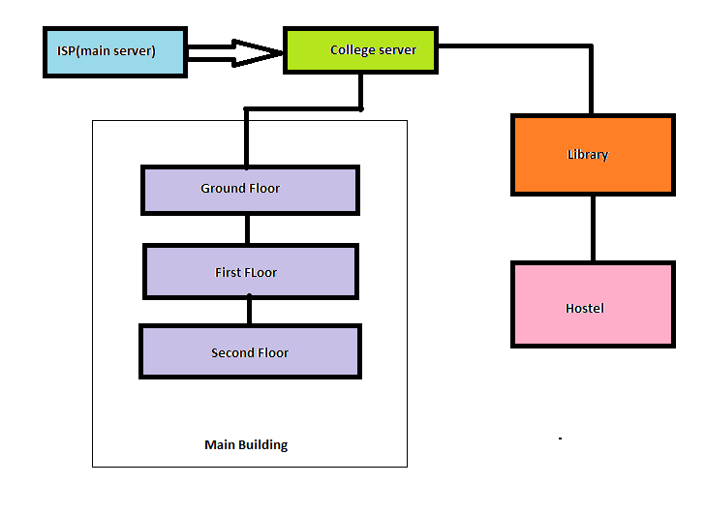

In starting, we have the main ISP Server that provides the main internet line to the college, further it is given to the college server that is data center from where the connections to the whole campus are provided.

One line is given for the main building in which series router connections (Bus Topology) are provided for the different floor connections which are further extended to the star topology for connections at different labs and offices. The second line from the college server (data center) is provided to the library which is further extended to the hostel.Again the star topology is implemented in the hostel for wireless connections(WIFI).

**4.Proposed work and simulation**

The various sub-parts of the network are shown below,

i)**ISP**(Main-service provider):

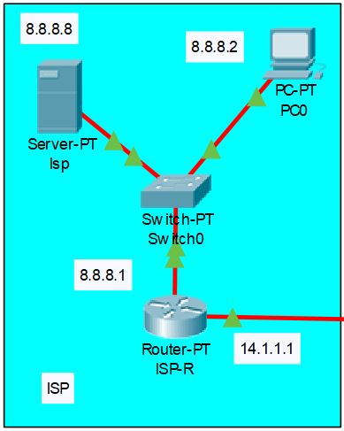

From the above fig we can see that the main internet sevice provider(8.8.8.8) is implemented and its connection is given to switch extended to the router which is furthur passed to the college server(data-center).The default gateway here is 8.8.8.1.

ii)Data-Center(College server):

From the fig. below we can see the college server, that is data-center ferom where the internet service is provided to whole college.The college server has ip 20.20.20.3, whose further connection is given to the router(GCOEJ ip:-20.20.20.1) through a switch. From this router connections to the main building that is to all floors and lab in the college is provided and library and hostel is provided.

A separate pc with ip 20.20.20.2 is provided for any network connections problems diagnostics in the campus.

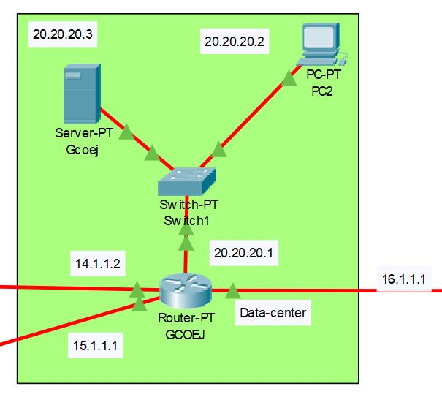

iii)**Floor plan**(Main buliding floors):

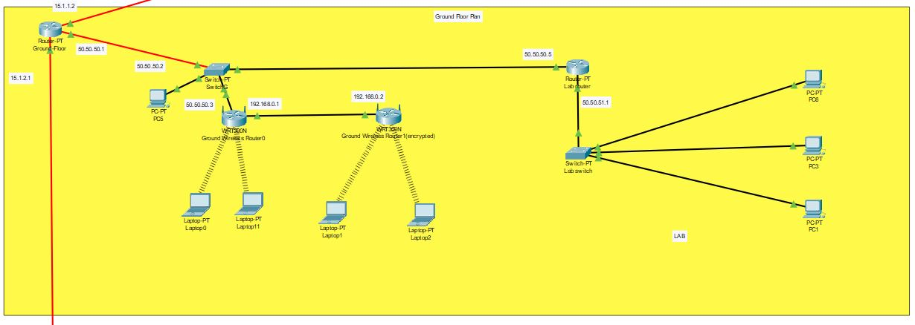

From the above figure we can see the router(ip:15.1.1.2)provide the connection to whole floor, whose connection is given through a switch to the further routers for the labs and wireless routers for the WIFI purpose.

The wireless routers are provided with the service of encryption so that with proper authentication one would not be able to access the internet service.

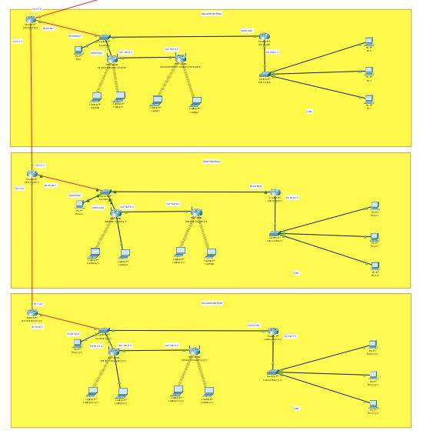

The above figure shows the connection of routers in the main building for internet connection, we can see that the routers are connected serially i.e the bus topology is implemented for the floor to floor connection and further the star topology through the switch for wireless routers and lab routers.

iv)**Library**:

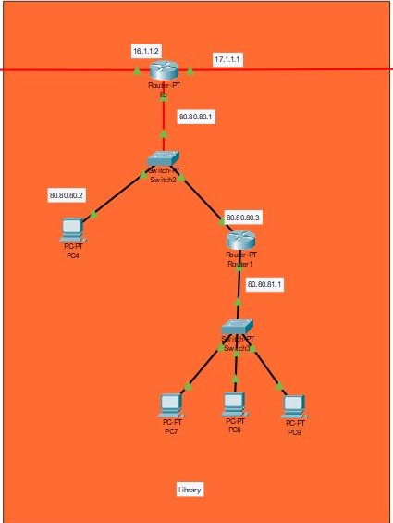

From the above fig. we can see that the hostel network is implemented. The net connection comes to the router(ip:16.1.1.2) from which the further connections are provided using a switch in which again the star topology is implemented.

v)**Hostel**:

The figure below shows the network implementation for the hostel. The router with ip 17.1.1.2 is the main router here from where the further connections are provided to the routers using a switch. Again here the star topology is implemented for the wireless routers through a switch .

From fig we can see that a separate pc and router is provided for the office from which the floor to floor connections are provided using the switch. And the wireless routers are connected serially on the floor which shows that the bus topology is implemented here.

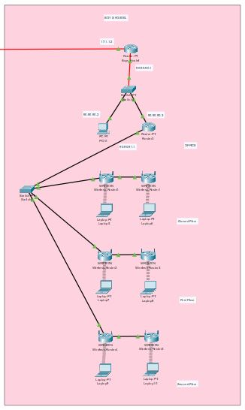

6)Whole campus:

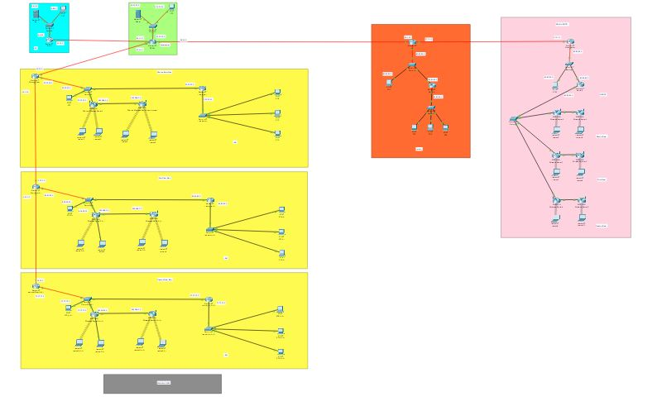

**5.Types of Topology used**

For interconnectivity of components, network topology describe the physical and logical appearance and interconnection between arrangement of computers, cables and other components in a data communication network and how it can be used for taking a packet from one device and sending it through the network to another device on a different network.

A network topology is the physical layout of computers, cables, and other components on a network. There are a number of different network topologies, and a network may be built using multiple topologies.

The different types of network topologies are: Bus topology, Star topology, Mesh topology, Ring topology, Hybrid topology and Wireless topology. The bus topology typically uses a cable running through the area requiring connectivity. Devices that need to connect to the network then tap into this nearby cable. To prevent signal bounce, a terminator is designed to absorb the signal when the signal reaches the end.

The **Star Topology** is a network topology in which all the clients or machines on the network are connected through a central device known as a hub or switch. Each workstation has a cable that goes from the network card to the hub or switch device. One of the major benefits of the star topology is that a break in the cable causes only the workstation that is connected to the cable to go down, not the entire network as it is with the bus topology.

Alternatively referred to as a line topology, a **bus topology** is a network setup in which each computer and network device are connected to a single cable or [backbone](https://www.computerhope.com/jargon/b/backbone.htm). Depending on the type of [network card](https://www.computerhope.com/jargon/n/nic.htm) used in each computer of the bus topology, a [coaxial cable](https://www.computerhope.com/jargon/c/coaxialc.htm) or an [RJ-45](https://www.computerhope.com/jargon/r/rj45.htm) network cable is used to connect them together. Some networks of today are implemented by having a combination of more than one topology: star and bus, star and ring, ring and bus or ring, bus and star. Networks implemented in this way are said to be hybrids.

A **wireless topology** is one in which few cables are used to connect systems. The network is made up of transmitters that broadcast the packets using radio frequencies. The network contains special transmitters called wireless access points which extend a radio sphere in the shape of a bubble around the transmitter. Wireless topology can either be an ad-hoc or an infrastructure based implementation.

**6.Configuration/Specifications.**

The configuration of devices used in designing this project are listed as follows,

1)**Servers**:-The server type used in this project is the simple PT-Server that has two access ports.For the best efficiency we have changed the port to optic fibre port **PT-HOST-NM-1CGE**.

2)**Routers:-**

a)Router:-The route type used is simple PT-Router in which also the ports are changed to optic fibre for better efficiency.

b)Wireless router:-The wireless routers used are **WRT300N** for the WIFI network,that provide encryption service.

Wireless Access Point Configurations The setup of the wireless access point is done by opening up the graphical user interface of the access point in Packet Tracer and then clicking on the config tab to access type of configurations available for the access point. Click on port 0 under the interface section to set the bandwidth of the Ethernet connection to the access point, and then set the duplex (half duplex or full duplex). Click on port 1 under the interface section to configure the SSID of the access point, authentication type (none, WEP, WPA-PSK, WPA2-PSK) and if any authentication type is chosen provide the passphrase for network connectivity.

3)**Switches:-**In this project simple switches are used i.e PT-Switches that provides 10 ports for accessing the network.

4)**Cables:-**

a)Fibre optic cables:- The **Gigabit Ethernet** ports of the **Cisco** MWR 2941 **router** can run in full or half- duplex mode—100 Mbps or 1000 Mbps (1 Gbps).

b)Copper cables:- **Copper** straight-through: This is a standard Ethernet **cable** that is used to connect two devices that operate in different layers of the OSI model (such as hub to **router** and switch to PC).

**7.OUTPUTS**

The internet service is working efficiently from every corner of the network, the following figures show the pinging to main server from various accessing points,

1)ping from datacenter to main server 2)ping from main building ground floor wifi to server

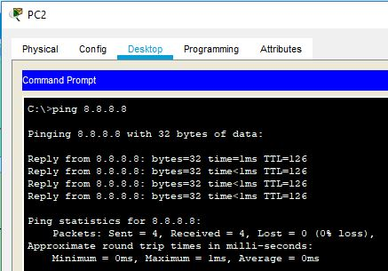 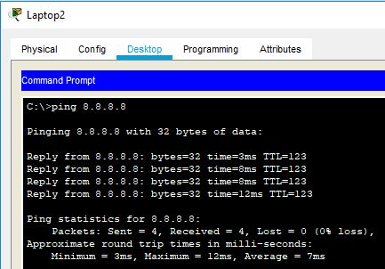

3)ping Main build. Gnd floor->server 4)ping Main build. 1st floor->server

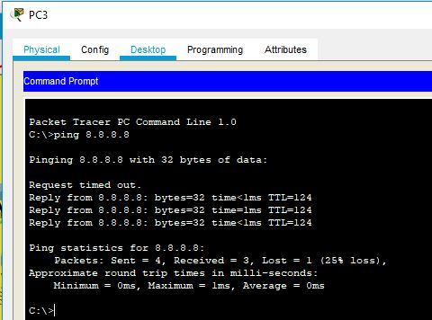 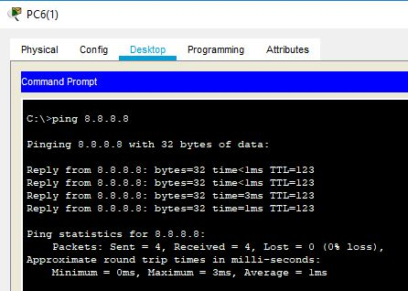

5)ping Main build. 2nd floor->server 6)ping library->server

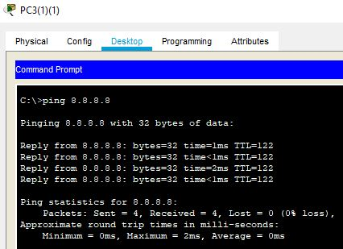 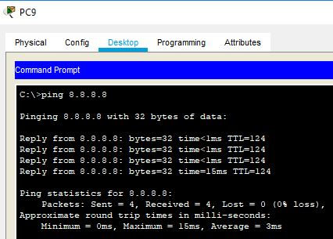

7)ping hostel ground floor->server 8)ping hostel 1st floor->server

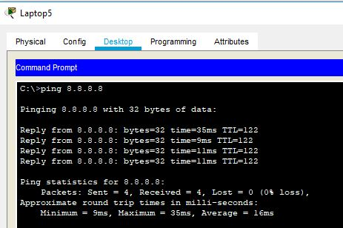 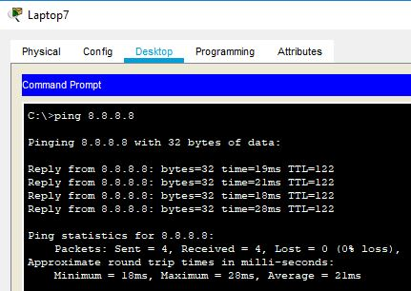

9)ping hostel 2nd floor->server 10)ping hostel office->server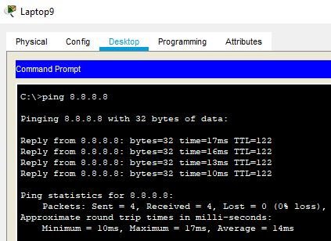 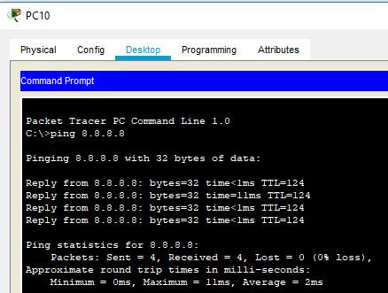

**7.Costing for network implementation**

**1) Data Center :-**

No. of device and quantity are listed below

1) router - 1

2) switch -1

3) server -1

Router price is 72800 Rs

Switch of fiber optic of around 27000 Rs

Server Price in india 150000

fiber optic cable required arround 3m cost 60 Rs Fiber optic wire per meter 20Rs

TOTAL COST :- 249860

**2) Main Building**

**Ground floor**

NO of device and quantity are listed below

1) router -2

2) switch-2

3) wire less router -2

for flooring connect copper wire 50m cost 500Rs Copper wire 10Rs per meter

to connect data center to main Building fiber optic wire of 40 meter is used cost

800 Rs

TOTAL COST :- 201300

**1ST floor**

NO of device and quantity are listed below

1) router -2

2) switch-2

3) wire less router -2

for flooring connect copper wire 50m cost 500Rs Copper wire 10Rs per meter

to connect ground floor to main Building fiber optic wire of 40 meter is used cost

800 Rs

TOTAL COST :- 201300

**2nd floor**

NO of device and quantity are listed below

1) router -2

2) switch-2

3) wire less router -2

for flooring connect copper wire 50m cost 500Rs Copper wire 10Rs per meter

to connect 1st floor to main Building fiber optic wire of 40 meter is used cost

800 Rs

TOTAL COST :- 201300

Main Building Cost :- 853760

**3)Library**

No of device and quantity are listed below

1) ROUTER -2

2) SWITCH -2

for connect copper wire 50m cost 500Rs Copper wire 10Rs per meter

to DATA CENTER to libraryoptic wire of 100 meter is used cost

2000 Rs

TOTAL COST :- 200,500

**4) HOSTEL**

No of device and quantity are listed below

1) ROUTER -1

2) SWITCH -1

3) wireless router :- 6

for connect copper wire 50m cost 500Rs Copper wire 10Rs per meter

to library to hostel fiber optic wire of 100 meter is used cost

2000 Rs

Total COST :- 105000

**9.Conclusion**

Thus, in this way we developed the “**GCOEJ NETWORKING MODULE**” using cisco packet tracer.

In this project we learnt to how to design and implement the networking module in cisco packet tracer. We successfully implemented the gcoej networking module for the main building, library, and hostel along with the main internet service provider and college server.

It is also noteworthy that, the configuration and specifications are for the initial prototype and can further be developed and additional functionality can be added to increase support and coverage. The procedures provide a veritable approach for the design of LANs for end-to-end IP network connectivity for next generation network (NGN) architecture implementations.

**10.References**

[1]. Tim Reardon, Planning, Designing and operating local area networks, DISAM Journal, Summer, 1997.

[2]. www.wikipedia.org/wiki/computer_networks, Retrieved 10th October, 2016.

[3]. www.wikipedia.org/wiki/local_area_network, Retrieved 10th October, 2016.

[4]. Garima Jain, Nasreen Noorani, Nisha Kiran, Sourabh Sharma, Designing & simulation of topology network using Packet Tracer, International Research Journal of Engineering and Technology (IRJET), 2(2), 2015.

[5]. Alan Dennis, Networking in the Internet age (John Wiley & Sons, 2002).

[6]. Kenan Xu, Performance analysis of differentiated QoS MAC in wireless local area networks (WLANs), Thesis Submitted to the Department of Electrical and Computer Engineering, Queen’s University, Canada. September, 2003.

[7]. David D. C., Kenneth T.P., David P.R, An introduction to local area networks, Proc. of the IEEE conf., Vol. 66, 1978. [8]. Todd Lammle, Cisco Certified network associate study guide (Wiley Publishing Inc., 2007).

[8] youtube video,etc